What we might find on our Anti Snare Walks

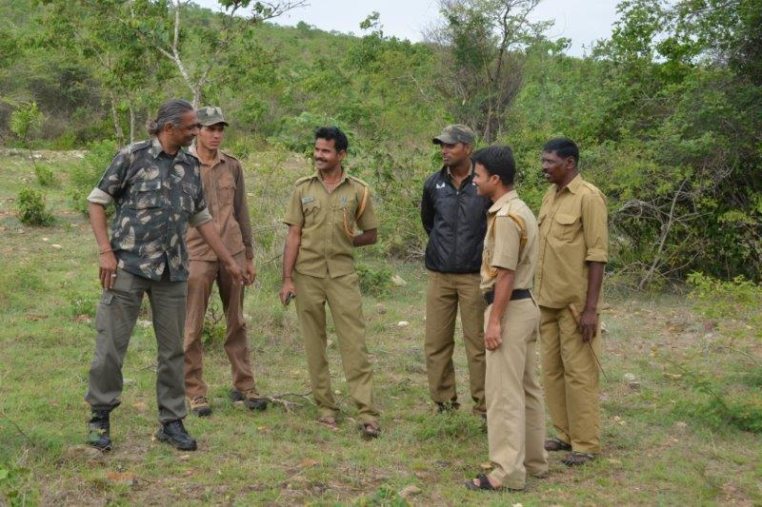
Each anti snare walk begins by a quick group discussion on the area we are going to cover, any areas we need to be particularly mindful of from past experience and the different kinds of snares we might find. We really need to be alert.
Here are a few pictures of what we come across:
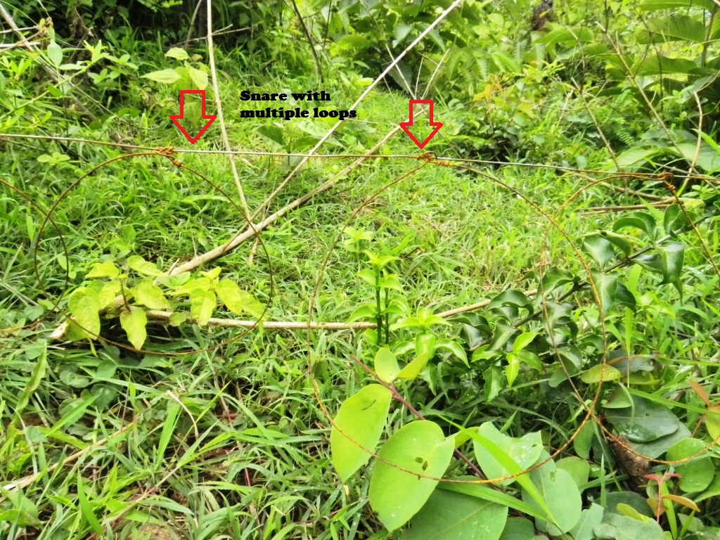
Snares are well camouflaged and laid directly in the paths wild animals use. These pathways are not often easily accessible to people. Sometimes the animals’ routes are artificially narrowed to ensure that they are led straight in to the snares.
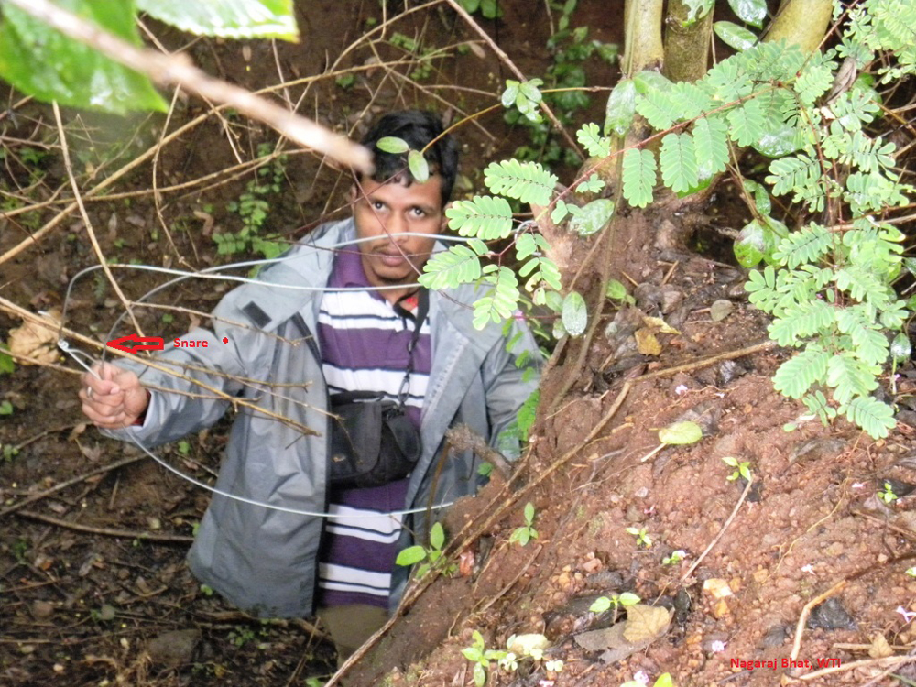
Snares can also be well hidden using ditches and trees to help camouflage them.
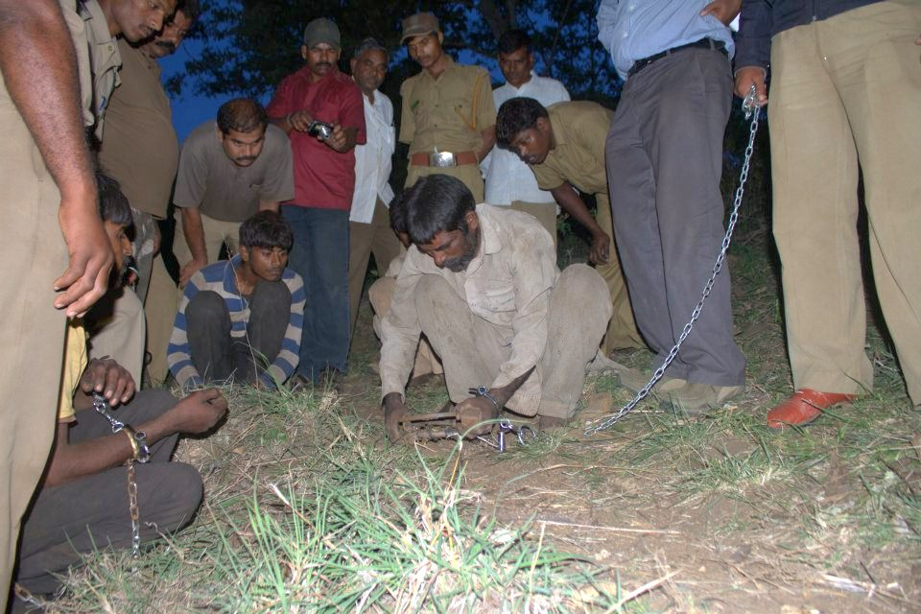There are occasions when we find deadly jaw traps as well.
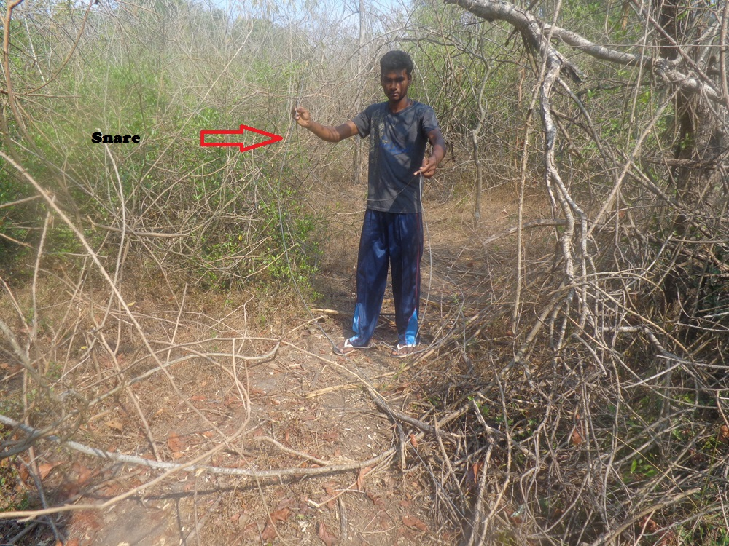
Snare loops vary in size depending on the animal targeted. Larger loops are used to trap ungulates like deer and carnivores like leopards and tigers. Tree branches are also strategically placed so that the targeted animals are forced to duck and are ensnared.
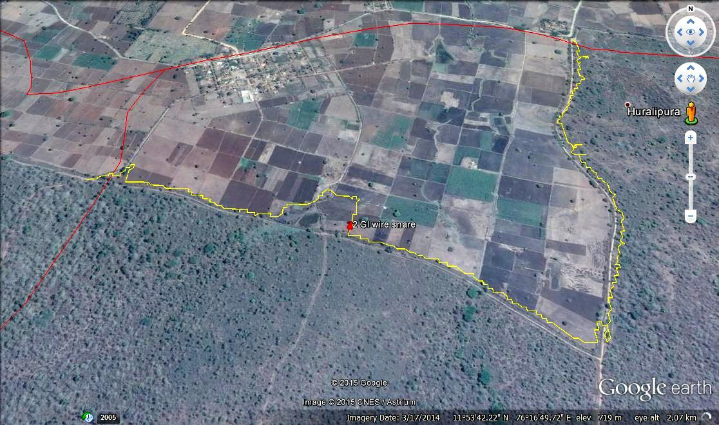
The location of every snare and trap we find is geo referenced before it is disarmed. This helps us keep track of areas that are the hot bed of snaring activities.
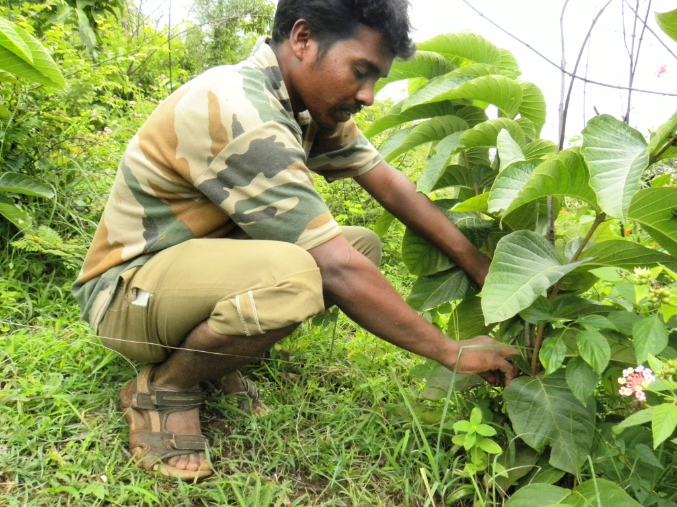
The disarmed snares are then taken back to Forest Department Office for proper cataloguing and storing as evidence.
The more snares we remove, the safer we can keep our forests and end an age old barbaric practice.

