GIVE HOPE TO 500 COLOMBIAN CHILDREN THROUGH PLAY

About Superarse Corporation:
Superarse Corporation is a private non-governmental organization founded in Medellín – Colombia, in 1970. We work with children who have their rights violated (mistreat, malnourishment, abuse, abandonment, neglect, among others) and with children who are exposed to situations of high social and psychological risks.
In Superarse, we are promoters and guarantors of the rights of the child. We are committed with the protection of children and adolescents, supported in a model of personalization of our services and sustainability, contributing to the construction of individual and familiar life projects.
Our Lines of Action:

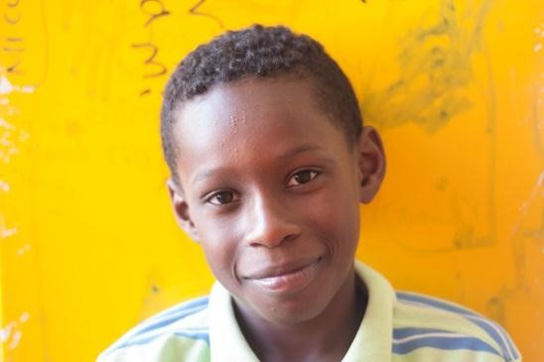
Specialized Protection Program (boarding house)
In this program we provide integral attention to children and adolescents who have their rights violated. They are classified by the Colombian Institute of Family Welfare (ICBF) under the measure of “special protection for the restitution of their rights”.

Preventive Attention Program for the childhood at risk
In this line of action we provide preventive care to children and adolescents who are exposed to high psychological and social risks (absent caregivers, child labour, school demotivation, exposure to situations of domestic or sexual abuse, exposure to drugs and alcohol, street risks, among others) . The attention in this program is provided 4 hours before or after school time on a daily basis, offering nutritional and academic reinforcement.

Provisional Homes
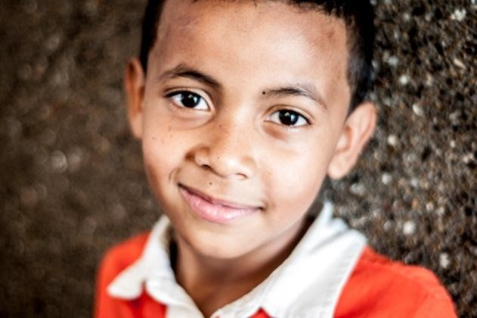
In this program we provide immediate and provisional care to children and adolescents in situation of threat or violation of rights (abandonment, abuse, social violence, absence of caregivers or responsible adults, among others).

Playrooms
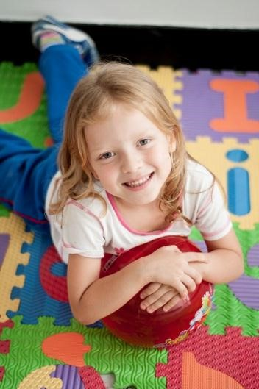
In Superarse´s Playrooms we use play and arts as essential components in strengthening resilience in order to develop higher levels of self-esteem and empowerment in children

Summary of the project:
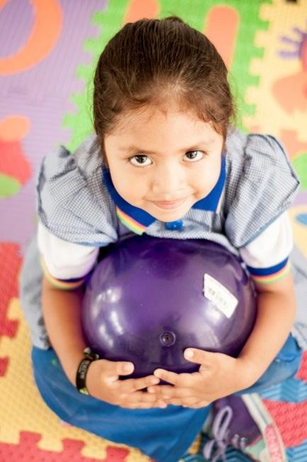
The aim of the project is to create a didactic playroom for 500 children abandoned or abused children, ages 2 through 18, in Medellin Colombia, This, in order to prevent psychosocial risks through the development of resilience, self-esteem and empowerment.
The project includes free meals, didactic materials, pedagogical services, and psychosocial support for abandoned and abused kids; preventing their enrolment in the armed conflict, child labour, drugs, and extreme poverty.

Description of the problem:
In Colombia 2 million children are mistreated every day, 35,000 are sexually abused, 14,000 join the armed conflict and 2.5 million children work informally (Watchlist, 2010) these risk factors undermine self-esteem and empowerment, hindering the possibility to adapt adequately to a situation and recover from it. 500 children in Medellin- Colombia, whose rights have been violated will benefit through play and integral attention developing self-esteem and empowerment and boosting resilience.
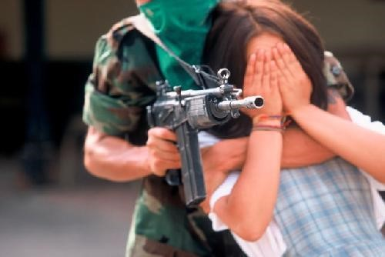
Source: http://conflictoarnadoencolombia.blogspot.com/
¿How will this project solve the problem?
Superarse provides integral attention through play as a therapeutic instrument, along with free meals, pedagogical support, didactic materials and psychosocial services to children at risk in Colombia.
In this project play has a crucial preventive role, because through play, children can symbolise feelings that would be hard to represent by language, providing an opportunity to work on the solution of conflicts in a safe and pleasurable mode (Erikson, 1963; Piaget 1951).

Long – Term impact:
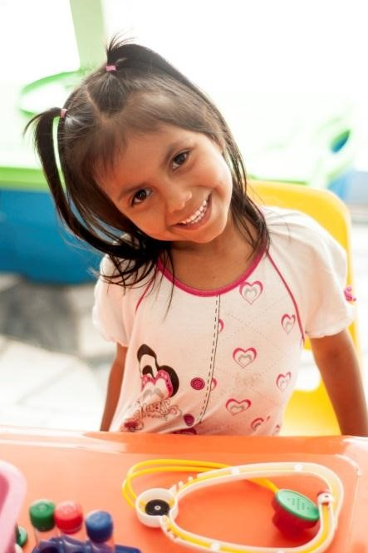
The project will enhance self-esteem, resilience and empowerment of Colombian children that have their rights violated and belong to the poorest sectors of Medellin, allowing them to build healthy life projects for the future.
Play will be the main instrument to transform the realities of the children as an alternative approach for developing social, cognitive and psychological skills.

Monthly budget
Item | Description | Total Cost in Dollars
Didactic Materials and toys | Replacements and new toys | 500
Pedagogical assistance | 1 person during 5 days per week - monthly | 700
Psychological assistance | 1 person during 1 month (1 day per week) | 400
Meals | Meals for 500 children | 900
Computers (At present we have 7 computers) | Maintenance computers monthly, for interactive activities with children | 100
Total |  | 2.600

