Training on Sewing and Cutting Program

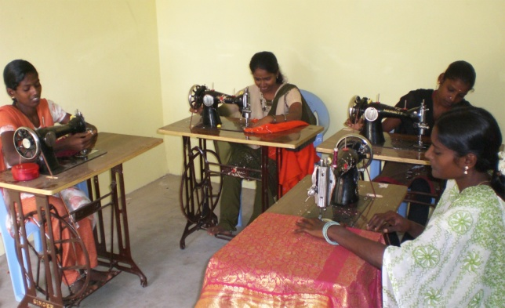
The main objective of this program is to provide the basic skill of sewing and cutting to 60 vulnerable female of the society so that they can uplift their living standard.

The female will be selected through an interview. In this program, 60 females from different parts of kadambathur block, Tiruvallur district will get opportunity to learn basic skill of sewing and cutting. Such type of income generating activities will definitely play a crucial role in uplifting their living standard in future.
CHHASE feel until women are empowered economically, it cannot be applied in practical. So, for the improvement of their living standard such type of program should not be limited only in training but should be commercialized for the benefit of female groups.

The aim of this training is to raise women's motivation to generate their income through sewing activity and also to provide and to strengthen sewing skills for women.

Sewing training is just one of the activities in the CHHASE fashion school. Embroidery, Beautician, artificial jewelry making, Village need based trainings is also carried out in the CHHASE fashion school.
CHHASE fashion school is part of the Humanitarian Protection and Peace building program in Tiruvallur district, Tamil Nadu. CHHASE fashion school is a place for women to develop their capacity and ability in a friendly environment. Some 688 women attended activities at CHHASE fashion school.
