DARE Network - Step Back to Myanmar - 2022

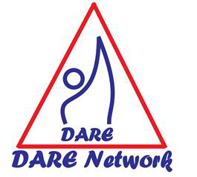
Drug and Alcohol Recovery and Education
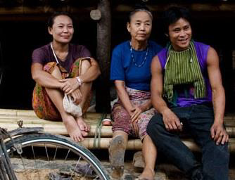
A Free Mind Cannot Be Destroyed

DARE Network is a grassroots community run organization that provides culturally appropriate, cross-cutting drug and alcohol addiction treatment and prevention education to the displaced peoples of Myanmar on both sides of the Thai-Myanmar border.

Background
DARE is the first and remains the only organization, that comprehensively addresses substance abuse within the refugee, migrant and village populations along the border. Operating since 2000, DARE currently runs centers in 5 camps and 1 migrant village along the border. As well we have a DARE Centre in Karen State running a comprehensive addiction program. DARE works to innovate an indigenous model of addiction prevention and treatment.

Since 2015 DARE Network has worked in Hpa’an District, Hlaing Bwe Sub-District in 40 villages. DARE has trained 40 Village Coordinators in Addiction Prevention and 20 Addiction Workers to provide non-medical, culturally appropriate treatment for substance abuse.

DARE reaches over 20,000 people a year through its prevention education, treatment and community support programs. DARE is run by the community, it has treated over 4500 people for addiction with an average 61% non-relapse rate over 21 years.

The Situation
Trauma, stress, loss of opportunity and freedom are the root causes of drug and alcohol abuse for the persecuted ethnic minorities of Myanmar.
The 2012 ceasefire has opened up drug trafficking routes in Karen State that increase the presence of drugs in small villages. Many of these villages have never before heard of addiction or know that recovery is possible.
Rates of drug use, especially Yaba (methamphetamines) are up to 80% in some villages. Even children eat the readily available pills that are wrapped to look like candy. Addiction tears communities apart, exacerbating entrenched poverty, illness and a lack of education that systemically ruin a community’s ability to develop and grow independently.

Step Back to Myanmar
DARE’s expansion to rural Karen State begins tackles these problems.

In early 2015, DARE worked with 20 villages to provide addiction education workshops and train local leaders to conduct addiction prevention education and small treatment programs. Now we work in 40 villages in Hlaing Bwe District.

Before the Military Coup we had a presence in 60 villages across Hlaing Bwe, Belin, and Thaton districts.
Our community-based model focuses on the careful transfer of knowledge from our highly trained and skilled staff to local village leaders, who then share with their community members.
DARE combats the harmful effects of addiction on the people and the community by ensuring access to treatment. It protects the communities through education and community involvement in support, treatment and prevention programs.

Our Program
- Treatment – 3 month residential and ongoing support groups
- Prevention Education – Teens for Kids, Men Working with Men for Happy Families, Home Visits
- Training – We train local people to become addiction workers and master trainers, to strengthen community resilience and sustainability

Our treatment is non-medical and culturally appropriate. Similar to our prevention education programs, treatment is community focused. Neither prevention, nor recovery, ends when someone leaves DARE treatment or an education session. We work with community members and leaders, families, other community-based organizations and leadership to provide the best ongoing community driven support to prevent and treat substance addiction.

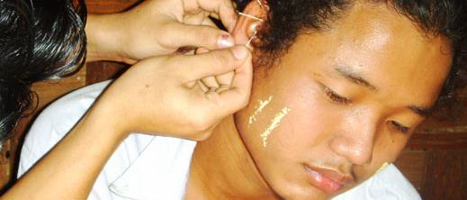

On the Ground
Impact and Results

DARE Network is passionate. It ensures adequate treatment and prevention services to the people of Myanmar. Each year we look for new ways to expand our programs and analyze the current environment. While the big issue, namely supply of drugs and alcohol is out of our hands, we do the best we can with the resources available to us to assist those affected by the trade.

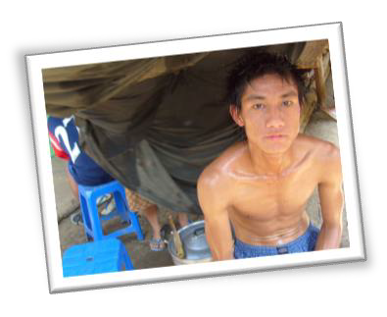
Client Story
Long Term Recovery Client (identity concealed)

“I started to use drugs & alcohol when I was a teenager. When I followed my friends somewhere, they would force me to use it; if you did what we said, you could follow us and enjoy with us. I spent my time using with my friends every time I was with them.
“I started to become addicted step by step until without drugs & alcohol I couldn’t do anything. Therefore I became under the control of drugs & alcohol.
“During my addiction, local authorities came and encouraged me to stop using. Moreover they let me know about the DARE treatment program for my recovery. After that I agreed
with them and went to the DARE treatment center.
“I felt happy while I was in the treatment center. The addiction workers showed good support to us. They gave us good knowledge and activities during the treatment period. I was satisfied with the addiction workers, who didn’t ignore me and had a good relationship with me. Therefore I am eager to change my mind and became a valuable person again.
“After treatment I had to face many problems. Mostly people who lived around me were addicted people. I remember while we were in treatment period, the addiction worker spent their time to give us
education to become a good person, so I could control my mind and try to avoid it easily. I wanted to inform all of the people who lived in the community; using drugs & alcohol were not a good thing. It will damage you and will destroy your people for the future.”

WHAT’S HAPPENING IN 2022 AND BEYOND?

DARE Network offers Humane Addiction Treatment respecting the human rights of addicts and their families.

1ST Addiction Prevention and Treatment Centre open in Karen State, Myanmar

During 2022 DARE Network has the following objectives.

- Run DARE Training and Treatment Centre near T’ree Hpoh Kwee village
- Train 8 new Addiction Workers in Karen State
- Facilitate 20 Village Coordinators to share Prevention Education to their own 20 villages and 20 other villages, 400 times in 12 months
- Provide 3 cycles of Addiction Treatment in DARE Centre in T’ree Hpoh Kwee
- Core DARE Staff support, monitor and evaluate program outputs
- Coordinate with CBOs and CSOs in Hpa’an District
- Outreach to other Ethnic groups and NUG
- Cooperate in the development of Indigenous Drug Policies
DARE Network continuous to support the Burmese Refugees in 5 Camps and 1 Migrant Area on the Thai/Burma Border
Activities for 2022
- Training of Addiction Workers
- Prevention Education and Community Interventions
- Treatment of Substance Abusers
We continue to seek more funding to help us meet these objectives and activities.
Update: The Military Regime of Burma has made a coup on the people of Burma and their duly elected government. This together with Covid19 has made all of our work more difficult. We continue to maintain our Treatment Centre in Karen State, as it is in a very isolated place.
We currently need support for our work in Karen State moving into 2023 and core support for our organization DARE Network
Our program in the Refugee Camps on the Thai side continue with strict Covid19 protocols.
Saw Law La Say, Program Director
www.darenetwork.com

