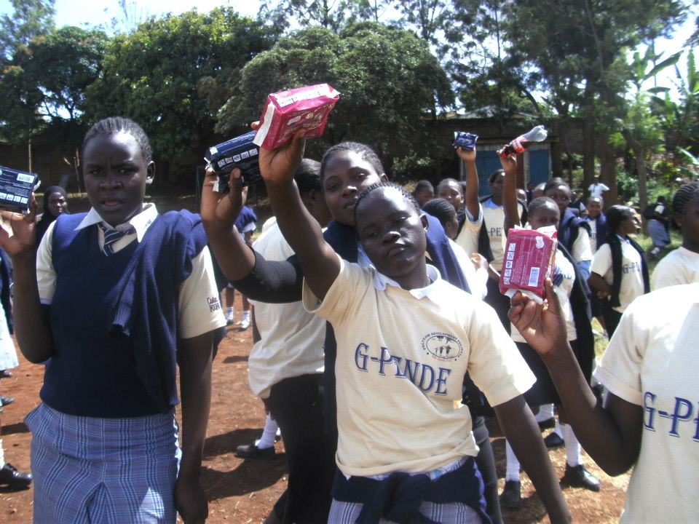

**OUR SUCCESS**

* School drop out among primary school going adolescent girls reduced by 60% since 2013.
* 5 needy girls pursuing their post primary education through the Educate Her Project
* Rotational Library Established in 12 school, 780 books
* Reproductive health talks and safe spaces established in 12 schools in Kibera.
* 4 out of school and 7 school teams of adolescent girls regularly playing volleyball in Kibera in 2014

**G-PENDE**

**Daily Lives Needs**

Sanitary Pads and Panties

Educate Her

***INDIVIDUAL SUCCESS STORY***

*Going through high school was considered impossible in my family since my three sisters all gave birth after joining high school. I was stressed and troubled because I knew I wasn’t different. I decided to put this on paper and share through the talking boxes. During the speak out sessions, this was the topic of discussion, things that stop us from achieving our dream, setting and protecting our values. I stood by my values throughout my high school and here I am. I completed my high school well and I am currently in college. I am also giving back to the community by volunteering at PDP. I know what “fear of the unknown can do to a young girl, exposing you to danger that you can hardly come out of. I am fully in charge of my life now, I love myself and encourage others to do the same:*

***Vivian Akinyi***

***22 yrs Old - Kibera***

**Contact Info**

Jane Anyango

Polycom Development Project

Kibera Law Court Drive,

P.O. BOX 16797 - 00100 Nairobi

**Mobile:** 0723954556

**Email:** [polycomdev@yahoo.com](mailto:polycomdev@yahoo.com)

**Website**: www.polycomgirls.org

/Polycom Development Project

/ polycomdev



**CURRENT NEED**

After listening to girls voices through the Talking Boxes, PDP has chosen to use GOAL Curriculum, “an award winning development programme which uses sport and life skills education to transform the lives of adolescent girls,” to influence change. PDP is seeking funds to roll out this curriculum in the 15 schools across Kibera Slums that are implementing the Talking Boxes project. This will reduce the number of girls falling victims to violence and manipulation and increase the number girls finishing their high school.

**OUR WORK**

Through schools and organized groups PDP uses:-

* **Sports** to mobilise and initiate talks on girls welfare
* **Talking Boxes** heart to heart sharing to listen to their inner voices
* **Sanitation** to promote hygiene and reproductive health talks
* **Educate Her** to mobilize funds for post primary education for willing needy girls

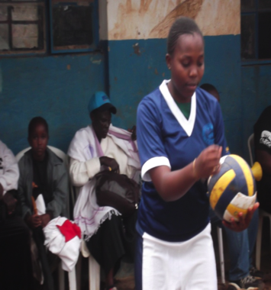

**POLYCOM DEVELOPMENT PROJECT**

PDP is a girls and young women empowerment organization based in Kibera slums in Nairobi, Kenya. PDP’s mission is to empower young women in Kibera through access to education, sports activities and sanitation to be able to manage their lives positively and develop a voice to influence policy and decision makers on issues that affect the lives of girls.

**ADOLESCENT GIRLS LIBERATION THROUGH VOLLEYBALL**