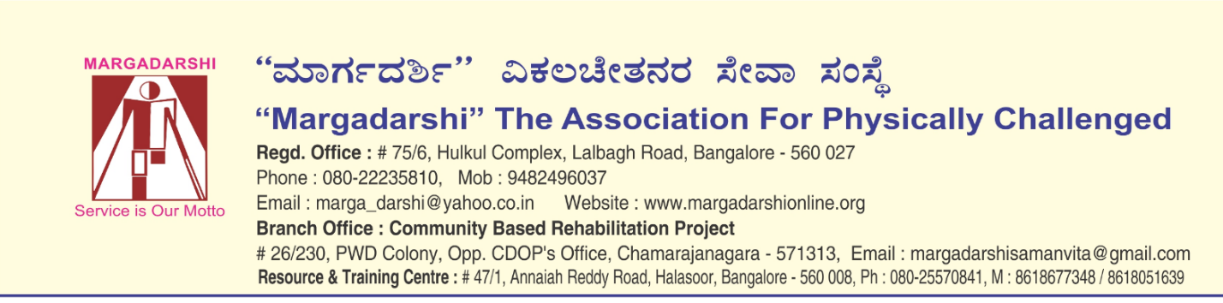

Proposal on Residential Care to the Women with Disability

Background:

Margadarshi The Association for Physically Challenged is a non-government organization, striving ceaselessly in the field of disability for over twenty five years (since 1988), aiming to empower persons with disabilities to become active contributors to society, through a range of services from Medical Rehabilitation, Educational Support, Livelihood Training, Counseling & Guidance and Advocacy. We do this through our Institutional and Community based activities and touch lives of around 10000 people with disability.

The Need

According to NSSO, there are 650 million disabled people in the world, 70% live in developing countries and 80% live below the poverty line with extreme poverty conditions. According to a conservative estimate, disabled people constitute 6% of the total population of India which equals to 60 million. 80% live in rural areas where no or very inadequate services exist. 82% live with extreme poverty conditions.

It is pertinent to point out that among disabled people, women come from the most marginalised sections of the society. While the Government of India is trying to do its bit by way of legislations and Schemes, these are proving to be inadequate and the delivery to the recipients is very slow. In fact, it is thought-provoking to note that not much information is available about people with disabilities in terms of who they are, where they are and what do they need!

This is where a section of the civil society like ours steps in. We are doing our bit to bridge the gap between what is available for people with disabilities and what is required by them. Today, due to various reasons, the social fabric of our society is being torn apart resulting in people with disabilities, specially women being pushed further beyond the fringes of normal social life.

Program focus and population served :
- Preparing the differently-abled girls to enter the Society as educated, well equipped individuals capable of economic independence and raising families.
- Provide women who are not literate with shelter and provide them skill based work suited to them

The beneficiaries are around 50 children/young women and adults with disabilities from under privileged section of Society.

Program/project description

The situation of Physically Challenged Girls is quite severe due to neglect by the family, lack of support, lack of integration at all levels in the society including that of education, medical, vocational and employment support services. When they belong to poor families the condition is further worsened and totally neglected. Realising this special need Margadarshi has taken up home for the physically challenged women with no means of support or having very little means. They are offered residential care, medical care, physiotherapy and vocational skills in addition to grooming them to develop leadership and life skills.. The Residents gain to find meaning in life and live a life with dignity in an atmosphere of love. The residents are engaged in productive activities throughout the day. Young residents are encouraged and facilitated to pursue education in their area of interest and seek suitable employment.

Project Outcomes:
- Young girls with disability, being educated will get jobs and take care of themselves and their families. Thus become contributing members of Society.
- Women with disability will earn a living through the sale of their skill work (making handicrafts items, paper bags, etc.)

Location of the Project : No.47/1, Annaiah Reddy Road, Halasoor Road, Bangalore 560 008

Geography to be served : Bangalore urban and rural, in 5 Hobli's of Kollegal, a Taluk of Chamarajanagar District, namely Kasaba, Ramapura, Hanur, Palya, Lokkanahalli.

Margadarshi The Association for Physically Challenged
Hostel Maintenance
Estimated Budget for 1 Year
Particulars | Per month | Per year | Amt. in INR | Conversion rate in US$ | Amt. in US$
Towards Residents: |  |  | 16,00,000 |  | 32,750
Food | 4000/day | 365 days | 14,60,000 | 80 | 18,250
Medical |  |  | 3,80,000 | 80 | 4,750
Salary of 1 cook | 10000 each | 12 months | 3,60,000 | 80 | 4,500
Salary of 1 helper | 5000 each | 12 months | 1,20,000 | 80 | 1,500
Clothing |  |  | 3,00,000 | 80 | 3,750
Towards Adminstration: |  |  | 9,00,000 |  | 28,875
Part Salary of a Manager | 50000 | 12 | 6,00,000 | 80 | 7,500
Part Salary of a Accountant | 17500 | 12 | 2,10,000 | 80 | 2,625
Part Salary of 2 Securities | 25000 | 12 | 3,00,000 | 80 | 3,750
Salaries of 2 wardens | 30000 | 12 | 3,60,000 | 80 | 4,500
Part Salary of 1 driver | 30000 | 12 | 3,60,000 | 80 | 4,500
Utilities (Gas,water,electricity) | 40000 | 12 | 4,80,000 | 80 | 6,000
Towards Fixed Over Head, Maintenance: |  |  | 5,20,000 |  | 8,650
Lift Maintenance | 4000 | 12 | 48,000 | 80 | 600
Building up-keep/maintenance | 12000 | 12 | 1,44,000 | 80 | 1800
Miscellaneous |  |  | 5,00,000 | 80 | 6250
TOTAL A+B+C |  |  | 30,20,000 |  | 70,275

