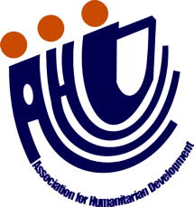

Proposal for setting-up of 1,500 Nadi filter in Bungoma County Government of Kenya, Africa by Association for Humanitarian Development, Pakistan

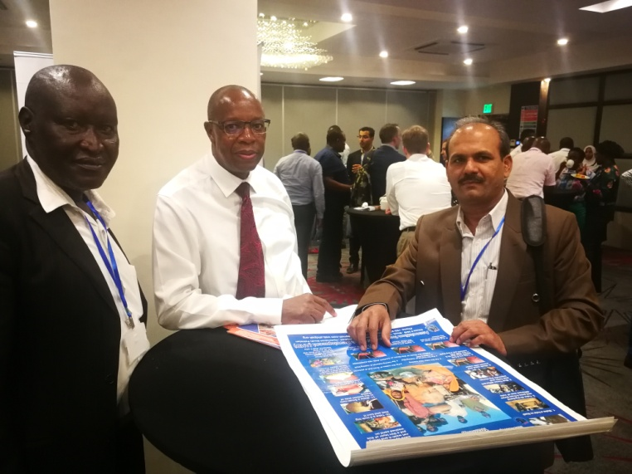
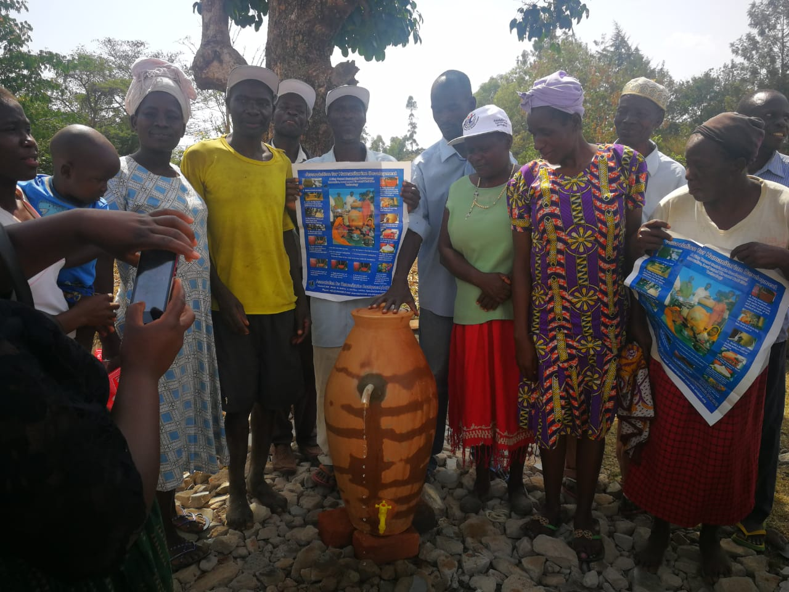

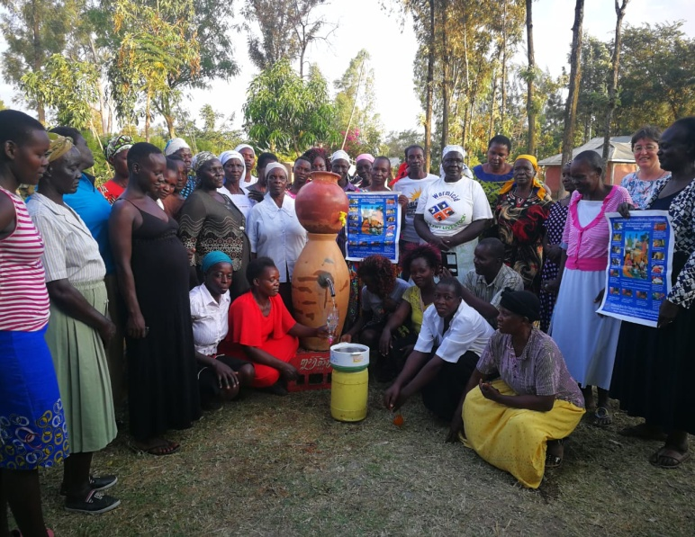
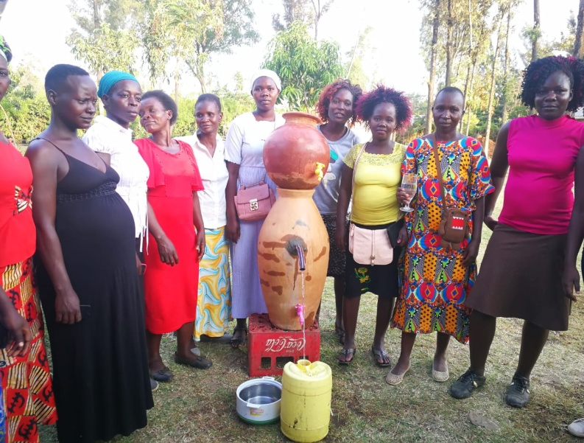

Submitted by:
Association for Humanitarian Development (AHD)
House # 39/b, Block-D, Unit. No. 2, Latifabad Hyderabad Sindh Pakistan
Phone: +92-22-3407819
Email: ahdpak@gmail.com Website: www.ahdpak.org

PROJECT SUMMARY:

Significant proportions of the population in Kenya live in rural areas where they are frequently dependent on small scale systems for their daily water supply. Such systems have been shown to offer only a limited capacity to control environmental risks, and are associated with higher disease burdens in the resident population. Protection of the catchment area, particularly the creation of effective water protection zones, is often a cost-effective way to increase compliance with the WHO Guidelines on Drinking-Water Quality, and a first essential step towards the creation of a water safety plan (WSP).

The present document is a proposal by Association for Humanitarian Development (AHD); a Pakistan based Civil Society Organization (CSO) for setting-up of Self Help Biological Sand Filter (Nadi water filter) in different regions of Africa. The proposed project would replicate the most successful model of Pakistan in providing water safety of small scale supplies, and reducing negative health outcomes associated therewith. In particular it focuses on the creation and enforcement of water protection zones in Africa with the aim of facilitating the introduction of Nadi water filters in the small scale water supply systems in the region thereby improving the health of the local population.

The innovation of AHD Nadi filter contributed in drinking water crises to the community that they have now opportunity to get clean and safe drinking water by filtering from Nadi filter unit. Nadi filter unit filter water from 98 to 100% removal of biological contamination. Since 2006-2007 to till a date about 54,000 families drinking clean and safe drinking water via Nadi filter unit at their household level in Pakistan.

In 2007 AHD implemented 100 Nadi filter units through ADP USA the families were using Nadi filter units share great story to donors and people visited them. After successful implementation 100 Nadi filter units, APFED approved AWARD for 1000 families in 2008. AHD successfully completed 1000 Nadi filter units, then Oxfam GB, WHO Pakistan, Misereor Germany, Govt. of Pakistan and others donors supported AHD Nadi filter unit reached up to 50,080 families with access to safe and clean drinking water for 500,800 people.

Many families’ helps and share Nadi filter technology in their relative residing in different parts of the country. Some families of Punjab adopted Nadi filter units through their relative and spreading the message of safe drinking water in other families the pictures showing the families installed Nadi filter units in 2007 still using it successfully, this is great achievement and success that the Nadi filter unit working since last 09 years. AHD brings new hope and blessing of safe and clean drinking water with them.

PROBLEM AND JUSTIFICATION OF THE PROJECT:

Africa faces huge challenges with multiple issues that adversely affect public health. One major challenge is the ability for both rural and urban Africans to access a clean water supply. According to the WHO (2006), only 59% of the world's population had access to adequate sanitation systems, and efforts to achieve the Millennium Development Goal, which is aiming for 75% by the year 2015, will fall short by nearly half a billion people.
The situation of access to clean water and sanitation in rural Africa is even more dismal than the previous statistics imply. The WHO (2006) stated that, in 2004, only 16% of people in sub-Saharan Africa had access to drinking water through a household connection (an indoor tap or a tap in the yard). Not only is there poor access to readily accessible drinking water, even when water is available in these small towns, there are risks of contamination due to several factors. When wells are built and water sanitation facilities are developed, they are improperly maintained to due to limited financial resources. Water quality testing is not performed as often as is necessary, and lack of education among the people utilizing the water source leads them to believe that as long as they are getting water from a well, it is safe. Once a source of water has been provided, quantity of water is often given more attention than quality of water There are limited sources of water available to provide clean drinking water to the entire population of Africa. Surface water sources are often highly polluted, and infrastructure to pipe water from fresh, clean sources to arid areas is too costly of an endeavor. Groundwater is the best resource to tap to provide clean water to the majority of areas in Africa, especially rural Africa, and groundwater has the benefit of being naturally protected from bacterial contamination and is a reliable source during droughts. However, the high costs associated with drilling for water, and the technical challenges in finding sources that are large enough to serve the population in need, present challenges that limit tapping the resource. Groundwater is not a fail-safe resource, either, when it comes to providing clean water. There may be contamination of the water with heavy metals, and bacteria may be introduced by leaking septic systems or contaminated wells. The implications of lack of clean water and access to adequate sanitation are widespread. Young children die from dehydration and malnutrition, results of suffering from diarrheal illnesses that could be prevented by clean water and good hygiene . Diseases such as cholera are spread rampantly during the wet season. Women and young girls, who are the major role-players in accessing and carrying water, are prevented from doing income-generating work or attending school, as the majority of their day is often spent walking miles for their daily water needs. They are also at an increased risk for violence since they travel such great distances from their villages on a daily basis, and are even at risk when they must go to the edge of the village to find a private place to relieve themselves.
Overcrowding in urban slums makes it even more difficult to control sanitation issues and disease outbreaks associated with exposure to raw sewage. It has been reported that underprivileged urban populations pay exorbitant amounts of money for water, which is often not even suitable for consumption, while resources allocated to those living in the wealthy urban areas are heavily subsidized, meaning the wealthy pay less for cleaner water and better sanitation systems

To address this situation, Association for Humanitarian Development (AHD) is proposing the replication of safe drinking Nadi filter unit for clean drinking water and sanitation measures in selected countries of Africa. The process would enable access to safe drinking water and sanitation services in 5,000 families at the initial stage and furthermore local Self-Help Group (SHG), CBOs, NGOs and interested organizations will be responsible to implement the said project in selected countries. AHD would work with local CSOs in implementing the pilot project. It may be noted that the lack of clean drinking water is forcing millions of people to drink unsafe water. This leads to an increase in diseases like diarrhea, the second leading cause of death in children under five. Floods, droughts, pollution and climate change have created even more problems in countries. The focus will be on vulnerable sections of the society in rural areas and urban peripheries; since this group of semi-urban users is growing fast and faces the greatest problems, especially with regards to sanitation. Combining clean water and increased production of food can support the families to reach improved nutritional standard and strengthen their food security situation. Urine is a pathogen free natural fertilizer that brings higher agricultural productivity if used correctly in food production.

OBJECTIVES:

The project aims to eradicate endemic poverty and related to lack of access to sustainable sources of drinking safe and clean water among vulnerable families in rural areas. By providing the low cost and easily adoptable Nadi filter unit at household’s level with free access safe water source, it aims to improve environmental and health condition, socio-economic conditions, as well as overall well-being of the low-income families. This project aims at initially set-up 500 Nadi water filters in African countries to serve vulnerable communities. These filters would be used to effectively reduce incidence of waterborne diseases and enable people to have access to clean water. The project would then be evaluated and rolled out within a business model suited to ensure setting-up of more Nadi water filter units. Ratio of chronic & water borne diseases will be decreased. Increase the level of knowledge and understanding concerning water and sanitation related diseases among rural communities. Eliminating by 50% the environmental health risks related to lack of clean drinking water.

General objective: Maximize health benefits of the people and improve access to portable water and sanitation facilities.

Specific Objectives:

- To promote the safe use of potable water by setting-up Nadi water filter units within selected communities within 12 months.
- To build capacities of village community members through trainings and workshops on safe drinking water and health & hygiene and usage of Nadi water filter units
- Find motivated female farmers that would like to collect their urine and learn how this natural fertilizer can help their food production capacity.
- To form Water and Sanitation Committees (WATSAN committees) and increase the level of awareness on personal hygiene and environmental cleanliness of project communities within 12 months.

Selection Criteria of WATSAN committee members:
- Should be married and above 20 years of age
- One member per family
- Willing to abide rule & regulations of CBO / SHG
- Willing to save monthly in CBO / SHG
- Willing to participate in project trainings and CBO / SHG meetings
- Willing to use and maintain model household/village/community sanitation facilities
- To keep village/community clean and neat
- Respect and expect women participation to committee meetings

METHODOLOGY:

This pilot project focuses on selected 10 Counties of Kenya at the average of 200 in each country, likewise 1,500 Nadi filters units models in 10 counties in six months time period. About 20,000 households’ women, children and old people will have a access to safe and clean drinking water at their household level. The families will be selected which are more vulnerable to lack of clean drinking water and sanitation facilities. AHD will ensure the overall project management leading the process within each district. The work will be carried out in the sector related to the provision of water and sanitation services. The project is developed with possible replication in other countries and services in mind. It will be implemented in a phased approach, using lessons learned from AHD’s experiences in Pakistan.

PROJECT INCEPTION:
Under the overall efforts of AHD will be responsible for ensuring the smooth implementation of the project at the national level. The Director of AHD will have the overall responsibility of the project’s implementation supported by a team of AHD staff in finance, ICT, monitoring and evaluation (M&E) and research. AHD will undertake an inception workshop at the national level. At the beginning of the project, the M&E expert with input from AHD will define a monitoring framework for the project. This includes a set of indicators to measure project progress.

PROJECT EXPECTED RESULTS:

It is expected that the project would lead to:
- Improved quality life.
- Morbidity reduction.
- Less medical expenses of the people in the project communities.
- Reduction of water and sanitation related diseases.
- Increased awareness on good hygiene practices.
- Adoption of effective and efficient hygiene promotion.
- Availability of adequate number of trained hygiene promoters.
- Development of appropriate hygiene promotion materials.
- Availability of adequate number of low cost water filters for communities’ use.
- Availability of adequate source of portable water to the communities.
- Reduction of poverty level of the people.

PROJECT INDICATORS:

The following are indicators to be used to measure the results achieved by the activities of the project:

Short Term goal indicators are:
Presence of safe drinking water sources available in the various communities.
Increase availability and knowledge of how to use safe drinking water.

Long Term goal are: Hospital attendance for water and sanitation related disease reduced, Healthy children in the communities, protection of water resources, increased food production

Objective (1) indicators are: Presence of at least 1,500 Nadi water filter units in the communities in use

Objective (2) indicators are: Increased level of knowledge and awareness among communities on protecting drinking water facilities.

Objective (3) indicators are: Presence of WATSAN Committees that also has sufficient knowledge of how sanitation can influence positively food security and health in the communities.

The following shall be the sources of verifying the indicators mentioned above: visits to verify water points and presence of Nadi water filter units , verification of health records at health facilities e.g. clinics and hospitals, community visit observations, interviews, spot check counting, surveys and House to House visits.

DESCRIPTION OF PROPOSED PROJECT ACTIVITIES:

The following is a comprehensive description of the main project activities, which AHD would undertake in 06 months:

- Identify project communities in selected Counties
- Assess communities for facilities under the project
- Identify Local Artisans for construction of Nadi water filter units
- Set-up Nadi water filter units
- Providing training in each County for 1,500 beneficiary households in community suffering from water borne diseases and using unsafe drinking water
- Find 1,500 households interested in household Nadi filter technology
- Publication of posters and broachers on safe water Nadi filter, health & Hygiene (5,000 posters on safe drinking water, 5,000 on health & hygiene and 5,000 on sanitation and link to food production )
- 2 Monthly project meetings on regular basis to plan schedules for the implementation of the project
- Community mobilization and visits to strengthen the households’ use of Nadi filter
- Mobilization workshops will be conducted at village/community level to form WATSAN committees
- Organize Training programs and orientation workshops for community members
- Form WATSAN committees in the project communities
- Train WATSAN Committees
- Monitor the implementation of the activities
- Draw monitoring and evaluation plan.

Detail Implementation Plan
Activity | Time Line |  |  |  |  |  |  |  |  |  |  |  |  |  |  |  |  |  | Responsible
 | 1st Phase |  |  |  |  |  | 2nd Phase |  |  |  |  |  | 3rd Phase
 | 1M | 2M | 3M | 4M | 5M | 6M | 1M | 2M | 3M | 4M | 5M | 6M | 1M | 2M | 3M | 4M | 5M | 6M
Identify project communities in selected countries |  |  |  |  |  |  |  |  |  |  |  |  |  |  |  |  |  |  | AHD
Assess communities for facilities under the project |  |  |  |  |  |  |  |  |  |  |  |  |  |  |  |  |  |  | AHD
Identify Local Artisans for construction of Nadi water filter units |  |  |  |  |  |  |  |  |  |  |  |  |  |  |  |  |  |  | AHD
Set-up Nadi water filter units and distribute household urinals |  |  |  |  |  |  |  |  |  |  |  |  |  |  |  |  |  |  | AHD
Providing training in each district for 5,000 households in communities suffering from water borne diseases and using unsafe drinking water and train farmers in safe reuse of urine in food production |  |  |  |  |  |  |  |  |  |  |  |  |  |  |  |  |  |  | AHD staff
Publication of posters and broachers on safe water Nadi filter, health & Hygiene |  |  |  |  |  |  |  |  |  |  |  |  |  |  |  |  |  |  | AHD
Monthly project meetings on regular basis to plan schedules for the proper implementation of the project |  |  |  |  |  |  |  |  |  |  |  |  |  |  |  |  |  |  | AHD
Community mobilization visits to strengthen the households use of Nadi filter and household sanitation products |  |  |  |  |  |  |  |  |  |  |  |  |  |  |  |  |  |  | AHD staff
Mobilization workshops will be conducted at village/community level to form WATSAN committees |  |  |  |  |  |  |  |  |  |  |  |  |  |  |  |  |  |  | AHD staff
Organize Training programs and orientation workshops for community members |  |  |  |  |  |  |  |  |  |  |  |  |  |  |  |  |  |  | AHD staff
Form WATSAN committees in the project communities |  |  |  |  |  |  |  |  |  |  |  |  |  |  |  |  |  |  | AHD staff
Train WATSAN Committees |  |  |  |  |  |  |  |  |  |  |  |  |  |  |  |  |  |  | AHD staff
Monitor the implementation of the activities |  |  |  |  |  |  |  |  |  |  |  |  |  |  |  |  |  |  | AHD
Draw monitoring and evaluation plan. |  |  |  |  |  |  |  |  |  |  |  |  |  |  |  |  |  |  | AHD

PROJECT MANAGEMENT & IMPLEMENTATION: The project implementation shall involve a senior staff of AHD comprising of an international project coordinator and the Project Director. All the AHD staffs have over 10 years of experience in community and project development.

LOGICAL FRAMEWORK

Narrative Summary | Measurable Indicators of  Achievement | Means of Verification | Important Assumptions
Strategic Objective
This project aims at initially set-up 1,500 Nadi water filters in each country to serve vulnerable communities. These filters would be used to effectively reduce incidence of waterborne diseases and enable the beneficiaries to have access to clean water. The project would then be rolled out to ensure setting-up of more Nadi water filter units. There would also be training on water safety methods and water-sources maintenance. |  |  | Beneficiaries pledge for project sustainability, its  running and maintenance  No security concern in the selected areas
Objective
- To maximize health benefits of the people and improve access to potable water and sanitation facilities  - To promote the safe use of potable water by setting-up Nadi water filter units within selected communities within 06 months  - To form Water and Sanitation Committees (WATSAN committees) and increase level of awareness on personal hygiene and environmental cleanliness in beneficiary communities within 06 months. | individuals were  provided with safe and healthy drinking water | Research units.  The post project follow up monitoring  /evaluation report in  office (record) | Diseases cases reduced  waterborne disease  prevented
Purpose
Provision of safe / healthy  drinking water through  Nadi Filter Model | Healthy water provided to  the needy families  Mortality rates reduced  and waterborne diseases  rates declined | Record at Basic Health  center (Govt officer)  Record at family based  Interviews.  Evaluation study findings.  Progress and final report.  Feedback from the relevant  government office  Feedback from beneficiaries  Project activities record in  office  Live Interview and case  study | High interest of  beneficiaries and  government in the project  The pledge of further  support from government to target beneficiaries in terms of hygienic promotion activities
Outputs
Installation of Nadi Filters for safe/healthy drinking water | Installation of 1,500 Nadi Filter at each district  Community mobilization visits to support the households in the use Nadi filter | Field visits.  Periodic reports  Feedback information from beneficiaries.  Activities documentation  (photos, case studies etc..)  Progressive and final report.  Interview and case study | Stability  Beneficiaries authorities cooperation
Activities Important | Inputs | Means of Verification | Assumptions
- Identify project communities in selected countries  - Assess communities for facilities under the project  - Identify Local Artisans for construction of Nadi water filter units  - Set-up Nadi water filter units 1,500 in 10 Counties  - Provide training in each County for 200 households in community suffering from water borne diseases and using unsafe drinking water  - Publication of posters and broachers on safe water Nadi filter, health & Hygiene (5,000 posters on safe drinking water, 5,000 posters on health & hygiene of women and children and 5,000 posters about natural fertilizer use in agriculture)  - 2 Monthly project meetings on regular basis to plan schedules for the proper implementation of the project  - Community mobilization visits to support beneficiary households that are using urinals and/or Nadi filters  - Mobilization workshops will be conducted at village/community level to form WATSAN committees  - Organize Training programs and orientation workshops for community members  - Form WATSAN committees in the project communities  - Train WATSAN Committees  - Monitor the implementation of the activities  - Draw monitoring and evaluation plan | Staff Salaries  Project Material Cost  Monitoring:  Grand Total | Financial report and record office  Record at community base center  (material stock record,  material verification sheet,  assets inventory record)  Financial Record  . | Previous experience of  staff in the area and  Project nature.  Availability of qualified  Expert  Delay of cash transfer from  Donor.  Natural disaster  Availability of material  required for the project  Existence of Problematic  Individuals in community.
Proposed Budget for 1,500 Nadi filter Replication in 10 Kenyan Counties
S. No | Activity / Component | Unit. Value in US$ | No. of Units | Total
1 | Program Officer / Nadi Trainers County level 4 * 06 | 550 | 24 | 13,200
2 | Honorarium for Project Director | 1,500 | 6 | 9,000
3 | Inception Workshop in 10 Counties | 800 | 10 | 8,000
4 | Material procurement from local area/storage Nadi pots etc | 1,500 | 10 | 15,000
5 | Nadi filter units | 30 | 1,500 | 45,000
6 | TOT on Nadi filter trainings | 500 | 10 | 5,000
7 | Publication of posters and brochures | 2,000 | 1 | 2,000
8 | Mobilization workshops and Trainings | 1,000 | 10 | 10,000
9 | Return Air Tickets for 2 AHD staff | 1500 per trip | 10 | 15,000
10 | Domestic travel in country | 1,000 | 10 | 10,000
11 | Communication Costs (Phone, Fax and Postage) | 1000 | 5 | 5,000
12 | AHD Finance and Admin support/office rent etc | 1,500 | 06 | 9,000
Grand Total in US $ |  |  |  | 135,200

PROJECT SUSTAINABILITY:

The following are measures to be taken to ensure sustainability:
- WATSAN Committees would be formed in all the beneficiary communities to take absolute responsibility for the facilities to be provided.
- Capacity building training would be provided to the WATSAN Committees for proper management of the Nadi water filter units. Local caretakers from the communities will be trained to do routine maintenance on the water facilities to be provided.
- Other sources of funding shall vigorously be pursued by AHD to source funding to continue with the project activities in project communities.

- Technical feasibility of the project activities shall be ensured through full participation of the project communities. Community animation would be carried out for the people to accept and own the Nadi water filter units that shall be provided. The people shall be thought that using Nadi water filter units for domestic purposes and maintaining good hygiene will improve their health and standards of living.

SOME USEFUL LINKS OF AHD WORK:-

- AHD also received international award of “Energy Globe Award” from Austria during 2014 the link: http://www.energyglobe.info/pakistan2014?cl=english

- https://www.youtube.com/watch?v=AuNu_xOWUE0

- https://www.facebook.com/ahdpak/photos/a.280051878750154.67703.153068324781844/552408444847828/?type=3&theaterRural%20communities%20love%20Nadi%20filter

- https://www.facebook.com/ahdpak/photos/a.280051878750154.67703.153068324781844/444943838927623/?type=3&theater

- AHD Nadi filter Video process to prepare at local level http://www.youtube.com/watch?v=TBvclfeW_NA

- AHD also WINS the Energy Globe Award 2014 for Pakistan http://www.energyglobe.info/pakistan2014?cl=english

- The power presentation attached pictures ling show the interaction of women and children http://www.ahdpak.org/program-safe-drinking-water.php

- Video and pictures available at facebook link a project posted at Global Giving for 10,000 families and so far we reached in 3,300 families https://www.globalgiving.org/projects/pakistan-flood-affected-families-support/photos/#donationOptions

Evidence Reports of AHD NADI FILTER:

- http://coldstorage.macbonsai.com/adp-library/Public/projects/biosand-water-filters/documents/March_2007_Report.pdf
- https://www.sdpi.org/publications/files/nadi-filter.pdf
- http://www.energyglobe.info/awards/details/awdid/85016/
- http://nation.com.pk/islamabad/19-Feb-2010/Funstarved-Islooites-demand-cinema-in-Capital
- http://www.solutionsforwater.org/solutions/rewarding-innovation-at-local-level-in-sindh-pakistan

Annex 1:
Brief Overview of the Organization:
Association for Humanitarian Development (AHD) is a social community based organization was established on December 2001-2002 and registered under the societies Registration Act: XXI of 1860 on 17 May 2003. AHD is Non-Government Organization which organizes humanitarian Development activities in Pakistan. AHD emphasize a right based, participatory approaches for community development, where rural people especially women and disadvantaged groups are partners rather than the subjects and objects of development.

AHD has been working since 2001-2002 to uplift rural communities and bring peace, justice, harmony & equal opportunities. Since its start AHD working to bring new solutions for the rural poor communities, in this regard AHD Fuel Efficient Stove model, Kitchen Grading and women development models initiated in hundreds of villages. During 2005-2006 AHD conducted research over safe drinking water, purpose to bring new invention technique to help poor villagers to have access to safe and clean drinking water at their household level. Women and children are less than 5 years suffering with water borne diseases. Several methods introduced in rural communities but not successful for long time. During 2007 AHD started working on mud pot Nadi filter to filter contaminated canal water for access to safe and clean drinking water to bring health in children and women.
AHD trained local staff and communities through Nadi filter training school, the NGOs, CBOs and community members are being trained to promote Nadi filter units on mass scale.

Main Objective of AHD:-
The main objective of the AHD is to work for the PEACE, JUSTICE, HARMONY and equality through the participation of most disadvantaged and marginalized communities for the sustainability as a whole to bring peace, justice, unity and harmony for all and to ensure availability of food and equal distribution of natural resources among the Marginalized communities.

AHD’s mission is mobilizing and motivation vulnerable people through different programs and projects, moving them towards sustainable development. AHD’s goal is promotion of self-help activities through capacity building among the vulnerable/poverty stricken communities towards sustainable development.
Annex 2:
INTRODUCTION OF THE NADI FILTER:
The innovation of AHD Nadi filter contributed in drinking water crises to the community that they have now opportunity to get clean and safe drinking water by filtering from Nadi filter unit. Nadi filter unit filter water from 98 to 100% removal of biological contamination.

The filter is simply an optimized residence for the “good microbes” that eat up the microbes that cause diseases. The filter is designed to protect the good microbes in the sand which would be destroyed if the sand was allowed to be churned up or drained of water. They require a stable surface to live on with a constant supply of dirty water and oxygen to feed on. The sand in the filter provides an enormous surface area for them to live on and they multiply to fill this space. This takes two to three weeks to establish. In the mean time the water is far better than before even after a day or two.

REPLICABLE OF INNOVATION NADI FILTER UNIT:

AHD has initiated several livelihood and development programs by targeting rural women & children. The major accomplishment in this regard, is the introduction of Nadi Filter in Pakistan to provide access of poorest communities to safe drinking water. AHD’s BSF Project is known as Nadi Filter (local name), because Nadi (a mud pot, 32-34 inches tall) is commonly used by local community in household for water storage purposes.

The innovation made with major objective of using limited available resources, particularly commonly used mud pots for water storage (such as; Nadi) in rural household for filtration that could sustained itself, without any external interventions. In support of this initiative, project by following participatory approach, focuses on mobilization of communities, formation of community groups, construction, installation & maintenance of filter and follow-up trainings in use of the filter, safe water practices & hygiene and sanitation.

Nadi filter technology project supported by national & international donors: Misereor Germany, UNEP-APFED, ADP & Oxfam GB, CDP Govt. of Sindh, Global Giving, & individual donors.
Nadi Filter is a technological adaptation of the centuries old slow sand filtration process. It is not a newly developed technology, several commercial and community-scale implementations exist in different countries. The largest use of BSF technology has been in the humanitarian arena. But in coastal areas of Sindh, it is first time to take such initiative at household level by AHD. Technology and method exist to bring improved water and sanitation practices to even the most remote areas. It’s an affordable, sustainable household technology, proven to be very effective in improving the quality of water to make it safe for drinking, cooking, bathing, and cleaning.

SUSTAINABILITY OF NADI FILTER UNIT:

AHD Nadi filter water unit is SUSTAINABLE is its nature, at present 90% Nadi filter units working since 2007 to till a date, some families reported their Nadi filter broken in 2010 flood and then 2012 & 2013 but as families learns and having skills to prepare same Nadi again. The mud pot can be cemented with small cement or mud. In some villages Nadi (Mud Pot) working since last 15 years, it means mud pot can be maintained long term and families learn this technology to use in future.

AHD is working to promote safe drinking Nadi filter in local, National & International NGOs for the replication of safe drinking water technology in vulnerable communities AHD Nadi filter model Women CBOs formation are the key activities to sustainable development in rural areas & helping women and children in rural area to get safe and clean drinking water direct benefit women and children.

Nadi Filter Design /Specifications
The Nadi filter innovation made from local material available in rural areas and communities residing in far & scattered areas can easily build through their own. There are 14 steps to prepare Nadi filter.

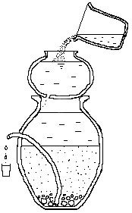
- The Nadi used for the filter must be 32 to 34 inches tall.
- A hole is made for the pipe in the side of the Nadi using a screwdriver and a suitable stone or hammer. The bottom of the hole must be 20 inches above the ground.

- A single piece of stiff flexible pipe 30 inch long, 1 inch diameter and with no splits in it is fitted through the hole with one end inside the Nadi touching the bottom. It is put in place and the hole around the pipe made water tight with cement.
- A water storage pot for the filtered water must be chosen. If it is a Nadi with a tap it should be put up high enough for jug to go under its tap. Put this clean water storage Nadi on enough bricks to make this possible. The filter Nadi can then be put in place on enough bricks for the protruding pipe to be just above the top of the storage Nadi.
- Potato size washed stones are placed in a single layer one stone deep at the bottom of the Nadi. The gaps between them form channels for the water to flow easily into the pipe.
- Small washed stones are placed on top filling the gaps between the potato size stones. Enough should be placed to prevent the next layer of gravel from falling through and blocking the gaps under the potato size stones or clogging up the pipe.
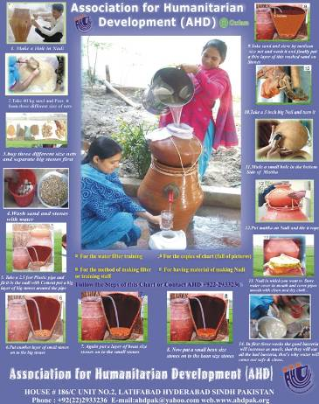
- A thin layer of washed, dhal size gravel is then spread to form a level surface over the small stones.
- A thin layer of washed seed size gravel in then spread to form a level surface over the dhal size gravel.
- These drainage layers must not exceed 4 inches in total thickness or there will not be enough room for the main material, the sand.

- Washed sand is then added to a level 5 inches below the level where the bottom of the pipe goes through the side of the Nadi.
- The matka is taken and a single hole is drilled in it using a 3 or 4 inch nail with a right angle bend in it to form a handle. At first this is difficult work but after a few minutes the hole is made without the need to hit it through with a hammer. Most screw drivers make holes that are a bit too large so a nail is better. The hole should be on the bottom of the matka about 4 inches to one side so as not to get blocked too frequently by debris settling in the matka.
- The matka is then tied in place on top of the Nadi with the hole in the matka in line with the pipe coming out of the Nadi. A stone is wedged between the matka and Nadi so that the hole in the matka can be seen and it is easy to notice if the hole becomes blocked. String must be used to fix the matka in place in order to protect the good microbes in the Nadi from being disturbed.
- A cloth is tied over the mouth of the clean water storage Nadi in such a way that the cloth is over the protruding pipe. The water should not be flowing onto the cloth at all, as this would re-contaminate the clean water.
- Once dirty water has been given to the Nadi every day for two to three weeks the filter will function effectively so long as the sand is not disturbed. During this period the water will gradually improve. If the sand and stones were well washed, water can be improved a little by the filter even on the first day.

For Further information, contact:

Mr. A. Khurshid Bhatti
President/CEO
Pakistan: Cell: +92-333-2661682
AHD Head office: Ph: +92-22-3407819
Kenya: Cell: +254 787 600887
E-mail: ahdpak@gmail.com

