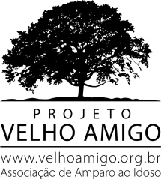

Transportation for the elderly

Projeto Velho Amigo is a non-profit association that since 1999 has contributed to the inclusion of the elderly, ensuring their rights and valuing their participation in society. It works in the search of resources and partners to serve the 17 institutions supported, contributing financial and human resources to about 1,500 elderly in a situation of vulnerability, in several houses located in São Paulo. Only attend institutions that welcome the needy elderly, mostly without family.

Target Audience
Elderly residents and participants of the supported institutions.

Goal
To provide the elderly with safety and gratuity so that they can participate in activities that contribute to the improvement of quality of life, social inclusion, as well as new possibilities for social life, physical and cultural activities, social assistance and health care Preventive measures.

Example of activities and actions:
- Health, beauty, dental and ophthalmological mutirão;
- Participation in lectures and events with specific themes;
- Go to theaters, shows and cinemas;
- Visits to museums participating monthly in the activities offered;
- Tours to nearby places;
- Dances and parties.

Needs
Support to cover transport costs in the year 2017.
US$ 19,000

Photos of some actions:

Theater Beach Carnival Dance
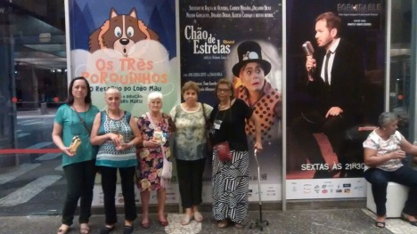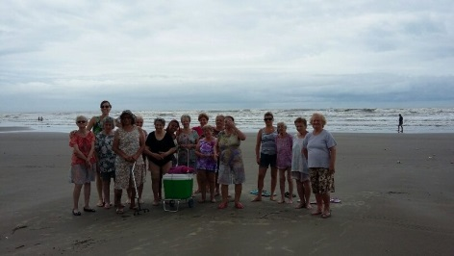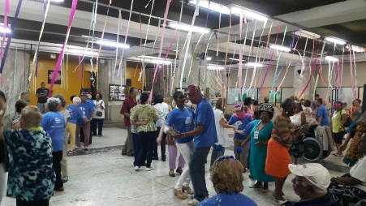

Museum Museum - Turn of the maturity Park - Health Turn
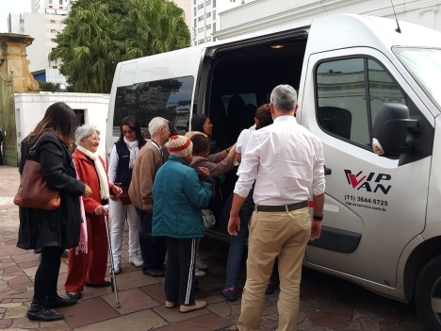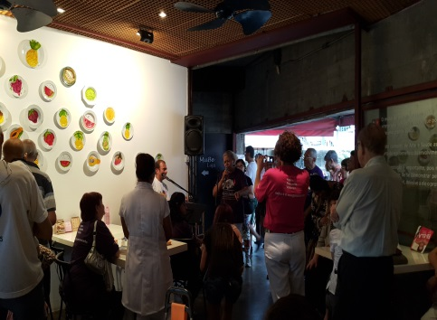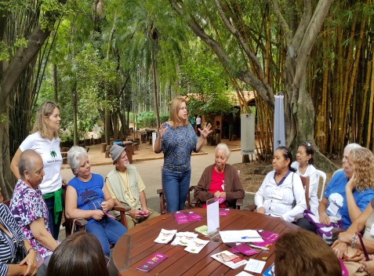

Eye care Dental care Health care
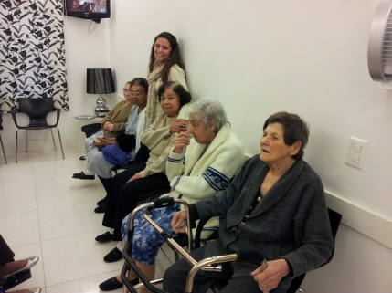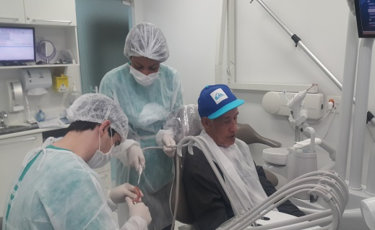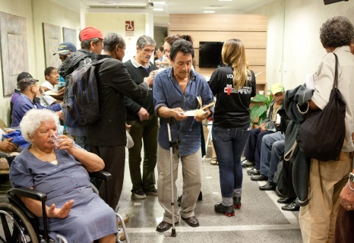

Marisa Simeão Pereira
Project Manager and Partnerships
11-3071-4040 / 3079-0018
marisapereira@velhoamigo.org.br

