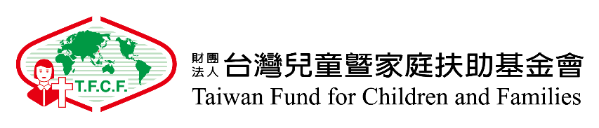
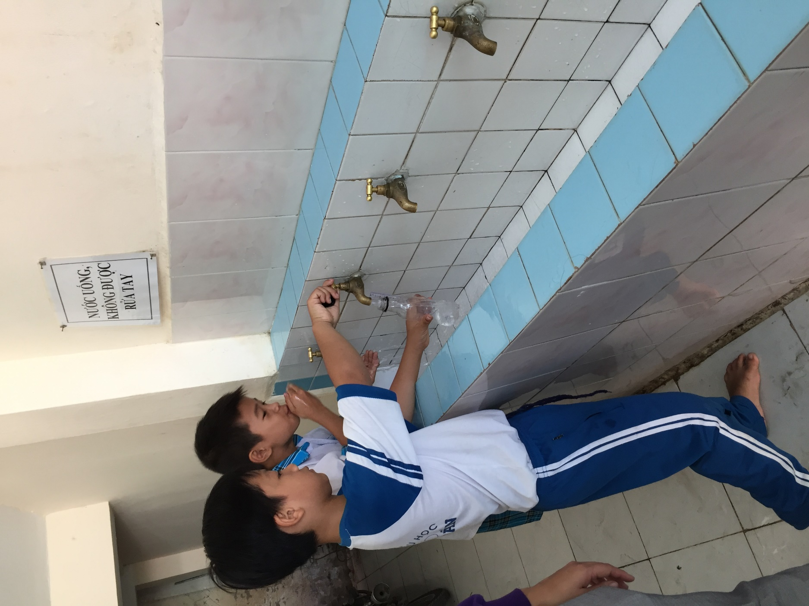
Clean Water for Communities in Vietnam

GlobalGiving Project:
Clean Water for Communities in Vietnam
By
Taiwan Fund for Children and Families Vietnam Branch Office
(TFCF Vietnam)
Organization Introduction

TFCF Vietnam
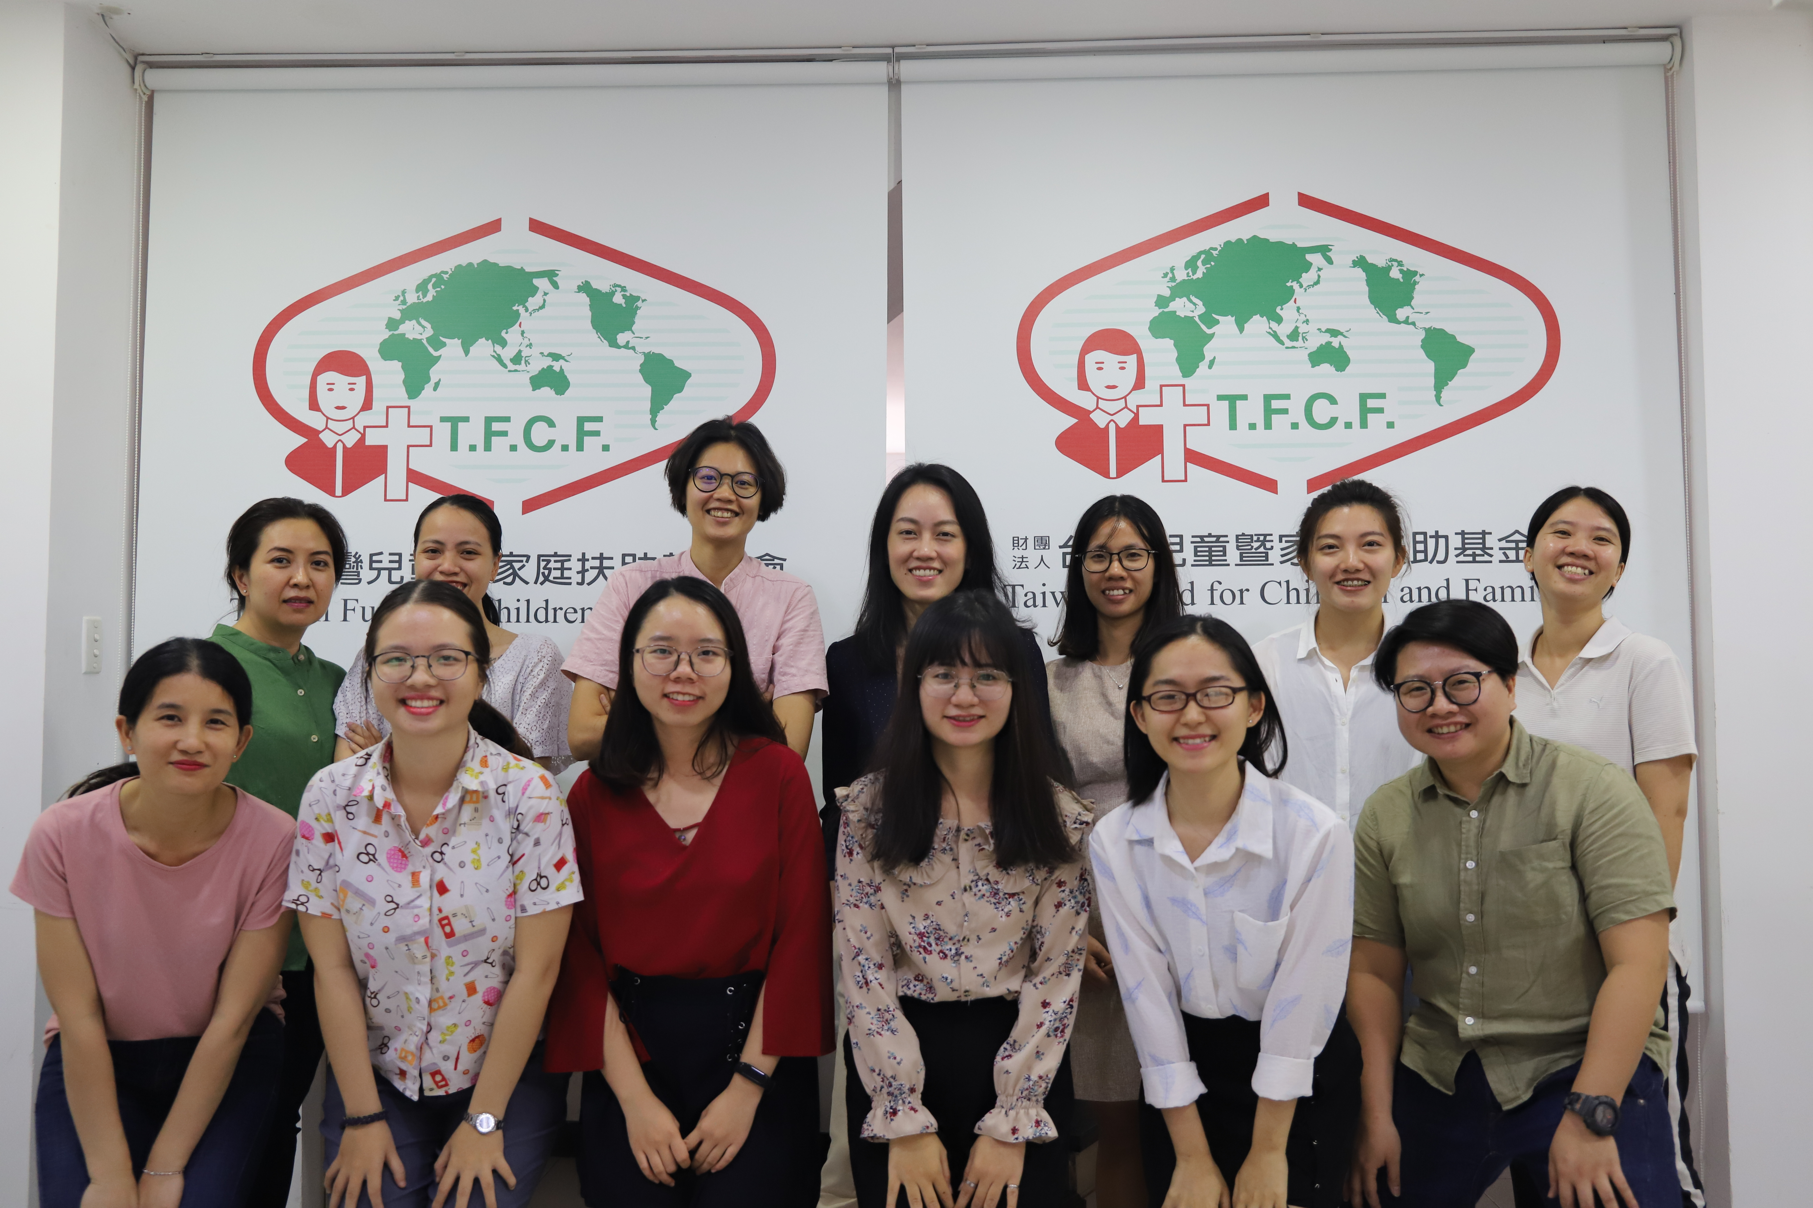
Taiwan Fund for Children and Families (TFCF), established in 1950, is a NGO aiming at helping children in need. Through a variety of programs, including children sponsorship, child protection, early intervention and advocacy campaigns etc., TFCF has not only served a number of children in need but also strengthened the social welfare system in Taiwan. As one of the biggest NGOs in Taiwan, TFCF sponsors 119,000 children in the whole world and has over 150,000 Taiwanese sponsors. So far, TFCF has six overseas branch offices in Mongolia, Kyrgyzstan, Swaziland, Cambodia, Vietnam and Philippines.

Taiwan Fund for Children and Families Vietnam Branch Office (TFCF Vietnam) was established in 2014. In order to assist needy children and families in Vietnam, our main goal is helping needy children and families for basic life needs and education. Until now, we have provided services for over 2,700 needy children in Vietnam. TFCF social workers visit children and families regularly and provide different services, including education, health care, emergency relief, and community supporting.

According to United Nations issued《TRANSFORMING OUR WORLDS: THE 2030 AGENDA FOR SUSTAINABLE DEVELOPMENT》, it announced 17 Sustainable Development Goals and 169 targets. They seek to realize the human rights of all and to achieve gender equality and the empowerment of all women and girls and balance the three dimensions of sustainable development: the economic, social and environmental.
Following the Sustainable Development Goals (SDGs) framework, TFCF Vietnam has provided services to Long Ho District, Vinh Long Province in Vietnam since 2016. We aim to attain the SDGs Goal 6: Clean Water and Sanitation: Ensure availability and sustainable management of water and sanitation for all.
Project Objective

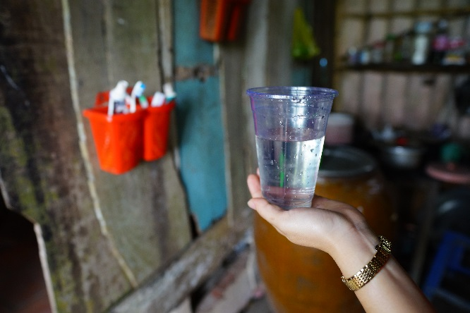

Water is the critical issue in VL province
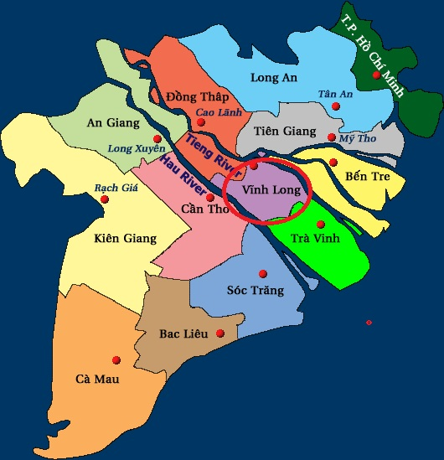
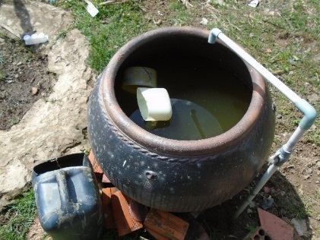
In Vietnam, Vinh Long (VL) Province is located in the Mekong Delta and people are engaged in agriculture mostly. It is facing severe water shortage, and there are water environmental problems in the Delta which caused the serious impact of agricultural production and human health. The river water has been polluted, and damaged the health of local people. Many children and families face a difficult situation in the living issues.

The shortage of safe water is a big issue in Vinh Long (VL) Province. Most of families don’t have tap water and river is the major water resource in daily life for drinking, showering and cleaning etc. Even boiling or spraying chemistry medicine into water, it's still not safe enough because of the pollution. The dangers of unpurified water are well known to cause a wide range health problems, such as personal hygiene, skin disease, and stomachache.

In Vinh Long (VL) Province, there are 30,198 children and 41,668 families living in Long Ho District, but 2,037 children and 2,169 families living in poor situation, including unsafety living space, unclean water for washing and drinking and unstable school attendance rate. Based on children’s need, TFCF Vietnam not only provides sponsored children with tuition and study materials, but supports community development.
Project Summary

At the beginning of the project, we planned to install two water purifier systems in schools and we did successfully in 2019. So far, there are more than 500 children benefitted in this project. We'll continue maintaining systems to keep providing clean & safe water for schoolchildren in VL Province. Addressing the water needs of children will be our effort to improve living conditions, and we will continue our work with your support to children in Vietnam.

In addition, we will help connect tap water for 40 families at least and install water tanks to purify river water for 50 families in An Binh and Dong Phu Commune. We hope that they can access clean and safe water to drink and wash hands and improve personal hygiene and prevent hygiene-related diseases.

Project Overview
TFCF Vietnam will select 90 families in Vinh Long Province which may participate in our clean water project. According to family needs, local water conditions and living environment, we will use two ways to help families. 40 families will connect with tap water, and 50 families will use tanks to purify river water.

Except home water system connected or purified, we will keep visit schools regularly and help evaluate the performance of water purifier systems and make sure we offer clean and safe water to children.
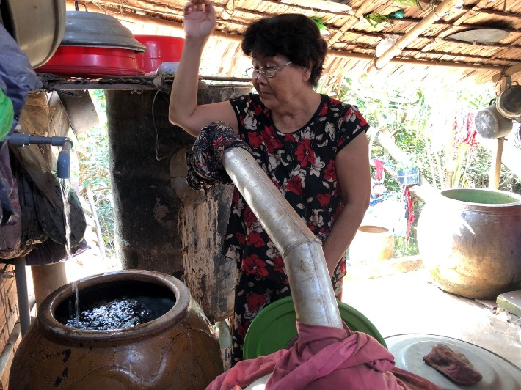

Most of families use polluted river water in their life, and we would like to help families connect with tap water and access clean water directly.

Project Scope

- We will help 40 families connect with tap water.
- We will help 50 families buy household water tanks to purify river water for families life use.
- We will visit families regularly and ensure the performance of our clean water project.

Potential Long-term Impact

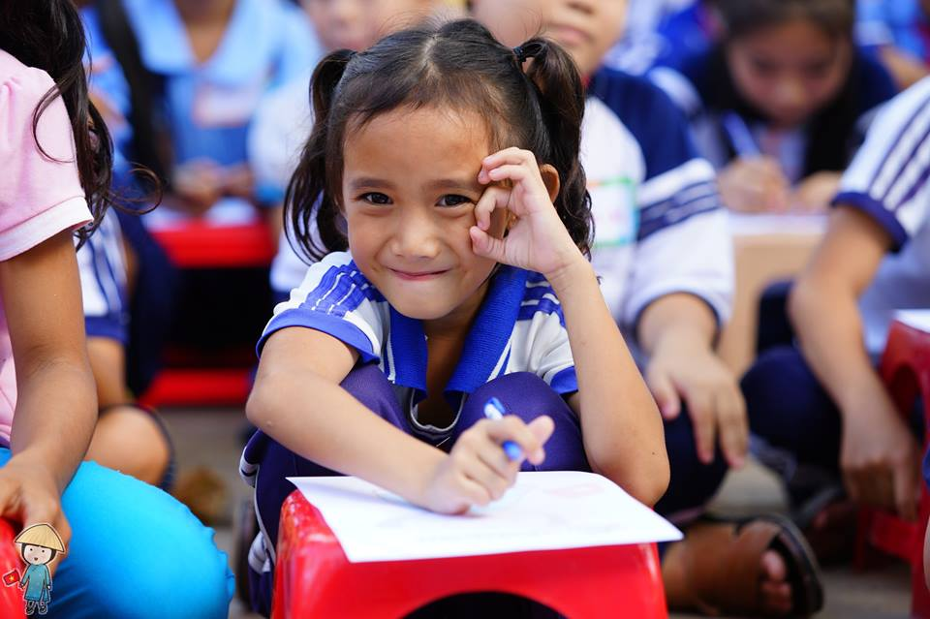
As we know that the human right to water and to sanitation constitutes the right of every individual, without discrimination, to sufficient, safe, acceptable, accessible and affordable water and sanitation for personal use.

Through our project, it would bring positive changes for assisted children and families, including drinking clean water, improving personal hygiene and preventing from hygiene-related diseases.

Keep children away from diseases with clean water.

Project Budget
Item | Unit | Unit price | Total (USD)
Tap water installation | 40 | USD80 | USD3,200
Household water tank | 50 | USD120 | USD6,000
Cost of Tube per kilometer including materials, services, shipping, maintenance parts, etc. | 460 | USD5 | USD2,300
 |  | Total | USD11,500

DONATION OPTION
- USD $10: Will help one family connect 2 kilometer tube.
- USD $25: Will help one family connect 5 kilometers tube.
- USD $50: Will help one family connect 10 kilometers tube.
- USD $80: Will help one family connect with tap water.
- USD $120: Will help one family buy one household water tank.

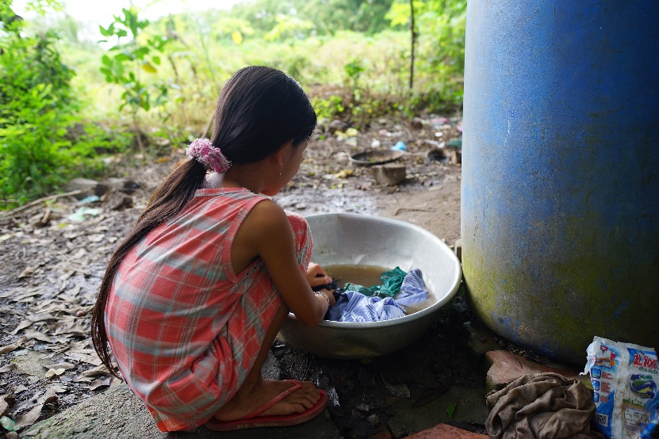

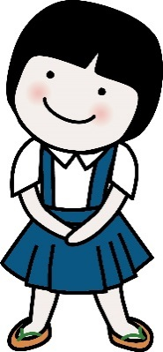
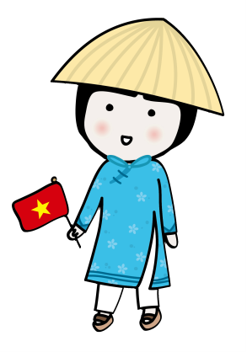

Children in Vietnam do their laundry in unclean water.

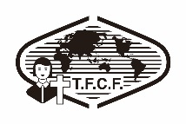
Taiwan Fund for Children and Families - Vietnam Branch Office
22 Bis Lam Son Street, Ward 2, Tan Binh District, TP. HCM, Vietnam
(+84) 8-3547 0229 ．vietnam@ccf.org.tw
www.ccf.org.tw

