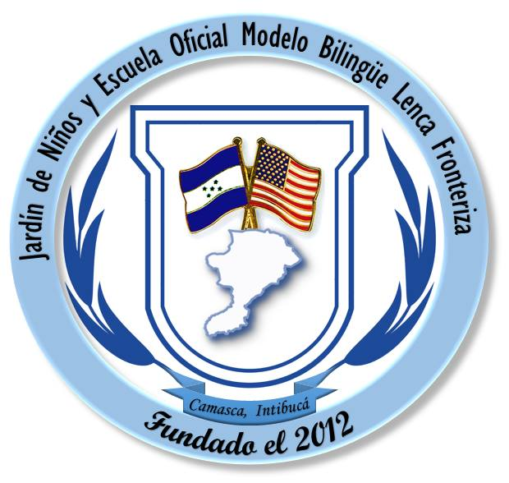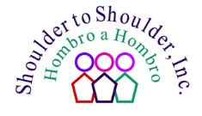

Building Excellence in Education

Good Shepherd Bilingual School

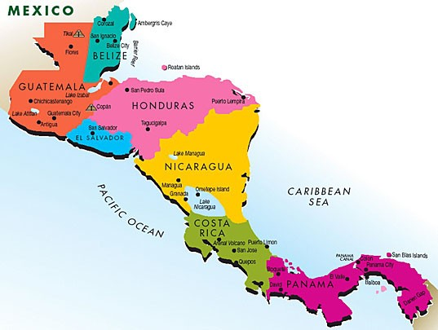
Map of Central America, indicating location of Honduras .

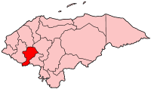
Map of Honduras, indicating location of Intibucá.

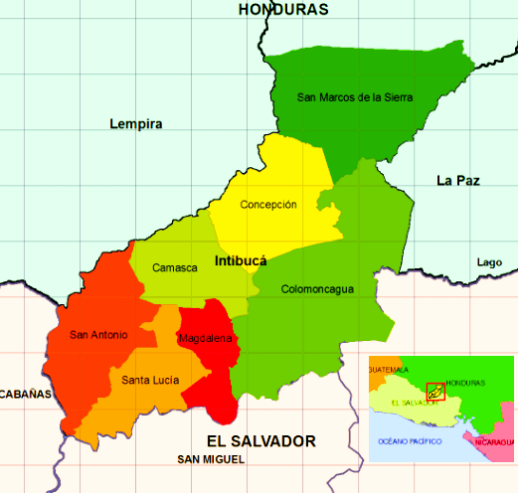
Map of Intibucá, indicating location of La Frontera (the Frontier Region).

Background

Depending on the metrics used, Honduras is ranked either the second or third poorest country in the Americas, always behind Haiti, sometimes behind Haiti and Guatemala. Intibucá is considered the poorest department in Honduras. “La Frontera,” the seven municipalities of southern Intibucá bordering El Salvador is by far the poorest area of Intibucá. A confluence of factors has contributed to this. The mountainous terrain is not conducive to agriculture. Roads are mostly unpaved, and during the rainy season unpassable. Many places have no electricity, and those that do are subject to frequent blackouts and brownouts. Water is scarce and the piping needing to deliver it antiquated and faulty. There is no industry on the Frontera. The principal source of income for families who have income is a family member who has migrated to a developed country and sends money home. Almost all families have at least one family member living in the US, but for most of them this means tragic stories, not a windfall of income. The average income for a family of six is less than two dollars a day.

Global climate change has further eroded development in the Frontera – which sits in the middle of a large swath of territory of Western Central America known as the Dry Corridor. For three years running, the Frontera has experienced drought that has destroyed the harvest yield of staple crops such as corn and beans. Peoples’ lives and livelihoods depend on these crops. When harvests fail, hunger, malnutrition, and the spread of disease amplify the loss.

Shoulder to Shoulder serves the over 70,000 people who call the Frontera their home. We do so proudly because we make a tremendous difference among the people we serve. We do this with respect, effectiveness, and sustainability because we always partner shoulder to shoulder with the people who are seeking the betterment of their lives and the development of their communities.
Vision
People of the Frontera, known as the Dry Corridor of Intibucá, Honduras, live longer, healthier, more productive and fulfilling lives in a strong community.

Mission

To work together with our communities to create, implement, and operate equitably accessible, sustainable health, nutrition, and education services.

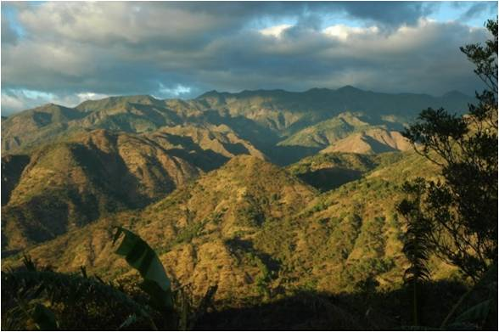
History:
Shoulder to Shoulder began its work in the Frontera 26 years ago with a partnership between the University of Cincinnati’s Department of Family Medicine and the townspeople of Santa Lucia, the southwestern municipality of Intibucá. Beginning with intermittent short term trips, called medical brigades, STS formed a relationship with the community that has endured. From the very beginning of its all-volunteer enterprise, STS asked the community to join in true partnership with their friends from North America, pledging to stand “shoulder to shoulder” with them to identify the most pressing community needs. Together, they worked to address these needs, focusing first on health care delivery and using that as a galvanizing tool to organize the community, inspire local leadership and develop programs to raise the quality of life. Today, Santa Lucia is home to STS’s largest comprehensive community health center, employing local health care professionals including doctors, dentists, social workers and allied staff who provide medical care, dental care, pharmacy and laboratory services, nutritional supplementation, and educational training. From Santa Lucia, we expanded into the other six municipalities on the Frontera. We built another major hub health facility in Concepción, and now operate over twenty satellite clinics strategically located throughout the Frontera. Partnering with the International Development Bank (IDB), the Honduran Ministry of Health, USAID, the Association of Municipalities on the Frontera, and many other organizations and government agencies, we have secured a sustainable model of decentralized health care, accessible to everyone living on the Frontera. When we began our service 26 years ago, a broken leg would foretell a life of dependence and pain; a simple infected cut or bug bite might result in infection and almost certain death; and health education and illness prevention was non-existent. But today, everyone has access to basic health care.
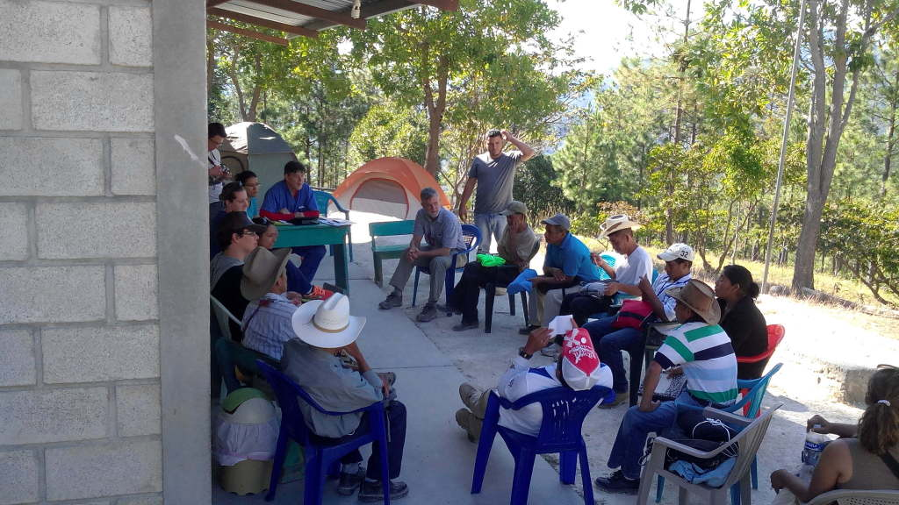
Community meeting at Pinares Clinic

From our first footprint on the soil in Santa Lucia, Shoulder to Shoulder recognized that the mission in Intibuca exceeded providing health care. Treating a wound or an illness is an immediate and necessary response, a triage measure if you will. Establishing a sustainable system of health care is an ongoing commitment. This commitment is realized in tremendous capital investments, partnerships that maintain the ongoing health care delivery under the decentralized model, and the augmentation of quality health care sustained by our US partners visiting the Frontera on service trips. What remains for Shoulder to Shoulder is development. This is not done in a day. Nor can it be achieved simply by writing a large check. Enrichment and empowerment that bring about substantive change only occurs with an ongoing investment in relationship. Our twenty-five year investment, the discernment of critical need that has come about because of it, has led us to focus on the need for education. Education gives people the tools to transform their environment, moving people from the imprisonment of endemic poverty to the establishment of social systems of dignity and enrichment.
Education:
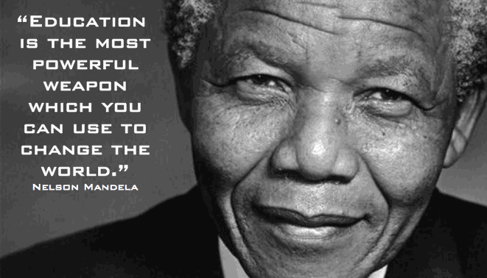:
Imagine what the world would look like if Mahatma Ghandi, Martin Luther King, or Albert Einstein had never learned to read or write. That shocking possibility exists for most children living on the Frontera. Whereas primary education through the sixth grade is free and mandatory by law, the reality is something different. Schoolrooms, few and far between and often in sad states of disrepair, are filled with too many children, sharing sometimes two or three grades. Teachers are ill-prepared, underpaid, and frequently not present to their students. There are no books or materials. Children need to pay for everything except sitting at their desk, if they have one to sit at. After sixth grades, children generally need to return to their homes; boys, to work if there is any, and girls, to help in the home or begin their own families. In this resource challenged environment, little is accomplished in those six years, including, all too commonly, literacy.

Private schools afford an alternative. Education at a private school is of a much higher quality. Yet, save for the few who are awarded scholarships, it is a privilege reserved for the wealthy. Even so, there are no private schools on the Frontera. In reality, private schools are not an alternative, but rather an election for those privileged to afford them.

The problem of poor education throughout Honduras is compounded in the extremely rural, resource challenged area of the Frontera. The lack of high quality, college preparatory, bilingual education prevents professionals from living in the region, even when they are employed by NGOs, governmental agencies or private organizations. Professionals working for such organizations typically maintain their families in one of Honduras’ three metropolitan areas (Tegucigalpa, La Ceiba or San Pedro Sula) and commute to the project community (5-12 hours) living in temporary housing and visiting their families periodically (weekends or weeks off). This makes it very difficult for the organizations working in the region to retain quality staff or to grow their organizations in the region. More importantly, these organizations do not become the economic engines they could be in these rural communities, because they cannot entice professionals to live there. And the largest impediment for relocation of these professionals is the lack of access to high quality schooling for their children.

Residents of these communities are also trying to develop themselves professionally, but they have no access to the education that would allow them to attend Universities. Even young persons fortunate to graduate local public secondary schools are generally not suitably prepared for higher education. In this catch 22 situation (communities cannot develop themselves without quality education while professionals are not drawn to the underdeveloped area because there is no quality education) makes development a fool’s dream, at best. If we are to make a real, substantial, sustainable impact on the vicious, cyclical nature of poverty, then we must make a dramatic impact on the education system.

Shoulder to Shoulder’s Response:

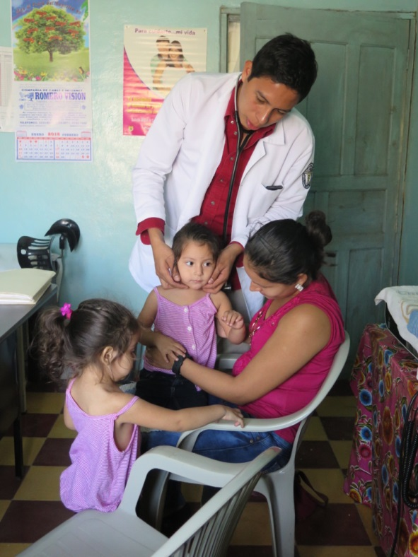
From the earliest days of Shoulder to Shoulder’s health mission in Santa Lucia, we recognized the need to invest in the local population by way of bettering educational opportunities toward seeding development. In those early days, individuals committed to Shoulder to Shoulder by way of mission trips identified talented youth. These young persons had great potential with no resources or opportunity. Many of these young persons were sponsored to attend secondary schools and went on to college. Many have already returned to the Frontera as young professions, paying back the trust and investment placed in them.
Dr. Rigoberto Marquez, benefactor of Shoulder to Shoulder scholarship Program

What began as individual responses to particular children and circumstances has become a well-organized program of granting scholarships for students to attain education beyond the sixth grade. Young students living in the Frontera who want to extend their education, but lack the financial means to do so, have the opportunity to apply for scholarships. The scholarships are based on merit, achievement in school, and financial need. Whereas you might think that this represents a great deal of money, it is actually very little by US standards. Less than twenty-five dollars a month is all that is necessary to keep a young person in school through graduating college.

100 - 150 Young Persons Assisted
Annual to Continue Their Education!!

In recent years, the program has expanded further. Particular donors, having established particular relationships with promising young persons, have decided to continue sponsoring in college careers. There are five such young adults who are presently receiving assistance to attend college and prepare their professional careers.

If opportunities are limited for all young persons, they are particularly limiting for girls. Here, one in every four girls becomes pregnant in her teenage years. This supports the generational cycle of poverty. In 2013, Shoulder to Shoulder began an ambitious, innovative program for girls in fifth and six grade call Yo Puedo (I Am Able). It is an empowerment program that seeks to heighten young girls’ self-esteem by bringing them to a fuller consciousness of their potentials. The girls learn of their abilities to make successful life choices and decisions. They initiate and sustain their own micro-business, making, marketing, and selling for profit products of their design. The program is still too young for us to track success, but in seeing the girls enrolled in the program, it is clear that the program is having an impact on the quality of their lives and the opportunities for their success.

These programs are making a difference in the lives of the individuals who are benefitting from them. Yet, the educational system itself, the crux of the problem, has not been touched. In changing the system, in improving the quality of education on the Frontera, we would open up a floodgate of talent and opportunity that has the potential to change the course of cyclical poverty and create sustainable development. Shoulder to Shoulder’s pressing question since its foundation has been how to alter the course of cyclical poverty.

Our Answer: The Good Shepherd Bilingual School

We knew we had to do something unique and revolutionary, but the roads we started down were not necessarily the roads we ended up on. At first we thought we would create a private, bilingual High School. But would that become yet another quality institution to which the poor would have no access? In 2012, partnering with the Good Shepherd community in Cincinnati and the people of the Frontera, we founded the Good Shepherd Bilingual School, initially a private, primary school whose students would be heavily subsidized by Shoulder to Shoulder donors. We built a state-of-the art building to house our kindergarten and first grade classes. We had excellent teachers and excellent curriculum. We had tremendous support. But still, we faced many obstacles.

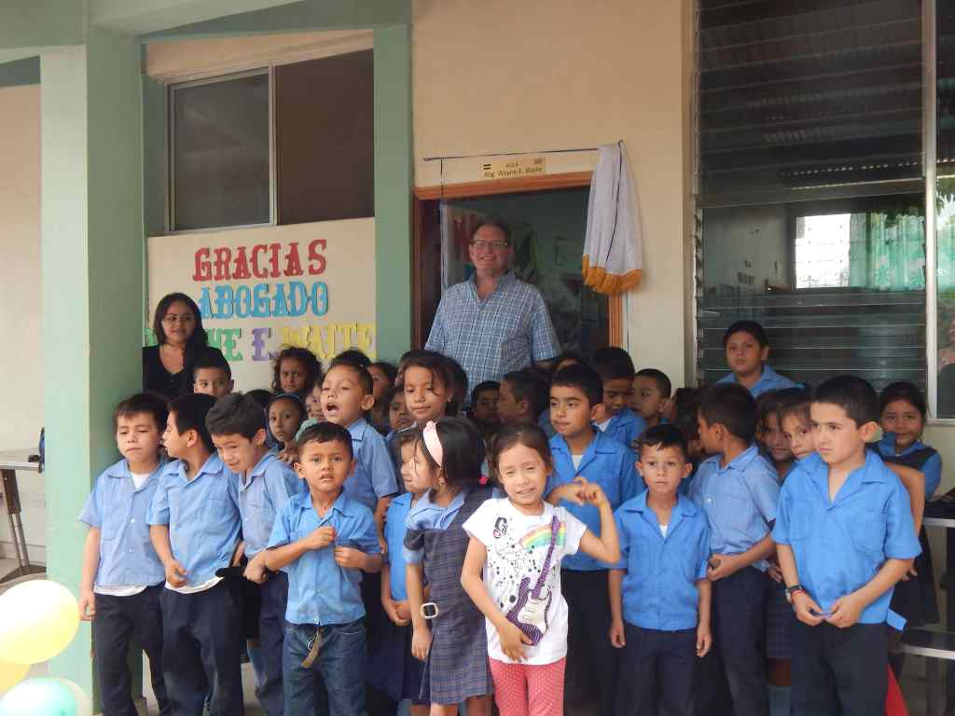

We would still need to build two additional buildings. As years advanced, we would need to recruit and hire additional teachers and staff. Operational costs would increase. Would we continue to be able to heavily subsidize tuition such that the school would truly be accessible to all children? And continuing as a private institution, would we really be able to have an impact on the public education system? Would it be enough to stand as an alternative to a failing, public system, or would it not be better to make the public system successful? This is where the revolutionary part applies.

In November of 2014, Shoulder to Shoulder made Honduran history, signing a contract with the Honduran Ministry of Education and the local association of municipalities on the Frontera that established the Good Shepherd Bilingual School as the only, model, bilingual, public school in Honduras. Like other private schools, it affords its students a rich, quality, bilingual education. Like public schools, it is accessible to any child who wishes to enroll. It is an education of superior quality that at the same time is free. Though it is free, the parents who enroll their children are critically and indispensably involved, generously and voluntarily offering their time, talent, and treasure according to their means. Without this commitment from the families, this experiment would certainly fail. But the commitment is present and it is sound.

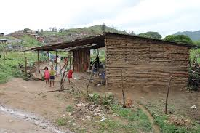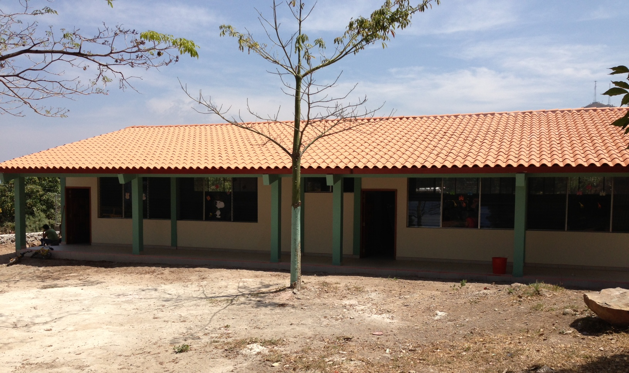
A school in Honduras The Good Shepherd Bilingual School

This is a challenging endeavor. Partnering relationships require patience and constant attention. But anything that is worthwhile, anything that has the potential to dramatically alter something as deeply embedded as systemic poverty, has to be a continuing struggle. But this is a struggle that we have been committed to for over twenty-five years and we have no intention of giving in.
In 2015, we completed construction on our second building of classrooms, extending our space to accommodate kindergarten through fourth grade. Our computer system and technology, featuring Kahn Academy, KAlite, easily meets the standard of any private school in Honduras. We have developed our volunteer program such that in this year an average of four native English speakers have been present to our children on a daily basis. Our children in third grade, and some of those in second grade, are becoming conversant in English.

But for all that we have accomplished, we have so much more to do. We are so proud of our donors and partners, those whose commitment is the sunrise peaking above the horizon of a long night of poverty. We will not stop asking for more from those we already know as well as those we have yet to meet because we are convinced of the integrity and sound purpose of our mission.

We are about to construct our third building of classrooms that will accommodate our students through the sixth grade. We respectfully submit our request that you assist us in this critically important milestone.

Our Future Plans:

We have begun a revolution in education in Honduras. If development, the empowered movement out of the enslavement of poverty to establishing sustainable systems of justice and dignity, is to occur, education must be accessible and of an unassailable excellence. Achieving this in one school is the model, the blueprint if you will, for making it a reality in all public schools. Some of the plans toward this goal are the following:

- Assisting High Schools in the provision of computer- based hardware and curriculum. This will include training in classroom implementation and accountability according to high standards of performance.
- Continuing our Sponsorship program for our students to create and sustain relationships of synergy.
- Development of “bilingual education tracts” in the High Schools.
- Searching out partners among other NGOs to replicate the success of the Good Shepherd Bilingual School.
- Developing a volunteer program that has its center at The Good Shepherd Bilingual Schools, but offers satellite services at other schools.
- Seeking out partners in Education Excellence among academic institutions and other institutions in the US and other developed countries.
Conclusion:

Twenty-six years ago, Shoulder to Shoulder, as yet unnamed, made a small footprint on the soil of Santa Lucia, Intibucá, Honduras. The wind, the rain, and certainly time has long since washed away any trace of that footprint. What has not been washed away, what cannot be erased by any force of nature or humanity, is a commitment to the power and integrity of the creation of just relationships. We met people who craved changed and embraced empowerment. We placed our shoulder against theirs and began our work together to create, implement, and operate equitably accessible, sustainable health, nutrition, and education services.

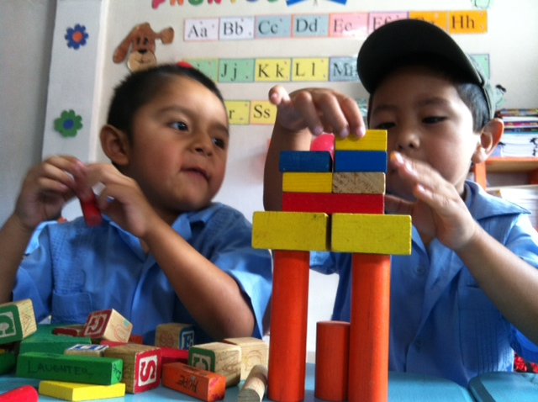
Please Help Us Build Our School

Much has changed in twenty-five years. We have reason to celebrate. But we do not have reason to rest. There is still so much that needs to change. Won’t you please help us to continue to build upon the solid foundation we have laid in the earth upon which we tread?

