FEMALE EDUCATION IN DISTRICT JACOBABAD

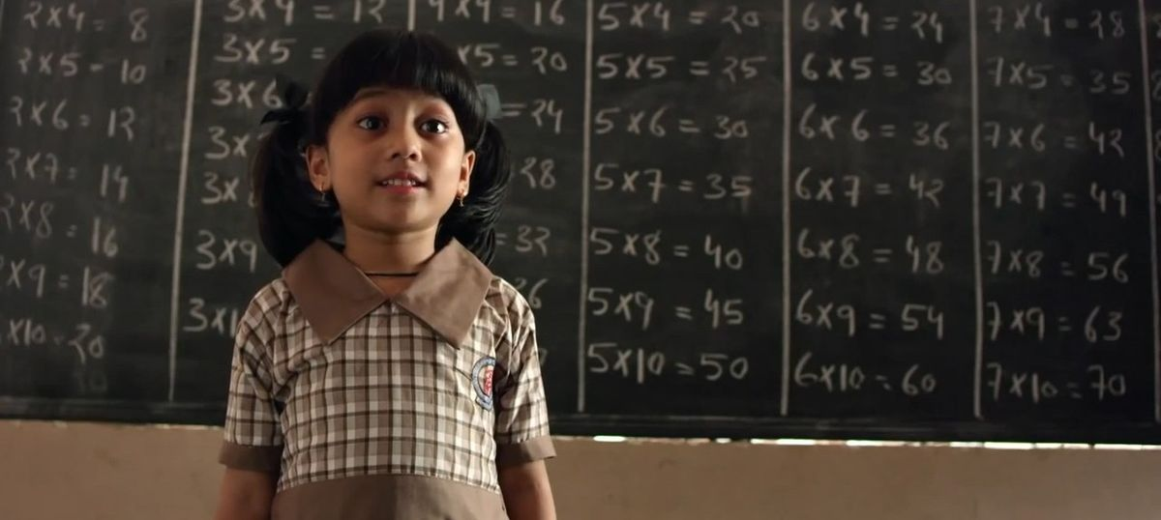

FAST RURAL DEVELOPMENT PROGRAMME (FRDP)

“Girls’ education and promoting gender equality is part of a broader, holistic effort. It includes ensuring that girls do not suffer disproportionately in poor and vulnerable households, and advancing skills and job opportunities for adolescent girls and young women.”
WORLD BANK

FEMALE EDUCATION IN DISTRICT JACOBABAD

MURK LARIK

FAST RURAL DEVELOPMENT PROGRAMME (FRDP)

CITATION
FAST RURAL DEVELOPMENT PROGRAMME (FRDP)
OFFICE: B-67, PHASE 1, NASEEM NAGAR QASIMABAD HYDERABAD

CONTENTS

- Abstract
- Introduction
- Pakistan’s Profile- Education
- Status Quo Of Sindh’s Educational System
- Where Jacobabad Stands In Academia?
- Causes Of Wrecked Female Education In Jacobabad
- What FRDP Is Up to?
- What Our Organization Now Looking For?

- ABSTRACT:
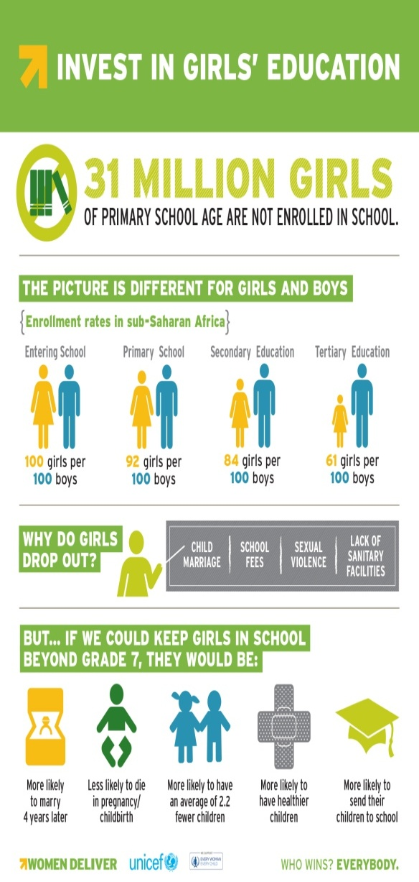
The aim to indite this proposal is to put light on the current situation of female education across the country particularly district Jacobabad. To put forward overall status of this region’s educational system as what’s its status quo? Why this is most deprived region in this regard? What reasons have made it so? What Fast Rural Development programme is serving there? What else can be done to achieve more effective results?
- INTRODUCTION:
It has been induced in this society, since the inception of human rights, that “Education is the most powerful weapon of the world since this can change the world.” This world considers educating women as much crucial as it is for men. The latter may responsible for enlighten them only, but formers are responsible for the up-gradation of their generations. The 180 million citizens of the state hold the right to receive education, of which 48.1 per cent are females. It seems that little success has been achieved by the state as far as imparting education is concerned. Policies and action plans are routinely produced. However, the reasons behind their failure have not been ascertained. Articles 15, 25, 26 and 34 of the Constitution ensure the rights of freedom of movement, equality of citizenship, access to and participation in public spaces and non-discriminatory treatment and full participation in national life to women, respectively.

- PAKISTAN- PROFILE IN EDUCATION:

Women's education in Pakistan is a fundamental right of every female citizen, according to article thirty-seven of the Constitution of Pakistan ^{[1]}, but gender discrepancies still exist in the educational sector.
Our country’s literacy rate declined from 60 percent to 58 percent, revealed the Economic Survey of Pakistan (2016-2017) that was released on May 2017. Currently, 31 million girls are out of school worldwide, out of them 3Million girls are of Pakistan. 30% of girls are educated in Pakistan as compared to boys. The Human Development Report (HDR) listed Pakistan in the category of “low human development” countries with a female literacy rate of thirty percent, and Pakistan has ranked 145 in the world in terms of human development.

Table1 Pakistan’s change in education score

- STATUS QUO OF SINDH’S EDUCATIONAL SYSTEM:
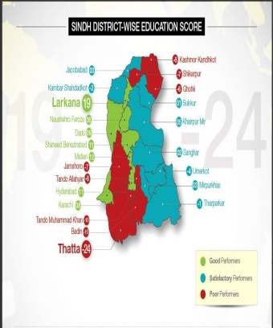
According to the Economic Survey of Pakistan (2016-17), Sindh’s literacy rate is 36%.
While, according to SDPI, the change in education score of Sindh is -1.58. If we consider only female education then the situation is even more severe. UNESCO Islamabad also reports that Sindh’s Gender Parity Index (GPI), a ratio measure of gross enrollment of girls to boys, has been declining since 2008-2009. While the urban areas maintained steady rates of 0.9 over the years, there was a marked decline in both primary and secondary enrollment for girls in the rural areas.
RANK |  | REGION | EDUCATION SCORE | ENROLLMENT SCORE | LEARNING SCORE | RETENTION SCORE | GENDER PARITY SCORE | CHANGE
2016 | 2015
6 | 6 | SINDH | 60.44 | 60.87 | 41.25 | 50.00 | 89.65 | CONSTANT
Table2: provincial educational score

- WHERE JACOBABAD STANDS IN EDUCATION?
Jacobabad is considered as least literate district of Sindh. It is ranked 124 out of 145 districts of Pakistan in education score according to the report of Sustainable Development policy institute (SDPI) 2016-17. Literacy rate of this region is mere 33.8%, the disappointing and alarming statistics indeed. However, functional schools in the region are 1362, 56 are temporary closed and 14 schools are permanently closed. The education score of this district is given below in table3

RANK | REGION | EDUCATION SCORE | ENROLLMENT SCORE | LEARNING SCORE | RETENTION SCORE | GENDER PARITY SCORE | CHANGE
2016
124 | Jacobabad | 45.21 | 47.37 | 24.20 | 39.00 | 70.28 | Worst
Table3: Jacobabad educational score

- CAUSES OF WRECKED FEMALE EDUCATION IN JACOBABAD:
The literacy rate of females in district Jacobabad is worst of all other districts of Sindh. The prominent and apparent causes of wrecked female education are:
- Schools are at distance of 5-6 km from the houses.
- Transportation facility to female students
- Traditional out dated mentality of people i.e. females are born to do home chores only.
- Severe weather conditions throughout the year.
- Parents feel security threats to send their daughters that far away.

- WHAT FRDP IS UP TO?
FRDP, not for profit secular welfare organization, has been working for the up gradation of humanity since decades. It has facilitated 2300 students both males and females to acquire quality education. We provide them with well qualified teachers, updated curriculum, furnished buildings, proper stationery and many other required facilities.
But, female education is beyond this. Foe them, the complete package will be the provision of security parameters, secure transportation, modifying the mentality of traditional region’s thoughts and myths (since they still believe that females are born to do home chore sonly), protection from the slaps of harsh weather condition and assurance of effective results from that learning environments.
FRDP firmly believes that the cardinal reason of wrecked literacy rate of that region and drastic drop out ration is non- availability of secure transportation facility to female students. Would we allow our girls to walk 4-5 km in harsh weather conditions of Jacobabad to gain education? The answer will be a BIG NO!!!

- WHAT OUR ORGANIZATION NOW LOOKING FOR?
FRDP, considering transportation main cause of female students’ dropout, will appreciate donor organizations’ attention towards it. As our organization has been operating primary and secondary schools over there since many years. Many females are blessed with the gift of learning but it has some hindrances in the way to triumph. We believe that if the transportation facility will be provided to students then dropout ratio will be reduced. It also will assure security to the parents of those female children, because walking 4-5 km for any female student is indeed a grave security threat. This will protect them, in summer, from the scorching heat of sun which shines brightest in this region. In winter, they will be at safe haven too.
The repercussions of this facility will be amazing according to our perception. Since, this will motivate other parents too so that they can send their daughters to schools. The academia of this region will improve drastically. This will also clears dust from narrow-minded people, who still believe that females are born to do home chores.

