Protect Chacma Baboons

in Sabie, South Africa
In 2006 the news of lethal baboon management within the pine plantations of Sabie created international headlines when it was revealed that approximately 200 baboons had been killed in an effort to reduce the damage baboons caused to pine trees by stripping the bark off the trees intended for the timber industry.
In the ensuing years, on-going lethal management of baboons has created huge conflict between the timber industry and concerned animal welfare and environmental groups. The issue reached boiling point in 2016 when enormous trap cages were discovered in the plantations by members of the public.
Baboon Matters investigated and was directed to mass grave sites where literally hundreds of baboon skeletons were discovered. From our investigations, we were able to ascertain that the baboons are lured into the trap cages and dispatched in an unethical manner and certainly the baboons would have suffered pain and trauma before death.
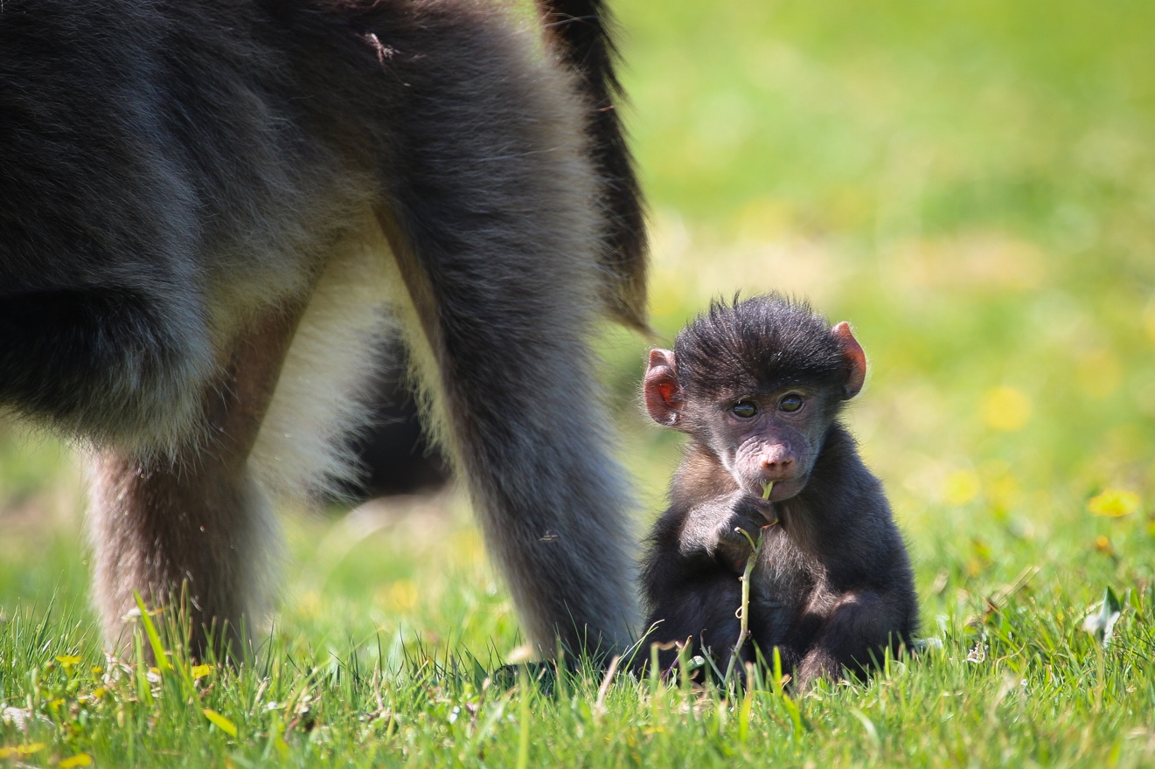
We have been informed that over 4000 baboons have been killed in the escalated killing process in the past 8 years.
We are told that it takes two years to dispatch an entire troop of baboons – meaning that there would be dramatic stress on the surviving troop members as the social structure is annihilated.
The plantation owners defend their decision to remove baboons by referring to science and research, but despite numerous requests for this information, and despite direct Public Access to Information requests, no records, baboon population data or relevant research has been forthcoming. Instead, it appears that crucial research has been over looked and to date there is no evidence to support why baboons would strip the bark of pine trees as it is unclear what benefit the bark and cambium has for baboons (if any).
Baboon Matters has been working with primatologists, botanists and environmentalist groups; collectively, we have grave concerns regarding the lack of comprehensive research and specifically the lack of data on baboon populations in the region – there is a great risk that the high volumes of baboons killed is not sustainable and will create a population sink.
Baboon Matters intends to undertake specific research to determine why the baboons value the bark and cambium. In addition, we will continue to liaise with all stakeholders, plantation owners and government agencies so that valid laws and permit systems can be implemented and managed.
A vital aspect of our project will be to ensure high levels of awareness and outreach so that the general public can insist that South African commercial pine plantations operate with high levels of ethical and scientific values in place.

