Dzherelo Children’s Rehabilitation Centre
pr Cherevonoyi Kalyny, 86A
Lviv, Ukraine
Hydrotherapy Pool for Children with Special Needs
Needs Description:
Children with special needs who attend daily programs or consultations at Dzherelo Centre need hydrotherapy classes in the therapeutic pool. Hydrotherapy is the use of warm, deep water in a quiet environment for the therapeutic effect of:

alleviating the discomfort of physical impairment

maintaining a range of movement

These classes help to improve the physical, psychological condition of children and reduce behavioral disorders. It is a series of gentle exercises which can be more manageable when carried out in a heated pool (32°C) while the water supports much of the body weight, the resistance of the water helps to strengthen the muscles.

Project Goal:
To provide hydrotherapy classes for children with physical and intellectual special needs aged 3 to 14 years. Classes will be held in the pool of the Dzherelo Centre every day from 09.30 to 14.00, in the form of group and individual sessions, under the supervision of certified hydrotherapist.
The pool is served by profiled company.

Anticipated result:
The benefits of hydrotherapy are huge and amongst other things can:
- reduce pain and muscle spasm
- strengthen weak muscle groups
- improve co-ordination
- improve posture
- improve balance

5 days a week Dzherelo’s pool will hold individual and group hydrotherapy sessions for children with special needs. Those sessions will be planned by a team of professionals: physical therapists, doctor neurologists, medical service. For each child will be individual program and course for 5 or 10 days.

ESTIMATED BUDGET
Total for 2018 (per year)

Cost item | CAD | UAH | USD
Salaries: (incl. taxes): | 4920 | 102357 | 3851
Hydrotherapist  Pool Maintenance specialist | 4162  778 | 86594  16187 | 3258  609
Materials, components and disinfectants | 1551 | 32271 | 1214
Utilities (water, electricity and heating) | 1208 | 25133 | 946
TOTAL | 12619 | 262542 | 9878

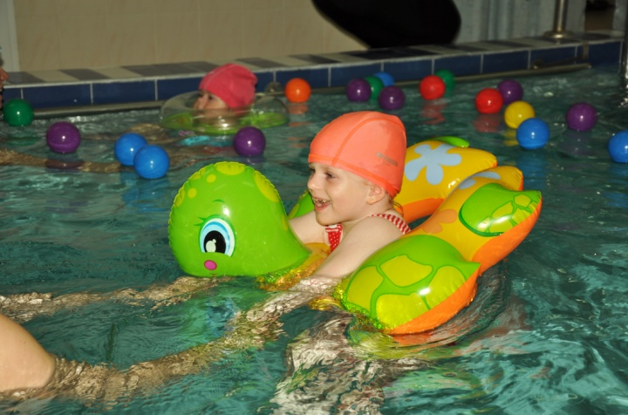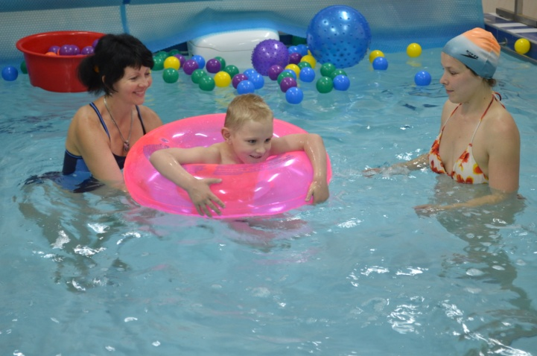

Dzherelo Centre will be very grateful for your continued support of families with special needs children in Ukraine.

