Housing & Rehabilitation for FLOOD AFFECTED

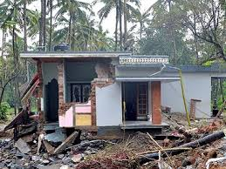
Kerala is going through the worst monsoon fury in more than a century. The floods have caused heavy infrastructure damages, hence there will be a need for redevelopment of several homes, schools, hospitals, roads, bridges, etc. that have been either demolished or heavily affected. . Many lives have been already lost, and thousands have been displaced. Several people who have been directly affected are in need for refuge and rehabilitation facilities in order to restore their lives.

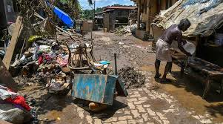
We will provide low-cost housing and construction support to re-build homes, communities and also institutions like schools, hospitals etc. affected by the flood. and also support the tribal people who been affected badly and shelter and toilets

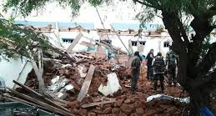
VETNGO is looking to rebuild the entire community and provide security for the victims by creating safe spaces like homes, institutions, etc. for long term. Securing the future of the children by creating a platform for them to be self-sustainable. The goal is to bring the people together and rise above the challenges of this disaster and make a difference in the community.

