អង្គការមជ្ឈមណ្ឌលសហសង្រ្គោះកម្ពុជា
Salvation Centre Cambodia
(SCC)
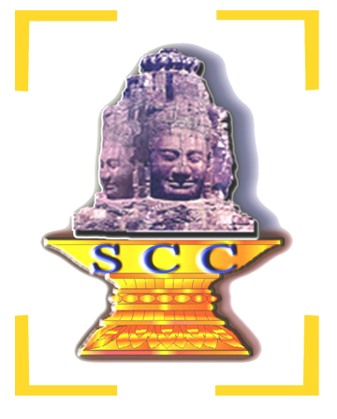

របាយការណ៌ប្រចាំឆ្នាំ​២០១៦
ចាប់ពីថ្ងៃទី ០១​ ខែ មករា ដល់ ថ្ងៃទី៣១ ខែ​ ធ្នូ ឆ្នាំ០១៦

រៀបចំដោយ​​ បុគ្គលិកអង្គការ អេស ស៊ី ស៊ី

Lists of ABBREVIATIONS

ACR/CA Australian Catholic Relief/Caritas Australia
ANC Antenatal Care
ARLP Action, Reflection, Learning and Planning
ART Anti-retroviral Therapy
ARV Anti-retroviral
AS Annual Survey
BS Baseline Survey
BTB Battambang Province
CAFOD Catholic Association for Oversees Development
CBE Children‘s Basic Education
CCC Cooperation Committee for Cambodia
CoC Continuum of Care
COP Community of Practice
CPN+ Cambodian People living with HIV/AIDS Network
CSO Community Support Officer
CSV Community Support Volunteer
DOTS Directly Observed Treatment, Short Course
DU Drug User
F2F Face to Face AIDS Project
GFATM Global Fund to Fight AIDS and Tuberculosis and Malaria
GPP Governance and Professional Practice
HACC HIV/AIDS Coordinating Committee
HCMC Health Centre Management Committee
HSS Health System Strengthening
KHANA Khmer HIV/AIDS NGO Alliance
MARP Most At Risk Populations
MEDICAM Medical Cambodia
MDG Millennium Development Goals
MHD Municipal Health Department
MMM Mondul Mith Chuoy Mith (Friend Helps Friend)
MSM Men who have sex with Men
NAA National AIDS Authority
NCHADS National Center for HIV/AIDS, Dermatology and STD
NSP National Strategic Plan
OVC Orphaned and Vulnerable Children
PAO Provincial AIDS Office
PLHIV People living with HIV/AIDS
PMR Planning, Monitoring and Reporting
PMT Program Management Team
PHD Provincial Health Department
PNP Phnom Penh City
PPTCT Prevention of Parent to Child Transmission
PWUD/PWID People Who Use Drug/People Who Inject Drug
SHG/SG Self Help Group/Support Group
SRP Siem Reap Province
STI Sexually transmitted Infection
VHV Village Health Volunteer
VHSG Village Health Support Group

About Salvation Centre Cambodia

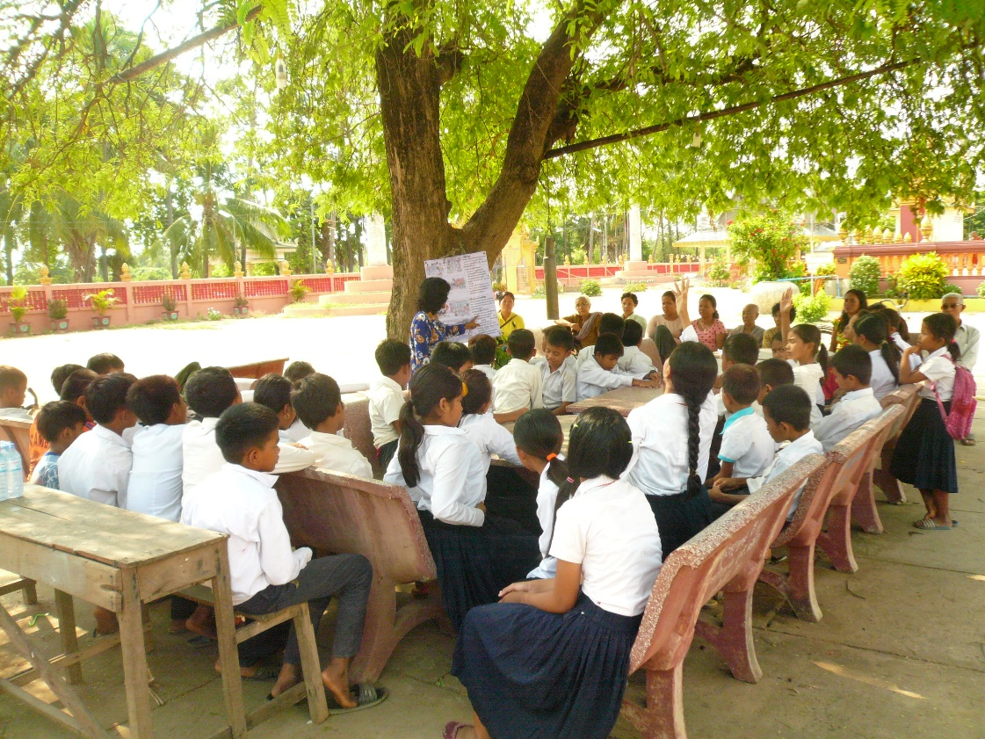

IDENTITY
SCC is a dynamic, Cambodian faith-based organization that has played a major role in the fight against HIV and AIDS. Through the loving kindness, compassion, sympathy, equanimity, commitment and dedication of a team of Buddhist monks, nuns, staff, volunteers and generous supporters, SCC has been able to improve the lives of many people infected with and affected by HIV/AIDS, particularly the poorest and least fortunate families, especially children, either orphaned or adversely affected by HIV/AIDS.

ទស្សនវិស័យ
ចង់ឃើញ​សង្គមកម្ពុជាមួយ ដែលមនុស្សគ្រប់រូប រស់​នៅ​ប្រកប​ដោយសុខុមាល​ភាព ពោរ​ពេញទៅដោយសិទ្ធិសេរីភាព​ សេចក្តី​​ថ្លៃថ្នូរ និងមាន​ជីវភាពធូរ​ធារ ។
VISION
A Cambodian society where all Cambodian people live with good health, freedom, dignity and prosperity.

បេសកកម្ម
អេស​ស៊ី​ស៊ីបេ្តជ្ញាចិត្តបង្កើនសមត្ថភាពបុគ្គលិក សហការជាមួយ​​បណ្តាញ​​សាសនា​​​ និង​​ស្ថាប័នពាក់ព័ន្ធនានា​ ដើម្បីកាត់បន្ថយភាពងាយរងគ្រោះ ​លើក​កម្ពស់​សេដ្ឋកិច្ច​គ្រួសារ ​​​សុខភាព​ និង សិទិ្ឋ ដល់គ្រួសារងាយរងគ្រោះ​ និង​គ្រួសារ​ក្រីក្រ និងជំរុញឱ្យ​កុមារ​ទទួល​បាន​ការ​អប់​​​រំ និងការការពារ ។
MISSION
SCC commits to develop capacity and sustainable community mechanisms through faith-based networks and with other stakeholders, to reduce vulnerability, and to foster livelihood, health and children’s rights to education.

គោលដៅ
នៅដំណាច់ឆ្នាំ២០១៨ ​​អេសស៊ីស៊ីនឹងរួមចំណែកយ៉ាងសកម្ម ជាមួយផែនការយុទ្ធសាស្រ្តថ្នាក់ជាតិ​ ដើម្បីជួយដល់គ្រួសារងាយរងគ្រោះនិងគ្រួសារក្រីក្រ​ ឱ្យរស់នៅ​​ដោយ​គ្មាន​ការ​រើសអើង​​ មានជីវភាពនិងសុខភាពសមរម្យ ហើយ​កុមារនៅក្នុងគ្រួសារទាំង​នោះ ​​មានឱ​កាសទទួលបានការអប់រំ​ និងមានសុវត្ថិ​ភាព​ ។
GOAL
By the end of 2018, SCC will make a significant contribution to achieve the national strategic plan by intensifying vulnerable families’ and children’s equitable access to health services and education.
គុណតម្លែ
​សាមគ្គីធម៌ ​ មេត្តាធម៌​ ជំនឿសាសនា ​ សិទ្ធិមនុស្ស​​ អភិបាលកិច្ចល្អ
ប្រជាធិតេយ្យ​ និងការគោរពច្បាប់
VALUES
SCC is guided in all its actions and by its core values, which are solidarity, spirituality, compassion, human rights, good governance, democracy and the rule of law.
1. GENERAL INFORMATION OF SCC

Salvation Centre Cambodia (SCC) was established as a local non-profit, non-governmental organization (NGO) by two Cambodian university students in 1994. The organization was founded to respond to the urgent need of Cambodian people for education, care and support relating to HIV/AIDS. This initiative has consequently inspired others to initiate similar activities.

SCC works strategically with Buddhist monks, nuns and achars to implement a wide range of HIV prevention and AIDS care activities. Through a group of core monk trainers and a dedicated team of staff, SCC has been able to improve the lives of many people infected with and affected by HIV/AIDS, especially OVC. SCC‘s holistic approach consists of HIV prevention, zAIDS care, advocacy, stigma reduction, livelihood activities, nutrition, support, and infrastructure and community empowerment in the context of Buddhist culture and religion.

According to the Ministry of Cult and Religion there are estimated 4,466 pagodas and over 56,304 monks throughout the country. Cambodia is a Buddhist nation (95% of the population identity as Buddhists), and as such has a strong tradition of respect for Buddhist monks. Buddhist monks hold a great deal of influence in Cambodian society and are often looked to as role models, particularly in areas of behaviours and belief. (Reference ―National Reviews of faith based responses to HIV in Cambodia – NAA&MCR.)

Utilizing Buddhist monks and nuns and the pagoda infrastructure provides great potential for reducing the impact of HIV/AIDS on communities in Cambodia. Many monks and nuns already act as teachers and community leaders, providing mental, spiritual and social support to people with various problems. By adopting a train-the-trainer approach, core trainer monks successfully cascade their knowledge, skills and expertise throughout the monk network to maximum effect. In collaboration with UNAIDS, the Ministry of Culture and Religious Affairs and Provincial AIDS Offices, SCC monks and nuns have also been able to train several monks from other provinces.

SCC has made an impressive and hard fought transition from a small local organization, to a well-staffed national resource, capable of changing lives for the better. This has been achieved through the provision of HIV/AIDS education and by meeting some of the basic needs of PLHIV, such as food, clothing, shelter, access to basic drugs, counseling services and social, mental and spiritual support.

The involvement of monks in the response to HIV/AIDS has also been pivotal in addressing the stigma and discrimination that is often faced by many PLHIV and their families. SCC also enjoys support from, and is fully authorized by, the Ministry of Health, Ministry of Social Affairs and the Ministry of Culture and Religious Affairs.

SCC promotes dignified and equal access to treatment for all those who are vulnerable to and affected by HIV. It also provides comprehensive care, enhances the capacity of PLHIV to cope with stress and the side effects of their medication. SCC seeks to reduce stigma and discrimination caused by families, neighbors and communities, and works to decrease the disparities in society and power inequities within relationships.

SCC works closely with the Municipal Health Department (MHD), the Provincial Health Department (PHD), the Provincial AIDS Office (PAO), Operational Districts (OD), and Health Centers (HC), referral hospitals, networks such as Cambodian people living with HIV/AIDS in Phnom Penh, Battambang and Siem Reap, and with other NGOs working on HIV/AIDS.

SCC has implemented its activities in collaboration with non-governmental organizations that work in 3 Khans, 3 health centers and one hospitals in Phnom Penh; 59 villages, 5 health centers 10 communes, one operational districts in Battambang province, and 232 villages, 28 health centers, 31 communes, 1 operational districts and 3 administrative districts in Siem Reap province.

Name of the Organisation | Salvation Centre Cambodia (SCC)
Address | #12 Eo, Street 79BT, Chamroeunphal Village, Sangkat Beoung Tompun, Khan Meanchey, Phnom Penh, KINGDOM OF CAMBODIA.
Contact Person | Mr. Prum Thoeun, Founder & President of SCC  (855) 12 901 738
E-Mail | thoeun@scc.orrg.kh
Fax | N/A
Project Title | Integration of HIV and AIDS, Education and Development (IHEAD)
Project-No. | N-KHM-2015-0143
Project Period | From 01/August/2015 till 31/July/2018
Reporting Period | From 01/January till 31 / December/2016
Author | Mr. Chhneang Sovanpheap, Program and M&E Manager

2. PROGRAM OVERIEWS
The positive achievement, however, still be challenged by a number of constraints. As was reported in the main findings, the project still struggles hard to detect and communicate with new cases of HIV/AIDs. There is more reports where new cases of HIV/AIDs infected persons, who decide not to access psychosocial care, either from SCC or from other NGOs, but, inseatd, they go directly to the clinic for medical treatment. Furthermore, recent concerns were also raised over the fact that, HIV infection might be upsurge or increased once again in Cambodia. Although there is no confirmation from any research study yet, the surprise evidence where over 200 cases of new HIV infections found in Roka commune, Battambang province, this concern above could still be valid and must be seriously monitored within the targets of SCC.
These development outcomes indicate need for PLHIV to be treated equally as ordinary villagers rather than still seeing them as vulnerable group. Many PLHIV have been seeking for way in which they can be reintegrated into society rather than to be identified as PLHIV.
The overall improvement in the livelihood of PLHIVs does not yet become the final end for SCC support. The evaluation of 2012 -2015 strategic implementation also revealed a small segment of PLHIVs remained most vulnerable, especially amongst the PLHIVs who are poor and physical weak. This becomes increasing concerns when additional supplementary food support has been cut and the funding support to psychosocial services has now been reduced significantly by the donors.
Similarly, most OVC are better cared for by their families and their wellbeing has been improved. Most of the OVCs expressed strong confidence and able to access to school. In this case, it is essential that, they should also be reintegrated into the society like other children. This should happen both within the community and in the school.
Program Goal:
SCC will have a significant contribution to achieve the national strategic plan by intensifying vulnerable families’ and children’s equitable accesses to health service and education.

Objectives 1:
To strengthen and enhance HIV/AIDS prevention amongst the high risks groups and continue to support and empower the most vulnerable PLHIV and their families to use offered proper treatment and care to stabilize their health status.

Objectives 2:
To enhance the livelihood of vulnerable families, the poorest of the poor, and the community members affected by natural disasters (floods, droughts and storms) by strengthening and diversifying sources of family incomes.

Objectives 3:
Access to education will be used by orphaned and vulnerable children, including OVC who live with HIV/AIDS and other chronic diseases.

Objectives 4:
To further strengthening SCC good governance system and improve all existing policies to ensure justice to all staff and good practice for all.

3. ACTIVITIES AND ACHIVEMENTS:

3.1 Management Structure:

The SMT met 4 times during the reporting period discussing important organizational matters such as planning, program/project management issues, budget management (such as dealing with budget under or over spends), responding to the auditor‘s recommendations, dealing with new funding proposal and other organizational affairs.
The Governing Board also met three times in the reporting period at Phnom Penh head office and has expressed the commitment in further supporting SCC both the program and organizational development with useful initiatives, vital advice and strategic guidance. Additional consultations took place between the director and the chairperson of the board.

The collaboration between the board, the executive director and the SMT was excellent and it is hoped that SCC will carry out all major tasks within the forthcoming months with great satisfaction.

3.2 Composition of the Staff
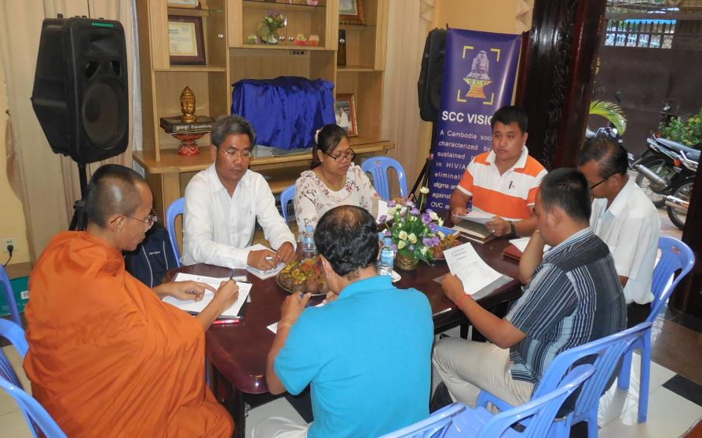
There were remained 74 contractual staff includes 5 management staffs, 3 administrate staffs, 57 in program / project staffs and 9 financial staffs for the period February to July 2017.
At the project level, there was staffs turn over as the followings:
- Ms. Leang Sokannika, SCC Project Coordinator from SCC Battambang, resigned from her post and moved to work for the organization and
Ms. Chhorn Sreymuch took instead of her responsibility for both Accountant and assisting projects at Battambang.
- Mr. Touch Len, SCC Assistant to Monitoring and Evaluation, resigned from his current job and there was no replacement to this position. Ven.Som Chea and Mr. Hun Socheat were appointed to responsible for Mr. Touch Len position.
- Mr. Ten Nimol, child education and child protection field officer in Phnom Penh slum area, was finished his contract with SCC and he moved to work for the other private company.
Even there were some staffs leaved, SCC management still working smoothly, SCC management has separated core work to the remaining staffs to responsible for each projects.

3.3. Highlight Achievements
3.3.1. High risk and vulnerable group behavior changes
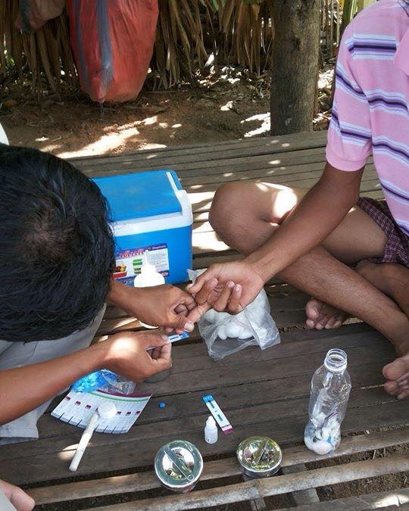
- 929 general community people received preventive education about HIV/AIDS, impact of the drug and primary health care in the reporting period.
- 2490 general community people and married couple participated outreach education session on drug and HIV/AIDS related issues.
- 1561 drug users, PLHIV, other vulnerable group and their families received Buddhist religious spiritual support and counseling from SCC monks/nuns and community support officers.
- 1520 youth and children received key important messages on negative impact of drug and how to get rid from HIV/AIDS transmission.

SCC carried out the community outreached prevention education with the drug users in Siem Reap province. SCC provided them with tailored prevention package of activities. Base on data analyses expressed that, only 31% of drug users reporting having many sexual partners compared to last year 48% and 87 % of drug users used condoms when having sexual intercourse with partners Compared to last six month only 72%.

3.3.2. PLHIV are ART adherence and become healthy
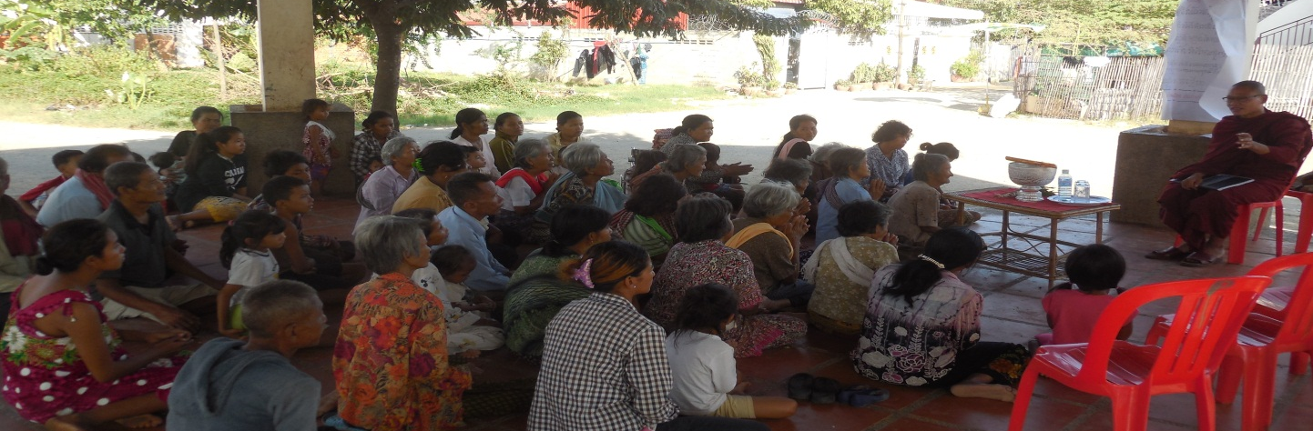
- 742 greatest PLHIV received direct psychosocial support and care. SCC provided them with a tailored package of support and referral to Pre-ART/ART sites, including transportation cost, home visit as required, and counseling/educations.
- In this reporting period 1661 PLHIV, OVC and their families received religious and spiritual support and counseling through Buddhist monks.
- 577 most in need or greatest need families received welfare and other basic need support.
- 592 PLHIV participated the self-help group meeting to share experiences and views.
- Most in need PLHIV received referral services of 1247 times of all major health services such as VCCT, TB, OI/ART, CD4 count and SRH…etc.
- Only 6 community people received HIV finger prick testing in the reporting period.
- Only 6 married couples received HIV prevention education.

98% of PLHIV under SCC's care and support are on ART but only 90.48% of them are reported ART adherence. ART adherence was increasing compared to last year only 89%. Also, 5% of all PLHIV receiving ART missed appointment with the doctors. Even if 90.48% are ART adherence but only 47.37% of all PLHIV were reported to have a very good physical health and able to work normally.

3.3.3. New cases of HIV/AIDS will be significantly prevented and decreased.
- 213 target population including drug users, migrant workers, entertainment workers and pregnant women were identified and referred for VCCT and 17 people were reported HIV positive.
- 81 negative partners of Sero-discordence couple referred for HIV testing in the reporting period.
- 15 newly detected PLHIV received care and support from SCC.
- 6 general community populations were referred for the finger prick testing during the outreach education activities.
- 81 Sero-discordent couple received positive prevention education from home care staff.
- 1561 community people received key message education on condom uses.

In the reporting period 2016, 213 target population including drug users, migrant workers, sex workers, and pregnant women were referred for VCCT and among them, 15 are HIV positive. This indicated that the transition rate (7%) at the community level is still high. Local authority said that few PLHIV still close their statue and not participate the HIV/AIDS program. Staff at the VCCT site said that there are many youth people involved with drug and they could get risk of getting HIV.
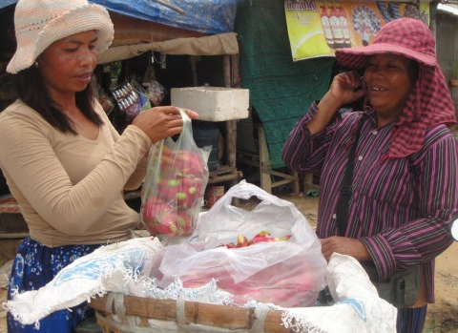
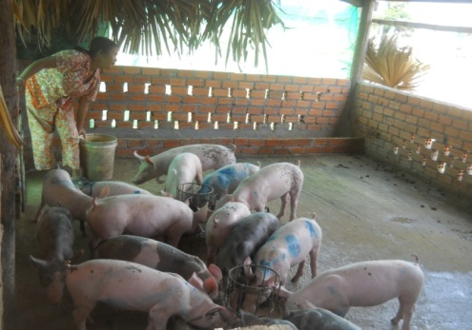
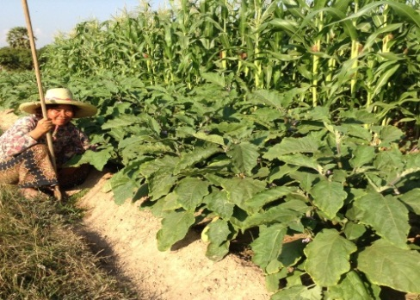
3.3.4. Stable income activities and a reasonable recorded income of SCC target groups.

- One expert from Agriculture department trained two livelihood groups in SCC Siem Reap on vegetable growing skills and raising animal skill.
- 20 families from the target in Siem Reap participated the training course by DoA at SCC's Livelihood Learning and Demonstration Centre.
- 20 PLHIV, OVC and vulnerable household were identified and prioritized for theincome generation activities.
- All of those 20 households received technical and financial support to set up small business scales.
- 42 vulnerable children received vocational training skills for building up their livelihood.

At the average in the reporting period, 52.63 % of SCC target group have stable income activities and a reasonable recorded income. This was increased compared to last year only 36.11%. And 58% among them were feeling good and very good about their livelihoods. They feel very hopeful for the future. Their sources of incomes are mostly in the form of selling labors and doing small business and could be categorized as follows: 18% are growing rice, 15% are growing vegetable, 27 % are raising animals, 25% are the construction workers, 5% are the factory workers, 15% are transport services, and 21% are doing small business at home. Surprisingly, 42.11% of PLHIV and other target group didn't have stable income and required SCC to provide more support, especially the agriculture related skill. on income generation

3.3.5. Formed community self-help group and saving.
- 27 PLHIV self-help group received training and refresher training on bookkeeping, and cash book.
- 592 members of self-help group met monthly to share experiences and views of confidence and independency.
At average in the reporting period, only 38.24 % of the target communes have been formed with the community self-help group and saving group. The target communes that have self-help groups were reduced 57.50% from the last year. This caused by the reduced fund from donors (KHANA) to support the self help and support group. Data analysis expressed that only 10.34% of the community self-help and saving group members are able to save and use the saving capital.

3.3.6. Save some money for healthcare expenses by setting up income generation activities save
- In the reporting period, No PLHIV, OVC and vulnerable household were identified and prioritized for the income generation activities and but 20 families of them accessed SCC livelihood learning and Demonstration Centre at Siem Reap Provinces.
- All of those 2 households received technical and financial support to set up small business scales such as growing vegetable, feeding chicken and Ducks, feeding fishes and pigs and handicraft products.
- 42 vulnerable children received vocational training skills for building up their livelihood.
- 27 self help and support groups met each other bi-monthly to share experiences and views related to income generating activities.
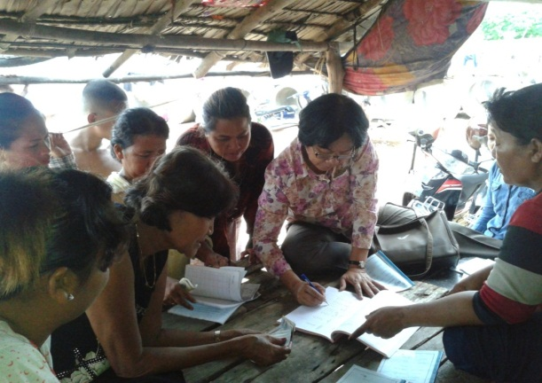
In the reporting period, only 14% of the vulnerable families were able to save some money for their health care. The data was decreased compared to the last year 22.22%. 59% of them had so concerns about increasing their income and only 41% of them had clear plan to increase income. Even if 85.29% of PLHIV and poorest families had the won house but only 6% have land for their livelihood and agriculture works. 35.29% of PLHIV and poorest families have the specific skill for their livelih0odactivities.

3.3.7. School ages children and children live with HIV/AIDS have accessed schooling
- In the reporting period only 542 most at risk children received education assistant from SCC CBE School.
- In this reporting period only 75 most at risk children from SCC school and community received school materials and school uniforms from SCC.
- 527 children from SCC school and the community received educational training on life skills such as physical and mental education, health, ..ect.
- 42 children received music vocational training such as dancing and music.

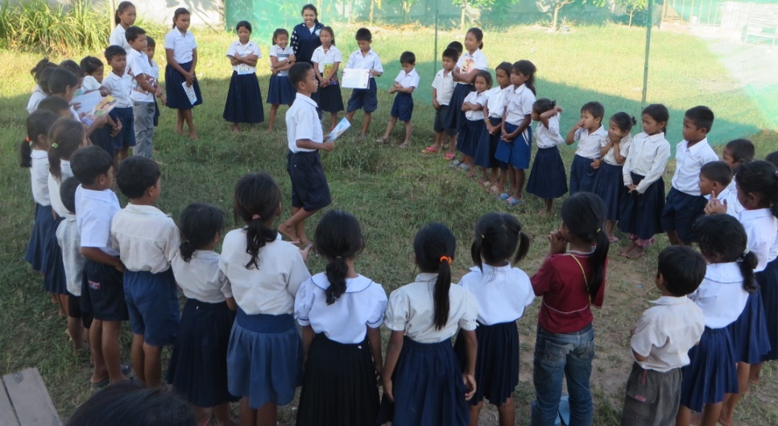
In this reporting period, 78 % of the PLHIV and poorest families said that they have the children going to school and 83% among them were reported to go to school every day and regularly. PLHIV and poorest families started to know about the importance of education. The data recorded that 18% of the PLHIV and poorest families that had the children to go to school completing primary and secondary school. 49% completing high school and only 33 % continuing study after their high school. Children of the PLHIV and poorest families have been cared for and assisted to access their schooling. This support has been widely known and appreciated by the community, including PLHIV, their families, local authority as well as the children themselves. In this reporting period, we recorded that 4% of PLHIV and poorest families wanted their children to stop learning earlier for their income generation activities.
3.3.8. School enrolment rate amongst vulnerable children and children live with HIV/AIDS
- 542 children received outreach education on the importance of education.
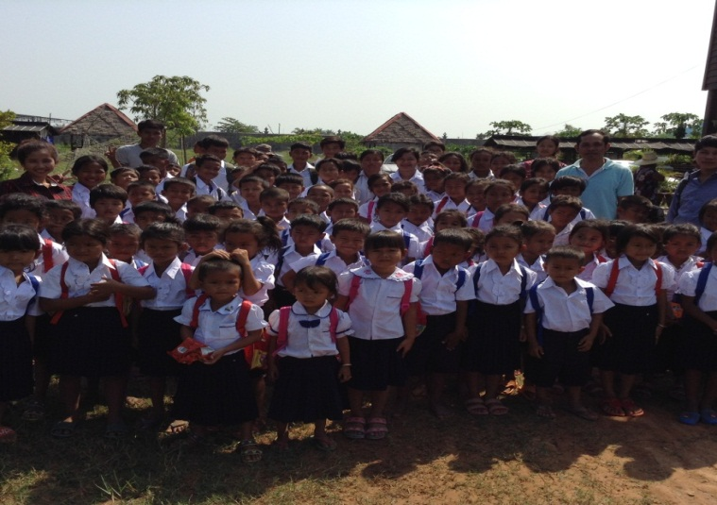
- 629 people in the community received outreach session on child education and children protections.
- Government staff conducted 6 times of supervision to SCC school and the project.

Based on the data that we collected from the state school in SCC target areas, we found that the enrollment rate in 2016 is 97.50%. The rate was increasing compared to the enrollment rate in 2015 only 96%. SCC also participated the enrollment campaign with the state school.

3.3.9. School dropout rate amongst vulnerable children is significantly reduced
- SCC participated 2 times with the public school for discussing about the children attendance at the public school.
- 415 children received outreach education on the importance of education.
- 1275 people in the community received outreach session on child education and children protections.

Based on the project reviews for this reporting period, 16.00% of the PLHIV and poorest families reported that they had the children dropping out from school. Reason for this dropping out were identified as follows: they were in lack of money for their children's daily schooling, no enough money for their schooling materials, the house are far away from school, some children assisted their parents to look for the income and some children said their parents were divorced

3.3.10. Strengthening SCC good governance system and improve all existing policies
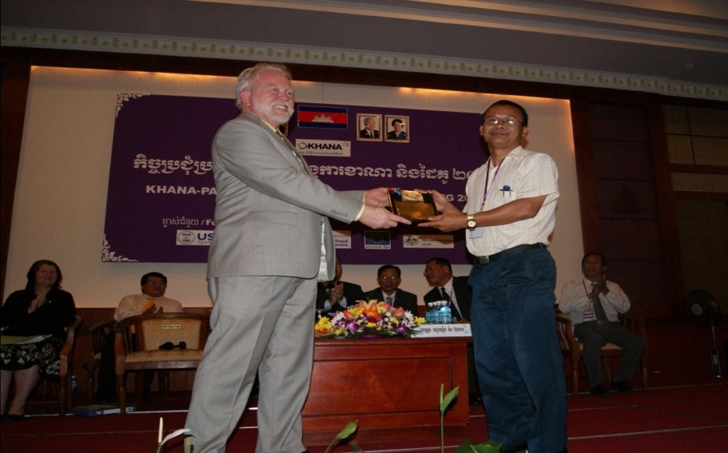
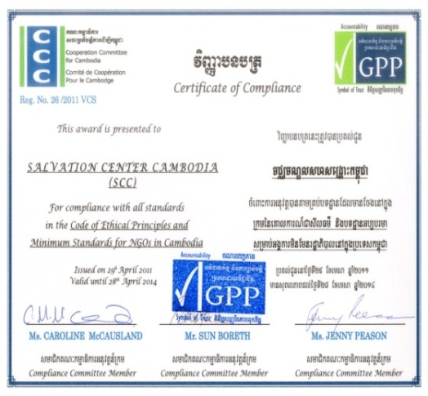
- 46 Monthly staff meeting took place at Phnom Penh, Battambang and Siem Reap, Financial manual and anti-fraud policy were also included in the meeting.
- 12 SCC staff and teacher participated the meeting and training conducted by other NGO and other relevant institutions.
- Management team conducted field visit 12 times to the project sites.
- 7 policies were update to adaption real situation and 1 CBPCS program manual was developed in the reporting period.
- 74 contractual staff was conducted annual performance appraisal.

Based on the project reviews, 60% of the staff could mention something about the bylaws. This was increased compared to the last year only 40%. 100% of the staff knew about the financial policy, and anti-fraud policies and they could mention some parts of the policies but some staff was still confusing between the financial and anti-fraud policies. 80% of the staff preferred SCC current leaderships and managements. 90% of the staff preferred learning and sharing events, they said when there had a new staff coming, they were generally provided orientation advices and encouragement. In this reporting period, 70% of key staffs participated a meeting, learning and sharing run by other NGO or institutions.

4. SUCCESSFUL STORY

The life of infected children
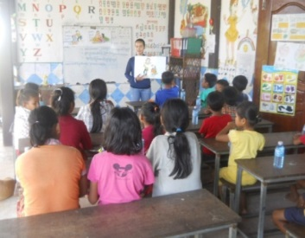
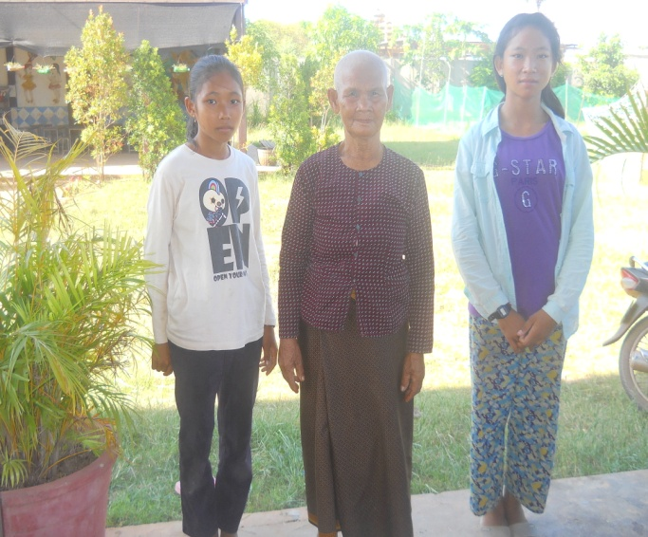
Pov Chana is thirteen year old. She is studying at the Bosh Krolanh primary school as well as SCC-CBE school. Her home address in Bosh Krolanh village, Chreav commune, siem Reap municipality, Siem Reap province. She is living with her grandma and her sister named Logn Net. They are living altogether with her grandma after her parents was died since 2007. Her family is a poorest PLHIV family which has no job, no own land and no property shelter in the community. They depended on her grandma’s job as growing some vegetable around her home and assistance food from community member for daily living. When she was five years old, they often got sick which unknown the real source of diseases. Her grandmother tried to buy the medicine from private pharmacies for treatment, however she did not feel better. Then her grandmother decided to bring them to the hospital for treatment. During her stay at the hospital a doctor advised them for HIV testing because she had TB. Because her health still not got better, they agreed with doctor to take their blood for HIV testing. Unfortunately, her received the result as HIV positive. During that time her grandmother worried much about the future life, but how ever her grandmother is still take care her and sister.
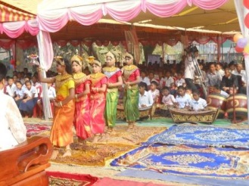
Channa and her sister have registered in SCC Home Based Care project since the 13th of September in 2010, which received any supporting such as transportation fee to receive ART, supplementary food, school uniform, school material, money and other support from SCC, which can make her health better than before. In the year 2011 Channa enrolled to study in Centre Base Education (SCC-CBE) in the BosKralanh village nearby her home that is supported by SCC. Beside of studying at CBE School, she was appointed as youth group leader in the SCC community centre, where she has the opportunity to receive money support amount 15 dollar per month. She also has the opportunity to study at the state school regularly. Even though, she has more opportunity to learn many objects in CBE School such as about English Language, morality, body hygiene, Khmer tradition music, but her life condition is not well! Her grandmother became older and cannot find the money for studying and daily living for her grandhild. With speaking slowly included tearing, her grandmother talked to the SCC staff. “Once day, I gave only 500 riels to Chana for studying a week with no food and nutrition while some day we have only rich eat with the water, and some other day she got sick without medicine, She add that, she is not able to take care of her granddaughter, because she is too old”

Good Livelihood through involving in service of home base care
Lives were very difficult and sympathize with Kim Sokpert’s family because of his wife and himself became serious of HIV infected without awareness of health situation. At this beginning Kim Sokphert and his wife weren’t able to handle the situation. They felt very shy and embarrassed about something they have done or a quality in their characters. He said that his wife and him absolutely suffered from this infection. Their neighbor and villagers discriminated their family. They don’t talk with the household or family member and don’t allow their children to play with sons and Kim Sokphert’s daughter. Sokphert wanted to commit suicide as he felt hopeless and pointless of his life on the world. Furthermore their family condition was so poor because they have no job and career then no income. The family was supported by their parent while they were sleeping on the bed.
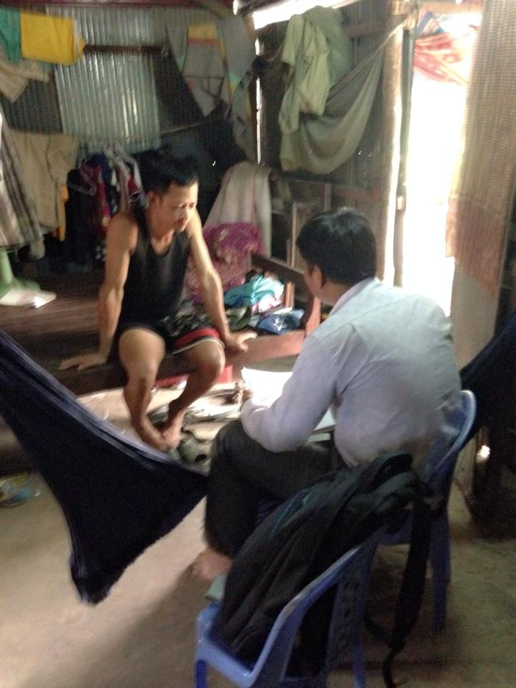
In 2008, discrimination and family condition were the main problem for this small family then they decided to escape from their homeland, Odormeanchey province, to Siem Reap province. When they first arrived at Siem Reap province, the family and health situation were even poor as they didn’t have their own land. They built a small cottage roofed from thatch on the pavement in Tropeang Ses village, Sankat Kokchork, Siem provice nearby Angkor Wat temple. Sooner CoE knew about this family information then CoE staff came to their house bringing with some donations such as mosquito net, rice, school uniform for their children and cooking ingredient. Therefore CoE staff motivated them to register at Pre-ARt/ART clinic to receive ARV. They agreed for this motivation but at beginning they weren’t on service regularly and correctly to doctor prescription as they had to hold in their livelihood for a whole family especially children education. Bit by bit CoE staff was able to have them punctuality on service receiving and self-esteem to stand up fighting with life trouble.
Now, this small family become a lot of changes if compare to previous livelihood. A husband could generate income of eighty dollars per month from his security guard at Community Base Education project (SCC project) close to the family plus about three dollars income per day from selling baby fish he fed in his big jars at home. A wife is able to earn one hundred and thirteen dollars a month from her work as a chef. One older son can earn over one hundred dollar from his job as a service position. What CoE is proud of their son is that he didn’t give up education, now he is studying year two at the university. Other one son and daughter are learning in Mok Neak primary about one kilo meter from their house.
To the end of his interview Kim Sokphert would like to dedicate his gratefulness to CoE that survives his family since the worst situation to better situation. He said his family learned an incredible life experiences that they never ever believe they can have today. He really appreciates what CoE has been done so far for his family and communities and he prays to Buddha to help CoE to continue the project for long year into future. Finally Kim Sokphert would like to recommend to all PHIV and poorest family not to give up perseverance and have to learn from life experiences until body in grave.

5. SCC’ FINANCIAL SUPPORT ANDPARTNERS

6. BUDGET PLANNED FOR 2016

