Project Plan: Waste no more!
powered by Green Phenix & Sea Turtle Conservation Curacao

Date: April & May 2019
Location: Curacao
Goals:
- Stimulate from waste to product production
- Increase local high quality production of souvenirs and long term applications
- Increase regional capacity for waste to product production
- Reduce plastic waste (stop landfill from filling up and plastic pollution from entering the sea)
- Increase recycling
- Reduce the need for exporting recyclables (save on emissions)
- Stimulate waste separation
- Create a circular revolution
Target Participants:
- Talented and passionate people with Caribbean roots that want to work towards a solution for plastic pollution
- People that are members of the Precious Plastic community
- Talented and passionate local people that want to have a career with purpose in recycling
- Tourism operators that want to be leading in sustainability
Target Stakeholders:
- Tourism operators / tourists
- Companies that want to become more sustainable
- Companies & people that want to help battle plastic pollution in the Caribbean
Root of the problem
Plastic pollution is a global issue. Our oceans are filling up with plastic. In the Caribbean region plastic is piling up on the windward sides of the islands. Plastic is floating in the water and if nothing changes by 2050 there will be more plastic in the sea than fish.

There is not a lot of recycling going on in the Caribbean and consumption is still on the rise. Most of the waste that is produced is brought to landfills. Landfills usually have limited capacity and therefor islands desperately need to recycle. But the problem on the islands very often is that there is not enough material to make recycling profitable. Which has the consequence that it is not done.

Worldwide only 14% of all the plastic that is used is being recycled. The other 86% either ends up in landfills, is being burnt for energy or becomes a pollutant in our environment.

System shift
There is a desperate need for a system shift, in which products will be used again at the end of their lifecycle. This way the concept of waste and pollution will disappear.
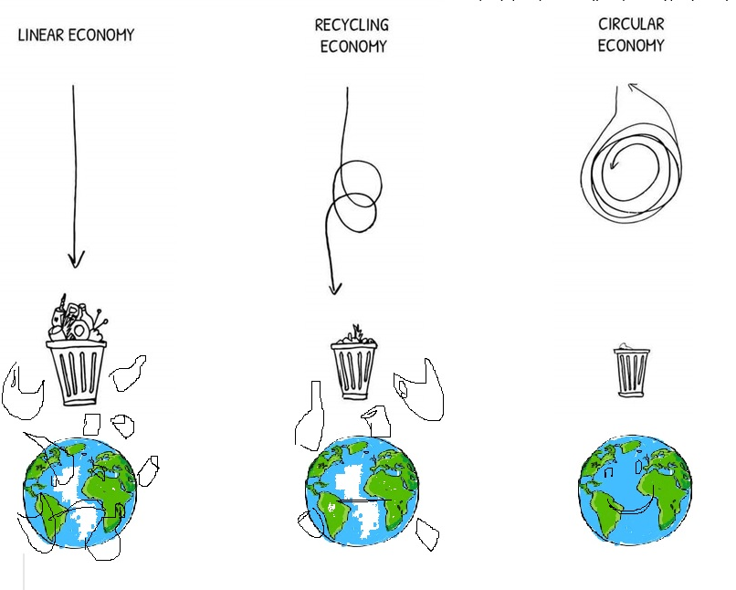

The Precious Plastic revolution
Precious Plastic started 5 years ago. It is a concept made by Dave Hakkens. He developed 4 machines that enable everybody to start recycling waste plastic in an affordable way. His idea has grown into a big community of enthusiastic people around the world recycling plastic. Over 200 plastic recycling workspaces have already been set up and a new one is opening up somewhere around the world every week. This is great and keeps expanding. However, the plastic problem is still enormous. Especially in the Caribbean.
Thanks to the precious plastic technology we can now do something about it. It just needs to be addressed a little different and in combination with existing stakeholders. Precious plastic workshops are usually set up very low cost. If there would be some investments to improve the recycling processes to professionalize the machines, there would be an ideal solution for small markets like the Caribbean Islands.
Project: Waste no more
The ‘Waste no more’ project is formed in a similar was as Precious Plastic V4 that is currently taking place in Eindhoven – the Netherlands. A team of 20 people will be working on creating products from plastic waste streams on Curacao. 12 will be international, 8 will be local, mostly from the Caribbean region, so that we will be building capacity for local recycling initiatives in the region.
The international participants will be facilitated to join the project, so that they can make a valuable contribution to solving the problem of plastic pollution and increasing their knowledge about plastic recycling, so they can set up a local recycling facility in their home country. Accommodations and meals will be provided for them.
The local participants will get a salary and during the project the participants are going through an education program. If they successfully complete the program they have a chance to get a job after the pilot.
The products that are made will be sold through existing sales channels, a web shop and through participating hotels. That way we will be able to reach a large number of people.
Project target
- Capacity building for recycling in the Caribbean
- Create awareness about the waste and recycling challenges that cause plastic pollution
- Repurpose plastic waste into meaningful items that can be used for a longer time
- Stimulate recycling
- Create employment opportunities
- Be the starting point for a revolution towards a circular economy in the Caribbean
Budget:
Costs | USD
8 local trainees – 3 months | 24.000
Housing 12 international volunteers – 3 months | 24.000
3 meals per day international volunteer  & lunch for all participants | 18.000
Transportation | 12.000
Location rental 3 months | 18.000
Electra & water 3 months | 6.000
Exhibition stand (bike) | 5.000
Compression oven, extruder & injector upgraded Precious Plastic | 25.000
Plate machine | 50.000
Genulate operable 3d printing machine | 50.000
Moulds | 25.000
Marketing and communication | 15.000
(Sub)total | 272.000
Unforeseen (15%) | 40.800
Total | 312.800

Revenue | USD
Crowdfunding support | 300.000
Revenue by sales of Phenix Bins | 25.000

The project will be scaled to the Caribbean when successful.

Present your startup final pledges

Pledge 1 EUR or more –
Stay Tuned: If you’re passionate about a healthy ocean, or just curious to follow along the journey of how we will accomplish this – choose this reward and have access to updates

Estimated delivery - January 2019

Pledge 20 EUR or more
Get a turtle pin Pull a pound of ocean trash
Choose your color later

Estimated delivery - January 2019

Pledge 100 EUR or more
Save 20 EUR (120EUR MSRP)
Buy a Phenix Bin Pull 5 pounds of ocean trash
Prevent 5 pounds of plastic go to waste
Choose your color later

Estimated delivery - May 2019

Pledge 500 EUR or more
The BIG 5
Save 100 EUR (600EUR MSRP)
Buy 5 Phenix Bins Pull 25 pounds of ocean trash
Prevent 25 pounds of plastic go to waste
Choose your color later

Estimated delivery - May 2019

Pledge 1000 EUR or more
Save 200 EUR (120EUR MSRP)
Buy 10 Phenix Bin Pull 50 pounds of ocean trash
Prevent 50 pounds of plastic go to waste
Choose your color later

Estimated delivery - May 2019

Pledge 2500 EUR or more
Angel package
Facilitate a talented and passionate volunteer for 2 months
Pull 150 pound of ocean trash
Prevent at least 500 pounds of plastic go to waste
Estimated start - April 2019

