Kenya Education

Kenya in a state where its impossible to find a real free education. All the promises about ir failed.
Its possible to understand the situation when you watch this film your read this link.

https://www.youtube.com/watch?v=KEvsOQPhVlY

http://theconversation.com/free-education-in-kenya-is-a-failed-promise-22453

Hai África Centre

Hai Africa is an NGO founded in May 2015 by the Brazilian Mariana Fischer.
It was during a trip which Mariana was going to work as a volunteer, that she met vulnerable children from the Kabiria community in Nairobi, Kenya. Shocked with the conditions of children and families, she saw in education a tool of transformation for that reality. Mariana has spontaneously rented a house, gathered a team of people from the community and today they offer humanized and conscious education, healthy food and affection to 39 children in kindergarten and 19 in elementary school. The kids who leave Hai Africa keep on pursuing their studies at the Bridge Primary School in Kabiria, Nairobi. Their studies have been sponsored through an annual crowdfunding campaign, for all the 19 students. After two years of contact with these kids and their families, or more specifically with the mothers, she realized that she could go beyond and also impact their reality, since the effect of the education would reach much further if these mothers could also have a better life opportunity. So in November of 2017, in partnership with Project Três, a women empowerment project that was taking place in India, Mariana managed to bring this project to work with Hai Africa, in Kenya. Thanks to this initiative, there are 15 women who have become artisans and today make products such as bracelets, soapstone goods and bags made out of recycled materials, in fair trade conditions.
Hai Africa has been developed for the past 3 years and continues to transform the lives of many people in the community. The NGO is mainly maintained through the donation of individuals and events, and our goal for the upcoming 2 years is to have impacted 100 kids by giving them the opportunity of studying with us and get the privilege to beneficiate from our own pedagogical method in a way to change their lives and afterwards, the world.

Our Pedagogy
Our teachers Leah and Jane do Rudolf Steiner training and did internship in waldorf primary school nairobi because we believe that the best alternative is show for them the benefits of a non- traditional education. Our pedagogy is based on playing, hand craft activities and love and our reference is waldorf schools.
Our school is located in a small house in Kabiria Community 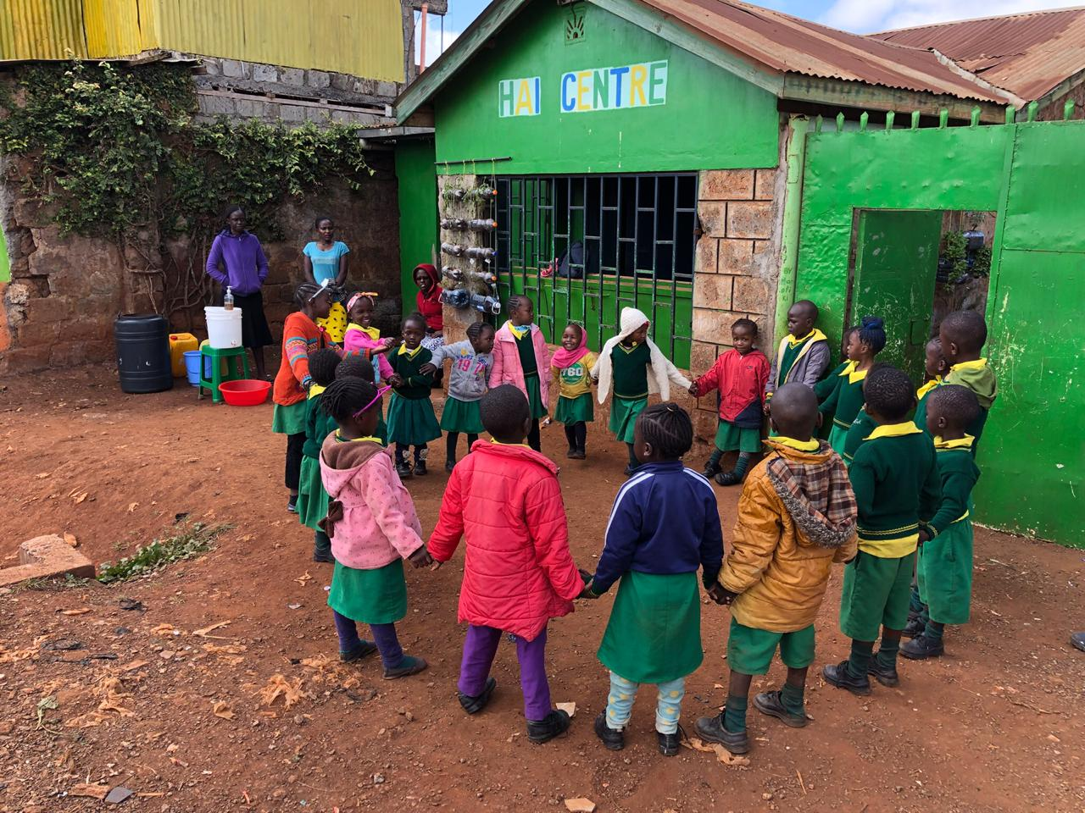
Budget:
Our annual cost in total is 50.000 dollars
Salaries | 1800 dollars month
Food | 500 dollars month
Rent | 300 dollars month
Administrative Taxes | 500 dollars month
Bank Taxes | 50 dollars month
Internet | 57 dollars month
Teachers College | 180 dollars month
Variable costs (donate platform, accounting) | 800 dollars month

Objectives:

To be a school to one hundred kids. Own pedagogical curriculum based in systemic education, waldorf pedagogy, ecological and holistic literacy autonomy. And our company with mothers in partnership with Project Três impacting 30 women. All of this in a big place.

What we need to realize:

Professional training and visit differents school in all the world.
A big land and new structure
Contacts, patient and love

In term of money 150.00 dollar per year.

Our ideas to be more sustentable

Sell mamas arts in other countries
Rent small house in our future big space
Create a small company to work with men and then sell organic fertilizer.
Create a small hen house and sell eggs inside community
Events and courses in all the world
Pedagogy consultant

