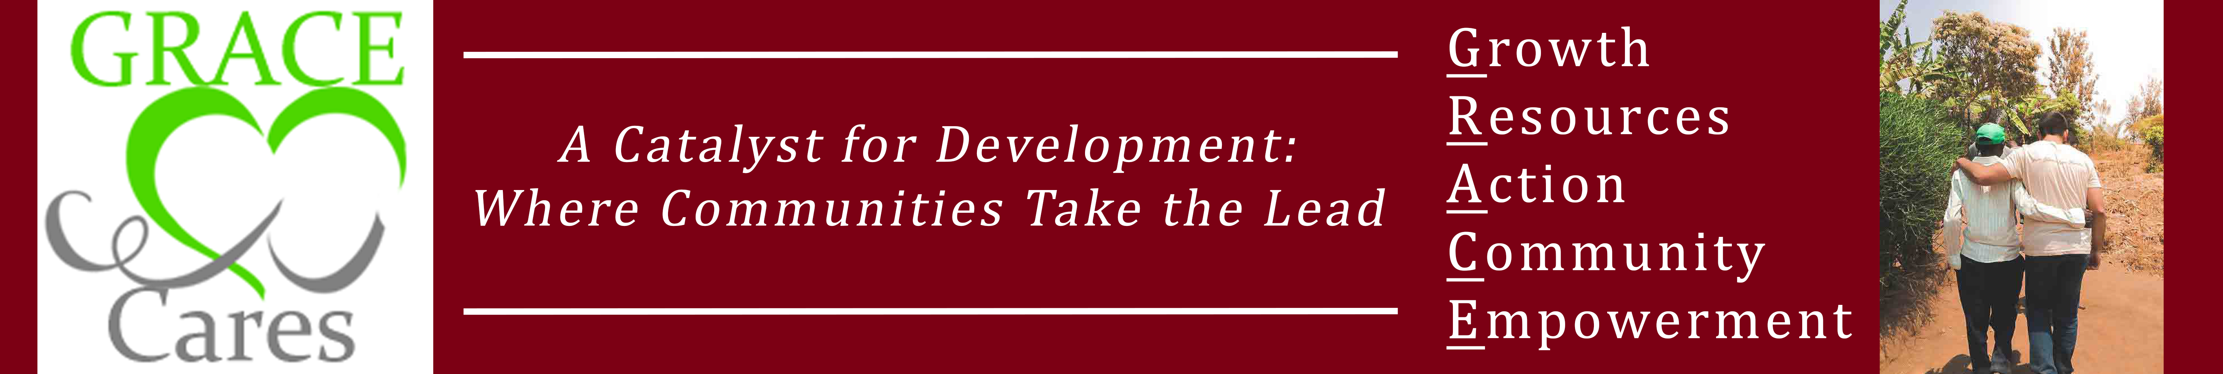

GRACE Cares
2017
Annual Report

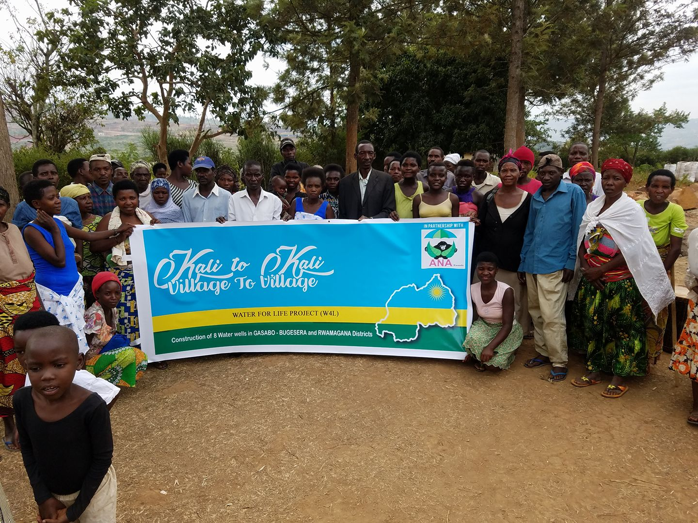
TABLE OF CONTENTS

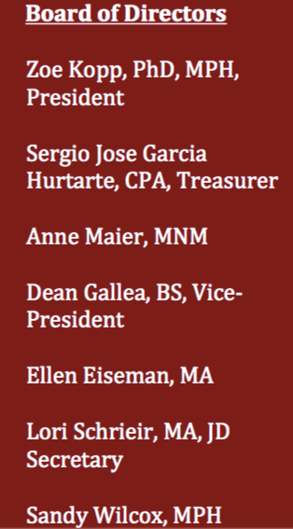
- Letter from the President

- Projects
- B4Peace
- Kali to Kali
- Lucknow
- Mayan Traditional Medicine
- Project Hearts
- Watha

- Financial Statement
- Donor List
- Giving to GRACE Cares

Letter from the President
GRACE Cares 2017
GRACE Cares’ mission is to partner with local heroes and communities on small- scale community development projects that make a difference by empowering people to improve their lives. We do this with respect to local cultures and traditions. This is accomplished by helping to build healthy, educated, just, peaceful and productive communities. GRACE Cares provides expertise, funding, and support for health, education, peace and social justice, cultural preservation, and economic development projects.
Growth: This past year we have seen all of our programs expand their vision of what they want for their community. This year, nine amazing, strong women have graduated from the Community Health Leadership Program in Project Hearts. Our Watha program is working together with a major animal rights group to help make the Watha tribe sustainable. We are also taking on a new project focusing on education to orphans and single mothers in India. B4 Peace has been working on an art show taking place in New Orleans, early 2018, which will focus on Building a Peaceful Community through art. Lucknow has been working hard on expanding their education and health programs. Mayan Traditional Medicine has been working with the Healers on their 2018 goals, including sustainable agricultural Lastly, Kali to Kali has been working hard in Rwanda providing well expansion, increasing education initiatives and the creation of gardens to make villages more self-sufficient.
Resources: These communities depend on financial support. We have been encouraging our programs to delve into their own fundraising and social media. This can be a challenge for some of our programs with limited resources. That is why we depend on our donors, who continue to help our current programs and now a new program for 2018.
Action: This year GRACE has reached out to the local community by presenting at “Strolling of the Heifers” in Brattleboro. We have become more active on social media – check out our Facebook Page! We also make a conscious effort to spread the word about our projects and our goals. In 2018, we are looking for additional board members to help provide fresh insight in this rapidly changing world. GRACE has also taken on new leadership staff which will provide us more focus and expand our programs.
Community: Every project we collaborate with, has a local hero(es) that feels passionate about strengthening their communities. These heroes work with their communities to determine community priorities ranging from providing sustainable agricultural programs and water systems, to education, to social support system, to teen pregnancy awareness. We observe our heroes have made amazing progress. By having an individual(s) with a vision and them watching it grow has proven that if someone wants to, they can make their community a better place.
Empowerment: 2017 was the year the world became empowered. In the United States, where political and social change is abundant, B4 Peace has made the silent voices heard. And internationally, Project Hearts is empowering women in Baitoa, which is a male dominant society. All of our programs were inspired from these global changes and it is easily reflected in the growth of all of our projects.
With gratitude,
Zoe Kopp, PhD

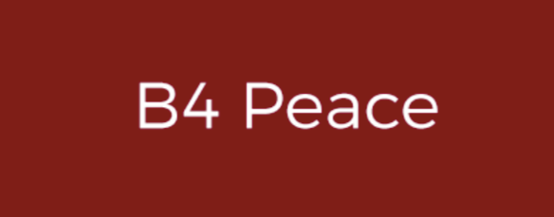
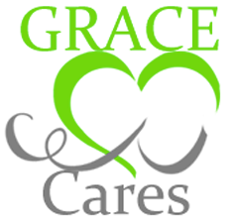

Background: GRACE Cares believes it is important to promote arts and education projects that develop individual and community awareness on the importance of peace. By doing so, they join citizens across the globe to reflect on decisions that impact the lives of vulnerable people. We agree on an agenda that respects the rights of humans: the right to be free to live peacefully wherever we want to be.
Activities: In 2017, B4 Peace undertook the planning of international peace art exhibition Building a Peaceable Community to be held in New Orleans in January-February 2018. Artists from around the word were invited to submit works of art on the theme of building peace. In a time of so many divisions and war in the world we wanted to inspire artists to work for peace. We also wanted to share the community art pieces GRACE has done in the past with the community in New Orleans which struggles daily with gun violence. We received submissions from all over the world and from New Orleans that inspired much hope. You can see the art submitted at: www.b4peace.org.
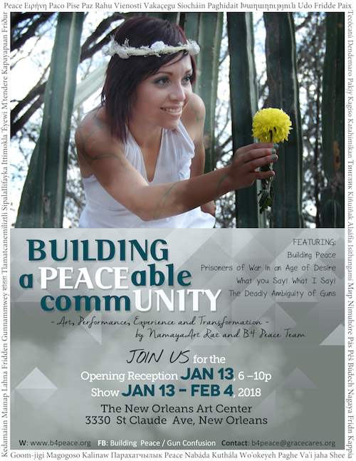
Namaya, B4 Peace’s Director, also won a grant from #quakeroutsidethelines to construct the Cross of Iron sculpture in honor of President Eisenhower’s 1953 speech of that name which cautions against military spending:
“Every gun that is made, every warship launched, every rocket fired signifies, in the final sense, a theft from those who hunger and are not fed, those who are cold and are not clothed.
This world in arms in not spending money alone.
It is spending the sweat of its laborers, the genius of its scientists, the hopes of its children.
The cost of one modern heavy bomber is this: a modern brick school in more than 30 cities.
It is two electric power plants, each serving a town of 60,000 population.
It is two fine, fully equipped hospitals.
It is some 50 miles of concrete highway.
We pay for a single fighter with a half million bushels of wheat.
We pay for a single destroyer with new homes that could have housed more than 8,000 people.”

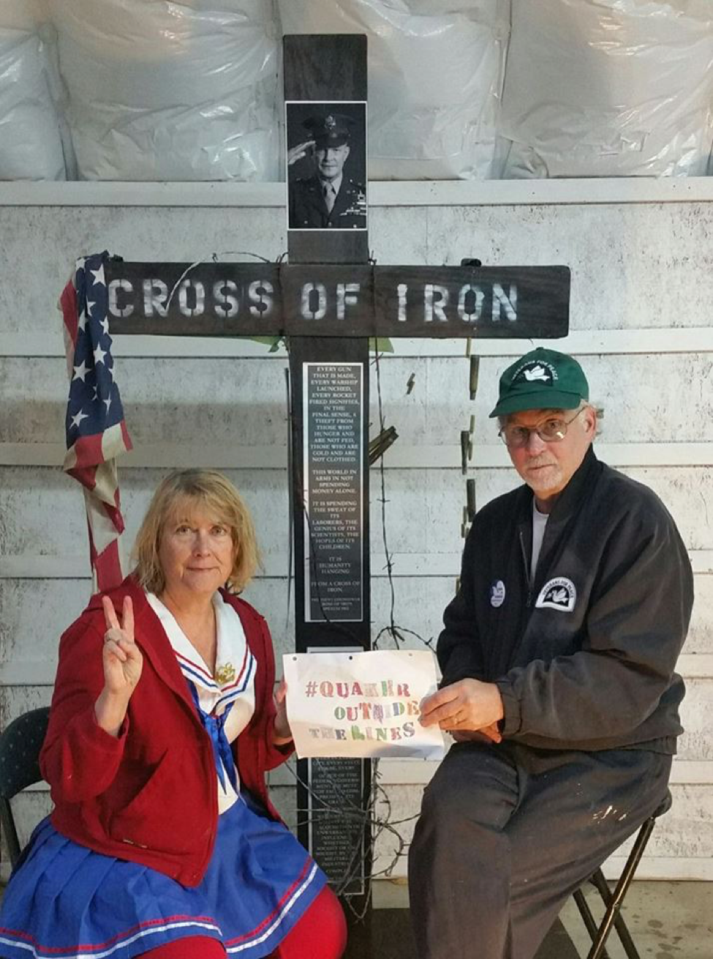
The sculpture and our Cost of War activity was a centerpiece in several community activities in 2017.

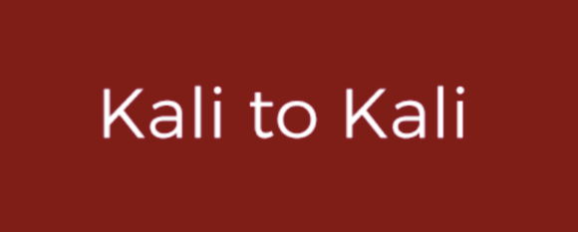

Background: The Kali to Kali Project (Village to Village Project) has supported children in rural Pakistan by creating a better learning environment with good infrastructures and school supplies. The aim was to increase the number of children in school, improve the quality of the school and ensure that they continue to attend school. Kali to Kali hopes to be able to partner with local heroes in additional communities around the world. Kali to Kali launched a program in Rwanda in 2015 with partner organization ANA Rwanda.
Activities: Sustainability is key! Since 2015, we have helped 4 communities by constructing 8 filtered water tanks and helped build 135 vegetable and fruit gardens. Each community that we work with has roughly 125 or more people who live in them. By creating local water systems, children (who would have to travel 5 to 10 miles daily to get water for their families), can now focus on getting an education. Having water in their village has also significantly helped with the spreading of water-borne diseases. The water tanks are multipurpose, and are used by everyone living in these communities for drinking, cooking, or cleaning. In order to maintain these water systems, Kali to Kali hired local engineers and contractors to teach the community how to maintain them. Kali has also focused on teaching these communities how to maintain their vegetable and fruit gardens. These gardens were originally constructed to fight malnutrition that plagues many communities in Africa. By growing their own food, provides a source of nutrition. Especially that many families we work with do not have enough food to consume daily; so these gardens provide a consistent food source.

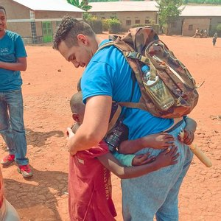
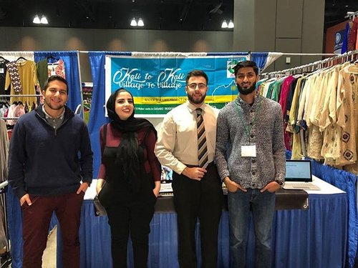
Future: In 2018 we are going to raise $75,000. This money will help fund a health educational project, where people in the communities can learn basic health necessities. We are also going to focus on providing English lessons for those who are interested. We are going to focus on how to make a profit for these communities with the resources they. I one village the school was in great need of infrastructure help. Lastly, we hope to raise additional money to build another 4 wells and 30 or more gardens for communities in need.

Background: In 2008, Nazeela Nasseri, a U.S citizen of Indian descent decided to take action after recognizing the need for basic education and healthcare through a visit with her maternal grandfather to the Amethi region. She began travelling to India annually and spending 8 weeks over summer vacation teaching English in the school for girls in Amethi. The Lucknow project was eventually established to introduce an Intensive English Program within schools in the region. Nazeela’s sister Afshan Nasseri is now the director of the Lucknow Project.

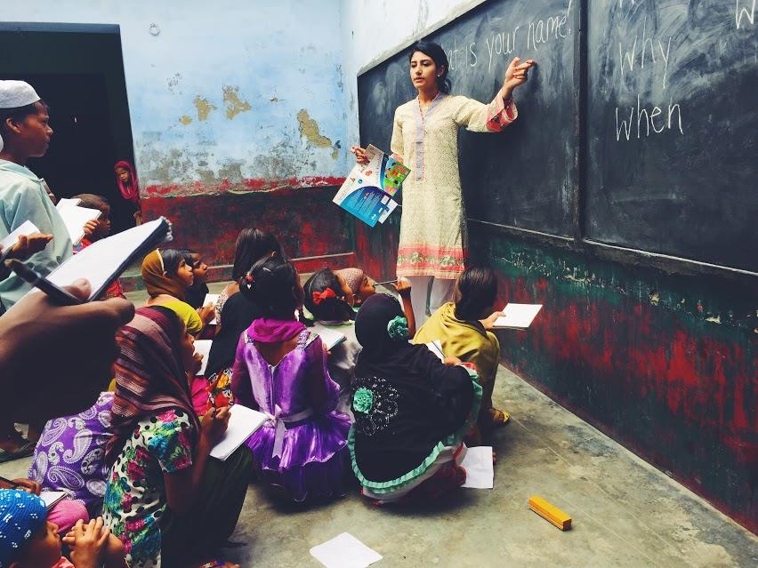
Activities: 2017 marks the first successful Internship Program. Three interns were selected with various backgrounds and interests. We taught approximately 500 students and conducted weekly tests to track progress. By working together we were able to analyze the needs of the students, and were able to give more attention and help to each individual student. Many students struggled because they had a poor English foundation, mostly because they began school at an older age. We isolated these students and provided tutoring which ultimately re-instilled confidence in themselves. We also conducted a two day long medical clinic, with the help of Dr. Romana Haider. The clinic allowed us to support around 200 patients with a variety of medical issues. This year the Lucknow Project increased their exposure to the world by creating “live videos”. Thousands of individuals were able to watch the project and from visualized the work we are doing and have accomplished, it urged them to get involved.

Future: I am currently speaking to around 8 volunteers who are interested in volunteering in both medical respects and teaching. Two doctors from Montreal will be holding medical clinics in Amethi, as well providing health education seminars. We are currently selling stickers to help fundraise for this project. With more help, we can work on a more structured tutoring program. Continuity of education is a difficult task in the communities we serve, mainly because students have to go home to help with family chores; however, I believe that there are some students who would take the opportunity of tutoring if it was offered. We are working on our sustainability. I am going to raise $1,000 to transform our ration program into a micro-financing program. We are going to raise additional money which will go to focusing on community values. We are planning to create a community garden and involve more diverse people in this project. By providing exposure to our community to different cultures will help promote tolerance.

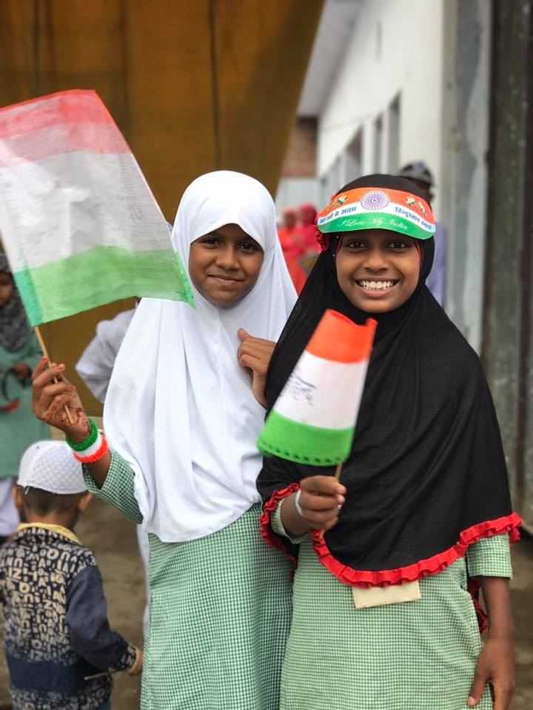

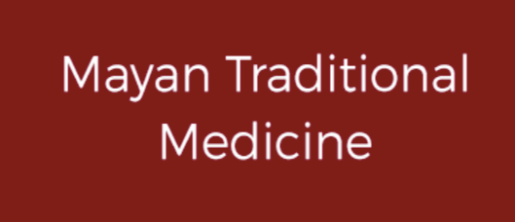

Background: In Guatemala, the two predominant health systems are the official or formal and the Mayan Traditional Medicine. The latter is still the most approachable for the prevention and cure of the community’s sicknesses, with much focus on the common and cultural illnesses. Although this is the 21st century, there are still challenges for the practitioners of Traditional Medicine, which include recognition and practice on a national and global context.
Through research and giving back, Mayan Traditional Medicine seeks to be viewed as an integral contributor to health, from its vision and management to local organizational activities.
Activities: 2017 has been a busy year for this program. There are four communities that are benefitting from Mayan Traditional Medicine and their gardens. The practitioners are 12 Mayan priests and priestesses, 3 wives (as the main group) of the oldest priests who always accompany them and the indirect beneficiary population.
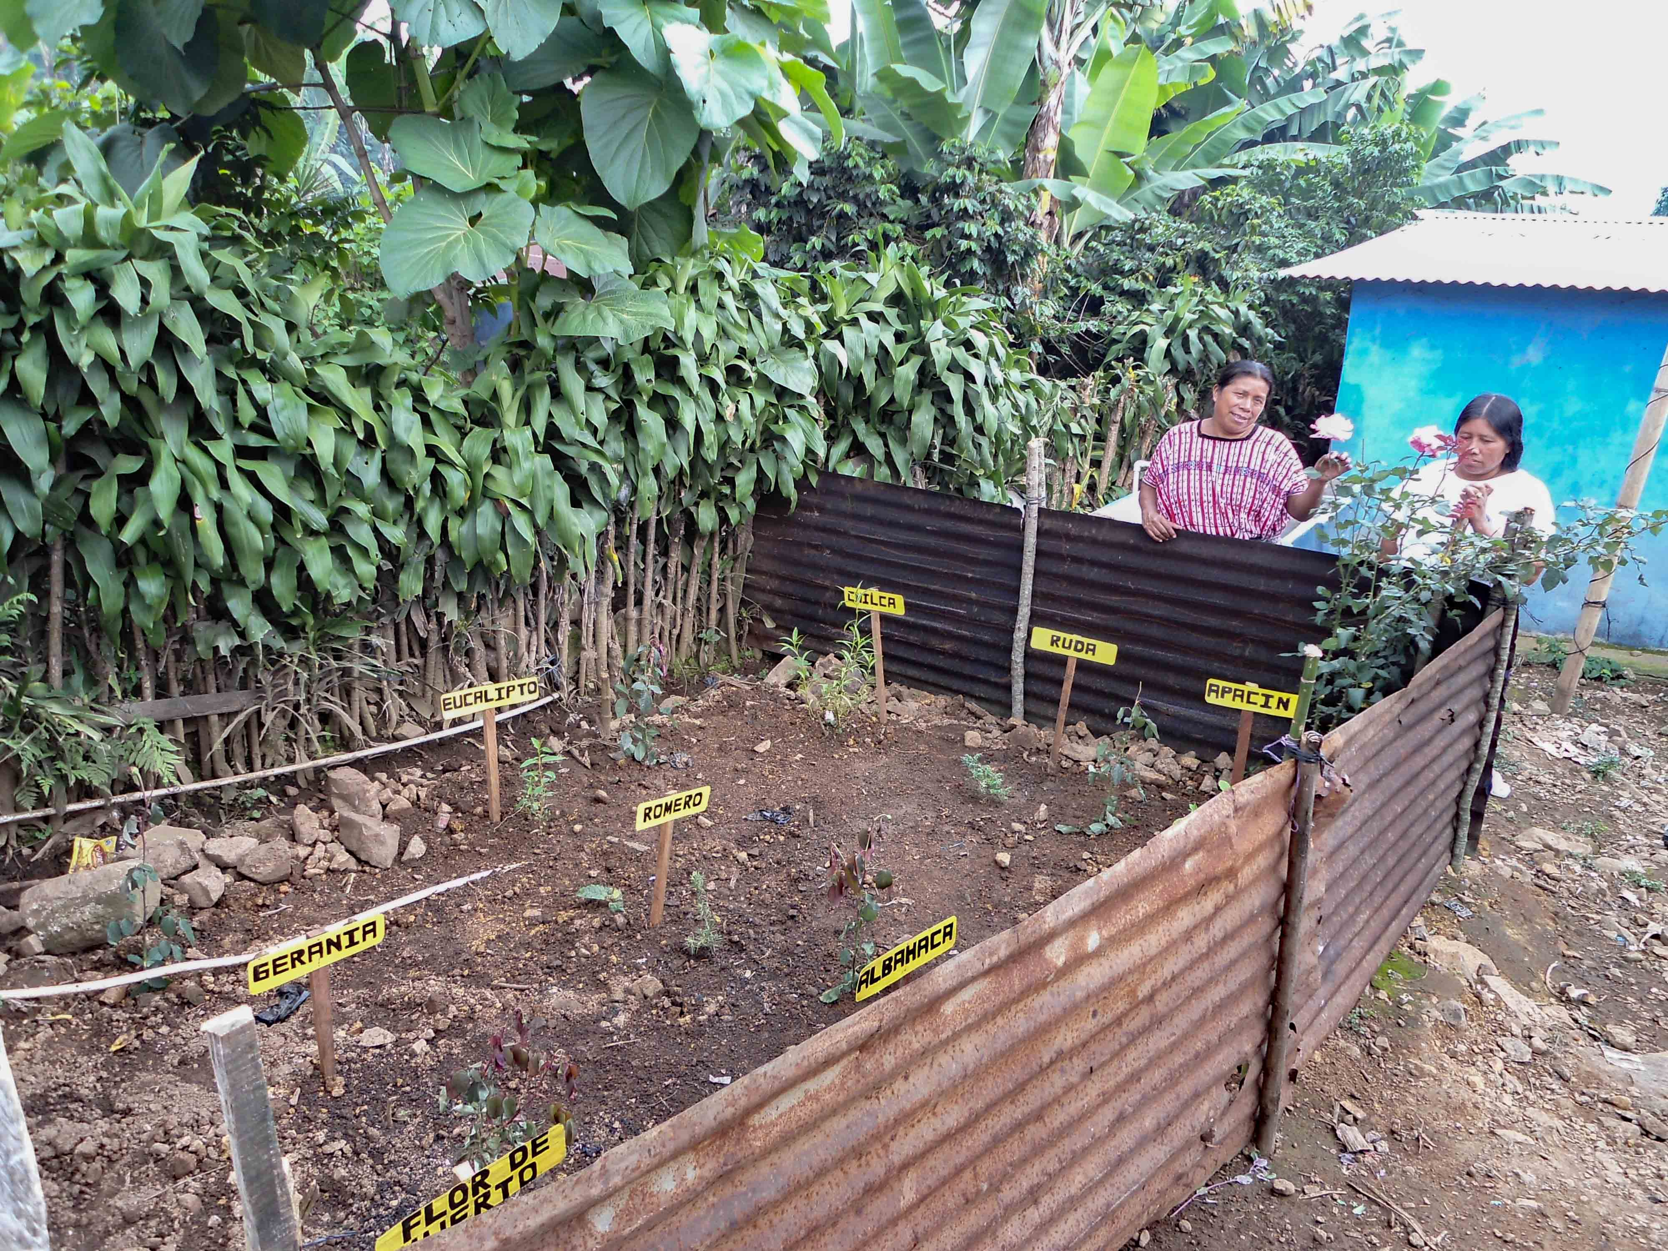
Future: With the growth of the gardens, storage of the medicinal plants for each Mayan priest is expanding. They plan to increase their storage areas. They are creating workshops for the younger generations where they instruct strengthening self-sustainability as well as promote this traditional and ancient knowledge to the children of the community. They are investigating Agricultural technical assistance on how to cultivate and harvest additional medicinal plants. They are creating a documentary video demonstrating cultivation, care, harvest and preparation of medicinal plants, which are helping the population they serve.

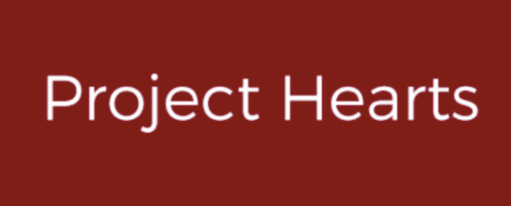

Background: Prior to being officially recognized as a Dominican NGO in 2011, Project Hearts existed informally in the personal service of founder Rubén Ottenwalder. After nearly 30 years away from his hometown, Rubén had followed the call to return to Baitoa and serve his neighbors in whatever ways he could. Often this took the form of providing food and clean water or building houses, but Rubén sought to meet all the needs he witnessed in his community. In 2007 GRACE Cares began partnering with Rubén, exponentially increasing his impact on the people of Baitoa.
Since 2011, Project Hearts has been refining its mission to ensure we are working in such a way as to truly empower our communities. For this reason, we are focused on addressing critical needs that fall into three primary categories: health, economic development & education.
Activities: 2017 has been a year of growth for the women in the communities of the Dominican Republic. The community health worker projects have grown and it have graduated 9 women. They have increased their agricultural program and it has been successful in their community where they want to expand their goals in 2018.
Future: In the coming year the community health workers plan to:
- establish a prenatal care unit
- promote healthy eating (demonstrating the crops they have produced) at major health fairs in the area
- integrate men into the community health leaders
- train 20 LICS, 120 couples of childbearing age and 100 pregnant women through their prenatal care
- work closely with local government health organizations to establish a referral system for patients as well as non-governmental health organizations and private for-profit companies to take advantage of their services, support, and knowledge and finds potential.
PH farming activities will include:
- creation of a “Dream Camp”
- establish farmers’ association in Baitoa
- increase educational awareness in schools about the benefits of increasing fruits and vegetables in their diet.
- encourage teachers and colleagues of schools for children to visit the Field of Dreams agricultural project
- order bee boxes to 30 to increase honey production
- sow approximately 1000 fruit trees
- teach 30 families to create their own gardens behind their homes where this can benefit over 120 people
- produce overall sustainability by providing all vegetables and fruits for community gatherings
- establish dialogue with other farming agencies for guidance and working cooperatively
- begin a breeding program for their livestock; sheep, goats and poultry. They will donate a pair of sheep to a family under the agreement that the family will, in turn, donate a pair of sheep in the future to another family.
Many homes in the area do not have a latrine or they are in poor condition. The WASH Program’s quest for creating sustainable solutions for sewage in their community in 2018 is to establish an additional 180 water tanks as well as distribute 100 filters.
The PH education program is expanding by:
- increasing awareness and create a program to lower domestic violence
- educating men in the community about their wives and women in general
- educating families on different ways to discipline their children and to use less violence
- training one man to be the liaison and guide for this program
- increasing home visits to 130 a week to the sick and disabled (5,200 visits a year!)
How to Plan my Life is a newer program that focuses on the teenage population. Their activities for the coming year are to:
- hire a coordinator to take this project forward
- support the integral education and health programs
- encourage youth leaders to come up with ideas to keep children out of trouble, for example, by establishing a cinema night
- increasing activities to lower boredom that gets young adults into trouble
- teach young girls about empowerment of their bodies and prevention of pregnancy
- teach young boys the meaning of “no” and not propagating the male dominance/domestic violence in their communities.
Administratively, PH is increasing their fundraising by holding galas and events to help their goals become reality.
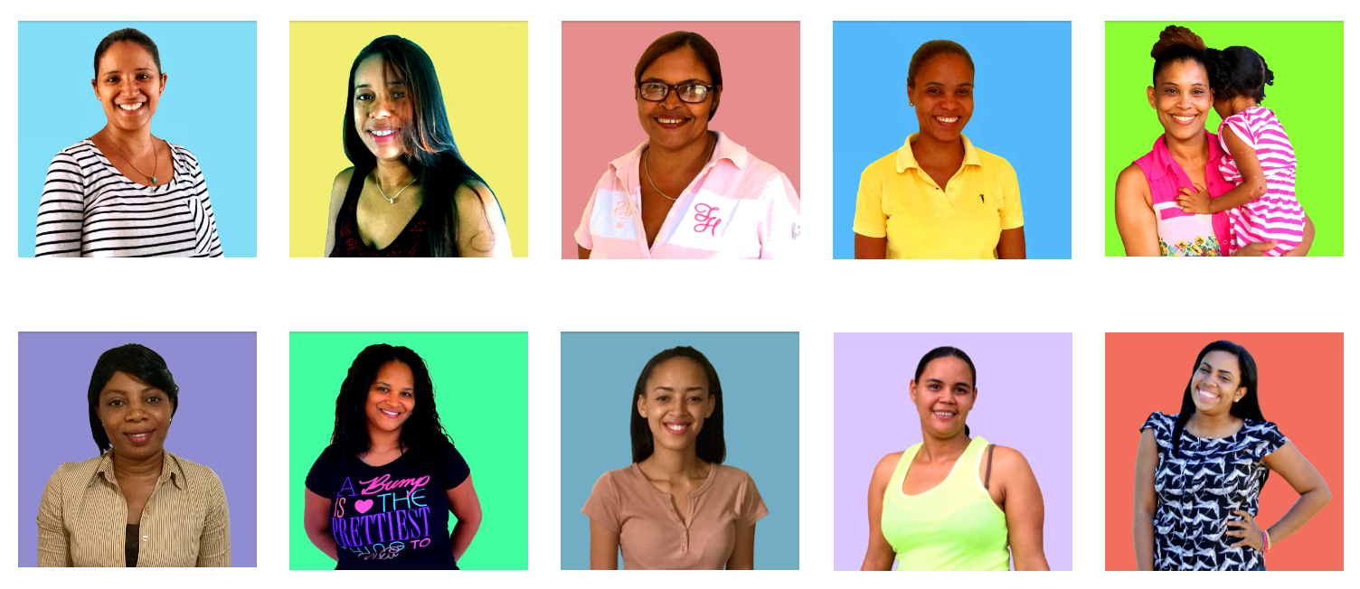
2017 Community Health Leadership Graduates

Background: Traditionally hunter gatherers are seldom documented. Gareth Roriston, a former Conservation Manager, will present on the Watha community of Galana, Kenya — their history, traditional culture, survival techniques, and current issues faced by the community as they homogenize into modern Kenyan society, at the potential expense of losing their history and cultural identity. In particular, the Watha's long history of elephant hunting as a way of life, in the face of the well-known crisis facing African Elephants today. The Watha are now a disenfranchised people.

Gareth is the process of creating a documentary to inform and develop interest in this essentially unknown or highly misunderstood culture. These days the misinformation and mystery isn’t limited to the outside world, but also the youth of this small tribe as they fall out of touch with their roots and heritage as a result of changing lifestyles and poverty. Proceeds from The Last Dance will be used to address maintaining the Watha’s sustainable traditional life and to address their health and education needs as they adapt to modern life

Activities: Gareth Roriston and local leader Guyo Badiva have teamed up to produce his documentary, The Last Dance, on the Watha tribe, a surviving community preserving the ancient Watha culture. With funding and advisory support from GRACE Cares, Guyo Badiva has incorporated the Watha Community Benefit Organization so that all documentary production benefits the Watha Tribe. Two shoots were completed in 2016, one in January and the second in October.

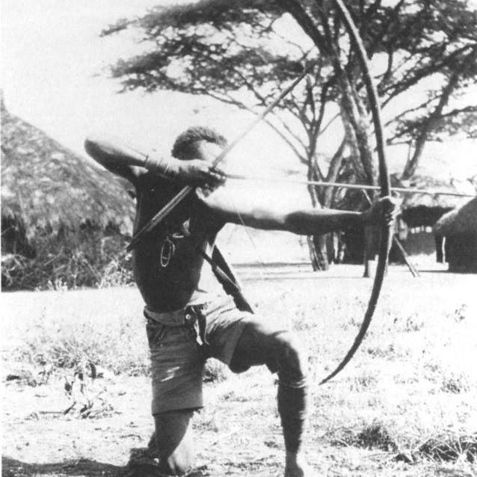
In this first shoot roughly two hundred community members gathered to take part. Traditional dances were filmed and explanations of their meanings were documented. Elders of both genders were interviewed about their lives and the sudden changes that have occurred regarding lifestyle as their traditional hunter-gatherer existence was outlawed. Some of these interviews will be used in the final film and those that aren’t will be catalogued and handed over to the community for their own archives.

The October shoot’s purpose was to capture the Watha doing what they are famous for; Understanding wildlife behavior. Footage of the Watha tracking and approaching elephant on foot was captured. The issue of elephant poaching by the community was a consistent theme along with strategies to resolve the issue.

Due to financial challenges and visa issues no trips to Kenya for filming were possible in 2017.

Future: Filming of the Last Dance is scheduled to continue into 2018. $50,000 are needed to finalize the documentary. Plans are in place for a third shoot whereby clear footage of the Watha approaching elephant will be captured. A small community living in another area who now subsist on small game and honey will be sought and interviewed. Issues of security and other relevant topics will be explored with this group.

Please follow these links to see sneak peeks of the Last Dance film.
Teaser 1: https://www.youtube.com/watch?v=60J3Xcx2z7s&t=1s Teaser 2: https://youtu.be/wkbxi-wwamQ

Follow the Last Dance documentary journey at their Facebook page: https://www.facebook.com/Watha.Info/
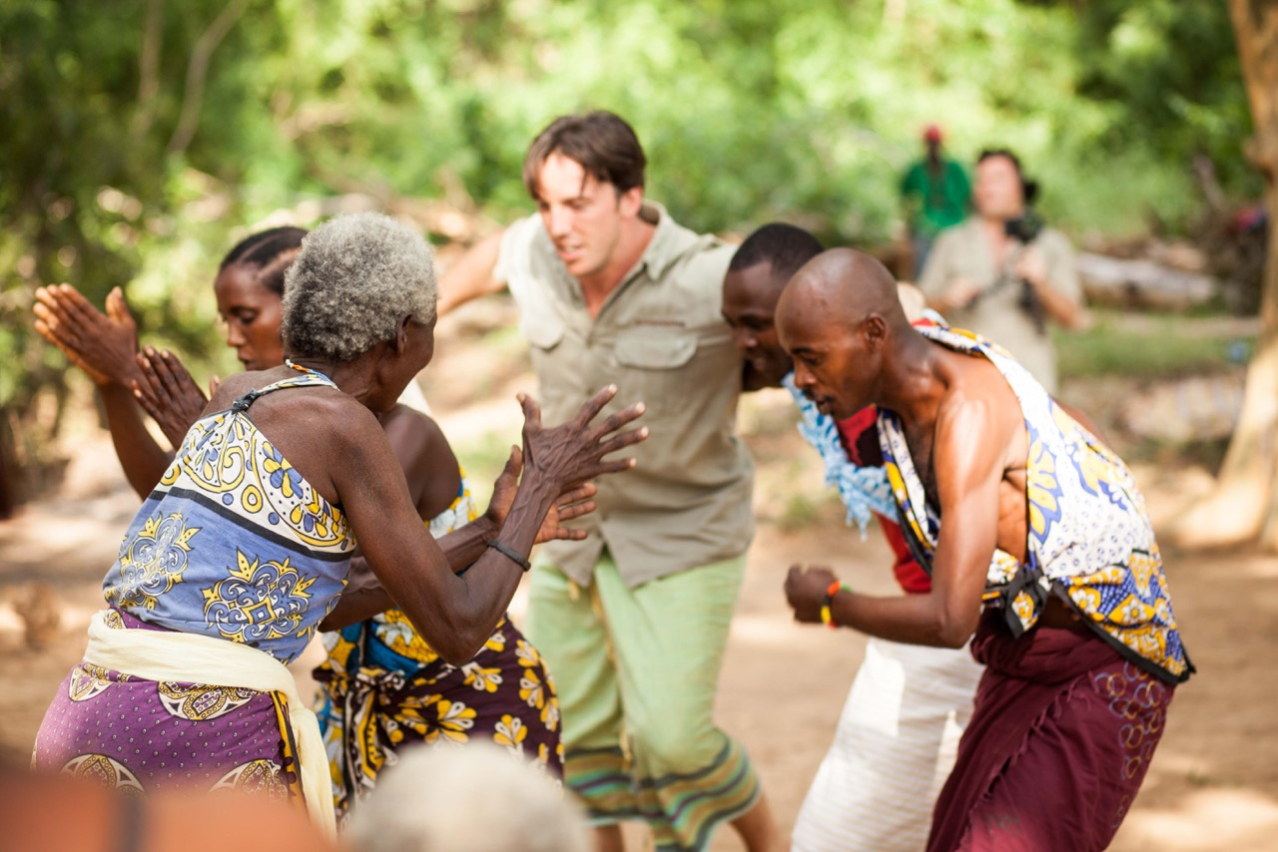

In 2017, GRACE Cares had a total operating budget of $188,368.46 received from donations. We gratefully received $47,918.91 in individual donations, $24,569.55 in corporate donations, and other major donations received equaling $115,880.00. Our total expenditures in 2017 were $173,373.64.

We are proud to say that $160,996.55 of our income went to programs. That is, 92.9% of expenditures went directly into our programs. Of the remaining expenditures $12,376.99 went to administrative, management and contract costs.

Our detailed financial review is available upon request at info@gracecares.org.

We are grateful for the generosity of our 2017 donors and volunteers as well as our Corporate, Organization, Foundation and Matching Donors

Zoya Abdullah  Asmal, AC  Mohammed Bajwa  Tamara Bavendam  Jane Berndt  Bachir Berrachedi  Elizabeth Block  Carol Bowen  Maggie Bruno  Justin Bullard  David Bumpus  Canton High School  The Colorado Trust  CVS Caremark Charitable  Nancy Csuti  Ann Desmarais  Ruben Diaz  David Dinius  Marissa Doiron  Thomas Downs  Ellen Eiseman  Endpoint Outcomes  Christopher Evans  Muhammed Enayetullah  First United Methodist Church  Michael Fitzgernald  Fundraiding Event  Dean Gallea  Cristobal Garcia  Masyn Garcia  Sergio Garcia  Kenneth Giancola  Roger Gillette  Glenn Godbold  Dorothy Goldberg  Darren Graves  Seema Haider  Mohammed T Haq  Opal Hawkins  Maria Heller  Susan Hebson | Linda Hirsch  Jennifer Hoffman  Laurel Hoffman  Paul Hoffman  Islamic Center of SW FL Inc  Christian Jaffe  Vina Virendra Joshi  Rasheed Kahn  Susan B. Kahn  Kemblesville United Methodist Church  Brian Kolak  Susan Zoe Kopp  Sandra Wilcox Kuritsky  Cindy Levine  Matthew H Liang  Francis Lutz  Tazin Mahnaj  Lamessa Mallic  Jody Massey  Amelia McCracken  Richard Miller  Muhammed Mir  David Moczulski  Rookshana Moosuddee  John Moretto  Tabinda Mubarak  Mohammed Munir  Scott Murray  Thom Namaya  Nappanee Missionary Church  Network for Good  Alda Ottenwalder  Elizabeth Peets  Pfizer  Patricia Pinckney  Paypal Giving Fund  Anna Plank  Charlotte Pollard  Areeba Rawalla  Reem Property LLC | Naeem Rehman  Norman Roberge  Mohammed Sabbagh  St. Joseph’s Abbey  Yasmin Sarwar  Lori Schreier  Schwab Charitable  Diane Schwartz  Uroosa Shah  Manell Shannir  Carolyn Smith  South Millwood Amish Church Dist. 92  Joyce Sullivan  Edward Suttor  Jon Thatcher  Steven W. Timmermann  Jill Tran  Deborah Tweeksbury  Duane Walters  Farida Yaqud  Syed Zafar  Ali Zaidi  Cathy Zouval

