Content of the document

- Profile of the organization
- Outline business plan of the project
- Budget of the project

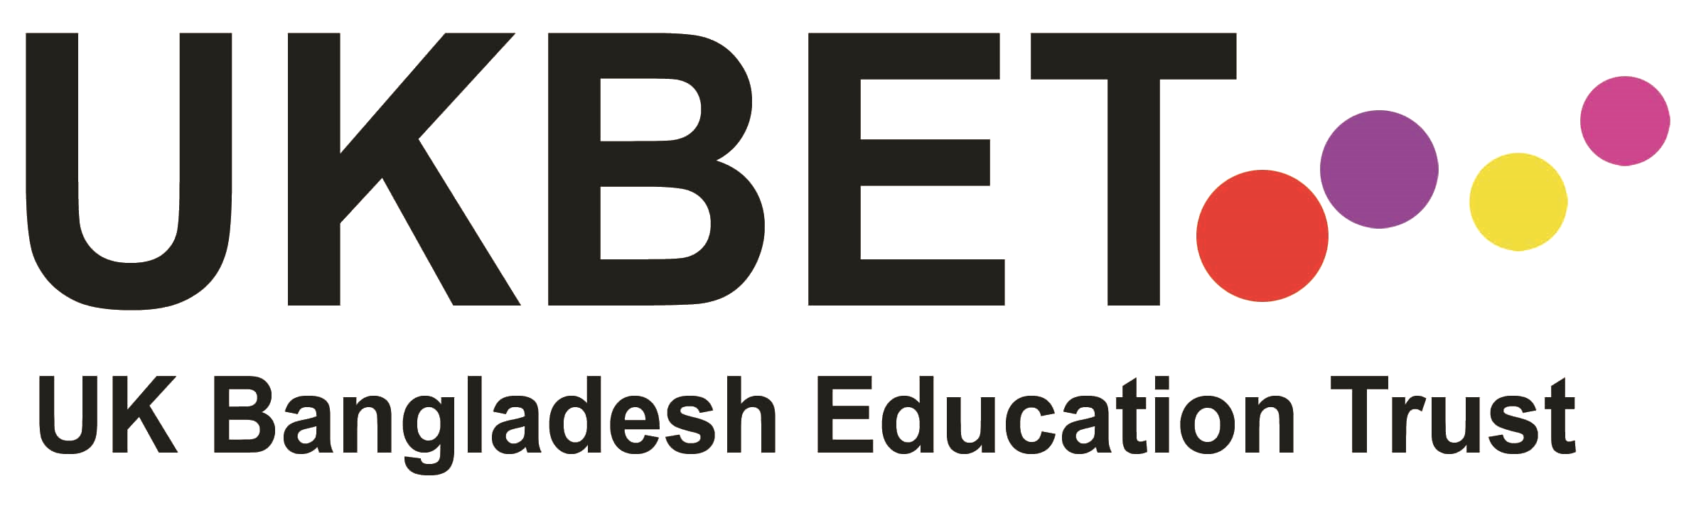
Who are we?
UKBET (UK Bangladesh Education Trust) is a UK registered charity and registered international NGO in Bangladesh. We have been working in Bangladesh since 1993.
Vision
The UK-Bangladesh Education Trust seeks to contribute to the relief of poverty, social injustice and exclusion from mainstream society in Bangladesh through innovative programs run in partnership with local, national and international organizations, funders and individuals.
What we do
At present we have four main Programs:
- UKBET’s Programs for Working Children: This project works for the education and rehabilitation of the children working in hazardous occupations. 1.2 million children in Bangladesh are engaged in different types of hazardous works everyday risking their lives and having injuries very often.

- Doorstep Learning Project: In Bangladesh many thousands of young girls work in domestic labor - most have no access to education. This innovative project sends Fieldwork/Teachers into the homes where children are working to teach them basic education and life skills.

- Teacher Training Programs: Our English Language teacher training programs are support English language teachers in government schools and are organized in partnership with expert teacher trainers from Learning Unlimited and St. Giles Educational Trust, UK.

- Book Reading Program: This program is run in partnership with the British Council to motivate school students to read.

Governance and Management:
There is a Board of Trustees in the UK and a Local Advisory Board in Bangladesh. Their role is to have general oversight of the direction and management of the work of UKBET. The staff team in Bangladesh is led by M A Sayem, Executive Director.

Background Paper and Outline Business Plan
Project for the children engaged in hazardous works

This Project provides education and rehabilitation for 100 Children engaged in different types of hazardous labor in Sylhet, Bangladesh. Working conditions for these children are appalling and illness and injury are commonplace.
In line with national policy and local need, UKBET’s Program provides basic education, support to families and improved safety at work. The approach is holistic involving all primary stakeholders - children, parents, and employers of children, government agencies, NGOs working on this issue as well as education providers and local influencers.

Major activities include:
- Setting up of 2 “Centers for Working Children”. These will be multi-purpose classrooms in a location where the density of children engaged in hazardous work is high. The education sessions, awareness programs for parents and employers, health and safety workshop and other associated activities will be held in these Centers.

- Children recruited will attend education and life skill sessions three days a week for one and half hours each day. A customized curriculum of basic education and life skills has been developed and is delivered by trained fieldworker/teachers.

- Many of the children are malnourished. They will receive Tiffin, a nutritious snack, after each session.

- Persistent illness and lack of adequate medical attention is a critical issue for many children and their families. Children and their families will have access to monthly free medical camps provided by local doctors and nurses.

- Entertainment and sports programs will be organized to motivate the children.

- The families of the children will be visited regularly by Fieldworkers/Teachers to tell them of the progress made by their children and learn of their wider needs. During these sessions help will be given in enrolling any younger children into school.

- Families will also be told of interest free small loans provided by Friends of UKBET and also referred to other NGOs and agencies for help as appropriate.
- Employers will be invited to attend an Awareness Programs including health and safety workshops with the objective of making their workplaces safer and confronting child labor issues.

- Each Centre for Working Children will have a 4 year life after which time it is anticipated that locally employed children will have been supported into mainstream schools, progressed to a Vocational Training Centre or moved into Non-Hazardous employment.

Human Resources:
- UKBET’s Executive Director, supported by the Deputy Manager take overall responsible for the Program. They review activities and data, control expenditure, monitor quality standards and provide regular reports to donors and Trustees.
- A Field Supervisor, reporting to the Executive Director, is responsible for 5 Centers, supporting and supervising the work of Fieldworkers/Community Teachers. Communication, coordination and standards are supported through regular team meetings.
- One Teacher and field organizer for each of the center, responsible for teaching and overall operation of a center working for the children, their families and the employers.

Finance
UKBET has had the opportunity to build the capacity of its local team in Bangladesh in relation to meeting the rigorous expectations and requirements of external funders, including project monitoring, regular reporting to external funders, working to agreed budgets, maintaining accurate evidence and records of all project spend, providing monthly finance reports and meeting Home Office and European audit requirements. Existing robust systems would be used to monitor and report project spend as required by Global Giving.
A spreadsheet outlining expenditure for this Project is attached.

Quality
UKBET is committed to ensuring the Project achieves its aims, objectives, milestones and targets in full and within budget and that ‘lessons learned’ can be assessed and disseminated on an on-going basis, as well as at the mid-point and the end of the project.
Impact evaluation is recognized as a vital feature of the project’s work: monitoring and evaluation are embedded within the structure of the project, actively involving all stakeholders and ensuring that all monitoring and evaluation requirements are met in full. UKBET has an MOU (Memorandum of Understanding) with Shah Jalal University of Science and Technology, Sylhet, Bangladesh, who will be involved in the evaluation process to ensure a rigorous and independent perspective.
Both quantitative and qualitative data will be collected and will include:
- Number of working children enrolled each with a standard initial assessment and profile
- Numbers of sessions attended
- Progress against baseline skill assessment in reading, writing and numeracy
- Increased confidence in personal and social skills against initial assessment
- Number of children progressing to statutory education or vocational training or non-hazardous employment
Evidence from these and other key indicators will be collected will be analyzed and reviewed with input from all stakeholders including direct and indirect beneficiaries of the Project. Lessons learned (which may include for example, elements which worked well, areas for improvement) will be shared via the dissemination activity and will be used to inform each stage of the project, as well as the planning of future projects

Governance
UKBET is a registered charity in the U.K. and registered as an NGO with the Bangladesh NGO Bureau. The Chair of the Trust Board is Annette Zera who receives monthly reports from the Executive Director. The Board meets 3 times a year and publishes audited accounts with the UK Charity Commission.

UK Bangladesh Education Trust (UKBET)
Budget of the project for the children engaged in hazardous works
Budget Heads | Costing Type | Cost per unit in USD | Total costing for four years in USD
Human Resource
Salary of teacher and Field organizer USD 1600/year. (One position for each of the center). | Recurring | 1600 | 6400
Partial Salary of Field Supervisor USD 600/year | Recurring | 600 | 2400
Partial Salary of Project Leader USD 600/year | Recurring | 600 | 2400
Material for set up of Center for working children
Venue rent in including maintenance USD 45 per month, 48 months | Recurring | 45 | 2160
Initial set up- Carpet, board , light , fan etc. | One time |  | 200
Education Material |  |  | 0
Books, Exercise Book, Bags, Pencil, Pen, Other material for per child per year USD 10.00, 50 Children in one center for working children | Recurring | 10 | 2000
Tiffin for children - USD 15 per child per year, for 50 children | Recurring | 15 | 3000
Basic Medical support for children. USD 5 per child per year | Recurring | 5 | 1000
Health and safety workshops, Materials
First Aid Kits with Training on First Aid. USD 25 for one person, 30 persons will be trained | One time | 25 | 750
Safety Materials Shoes, Gloves, Mask, Glasses etc. USD 25 per person, for 50 person | One time | 25 | 1250
Awareness Campaign
16 Health and safety workshop/ awareness program over four years for the employers. USD 45 for one program | Recurring | 45 | 720
16 awareness Programs over four years for the parents. USD 45 for one program | Recurring | 45 | 720
Material for campaign - banner. Leaflet etc. | One time |  | 300
Costing for Children's Family Visit by teachers - USD 15 per month for 48 months | Recurring | 15 | 720
Admin Costing
Office costing (Shared) USD 20 per month, for 48 months | Recurring | 20 | 960
Total costing of one "Center for working children" for four years of life span. One center will work with 50 working children, their families and their employers |  |  | 24980
Costing for 2 Centers for working children. |  |  | 49960
Cost per child(2 Centers will work with 2*50=100 Children) |  |  | 499.60

For clarification or further information please contact:
Annette Zera, Chair- Board of Trustees, UK az@annettezera.uk
Or
M A Sayem, Executive Director, Bangladesh sayem@ukbet-bd.org

