SUNI-RIDGE SAND FOREST PARK ENVIRONMENTAL REHABILTATION CENTRE
WILDLIFE EMERGENCY TREATMENT
&
RECOVERY STABLES WITH BOMA/PENS

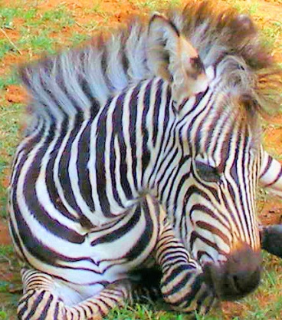

The concept plan includes, but is not limited to the following general guidelines: A detailed budget is available on request.
1. BOMA PENS
Poles, concrete, pole wire, fencing wire, sliding gates, ramp, delivery of poles.
The pole fenced structure area is based on best design options with professional guidelines being applied. It includes a ramp for offloading from a truck, an outdoor shelter, water points and troughs and feeding troughs and entry gates.
Structure criteria:
The structure would be treated timber poles anchored in concrete and laced with 4mm wire. Treatment options of the poles are included as recommended by the University of Pretoria, Onderstepoort Veterinary Institute – Wildlife Department. The top of the pole fencing would have extended predator proof electric fencing.
Size of the boma is 15 X 20 meters.
Poles
Concrete anchors for poles
Wire - lasing for poles
Electrified extensions on the top
2 wide sliding gates, one narrow suited to offloading animals

POLE BOMA CONTINUED…./

Ramp
Delivery of items will be provided by suppliers
Labour: 2 weeks for 4 persons
It is assumed that the timber fencing could be erected in 14 days from date of delivery of material.

2. OUTDOOR SHELTER
Roof, support poles, troughs
Timer quantities are included and estimated with the Boma/pen poles.
Roof:
The roof would be comprised of cromodeck roof sheeting
A concrete drinking water trough with tap on hand water and feeding trough
Concrete, cement and stone
Plumbing with water supply pipe work and tap Concrete, cement and stone
Labour. 2 days for 2 persons

3. INDOOR STABLES AND WILDBABIES NURSERY
The Indoor stables would be comprised of brick walls, windows, roof, 6 entry doors, 4 exit doors into pens, floors, lights, temperature control.
Size 2.5 x3.5 - It is proposed that three stables are erected.
The stables would be comprised of concrete blocks, treated timber and a concrete floor with a drain.
There would be a "stable door" at the front entrance and a sliding opening at the back of the Stable to enable loading from the back and access from both front and back.
Each stable will lead through a gate into its own pole enclosure and then out into the larger enclosure
There would be a shade cloth /mosquito proof window/opening of 2M X 1.5M
Timber is included in Boma estimation.
Gates from pens into outside boma (4)
Poles for pens
Concrete floor and drain
Rroof sheets - cromodeck
Mosquito proof/shade cloth/windows.
Lighting
Temperature control
Labour 1 month for 4 persons

4. KEEPER'S ACCOMMODATION AND FEED ROOM
The Keeper's accommodation would be constructed from concrete blocks, Cromodeck Corrugated Roofing and a concrete floor. The room will be furnished with Curtains, a bed and bedding, a floor mat, side table, bedside lamp table and chair, cupboard and mirror. There will be an adjoined shower, toilet and basin. The feed room will be separate and will have an entry door from outside. The feed-room will have a lockable cupboard and table with a water basin.
The accommodation approx. 25 m2
Corrugated Roofing
Concrete floor
Shower
Toilet
Windows to be positioned in toilet and feed room.
3 "Stable doors" (doors that open separately top and bottom) - 1 in feed room 1 in accommodation & 1 in toilet/shower room.
Furnishing including cupboard, table, chair, bedside table, lamp, floor rug, curtains, bed for accommodation
Labour 1 month for 4 persons
Management - Tools, equipment, power, consumables and salaries.
Contingency 10%

