PROPOSAL FROM CALCUTTA RESCUE

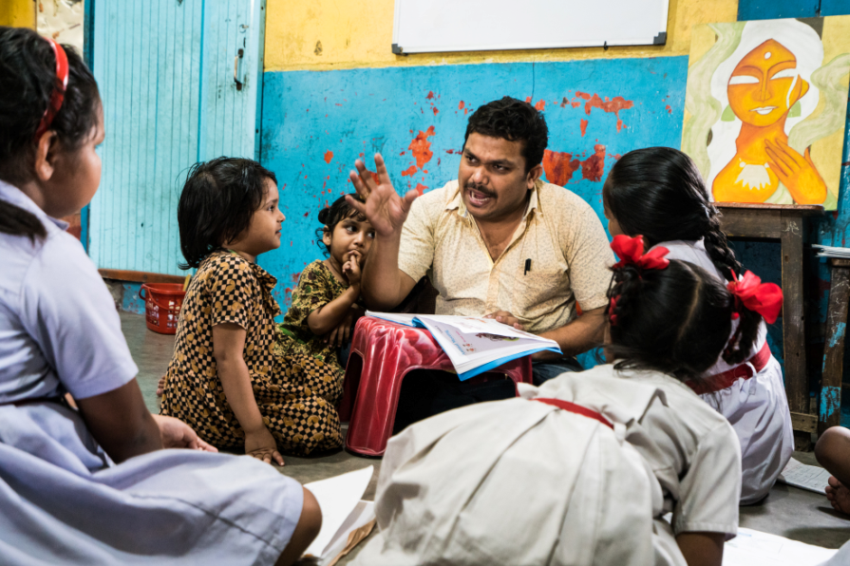

Submitted By: Calcutta Rescue

- About Calcutta Rescue
A.1. Our Mission
Calcutta Rescue works to significantly enhance the well-being, learning and living standards of the poorest communities in and around Kolkata. We only work in areas of high need where there is inadequate provision by government, non-profit or private organisations.

We initiate alliances and work collaboratively with others to ensure we deliver quality services to these communities. We also provide specialist healthcare assistance for impoverished people approaching us from other districts where such services are deficient.

A.2. Genesis of Calcutta Rescue
Calcutta Rescue (CR) is an Indian charity providing health care and education to the people who are economically most disadvantaged and socially most disfavoured in Kolkata and West Bengal. British physician, Dr. Jack Preger, began his work on the pavements of Kolkata 40 years ago, and established Calcutta Rescue as a registered Society in 1991. Since then it has grown to over 150 Indian employees serving over 17,000 impoverished and destitute people through our health clinics and providing education and nutrition to over 650 children in our two education centres. In addition, our arsenic-free filters ensured that 12 villages could access clean drinking water; and our Handicrafts project provided a livelihood to 40 poor individuals. We do all of this on an annual budget of less than Rs. 8 CR.

The particular strength of CR has been to focus on the people who are helped by none and to “rescue” people from the consequences of ill-health, illiteracy and poverty. This includes providing good healthcare, quality education for children and development of skills which would ultimately lead to employment opportunities and a stable income.

B. Our projects

B.1. Health clinics
Calcutta Rescue’s health programme aims to help the most vulnerable and disadvantaged people in Kolkata and rural West Bengal to get the medical treatment they desperately need. We presently have four fixed clinics providing treatment and medicine for all types of common ailments including specialized treatment on HIV, TB and Leprosy. Individuals from all over the state visit these clinics and come from as far away as Jharkand and deep in the Sunderbans.

B.2 Street mobile clinics
The two street medicine mobile clinics of Calcutta Rescue provide medical care to 20 slum communities in Kolkata. The doctors and the healthcare team visit the slums and street dwellers all over the city. The clinics are run from the back of mobile vans, which has basic medical equipment and a stock of drugs for common ailments.

B.3 Education centres
There are two education centres of Calcutta Rescue located in north Kolkata which serve street and slum children. These centres provide educational facilities in a safe environment, two nutritious meals a day, medical and dental care, counselling and social worker support and recreational facilities. Another important component is that students are also provided with vocational training wherever necessary

B.4 Handicrafts project
Calcutta Rescue’s handicrafts unit manufactures beautiful handmade products, using recycled materials like old saris. The artisans are ex-patients and school dropouts who otherwise would struggle to make a living or would even have to beg to survive.

B.5 Safe drinking water
West Bengal has the highest number of arsenic-contaminated areas in India, more than double any other state. Since 2003 we've installed arsenic-removal filter taps in 12 villages in Malda district, 300 km north of Kolkata. These taps provide families with clean, safe water so that future generations aren’t slowly poisoned by arsenic, which can cause diseases all over the body, as well as intestinal and neurological problems.

C. Our achievements and awards
- Calcutta Rescue was awarded Platinum rating by Guidestar India - highest level of recognition for transparency and public accountability for 3rd year running.
- Calcutta Rescue became an empanelled partner of the Tata Institute of Social Sciences (TISS) National Corporate Social Responsibility Hub.
- Our founder, Dr Jack Preger, was named Philanthropist of the Year at the Asian Awards in London in 2018.
- Dr. Jack Preger was also inducted into The Telegraph Education Foundation Hall of Fame – a rare honour reserved for the state’s greatest educators.
- Calcutta Rescue received the Jhumar Mal Bachhawat memorial award from Rotary Calcutta for Exemplary Contribution for the education of underprivileged students.

Supporting education programme

D. Background
D.1.Status of education in Kolkata Slums
Many children (both boys and girls) living in the slums and on the streets of Kolkata do not go to school. When they do, they often lack access to the necessary conditions – both material and social – to successfully continue their studies. Many are from single parent homes and many live in environments where alcohol, drugs and physical and sexual abuse are unfortunately commonplace.

In India half of class V children still cannot read a class II reading book. The same is true for numeracy attainment. For children coming into Calcutta Rescue, attainment levels are even lower due to the fact that we are helping the most vulnerable and underprivileged children in society. Without education in a safe and secure place, these children have little hope of escaping the poverty trap. That is why at Calcutta Rescue we are so focused on the basics –
numeracy and literacy – and ensuring our children have a happy environment to study. If children read well, they can learn history and geography. If they are good at maths, they will be better at science and computer programming. Of course, academic success is directly correlated to children having fun and having a safe and comfortable place to learn. Our programme focuses on learning through playing and using audio-visual techniques, as well as traditional teaching methods

D.2.Calcutta Rescue’s Intervention: The Education Centres
We run two centres (supporting around 700 children), which aims to support children living in the slums and on the streets to get a good education. We provide a stimulating learning environment, and we give children the materials, such as uniforms and books, bags, shoes and socks, all stationeries etc.
After providing a solid foundation through our carefully crafted preschool education, we send all our children to good formal government schools from the age of six. They get complete financial support from us throughout their academic life. Not just that students who do not pursue academics are also trained and put into different vocational stream. Our vocational training manager continuously works with the students on this aspect. Our teachers ensure that students truly understand concepts in maths, are able to master their own language (Bengali or Hindi) and are competent in English. In the time they spend at our centres, students can do their homework, join computer lessons and take part in extracurricular activities, such as art, craft, dance, drama and sports.

All children receive two meals per day, which have been carefully formulated to ensure they are exposed to a balanced diet. In addition new clothing is provided at the time of Durga Puja and sweaters before the onset of winter.

Due to the very difficult home environments where our children live, Calcutta Rescue employs a counselor and social worker to deal with some of the more complex issues – with the objective of enhancing the child’s and his/her family’s well-being. These are services which are scarcely available in the government system.

In FY18-19, we were incredibly proud to win top prize in the ‘A School That Cares’ category at the annual Telegraph School Awards for Excellence. Five other schools were nominated, and four of these were leading fee-paying institutions, so bearing in mind the difference in our budget, it was a fantastic achievement.

E. Objective
- To mobilize and motivate children from the slums and put them firmly on the track of literacy through quality education and by providing them with an environment that supports education.
- Provide high quality relevant education through our learning centres.
- Encourage and enable each child to become an independent thinker and self learner.
- Make learning joyful
- Help transform community

F. Activities
- Remedial classes for all students
- One-on-one and group-based mentoring
- Targeted material support such as provision of school fees, uniforms, supplies, or transportation for children who would otherwise be unable to continue their education.
- Nutritional support, therapeutic support, basic health care support and vocational training support
- Counselling of the students and engagement of families, schools, and communities to help drive sustainable change.

CR will closely monitor each child’s progress through his/her life skills session attendance and academic performance.
G. Output and Outcome
G1.Output:
- Better performance in school
- Reduced/eliminate dropout amongst the children
- Greater engagement of parents
G.2. Outcome
- shift in community attitudes and steadily strengthening of local support for children’s’ education.
- Children developing strong life skills such as self-confidence, creative problem solving, and perseverance
- Seeing students from our program completing education successfully

H. Funding details
Budget head | Per unit cost/yr (INR) | Remarks
Rent, electricity, taxes and maintenance of the education centre | 1,062 | A premises is hired, where these children are taught, food is cooked and all related activities takes place here
Books and stationeries | 3,753 | All children are provided with books, copies, pens pencils etc. A stock is purchased twice a year and maintained at our education centres for distribution
Computer expense | 40 | Children are made to sit separately on PCs and practise during their computer classes
Uniforms | 647 | All students are provided with their school uniforms, shoes and socks and sweaters during winter season
Teacher's expense (training expense also included) | 7,200 | Language, maths, computer and activity teachers are engaged for the students. Here 3 teachers expense is being considered @ 10000/- per month
Printing, xerox, communication and magazine purchase expenses | 55 | Students are given study materials as required
Student's activity expense | 129 | Students are taken to various places to emphasise studing by doing and creating maximum impact
Social awareness programme | 95 | Various annual events and social awareness programmes are organised to make it a joyful learning
Transportation | 1,414 | The students are brought to our educational centres and again dropped back home. This is done to eliminate dropouts
Health support | 282 | Students are provided with regular health checkup, dental checkup. Medicines, soaps to maintain hygiene
Nutritional Support | 4,844 | Students are provided with breakfast, lunch and an evening snackes. Their diet is based on their nutritional requirement and as prescribed by our doctors
Cleaning, cooking, helpers and maintenance expense of centres | 1,137 | A group of support staff does the backend work like cleaning, cooking and maintenance of the centre, so that our children can study in a proper environment. Helpers are engaged to bring the students to school and back to their homes.
Asset depreciation | 35 | For computers and other study equipments used in the centre
Programme Total | 23,658
Overheads | 2,839 | (includes monitoring, supervision and documentation and reporting cost
Grand Total | 26,497

General Information
Organization Name: Calcutta Rescue
Address : 85, Collin Street, Kolkata – 700 016, West Bengal, India

Contact Person within the organisation
Name : Sibani Basu Sen
Designation : Head Fundraising
Address : 85, Collin Street, Kolkata – 700 016
Phone No : 9830361790
Fax : (033) 2217 5675
Website : www.calcuttarescue.org
Annual Report : http://www.calcuttarescue.org/en/what-happened-201819

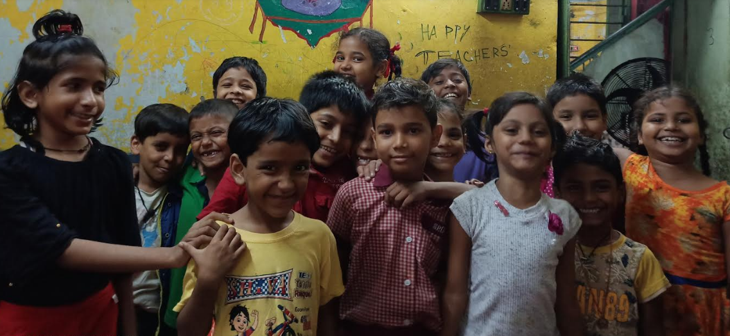
THANK YOU

THE SLUM IS THE MEASURE OF CIVILISATION – JACOB AUGUST RIIS

