


A THREE MONTHS COMPREHENSIVE SUSTAINABLE MENESTRUATION MANAGEMENT TRAINING HELD IN MPIGI DISTRICT;MAY - JULY, 2016
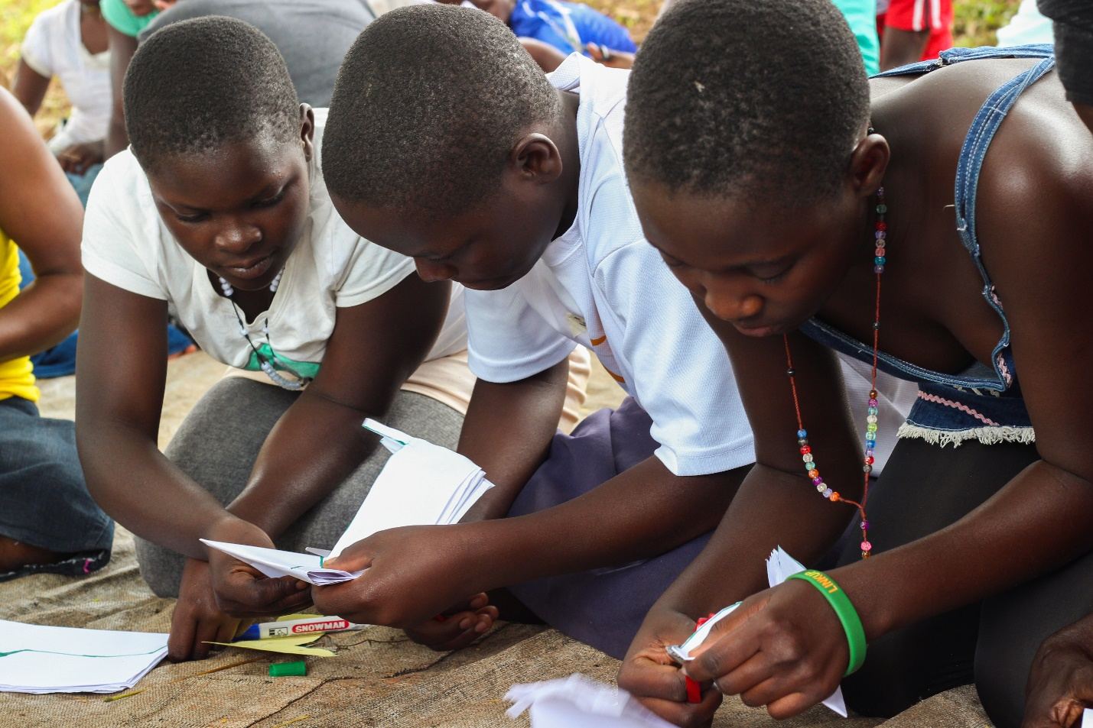

SUPPORTED BY NOURISH INTERNATIONAL-UNC CHAPEL HILL

Acknowledgement
Having completed the three months comprehensive menstruation training in 11 centers in Mpigi District, I would like to express my deepest appreciation to all those that have participated in planning and implementation of this project. Your contributions stimulated suggestions and encouragement that helped me to coordinate this project especially during implementation process. Furthermore I would like to acknowledge the crucial role of the Mpigi District leadership and management team for their continuous support and guidance in coming up with innovative ideas and giving strategic direction to the project.
Nourish International is credited for its commitment in supporting the project with funds worth $5635 which enabled us purchase training materials, pay the trainer who trained Mountains of Hope staff and the four interns, cover transport costs of trainers, make mobilization in communities, and pay for meals of trainees, thanks also for the four (4) interns that helped during implementation of the project. Through your support we have helped meet the needs of the community, but also forge a favorable working partnership that is geared towards implementation of community based sustainable projects for transformation of the community.
We are also grateful to Mpigi community, village leadership, the local administration, Religious leaders, school administration, traditional leaders, opinion leaders, various stakeholders and the entire community for their collaboration and support during implementation, some of them offered free training venues and others did mobilization work in their communities.
The participation of other stakeholders like schools, community leaders and their support during implementation and planning processes is appreciated. Gratitude is also due to community membersfor their involvement in the prioritization, problem analysis, and visioning plus reflection exercises.
Special thanks goes to the Nourish UNC Interns and the entire Mountains of Hope big team who helped me assemble the parts and gave suggestions. Below is the list of the Mountains of Hope big team that carried out the project:
1. James Malinga, Mountains of Hope Director
2. Lilian Malinga, trainer
3. Anyait Caroline, trainer
4. Mercy Amuron, trainer
5. Sammex Senabulya, trainer (present only at the first training)
6. Lukwago Joseph, intern/trainer (present beginning 10 June 2016)
7. Julia Wilson, intern/trainer
8. Giulia Curcelli, intern/trainer
9. Jessica Trujillo, intern/trainer
10. Abbey Cmiel, intern/trainer
You are all appreciated for your patience and overall support towards these entire processes.

Affirmation
This is to affirm that unless as acknowledged by the references and quotations from other authors indicated in this document, the information contained herein represents work under taken during implementation.

Author:

James Malinga
Executive Director
Contact: 256772413465/256701413465
Email: info@mountains-ofhope.com
Website: www.mountains-ofhope.com

Introduction
Mountains of Hope Children’s Ministries (MOH) is a non-profit NGO working in Mpigi, Uganda to empower marginalized rural communities regardless of race, ethnicity, gender, or faith. The organization addresses the basic needs of vulnerable children and their communities, including healthy food, maternal health, sustainable farming and financial trainings as well as distribution of water filters, school scholarships and more. By making each of these resources available, Mountains of Hope strives to expand access to jobs, education, healthy food, and healthcare to comprehensively improve the lives of each person they work with.
One prominent piece of the work Mountains of Hope does, and the focus of this report, is Comprehensive and Sustainable Menstruation Management Trainings. In order to address the multifaceted issues surrounding menstruation, Mountains of Hope created a menstruation management and pad-making training. The 10 week concentration on menstrual health was funded by Nourish-UNC, a branch of the nonprofit organization from the United States, Nourish international. The Mountains of Hope staff, in partnership with four interns from Nourish-UNC, has now hosted trainings at 11 community centers for over 600 individuals.
The current issue:
In many cases, schoolgirls are told they can't come to school when they are on their periods. In other cases, they don't have enough money or are afraid to ask their parents for pads and are so fearful of bleeding through that they skip school or other activities. Many girls and women ask their male friends or neighbors for pads in exchange for sex, which leads to HIV spread and early pregnancy, keeping girls out of school. Furthermore, many of the girls we work with felt pressured to find boyfriends or husbands who can buy pads for them.
Inadequate access to pads isn't the only issue forcing girls to marry early or drop out of school. Many community-wide issues also inhibit what girls can do on their periods. For example, many schools and churches don't have clean and safe places for girls to use, preventing them from changing their pads. Also, many schools fail to teach about menstruation or teach inaccurate information. As a result, girls are afraid when they get their periods for the first time and boys taunt or tease girls who are on their periods rather than support them. Furthermore, a girl's siblings or family will not understand that she needs more time to bathe and wash her pads (if she uses a reusable one) when she is on her periods and will become extremely frustrated when she uses extra water or can't complete all of her household chores.
Mountains of Hope believes that in order to make sustainable change the entire community must be knowledgeable and involved in menstruation management. It is not just the role of the girl or woman to care for herself while on her period. It is also the responsibility of her siblings, parents, teachers, and government leaders at all levels to make sure she has the resources to remain safe, clean, and healthy while on her period.
The Comprehensive and Sustainable Menstruation Management training was strategically called to respond to the challenges girls face during their menstruation.

Objectives:
1. By the end of the training, participants should be able to understand the definition of menstruation.
2. By the end of the training, participants should be able to differentiate the myths from facts of menstruation.
3. By the end of the training, participants should be able to collectively manage menstruation very well at all levels, i.e. home, school, church, health centers, during sports activities, etc.
4. By the end of the training, participants should be able to make their own homemade reusable sanitary pads.
Each team member helps to inform and engage the community in conversation about menstruation and assist participants in creating re-useable sanitary pads.
Prior to each training, Mountains of Hope team reaches out to a local leader such as a school teacher or religious leader to mobilize community members. We hope the local leaders become a contact for future actions to improve access to and knowledge about menstruation management. Only when a local individual takes this role can the project be truly sustainable because these leaders can inform and mobilize more of the community in future work.
Mountains of Hope also believes the trainings only make a lasting impact when the whole community, not just women and girls, take responsibility for menstruation management. Currently, most men believe that periods are only an issue for women to deal with and neglect their responsibility to help women and girls on their periods. For example, many refuse to purchase sanitary pads for their daughters or wives. For this reason, we include men and boys, in addition to women and girls, in the trainings. This ensures that all attendees are knowledgeable about menstruation and how to manage it.
Once the participants of the training arrive, we begin the day by inviting the community leader to speak, introducing the team, and leading a short prayer.
Next, we encourage participant involvement by asking their expectations for the training. This practice gives the team an understanding of how interested partisans are, how knowledgeable they are about the training, and what specific interests they may have. We then conduct a survey to measure the community's current involvement with and knowledge about menstruation, as well as how well it is managed among participants.
The team then teaches and starts conversation about the three pieces of comprehensive and sustainable menstruation management: Meaning, Myth, and Management of menstruation
Participant’s expectations
Expected to learn how to make pads.
Expected to learn about menstruation
Participants expected to learn more skills on menstruation management
Expected to learn how to make pads.
Expected to learn about menstruation
Participants expected to learn more skills on menstruation management.
The participants expected to learn how to make sanitary pads.
The participants expected to get materials for making sanitary pads.
The participants also expected to learn on how to make soaps.
Expect to learn what we are going to study expect to put in practice what they are going to learn.
Expected allowance
Expected to get certificates after the training
The participants expected a work shop on development.
The participants also expected to get new ideas on how to make money out of the training.
Attendance for all the training centers.
Women | Girls | Men | Boys | Total
208 | 199 | 54 | 72 | 533

The table shows the pretest exercise in all eleven training centers this involved asking the participants questions carefully and telling them to stand up if they fell in that category.
Question | men | Women | boys | girls | Total response
Stand up if you know the meaning of the ward menstruation? | 24 | 62 | 15 | 38 | 139
Stand up if you have ever gone through menstruation | 0 | 131 | 0 | 48 | 179
Stand up if you have ever seen a sanitary pad | 15 | 112 | 15 | 137 | 284
Stand up if you have ever bought sanitary pad | 21 | 83 | 7 | 70 | 181
Stand up if you have ever asked for a sanitary pad. | 1 | 49 | 4 | 31 | 85
Stand up if you have a safe place to bath and change your pad at home, school, church, health center. | 0 | 43 | 0 | 27 | 52
Stand up if your father or husband supports you access sanitary pads | 0 | 41 | 0 | 16 | 57
Stand up if you have ever told a male person that you are in your menstruation periods | 0 | 76 | 0 | 17 | 93
Stand up if you have less than five knickers | 0 | 62 | 0 | 57 | 119
Stand up if you were deceived about menstruation | 0 | 81 | 0 | 76 | 157
Stand up if you know any cultural practice on menstruation management | 8 | 53 | 0 | 19 | 80
Stand up if you ever supported someone through her menstruation periods. | 12 | 86 | 1 | 39 | 138

The above data was derived from all the 11 training centers (villages) which include:
- Kitaanuulwa
- Bulyasi
- Namabo
- Bumyuka
- Ggoli Seeta
- Mbute
- Muyira
- Buyiga A
- Buyiga B
- Sikansimbi
- Besania
Observation from the table above shows the following:
- It shows a big gap in men and boys’ involvement in menstruation management.
The pretest also shows that most women still believe in old cultural myths about menstruation. One respondent said that men are not supposed to see a women’s underwear, so they only hang them inside the house to dry. Women also say this.
- It also shows that most men and boys are very ignorant about menstruation.
- Most men do not support their wives and daughters during their periods.
- Most men do not buy pads for their wives and daughters.
- Some women still believe in the old cultural practices and myths about menstruation.
- Menstruation is still kept a secret in most communities.

Most respondents were shy to stand up mostly the men who never believed in talking about menstruation in public.
It shows that most boys and men are very ignorant about menstruation. Men still believe that menstruation is only for women and its only women who are supposed to handle it.
Most men do not support their wives and daughters during periods
It also showed that most men do not buy pads for their wives and their daughters.
Some women still believe in the old cultural practices about menstruation. They do not allow a girl who is in her periods to leave home. They believe she should stay at home until her periods are over, the senior woman teacher of Besania primary school madam Nalubwama Zaitun noted that some girls do not attend school when they are in periods, because some of them do not have what to use so they stay at home until there periods are over. Some parents still believe in the old traditional practice of making girls stay at home owing to the African Traditional Society where girls were not allowed to cross the junction.
The mini surveys carried out during trainings showed that most schools, churches, mosques and homes have no safe places for girls to change their pads from, it was discovered that most of the and girls and women do change their pads in toilets when they are in schools churches and at home which also leads to contraction of infections like candida among others.
Myth:
In myth, we go over the common misunderstandings about menstruation. First, we encourage community members to share a myth they were told or have heard about menstruation. The most common myth the community shares is that women or girls on their period should not be allowed to leave the house or cross junctions. If they do so, it is believed that they will bring misfortune to anyone they meet. Another common myth is that a girl should not climb trees while she is on her periods because then that tree and its fruits will shrivel up and die.
Below are the myth that were shared by the participants
- The girl is not supposed to cross the junction when she is in her periods.
- The girl is not supposed to climb tress when in her periods when she is in her periods.
- A woman in her periods is not supposed to pass through any plantation for example, in the eggplant plantation, pumpkin plantation because it is believed that the plants would dry up.
- A special meal was always prepared for the girl who has just started her periods.
- If a dog eats your used pad, you will continue bleeding.
- You get a used pad and dry it. If you have you pimples, you put it on your face and they will not appear anymore.
- When you reach your period, your mother cooks you mushrooms, bananas, without salt, and you eat, so the mother decides the day you finish your period.
- When it is your first period and you tell your mother, she takes you to jump a certain type of grass-elephant grass (“muli”) and the number of muli you jump will be the length of your period.
- A woman or girl having her period cannot touch pumpkin or climb a mango or jackfruit tree because it is believed that when they touch it, it will rot. Never cross junctions when you are menstruating.
- Do not touch eggplants and pumpkins when you are menstruating because they will dry up.
- It is also believed that a girl in her period should not run around and should stay in the house until she finishes her period.
- A girl is always given a special meal when she starts her first period. They believed the ceremony would take away the curse from her and relieve her menstrual pain.
- A girl who is menstruating is not supposed to touch a man’s hands or he will be cursed.
- A man is not supposed to meet a woman first thing in the morning because it was believed women in their periods would bring a curse to whatever the man was going to do that day.
- Sometimes if there’s no cultural practice performed for a girl’s first period, all of the kids produced will die.
- If taken to a newly built house and you jump the steps, the number of steps you jump is the days you spend in your period
- No passing in a garden of beans and other vegetables for fear that they will rot
- No jumping the rope of a pregnant cow because it will give birth prematurely.
- If the first pad you put on during your periods falls in the toilet, you don’t give birth
- You go to the junction and you pick stones and the number of stones you pick are the number of days you spend in your periods.
- Some cultural practices are performed.
- You give your first pad to your mother and she keeps it so you cannot get pregnant while at home.
- During your periods you do not jump the red ants or else you will get stuck on them.
- The mom tells the dad about their girl and they cook some food for her and then the dad puts a cloth around your waist and that means you’re a grown up and no more beating you.
- When a girl reaches her periods, they take your first pad and put it in the banana plantation so that a girl shouldn’t get pregnant when still at home (kulujja).
- If you heap potatoes when in periods, the potatoes will not grow.
- You keep your first used pad, or else you will give birth at home.
- You don’t look into others’ mirrors. When you do so, it will appear dark.
- If another person takes your used pad and performs witchcraft on it, if you get pregnant, you will give birth prematurely.
- Banyankole - if a woman is menstruating inside a house while it is being built, the house will leak forever.
After discussing each of the myths and explaining to the community that they are not true, we ask the participants whether a list of statements are true or false. These statements address many misconceptions including: once a girl starts her periods she is ready for marriage or when a girl is on her period she cannot attend school. This way, we inform the community about the truths about menstruation.
We also ask the participants why they think many of these myths exist. Traditionally, most of the myths prevent girls from leaving the house so they are not embarrassed when the blood bleeds on to their clothes or their pads fall out. However, we know that if a girl has access to clean and secure pads as well as safe places to bathe and change her pads, she can do all the activities she normally does. We want the community to know that when a girl is on her periods she can still attend school, walk through junctions, climb, play and does everything she normally does. She just needs the support of her family, teachers, classmates, friends, and government officials to make sure she has the things she needs.

Success of the training.

First, the MOH team discussed the biological process of menstruation and how it affects women. Participants were informed about female anatomy and the menstrual cycle. During a normal menstruation cycle an egg is released from one of the woman's ovaries. This egg travels through the Fallopian tubes and into the uterus. If the egg is fertilized by a male sperm while in the uterus, it will embed itself into the uterine lining, blood and nutrient lining on the uterus. If the egg is not fertilized, the woman's body will shed the unused blood lining in what is called a "period". The period usually lasts 3-7 days, although it can be shorter or longer. Once a girl begins menstruating, around 9-12 years of age, this cycle will occur approximately every 22-35 days until she reaches menopause. Usually around 40-50 years of age, a woman will enter menopause, during which she ceases to have her period.
Although there are patterns in how girls and women experience menstruation, we emphasized that everybody is different. Unless there are other complications, the girl or woman should not worry if her period or cycle is longer or shorter, or otherwise different from the averages we present.

The trainers also informed the community on the potential abnormalities that can occur during menstruation. For example, the ovaries occasionally release more than one egg during a cycle. If both are fertilized the woman can have twins. Additionally, some women worry if their period lasts longer than the average amount of days or if they "skip" a period. We assure these women that they can consult a doctor if they would like but they should not worry because every person is different. Without the comprehensive knowledge about the biological processes making up menstruation, it is difficult to overcome the stigmas and misconceptions individuals hold. Only once the community understands that periods are natural, normal and part of the female biology can we show them that menstruation is not something to fear or make taboo.

Participants were also taught how to manage menstruation using different stake holders.
At the end of every training, participants were given certificates of attendance.
The training included informing communities about how menstrual health can be collectively managed. We teach the community about "The Onion Theory" which outlines each person's role in managing menstruation:
Girl child: keep clean by bathing twice a day, learn how to use and change pads, learn how to clean the reusable pads, learn how to deal with symptoms such as cramps or headaches while on her periods.
Family: has to make sure the girl child has access to pads, clean water, and a safe place to bathe/change her pads. It is also important the family gives the girl more time to use the bathroom and assigns her fewer household chores when she feels weak.
School/Place of Worship/After-school activities: staff needs to be well informed on menstruation and how to deal with it. This staff should be able to inform any girl on her period who is scared or unsure of how to manage her menstruation. The place should also have a clean place for girls to safely change their pads without fear of men or boys walking in.
Government: Government officials need to ensure that policies and actions are in place to ensure girls and women have the resources they need while on menstruation. Policies must ensure that pads are affordable and available. Also governments should allocate funds to building safe places for girls and women to change their pads, making pads available at low-income schools, and encouraging sciences teachers to thoroughly teach about menstruation.
All participants were informed on the types of pads that are available, and how to keep clean while menstruating. We teach participants about how to bathe while on their periods, how to change their pads, what to do if they have cramps or headaches. We also present disposable and reusable pads and how to use them. We also go aver the costs of each so that participants know what they can afford. Often times, the women and girls we work with cannot afford either manufactured option, as they can cost over 100,000 Ugandan Shillings per year per woman.
All participants were taught to make reusable sanitary pads on the second day of training. The pads are simple to make, use and clean, and can be constructed with materials found at home. In fact, each pad only costs about 2,500 Ugandan shillings to make, and less if the cloth can be found at home. Each participant, including men and boys, left with their own reusable pad which they can use or give to a family member or friend. With proper care, the pads will last at least a year.

Mountains of Hope encouraged participants to use their learned skills to continue making pads for the future, and for the other women and girls they know.
We also encouraged participants to create businesses selling the reusable pads. These businesses help individuals to earn a sustainable income for their families and make inexpensive, reusable pads more available in the community.

10 Women of Goli seta, one of the training centers have formed a group in their village called Seeta pad which is aimed at making sanitary pads for sale to enable them sustain their families financially, they will also begin carrying out trainings on pad making in their sub county especially targeting schools and mothers- said Nakittos a group leader.

Challenge encountered during the training.

One of the most pressing issues women or girls on their periods face is inadequate access to pads. Currently, most of the women we work with use rags, or pieces of towel or mattress, because they can't afford or find pads. Many also fear to ask their husbands or fathers for pads. Additionally, many women are not informed on how to properly clean their pads or bathe while menstruating. As a result, they are prone to infection from the dirty materials or cannot go to school or work because they fear the makeshift pads will fall out.

There was a burial in the community on the first day, so people arrived late and had to leave early, and some never came at all.

Girls were not participating freely during the training.

We had a difficult time convincing them that myths were not true. Cultural influence from traditional African society meant women were not allowed to talk about menstruation in public, so they used myths to hide from men.

Older women did not return the second day because they did not agree with teaching about menstruation when men are present.

Some older women did not come because they claim to have reached menopause so the training was not important to them.

Teaching in one large group took a long time.

The rain interrupted in some centers which forced us to move inside and start the paper pad making earlier than planned

The rain also meant that attendance was low on the second day because people were planting.
It was difficult to convince people that the myths were false.

Some men who came for the training the first day never turned up the second day because they believe that menstruation is only supposed to be the concern of women, not men’s issue

The older men (the seniors) were shy because most of them were looking down and never wanted to look at the trainer. They feared discussing menstruation issues in public because in traditional African society, it is believed that menstruation is a private issue and is supposed to be handled by the women and their daughters while men were exempted from such issues. Some of them still believe this. For example, Mr. Kamoga Fred and Mr. Nsubuga Peter told the trainer that menstruation is supposed to be discussed with only women, and they assured the trainer that they will not turn up again on the second day.

Women still believe in their traditional ways of managing menstruation. For example, they still believe in the old myth of a girl staying in the house when she is menstruating until when her periods are over and she can resume her daily duties.

We finished instruction early, which we handled by offering more time to ask questions and posing more discussion questions to the community.

We had a difficult time convincing the community that the myths were not true. They still believe that, for example, when a girl is in her period she is not supposed to pass around the vegetable garden because the vegetables will dry up.

Some participants had problems learning how to sew and how to hold scissors, which meant some materials were spoiled and wasted.

The community arrived very late, and we almost questioned whether we would be able to do the training at all. This also made the first day very rushed.

The group began quietly, but they participated more once given sweets and some time to become comfortable.

We had to explain the calendar many times before they understood.

The change in location meant that different participants attended on the first and second days.

It was very windy, which made sewing and cutting fabric very difficult in an outdoor venue.
Conclusion
Through the trainings we strive to show communities that by ensuring women and girls have adequate access to pads, clean bathrooms, and a supportive network of friends and family, they can continue with normal life even when on their periods. We know that when women and girls obtain a complete education and can maintain a consistent job, they are more successful and can better care for their families. We hope that menstruation management is no longer neglected in the communities we work with and that we gain the support of all participants, especially men and boys. Over time, we plan to continue communicating with the communities we work with to ensure that the pads are well-used and knowledge about menstruation management becomes widely available.
Mountains of Hope is continuing to plan and host menstruation management trainings, as well as work with communities to ensure that women and girls have the resources they need to stay healthy and safe.

Some of the training pictures
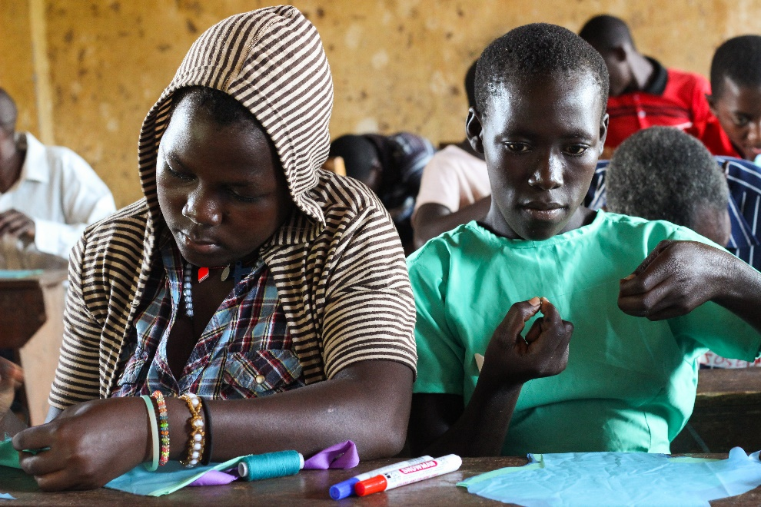
School girls sewing pads in one of the training centers

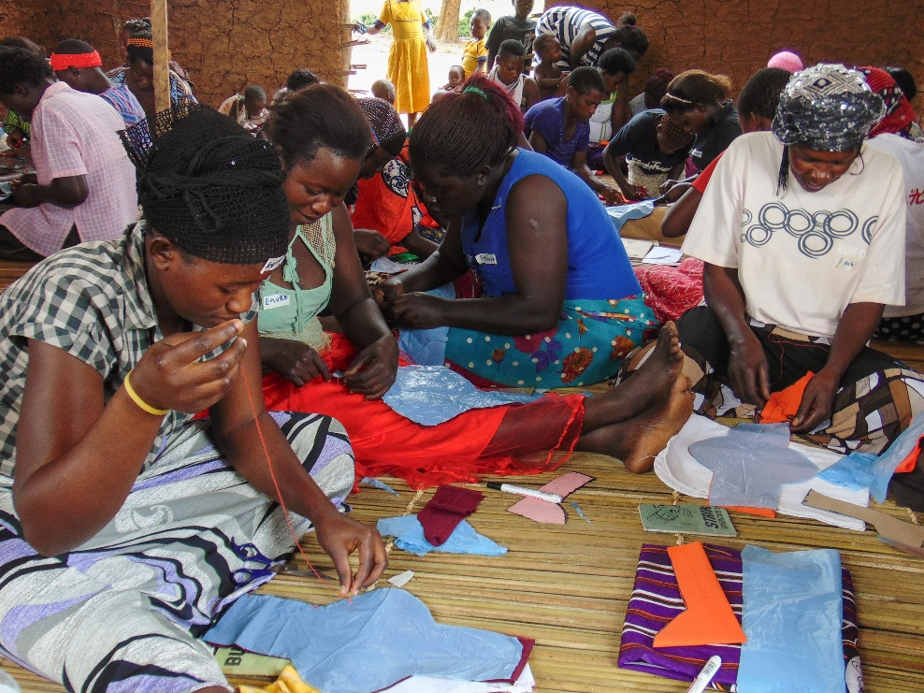
Women sewing pads in one of the training centers in the Island

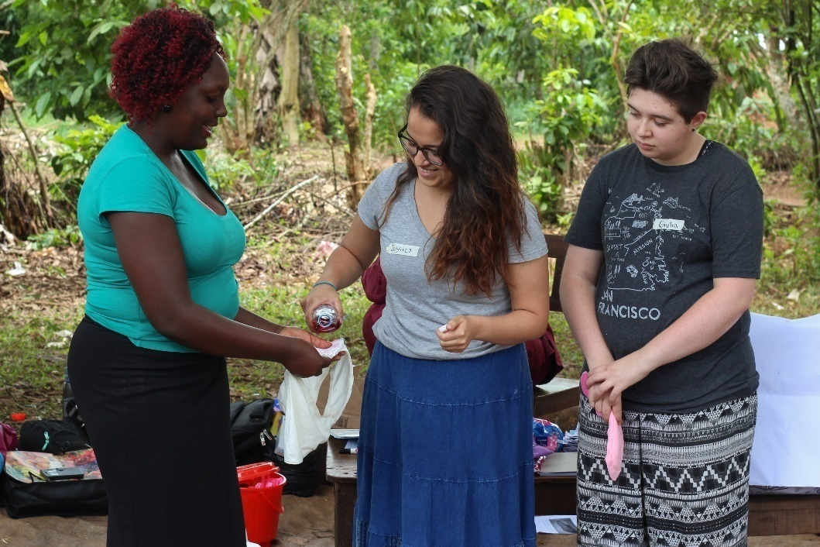
Trainers showing trainees how to clean nickers and sanitary pads during menestruation

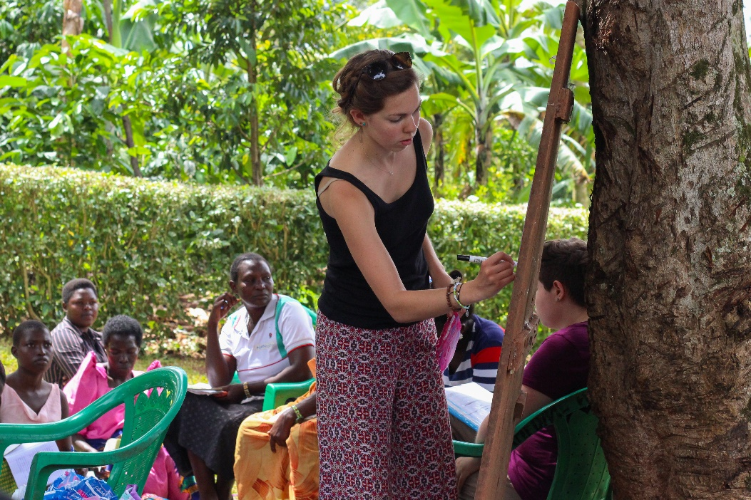
Nourish UNC interns training participants during menstruation trainings

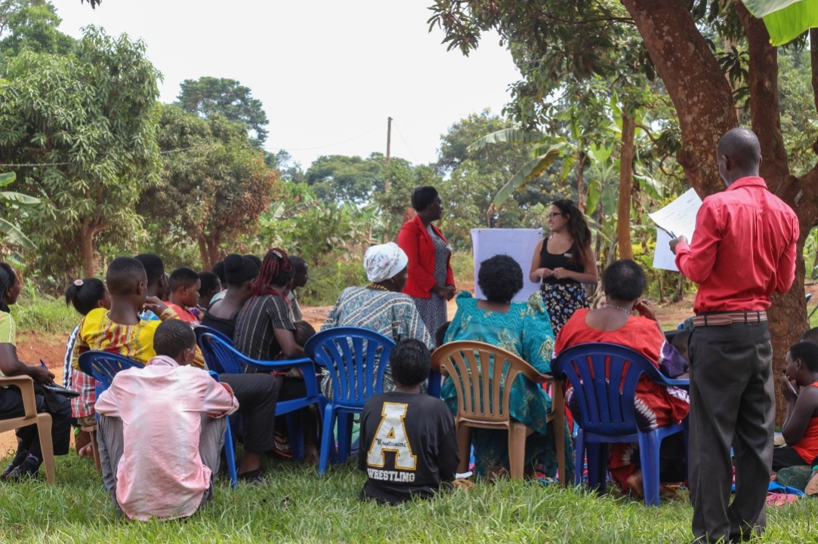

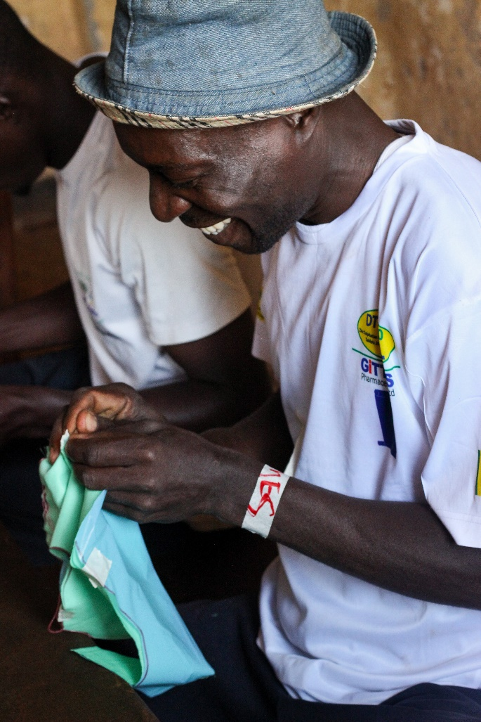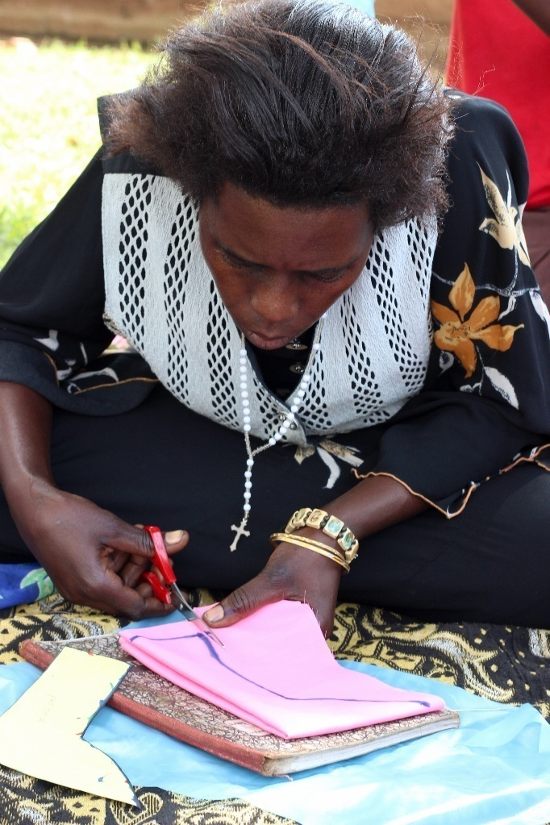
Older men and women appreciate the training, they told us more about the myths
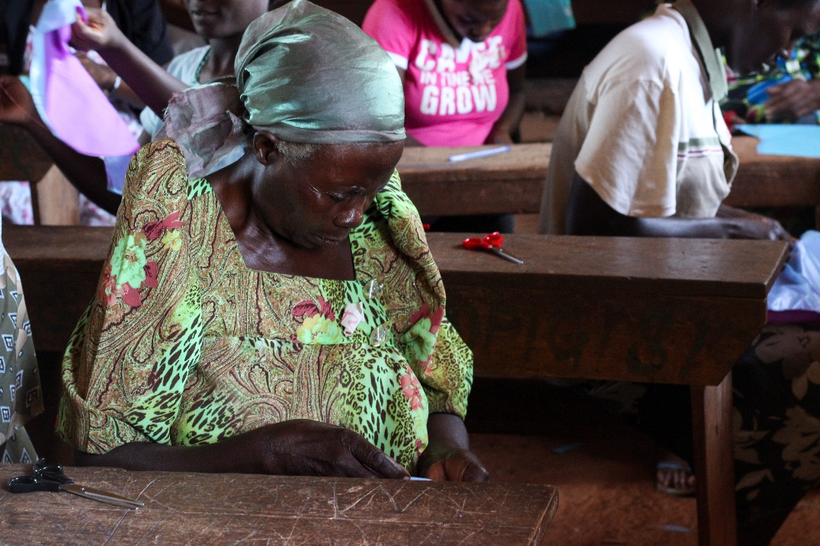
This old woman was one of those that were trained, she made a sanitary pad for her grand daughter

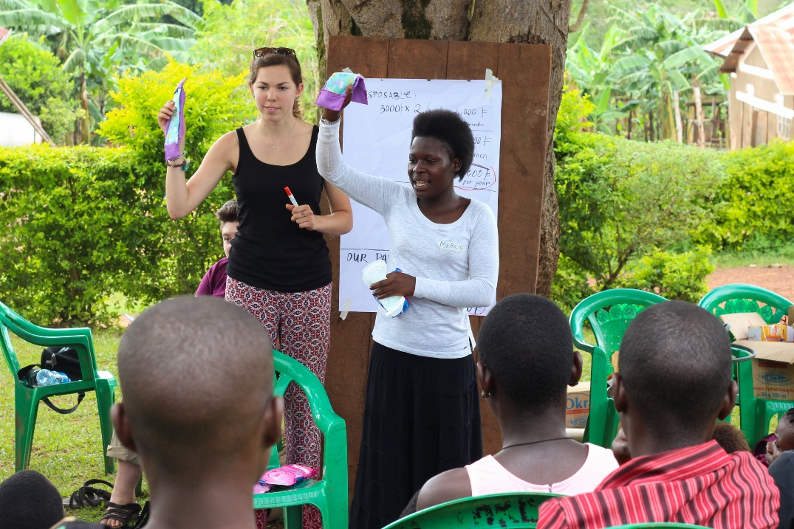
Trainers showing trainees a sample of a complete pad

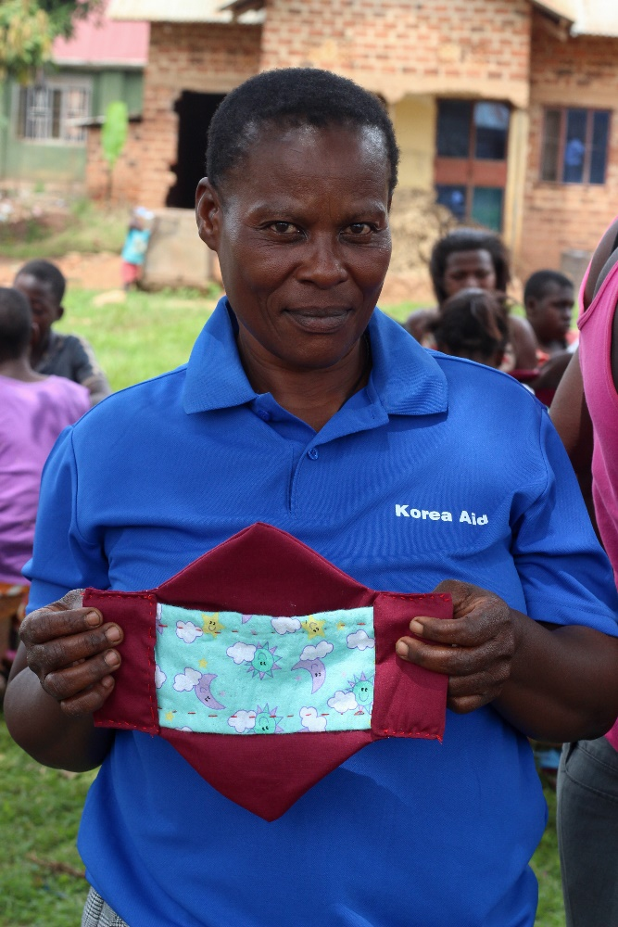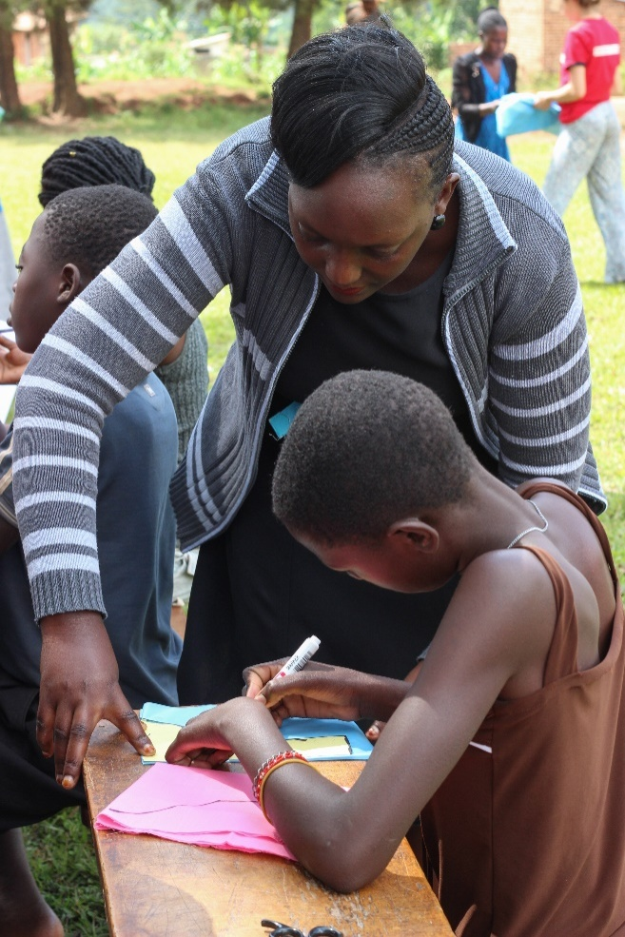
Trainers were available to give support to the trainees all the time
A lady showing her complete sanitary pad during training

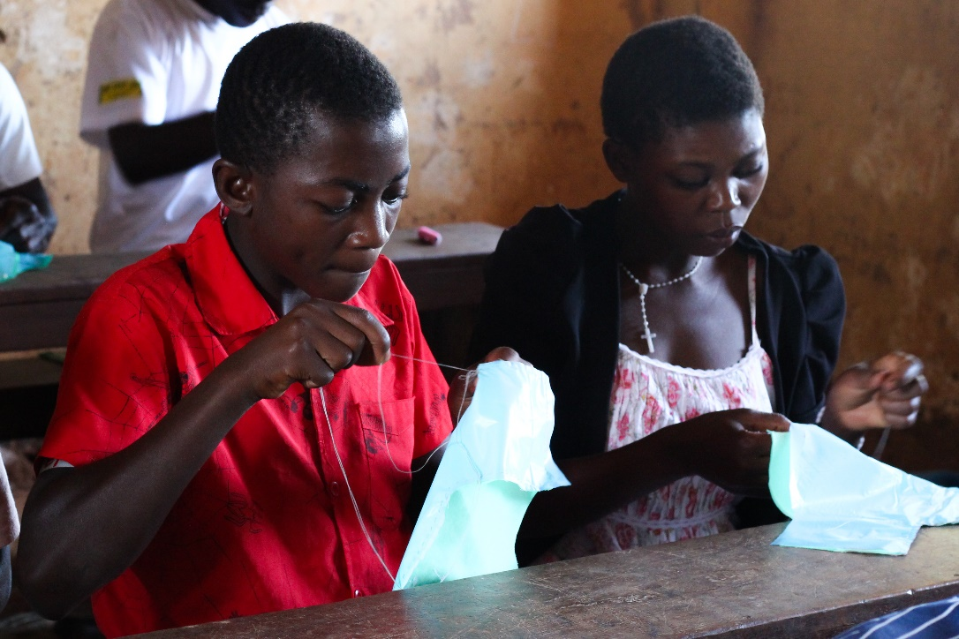
Boys and girls from Primary and Secondary schools also learnt to make their own pads

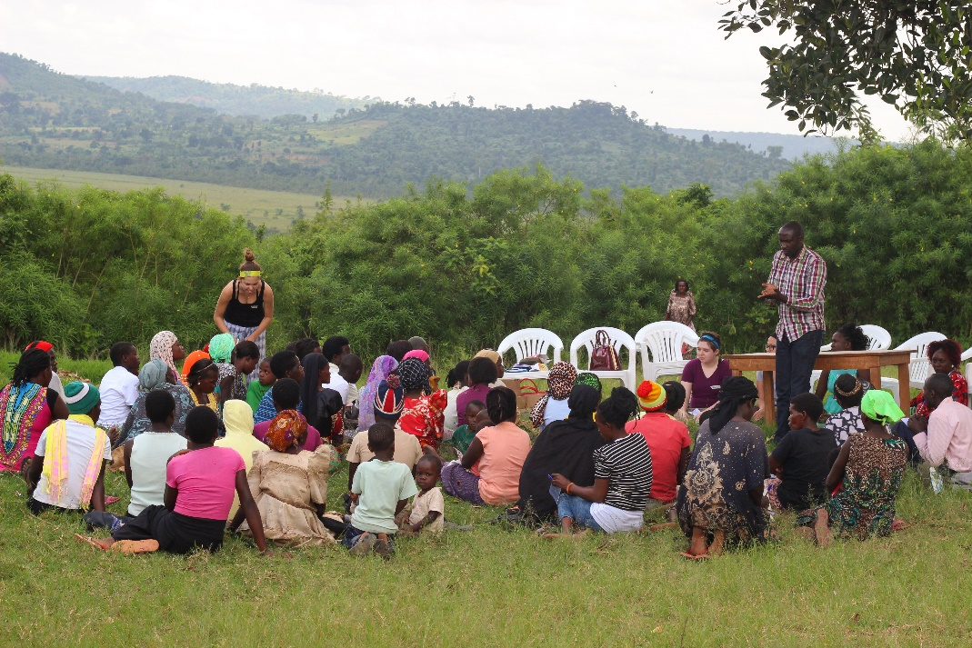
James closing one of the training in the community
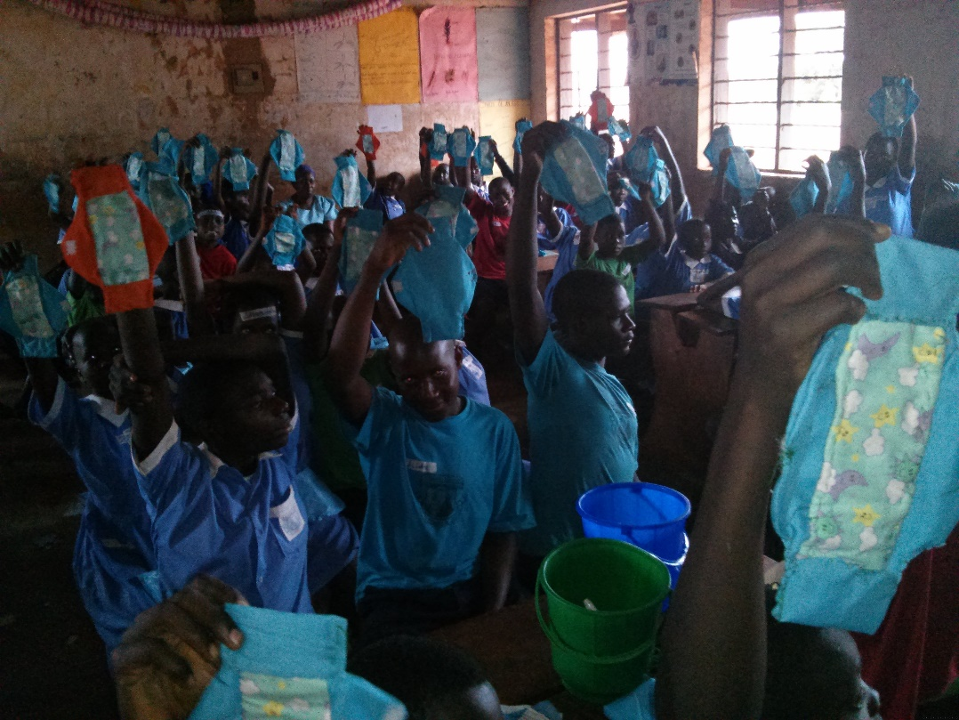
School children showing their completed sanitary pads after training
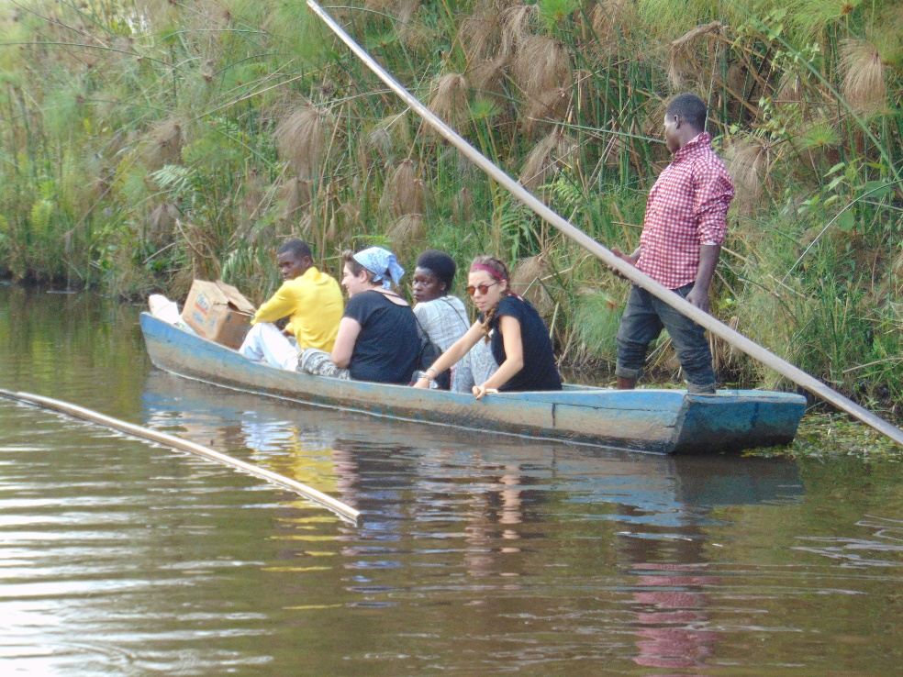
Trainers sailing on a small boat/canoe to the Island to train the community to sew their own pads

