~ CIARTES Y SI A. C. ~
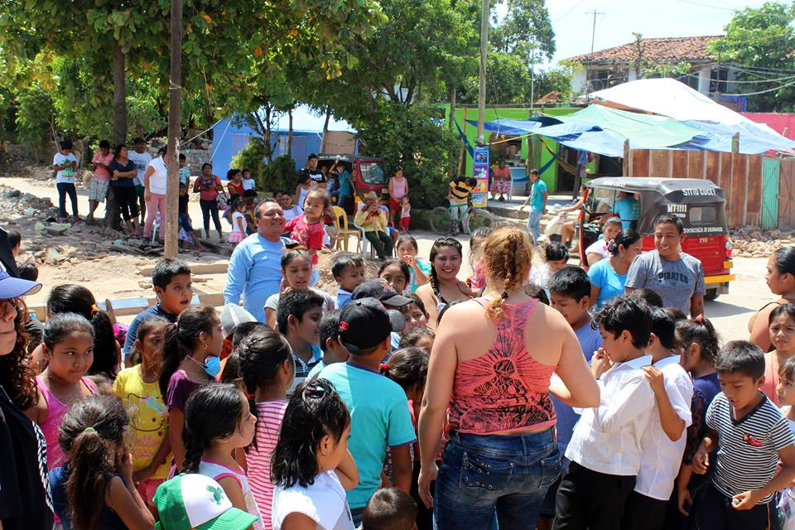

We are a Civil Association created to generate unique experiences that spring from art and the encounter of life, we work for the expansion of consciousness through three lines; interculturality, planetary consciousness and youth and gender with a total focus on creating art for peace.
Currently the headquarters is located in Pachuca de Soto, Hidalgo, where our multicultural forum is located. We do artistic training, creation, research and dissemination, looking for versatile ways to reach specific audiences and to weave various disciplines, finding the best artistic language for each occasion.
It is important to mention that our actions and processes are governed by teamwork, responsibility, efficiency, honesty, and social commitment, we currently have fifteen years of experience in creative work, research and education in the arts area scenic.
One of our main objectives is the creation and promotion of quality interdisciplinary artistic productions, paying special attention to vulnerable sectors of the population, positively impacting the quality of life of the people and the communities where they are developed.
We have focused our attention on what some theorists call “New theatricalities”, to carry important messages through complex artistic languages, but with attractive outlets for the new generations. The young people we work with are often silenced because they live in adult-centric communities, however, the possibilities of being heard within their communities are expanded when they are invited to other spaces with greater social recognition and influence (radio, internet, television programs).
We want to consolidate a space that is a reference in our country, where everything that the company produces has a high quality, as well as a high impact on the expansion of consciousness and the search for solutions through art, the improvement of the social environment, mainly of children and young people. We want to contribute to the professionalization of the art and culture of Hidalgo, offering innovative experiences to vulnerable populations.

