A counterfactual QALY for USD 2.60–28.94?

Summary

Reach Out Cameroon (REO) seeks up to USD 618,750 to continue its mobile clinics project in the conflict Northwest and Southwest (NWSW) regions of Cameroon for 6 months from October 1, 2020. The mobile clinics provide free primary preventive and curative healthcare in communities without other free primary care to persons of whom 95% are internally displaced and whose average daily expenses are below 1.25 USD (World Food Programme, October 2019). REO estimates that 74.7% of patients do not have other (paid) health facility in their community and 81% cannot pay for healthcare. We further estimate that during the past 5 months, the mobile clinics provided a counterfactual quality-adjusted life year (QALY) for USD 2.60–28.94. The ongoing project has been financed from a WHO emergency grant that ends on September 30, 2020. If you consider this project competitive, please donate now. We will also appreciate any feedback.

Background

In September 2017, the Anglophone Crisis, an ongoing conflict between state military and non-state armed groups, began in the NWSW regions of Cameroon. Recurrent cycles of inhabitant displacement followed. In December 2019, 466,000 internally displaced persons resided in the region (Internal Displacement Monitoring Centre, 2019). The crisis also led to closures of health facilities. In 2019, 53% of persons within the Divisions where mobile clinics operate reported inability to access healthcare (International Organization for Migration, 2019).

Current project overview

Since March 2020, Reach Out has been operating 8 mobile clinics in 5 Divisions of the NWSW regions of Cameroon. Each mobile clinic is staffed by 1 doctor, 3 nurses, 1 driver, and 1 safety officer. The clinics provide free primary healthcare to all patients. This care includes prevention, diagnosis, and treatment.

Current project data

We scaled our past data from 154 clinic-weeks (8 clinics, ~5 months) to 208 clinic-weeks (8 clinics, 6 months). A workbook version can be accessed here.

Total diagnoses by condition severity (35,533)

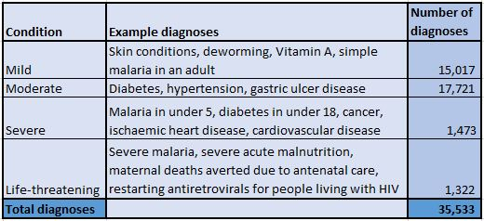
% of patients with no other free health facility in their community: 100%

Mobile clinics operate only in communities without other free government or NGO primary healthcare facility.

% of patients unable to pay for healthcare (81%)

The below % of patients unable to pay for healthcare are averages of estimates of the 8 mobile clinic doctors.

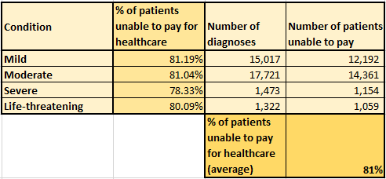

Patients by age group (average age: 31.7 years)

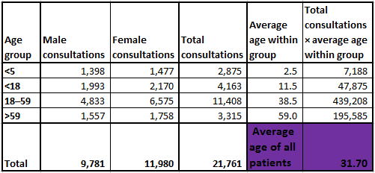

% of patients without other (paid) healthcare facility in their community (74.7%)

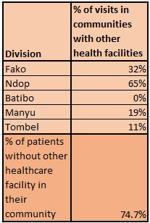

Preventive care outputs

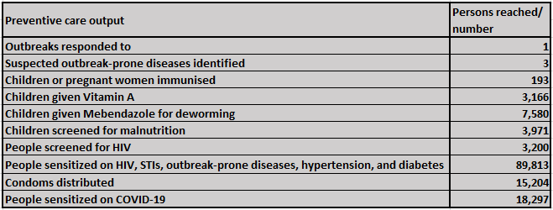

Past cost-effectiveness calculations (counterfactual QALY for USD 2.60–28.94)

Calculations can be reviewed in the data workbook.

Our calculations do not consider any health outcomes resulting from preventive care measures and may thus underestimate the project cost-effectiveness.

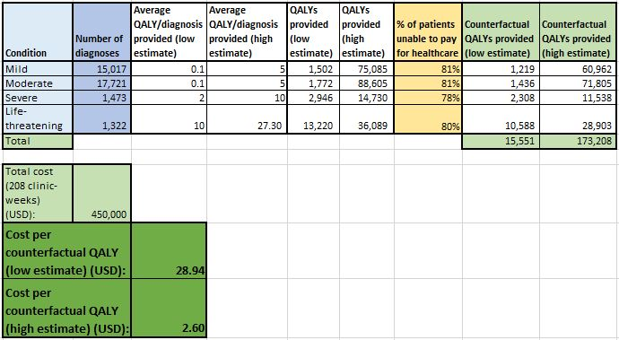

Cost-effectiveness updating

If we continue the project from October 1, 2020, we will collect baseline, midline, and endline health outputs/outcomes data in communities where mobile clinics begin to operate and in comparable non-intervention communities. Based on this data, we will update the project cost-effectiveness estimates.

Room for more funding (USD 618,750)

REO can utilize USD 618,750 to run 11 mobile clinics for additional 6 months from October 1, 2020, with the current counterfactual cost-effectiveness. The ongoing project has been financed by a WHO emergency grant that ends on September 30, 2020. So far, REO has secured USD 992 for this project (September 5, 2020). We will update this number when additional funding is secured. During the next 6 months, we will continue to seek further institutional funding.

Donation details (tax-deductible in USA and Germany)

We will appreciate any donations.

If you are interested in soliciting donations that would not have happened otherwise, e. g. in your company or at your school, please contact Bara, a trained economic diplomat. Also, please let us know if you can work with us on grant writing.

US bank account

German bank account

Donations are tax-deductible in Germany and subject to national tax deduction laws in other European countries.

Currency:
IBAN: DE43 5206 0410 0008 0074 54
Payee’s name: "Freundeskreis Reach Out Cameroon e.V."
Payee’s address: "Gleina 48, 07586 Bad Köstritz"
Bank name: "Evangelische Bank"
Bank address: "Kohlenstrasse 132, 34121 Kassel"
Bank BIC: GENODEF1EK1

Feedback and questions

Please comment below with any feedback or questions.

Contact details

For other general questions, please contact Marc (marc@reachoutcameroon.org, WhatsApp: +237 650 32 34 92), the Humanitarian Coordinator of REO. For technical inquiries, contact Dr. Jarman (eljarman89@gmail.com), the mobile clinics project coordinator.

References

GBD 2016 Diarrhoeal Disease Collaborators. (2018). Estimates of the global, regional, and national morbidity, mortality, and aetiologies of diarrhoea in 195 countries: a systematic analysis for the Global Burden of Disease Study 2016. Lancet of Infectious Diseases, 18, 1211-28. Retrieved from https://www.thelancet.com/journals/laninf/article/PIIS1473-3099(18)30362-1/fulltext
Health Cluster. (2020). Immunisation 2019 in South West region, Cameroon. Health Cluster meeting. Buea: Health Cluster, Southwest.
Human Rights Watch. (2020a). Cameroon Events on 2019. Retrieved July 9, 2020, from https://www.hrw.org/world-report/2020/country-chapters/cameroon
IDMC. (2019). Global Report of Internal Displacement 2019. Geneva: Internal Displacement Monitoring Centre. Retrieved from https://www.internal-displacement.org/global-report/grid2019/
IDMC. (2020). IDMC Cameroon. Retrieved June 17, 2020, from https://www.internal-displacement.org/countries/cameroon
Internal Displacement Monitoring Centre. (2019). Global Internal Displacement Database. Retrieved February 10, 2020, from https://www.internal-displacement.org/database/displacement-data
International Organization for Migration. (2019). Multi-Sector Needs Assessment. Geneva: OCHA.
MINSANTE. (2019). Northwest Regional delegation of Public Health / Southwest Regional Delegation of Public Health. Buea / Bamenda: MINSANTE.
Norweigan Refugee Council. (2020, August 20). Africa is home to nine of ten of the world’s most neglected crises . Retrieved from Norweigan Refugee Council: https://www.nrc.no/news/2020/june/africa-is-home-to-nine-of-ten-of-the-most-neglected-crises/#:~:text=Cameroon%2C%20DR%20Congo%20and%20Burkina,and%20deprioritized%20in%20the%20world.
OCHA. (2020e). CAMEROON North-West and South-West regions - Operational Presence. Geneva: OCHA. Retrieved from https://reliefweb.int/map/cameroon/cameroon-north-west-and-south-west-regions-operational-presence-march-2020
Organisation for the Coordination of Humanitarian Affaris. (2020). Geneva: OCHA.
Regional Delegation of Public Health Southwest. (2020). Cholera Outbreak Situation Report No 28. Buea: MINSANTE.
Schwinger, C., Golden, M., Grellety, E., Roberfroid, D., & Guesdon, B. (2019). Severe acute malnutrition and mortality in children in the community: Comparison of indicators in a multi-country pooled analysis. PLOS ONE, https://doi.org/10.1371/journal.pone.0219745.
Tekelab, T., Chojenta, C., Smith, R., & Loxton , D. (2019). The impact of antenatal care on neonatal mortality in sub-Saharan Africa: A systematic review and meta-analysis. Europe PMC, 10.1371/journal.pone.0222566 .
UNICEF. (2019). MATERNAL AND NEWBORN HEALTH DISPARITIES. Geneva: UNICEF. Retrieved from https://data.unicef.org/wp-content/uploads/country_profiles/Cameroon/Maternal%20and%20newborn%20health%20country%20profiles/country%20profile_CMR.pdf
World Data Atlas. (2020, 18 August). Cameroon - Neonatal mortality rate. Retrieved from World Data Atlas: https://knoema.com/atlas/Cameroon/Neonatal-mortality-rate#:~:text=In%202018%2C%20neonatal%20mortality%20rate,1%2C000%20live%20births%20in%202018.
World Food Programme. (October 2019). Emergency Food Security Assessment.

