**Project Proposal**

**Community-based Prevention of Coronavirus (Covid-19) in Sindh Province, Pakistan**

Association for Humanitarian Development (AHD), Hyderabad, Sindh

Pakistan

**Table of Contents**

**1.0 Background** 3

**2.0 Project Intervention Logic** 4

**2.1 Overall Objective** 4

**2.2 Outcome** 4

**2.3 Outputs** 4

**2.4 Major Activities** 4

**3.0 Project Implementation Strategy** 7

**3.1 Strengthening Enabling Environment** 7

**3.2 Hygiene Promotion** 8

**3.3 Access to Hardware** 8

**4.0 Project Management** 9

**4.1 Project Manager** 10

**4.2 Health & Hygiene Promoters** 10

**4.3 Admin Officers** 10

**4.4 Finance Officer** 11

**4.5 Monitoring and Evaluation Officer** 11

**4.6 Office Attendants** 11

**5.0 Project Monitoring and Reporting** 12

**6.0 Project Work Plan** 15

**7.0 Project Budget** 15

**8.0 Organisational Profile of AHD** 15

# **1.0 Background**

The governments around the world are responding to an outbreak of respiratory disease caused by a novel (new) coronavirus. The disease was first detected in China and which has now been detected in more than 160 locations internationally including Pakistan. The technical name of the virus is “SARS-CoV-2” and the disease it causes has been named “coronavirus disease 2019.” It has been abbreviated as “COVID-19” for general communication. World Health Organisation (WHO) declared the disease as pandemic and asked for greater national and international efforts to take preventive actions. It is a major crisis of Public Health in the history of Pakistan.

The disease has caused severe illness, including illness resulting in death is concerning, especially since it has also shown sustained person-to-person spread in several places. These factors meet two of the criteria of a pandemic. As community spread is detected in more and more countries, the world moves closer toward meeting the third criteria, worldwide spread of the new virus. This is a rapidly evolving situation and every major business organisation is undertaking risk assessment to manage the impact effectively.

Here are some of the key points of our assessment in the context of Pakistan:

The Government of Pakistan did not take leadership role in coordinating and resourcing the preventive efforts when Pakistani pilgrims from Iran returned. After initial media spike, the issue of managing the returnees were left to provincial Government of Balochistan. Though the provincial government made efforts but it lacked resources and capacity to screen and adequately quarantine. The mismanagement of the federal and provincial governments resulted in spreading of the virus to the healthy pilgrims at Taftan boarder’s crossing with Iran, where they were held in appalling conditions for weeks. Since majority of the pilgrims were from the provinces of Sindh, Gilgit Baltistan and Punjab, the other provincial governments raised their resources and intervened. The Government of Sindh established its first largest quarantine facility at Sakhar.

For the majority of people in Sindh province, the immediate risk of being exposed to the virus is now medium to high. As of March 19, 2020, the total confirmed cases are 331, out of which 213 are in Sindh province. Sindh government has taken steps to reduce gathering of people at public places and has declared health emergency in the province. The civil society organisations are working closely with the Public Health Department and Health Department at provincial and district levels. The focus of the current activities is on urban areas whereas rural areas are also high risk in the province. There is an urgent need of community led preventive work against the spread of Coronavirus (Covid-19).

AHD has been working in the rural areas of Sindh since 2001 in Water, Sanitation and Hygiene (WASH) sector. At this critical moment, AHD has started collaboration with the provincial authorities and now making efforts to raise funds for effective preventive work against the spread of Covid-19 in the rural areas of Sindh.

# **2.0 Project Intervention Logic**

## **2.1 Overall Objective**

The overall objective of the project is to contribute in the efforts of federal, provincial and district governments in taking preventive measures at the household and community levels against the spread of Coronavirus (Covid-19) in the rural areas of district Hyderabad, Sindh, Pakistan.

## **2.2 Outcome**

The transmission of Covid-19 is significantly slowed down for the children, women and men (with particular focus on elderly and already sick people) living in rural areas of district Hyderabad through (1) increased awareness about the Covid-19, (2) promotion of hygiene and (3) access to safe drinking and handwashing water, distribution of soap and other preventive non-food items.

## **2.3 Outputs**

The project has the following four outputs:

1. Fifteen Coronavirus Surveillance & Coordination Committees of men and women formed and functional in 15 villages of district Hyderabad.
2. Covid-19 Awareness Campaign message reached and completely understood by 15,000 men, 15000 women and 10,000 children in 15 villages of district Hyderabad.
3. Planned, systematic promotion of hygiene enabled people to take preventive actions against the spread of Covid-19 disease at the (1) household, (2) market, (3) school and (4) community levels in 15 villages of district Hyderabad.
4. Access to safe drinking water, soap and handwashing facilities increased by 70% at the household, school, market and community levels against the spread of Covid-19 disease in 15 villages of district Hyderabad.

## **2.4 Major Activities**

The following are the major activities under each output:

| **Output No. 1.0:** Fifteen Coronavirus Surveillance & Coordination Committees of men and women formed and functional in 15 villages of district Hyderabad. | |
| --- | --- |
| 1.1.1 | Selection of villages and small rural towns in District Hyderabad on the high risk of Covid-19 spread. |
| 1.1.2 | Initial contact and mobilising people through door-to-door contact for taking proactive community-based actions. |
| 1.1.3 | Develop ToRs of the 15 Coronavirus Surveillance & Coordination Committees at village level with input from communities and district administration (especially Sindh Health Department). |
| 1.1.4 | 15 training sessions organised for the smooth functioning of Coronavirus Surveillance & Coordination Committees. |
| 1.1.5 | 15 Schools contacted for formation of child-to-child groups for promotion of hygiene at school and homes. |
| 1.1.6 | Monitor and review the work of Coronavirus Surveillance & Coordination Committees. |

| **Output No. 2.0**: Covid-19 Awareness Campaign message reached and completely understood by 15,000 men, 15000 women and 10,000 children in 15 villages of district Hyderabad. | |
| --- | --- |
| 1.2.1 | Mass awareness campaign about preventive measures against nature and spread of Coronavirus will be designed through verbal, print, electronic and social media. |
| 1.2.2 | Child-focused awareness campaign will be designed to inform children and reduce stress & fear among them. |
| 1.2.3 | Consultative meetings held with the district and provincial authorities for developing appropriate communication materials. |
| 1.2.4 | The campaigning materials (print, electronic, social media) developed and pre-tested. |
| 1.2.5 | Approval obtained from the provincial government for the dissemination of awareness materials |
| 1.2.6 | Campaign launched and sustained for at least one month. |
| 1.2.7 | Review and monitoring of Campaigning work to take time actions. |

| **Output No. 3.0**: Planned, systematic promotion of hygiene enabled people to take preventive actions against the spread of Covid-19 disease at the (1) household, (2) market, (3) school and (4) community levels in 15 villages of district Hyderabad. | |
| --- | --- |
| 1.3.1 | Undertake rapid assessment for planning hygiene promotion strategy (and other project work). |
| 1.3.2 | Prepare Hygiene Promotion Strategy based on principles of Behaviour Change Communication and Social Mobilisation. |
| 1.3.2 | Train hygiene promoters to conduct home visits for promotion of hygiene. |
| 1.3.3 | Organise community and activities with adults and children for community level cleaning including solid waste management. (Cross link: Activity No. 1.4.9) |
| 1.3.4 | Use of mass media e.g. radio to provide information on hygiene for prevention of Coronavirus. |
| 1.3.5 | Coronavirus Surveillance & Coordination Committees develop their village level work plan and implement it. |
| 1.3.6 | Develop linkages of Coronavirus Surveillance & Coordination Committees with the district administration and district health department. |
| 1.3.7 | Install Public Information Board and continuously update them about the cleaning activities of the village. |
| 1.3.8 | Obtain & provide information from district authorities through committees about spread of Convid-19 in the district and share the information at village level. |
| 1.3.9 | Review and monitoring of hygiene promotion work to take timely actions. |

| **Output No. 4.0**: Access to safe drinking water, soap and handwashing facilities increased by 70% at the household, school, market and community levels against the spread of Covid-19 disease in 15 villages of district Hyderabad. | |
| --- | --- |
| 1.4.1 | Conducting rapid assessment for need identification for safe drinking water, soap and handwashing. This will be conducted as part of Activity 1.3.1. |
| 1.4.2 | Distribution of hygiene kits to 2000 families based on our initial assessment of the situation under Activity 1.3.1 & 1.4.1. |
| 1.4.3 | Distribution of local water filter and containers (Nadis) to 2000 families. |
| 1.4.4 | Train people to manage the functioning of local water filter and keeping it effective. (Nadi training) |
| 1.4.5 | Train people in preparation of effective masks at local level. |
| 1.4.6 | Training people in preparation of effective disinfectant at local level. |
| 1.4.7 | Public distribution of 5000 masks and small hand disinfectants (preferably made at the local level). |
| 1.4.9 | Distribution of materials to 15 committees for effective management of solid waste in public areas (e.g., wheelbarrows, spades, brooms, waste bags, etc.). Please also see connected Activity No. 1.3.3. |
| 1.4.10 | Installation of 100 handwashing points at public places along with provision of soap. |
| 1.4.11 | Effective management of handwashing points and continuous resourcing them with water and soap for two months. |
| 1.4.12 | Preparation of 15 temporary community isolation facilities for high risk villages with an average capacity of 5 persons per facility. |
| 1.4.13 | Instituting surveillance system around major movement of people in rural areas. |
| 1.4.14 | Review and monitoring of provisions for hygiene promotion. |

The comprehensive Project Logical Framework is enclosed as Annex-001 (Logframe) for ready reference.

# **3.0 Project Implementation Strategy**

The project focus is on prevention the spread of Covid-19. The major infection routs of the virus are related with the public health. The lack of awareness, inadequate water & sanitation resources and poor hygiene practices sustain the spread of virus. Therefore, it is essential that the project adopt holistic and integrated approach for addressing the situation.

We will prevent the spread of Covid-19 through the following combination of three strategies:

### **3.1 Strengthening Enabling Environment**

Right-based approach

Pakistan is a democratic country and every citizen has [fundamental rights](http://www.pakistani.org/pakistan/constitution/part2.ch1.html). The Constitution of Pakistan (1973) protects these rights. The Government of Pakistan is responsible to provide adequate and high-quality preventive WASH services to all the citizens currently at the risk of Covid-19. However, the State of Pakistan has chronic governance crisis at all levels and is unable to protect its citizens. AHD, therefore, will closely work with the government agencies to ensure that work of AHD is genuinely helping and reinforcing the efforts of various government departments. Moreover, AHD will also organise people in high risk villages to organise themselves and establish Coronavirus Surveillance & Coordination Committees. AHD will also be investing in building capacity of these committees to be functional and work closely with the government as right-holder on part of the citizens.

In our campaigning work, we will also raise awareness of the people about their entitlements announced by the Government of Pakistan, Government of Sindh and leading private companies. The information will enable the poor and excluded to apply and follow up with the concerned agencies for their entitlements.

Working and coordination with key stakeholders

AHD will work under the leadership of Provincial Disaster Management Authority (PDMA) Sindh. It will closely support district Health Department and will also be working with Public Health Engineering and Rural Development department during the implementation of the project.

AHD has also planned consultative meetings with district and provincial authorities besides coordinating closely with other civil society organisations. Our response will be coordinated with other key humanitarian stakeholders. In the coordination process, we will also promote local leadership of the humanitarian response and will be part of all provincial, national and global networks.

Focus on vulnerable and excluded people

In our implementation strategy, we will give priority to elderly, already sick and excluded groups such as Hindus, agricultural labourers, tenants and landless families. While focusing on the public and commercial areas, we will also be covering public and private transporters and other people who move frequently to different areas as part of their routine work.

### **3.2 Hygiene Promotion**

Participatory social mobilisation

AHD will be mobilising local communities through door-to-door meetings, contacts and building narrative of common good at community level. In our mobilising work, we will be emphasizing individual and collective responsibility for implementing recommended personal-level actions for the prevention of Covid-19. In our hygiene promotion work, we will also be enlisting support from local businesses, mosques and community organizations to ensure and facilitate implementation of recommended actions. Our participatory hygiene promotion will be done in a way that minimise disruptions to the daily life to the extent possible.

Feedback loop

AHD will establish functional feedback loop with the local communities. We will actively seek their guidance about the location of water and sanitation facilities. Moreover, we will also incorporate feedback on the beneficiaries about distribution points of hygiene kits and quality of the materials in the kits.

The committees will manage and supervise the use and functioning of handwashing points. AHD will ensure minimum disruption in the services of handwashing at public places.

Covid-19 Campaign

Besides face-to-face interaction and promotion of hygiene, AHD will also be undertaking extensive communication campaign to raise awareness about Covid-19 and replace the fear factor with confidence at the community level.

### **3.3 Access to Hardware**

Safe drinking and handwashing water

AHD will raise awareness about the importance of safe drinking and handwashing water through its community-based hygiene promotion work. However, we believe that the promotion work will only be effective if AHD provide access to hardware for safe drinking and handwashing water. We will train and provide slow sand water filter (Nadi) to target villages at household and community level. Moreover, we will also establish handwashing points at community level, especially in the areas frequented by people such as bus stops, markets, health facilities, etc.

Community led cleaning

AHD will undertake major community led cleaning and safe disposal of solid waste during the implementation of the project. AHD will provide essential items such as wheelbarrows, brooms, soaps, safety gears, disinfectants, etc. The initiative will be anchored in hygiene promotional work.

Distribution of WASH related non-food items

AHD will be distributing masks, sanitisers and hygiene kits as part of its hygiene promotional work. The provision will help communities to take preventive actions. Due to slow down of local economic activities, the local people are rapidly loosing ability to purchase soap and other non-food items to prevent spread of Covid-19 in their communities.

Linkages for other needs

Our project is focused on water, sanitation and hygiene promotion; whereas in local communities the economic activities have been almost halted and people are facing sever economic crisis. We will work with other philanthropic organisations for the provision of food and will facilitate linkages of our targeted communities with the other private and public organisations such as Pakistan Bait-ul-Mal, provincial Social Welfare Department, etc.

Change Model of AHD

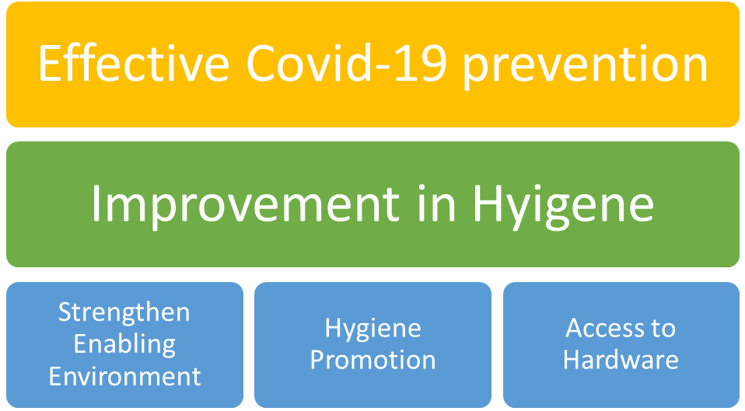

# **4.0 Project Management**

AHD has extensive experience of managing WASH projects for the last 19 years. It has developed profile in improving access to safe drinking water at household and community level. The current project is inline with our existing Programme Strategy and we are developing proposal in continuation of our previous work in WASH.

AHD will hire project team consisting of 23 persons for the project’s implementation. The purpose of the team will be to contribute in the implementation of current project by identification, building capacity and evolving partnership with local communities and take responsibility for completing the project activities in line with the Core Humanitarian Standards (CHS).

Following are the details of the project team:

## **4.1 Project Manager**

The main responsibilities of Project Manager are providing leadership to the project implementation, managing relationships with staff and local communities, representation of AHD and Project with key humanitarian stakeholders at the district and provincial level. Moreover, the position will also be responsible for security and safety management of the project team. Project Manager will be the budget holder and will report to the Executive Director of AHD. The core performance objective of Project Manager is to ensure that the transmission of Covid-19 has significantly been slowed down as result of implementation of the project.

The position holder will work for four months to ensure that all project closure and reporting requirements are met as per contractual requirements of the donor and government.

## **4.2 Health & Hygiene Promoters**

The project will hire 16 Health and Hygiene Promoters (eight women and eight men). AHD will form eight Health & Hygiene Promotion Teams. The teams will be responsible to establish and make functional 15 Coronavirus Surveillance & Coordination Committees and transmit Covid-19 awareness messages to 45,000 persons through awareness campaign. Moreover, they will undertake planned, systematic promotion of hygiene that should result in enabling local people to take preventive actions at personal, household and community levels. The teams will also be distributing non-food items to local communities as per the project plan and criteria.

The positions will report to Project Manger and will be hired for the duration of three months.

## **4.3 Admin Officers**

The project will hire two Admin Officers. One officer will be responsible to lead the procurement of non-food-items, their transportation, warehousing and distribution to the beneficiaries. The other Admin Officer will provide office administrative support to the whole project team in routine work, especially in making arrangements for field travel, holding training sessions and dealing with the mandatory requirements of obtaining NOCs and other paper work from the relevant departments of the federal and provincial governments.

The position holders will report to Project Manager and will be hired for the duration of three months.

## **4.4 Finance Officer**

The project will hire one Finance Officer. The position holder will be responsible for the book-keeping of the project expenses, advising on cash flow to the Project Manager, preparation of the budget versus actual report on weekly basis and financial reports for the donor. Moreover, the person will be accountable to maintain the financial record as per Pakistan’s Accounting and Financial Reporting Standards for Small-sized Entities.

The position holder will report to the Project Manager and will work for four months to ensure that all project closure and reporting requirements are met as per contractual requirements of the donor and government.

## **4.5 Monitoring and Evaluation Officer**

The project will hire one Monitoring and Evaluation Officer. The position holder will be responsible to prepare Monitoring Framework of the Project, institute a functioning monitoring system, lead on reporting and flag key issues to the Project Manager.

The position holder will report to the Project Manager and will work for four months to ensure that all project closure and reporting requirements are met as per contractual requirements of the donor and government.

## **4.6 Office Attendants**

The project will hire two Office Attendants. The project has large team and support requirements of the team will also be extensive. The Office Attendants will undertake routine office cleaning, support to project staff and assist Admin Officer in transport, warehousing and distribution of non-food items.

The position holders will report to one of the Admin Office and will be hired for the duration of three months.

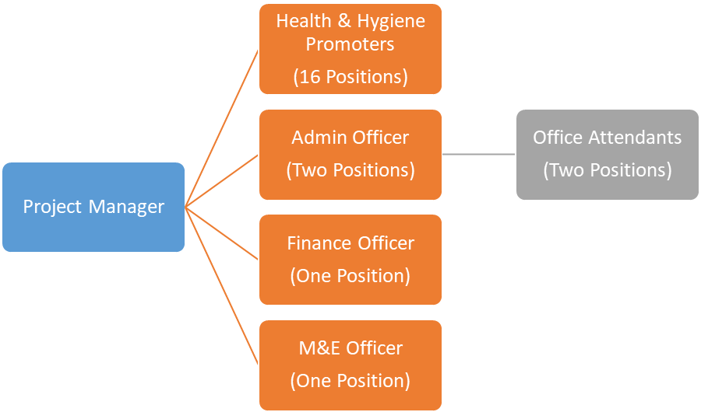Project Organogram

# **5.0 Project Monitoring and Reporting**

At project planning phase, AHD has formulated indicators for overall objective, project outcome and project outputs. The Project Manager along with M&E Officer will revise and improve the indicators within the first month of project implementation. The following monitoring plan is, therefore, tentative at this stage of project formulation:

Matrix of Project Monitoring Plan

| **Level** | **Indicator** | **Frequency** | **Methodology** |
| --- | --- | --- | --- |
| **Overall  Objective** | Slow down and gradual reduction in spread of Coronavirus (Covid-19) in Sindh province. | Weekly | M&E Officer will prepare weekly situational reports based on the information from government and independent secondary data sources. Project Manager will finalise the situational reports and will send them to wide range of national and international stakeholders. |
| **1.0 Outcome** | **Indicator Reference 1.A:** Significant slow and reduced spread (at least 70% less) of Coronavirus (Covid-19) in project's targeted villages compared to the other villages at high risk in Sindh province.  **Indicator Reference 2.A**: Conspicuous reduction of stress and anxiety (at least 80%) among the children, women and elderly people compared with the figure of our initial assessment (initial assessment, see Activity No. 1.3.1 & 1.4.1). | End of Project | The data will be collected through qualitative and quantitative research techniques. The information will be triangulated on timescale through use of different research techniques. The progress on these indicators will also be communicated to the donor, government and media. |
| **1.1 Output** | **Indicator Reference 1.1 A**: 15 committees established and strengthened.  **Indicator Reference 1.1.B**: 15 implementing measures and engaging with authorities (with particular focus on prevention and information exchange). | Weekly | M&E Officer will collect the information from the project team. The information along with analysis of the bottlenecks will be reported. Project Manager will flag the critical issues to Executive Director as well. Moreover, the indicator tracking information will also be shared with other organisation for possibility of synergies, etc. |
| **1.2 Output** | **Indicator Reference 1.2 A:** Campaign enabled 45,000 persons in XXX villages of district Hyderabad to make informed decisions and to take up health and preventive recommendations. | Bi-weekly | Evidence about making informed decision and taking up health preventive measures will be collected mainly through primary data sources. The research techniques will be (1) Key Informant Interviews, (2) Transact walks and (3) document review and analysis. The data will be collected twice in three months of the project duration. M&E Office will send the report to Project Manager. She/he will also highlight the need for corrective actions. The Project Manager will share the report with donor, government and other stakeholders. The Project Manager will also be responsible for taking corrective actions (if any). |
| **1.3 Output** | **Indicator Reference 1.3.A:** Adequate water handling practices to minimize contamination practised by XXX % of the population in targeted villages. **Indicator Reference 1.3B**: 80% people are properly washing their hands (more than 5 times during the day) with soaps. **Indicator Reference 1.3C**: All people (100%) with flue or coughing are using protective masks and staying in private places (instead of market or public places). **Indicator Reference 1.3D**: All sections of the community, including vulnerable groups (like Hindus), are consulted and represented in Surveillance & Coordination Committees. **Indicator Reference 1.4E:** All public spaces in villages and markets are cleaned, disinfected and solid waste disposed on monthly basis. | Bi-weekly | The information will be collected mainly through primary data sources using the research techniques of (1) participant observation, (2) key informant interviews, (3) transact walk and (4) review of documents. The information will be collected after every month.  M&E Office will send the report to Project Manager. She/he will also highlight the need for corrective actions. The Project Manager will share the report with donor, government and other stakeholders. The Project Manager will also be responsible for taking corrective actions (if any). |
| **1.4 Output** | **Indicator Reference 1.4A**: X% of the population has access and is using safe water for drinking. **Indicator Reference 1.4B**: X% of the population has access to soap, handwashing facilities, masks and disinfectants. **Indicator Reference 1.4C**: X% of population is actively participating in adequate cleaning and management of solid waste. **Indicator Reference 1.4D**: XXX number of people trained in various skills of hygiene promotion and prevention of Covid-19 at community level. | Bi-weekly | The information will be collected mainly through primary data sources using the research techniques of (1) participant observation, (2) key informant interviews, (3) transact walk and (4) review of documents. The information will be collected after every month.  M&E Office will send the report to Project Manager. She/he will also highlight the need for corrective actions. The Project Manager will share the report with donor, government and other stakeholders. The Project Manager will also be responsible for taking corrective actions (if any). |

AHD will prepare internal and external project progress reports. The internal reports will be shared within AHD and Project Team whereas external reports will be shared with the AHD teams and external stakeholders. The following are the tentative planned reports:

Project Reporting Cycle

| **Ref.** | **Report** | **Prepared by** | **Sent to** | **Frequency** |
| --- | --- | --- | --- | --- |
| 1 | Journal of Progress. The report will contain information about the daily activities, lessons learnt and potential bottleneck or challenges. | Health & Hygiene Promoters | Project Manager & M&E Officer (Internal Report) | Weekly |
| 2 | Yellow Project Progress Report. The report will contain information about the implementation status of the project work plan. Moreover, the report will also contain information about the measurement (qualitative) of indicators. | M&E Officer | Project Manager (Internal Report) | Weekly |
| 3 | Budget versus Actual  Report. The report will not only provide quantitative information but will also include analysis of the potential issues in the pipeline. | Finance Officer | Project Manager | Weekly |
| 4 | Blue Project Progress Report. The report will consolidate the weekly reports and will list the corrective actions taken. | M&E Officer | Project Manager & Executive Director (Internal Report) | Monthly |
| 5 | Monthly Financial Report. The report will contain all the expenses made during the month and will also be providing reconciliation with the bank accounts and aging analysis of various pending payables & receivables. | Finance Officer | Project Manager & Executive Director (Internal Report) | Monthly |
| 6 | End of Project Report. The report will contain information about all the project activities. Moreover, it will also contain financial information. | Project Manager (with input from M&E and Finance Officers) | Board of Directors and Donor (External Report) | End of Project |

# **6.0 Project Work Plan**

Please see Annex-002 (Gantt Chart) for the Project Work Plan.

# **7.0 Project Budget**

The total project budget is PKR 36,749,150 (USD 237,091) for the period of three months. Out of the total budget, 76.02% will be spent on direct project materials and services. Human resources are 13.82%, whereas utilities & other services are 3.62% of the total budget.

Summary of Project Budget

The detailed project budget is enclosed as Annex-003 (Budget) for ready reference.

# **8.0 Organisational Profile of AHD**

The organisational profile of AHD is enclosed as Annex-004 (Profile).