HEALTH AND FAMILY WELFARE SERVICES, KARNATAKA

COVID – 19 RESPONSE

Quarantine intervention to control the spread of COVID – 19 virus in the city of Bangalore, Karnataka

23/03/20

Officers In Charge

Government of Karnataka

Pankaj Kumar Pandey, IAS, Commissioner

Commissionerate
Health, Family Welfare and AYUSH Services
Ananda Rao Circle, Bangalore-560009

Dr. Parimala Maroor
Project Director, Reproductive and Child Health

Directorate of Health & Family Welfare Services
Ananda Rao Circle, Bangalore-560009

Aarogya Seva

Dr. Dayaprasad Kulkarni
Director, Aarogya Seva

Aarogya Seva, Siddhapura main road
Jayanagar 1st block, opposite Lalbagh
Bangalore – 560011

INDEX

Understanding the Requirement Pg. 4

Proposal Pg. 6

Budget Pg. 7

UNDERSTANDING THE REQUIREMENT

COVID – 19 virus or as it is popularly known now as the Corona virus is a worldwide pandemic as declared by the World Health Organization as of 11 March 2020. WHO defines it as “an infectious disease caused by a newly discovered coronavirus. Most people infected with the COVID-19 virus will experience mild to moderate respiratory illness and recover without requiring special treatment. Older people, and those with underlying medical problems like cardiovascular disease, diabetes, chronic respiratory disease, and cancer are more likely to develop serious illness.”
WHO’s has classified the COVID – 19 virus as “very high” risk. With a total of 19,18,138 confirmed cases globally as of 16th April 2020, and reports of new cases pouring in from countries all over the world every hour as more persons are tested. India, the second most populous nation in the world is just starting diligent testing and is already falling behind on efficient response to the virus.
As per assessments of the Indian healthcare system, trend of the virus in severely hit countries such as China, Italy and the USA and its trajectory in India, it is estimated that India will see about 30,000 Covid-19 deaths by May. As reported by The Print “It took India forty days to reach the first 50 cases, five more days to reach 100 cases, three more days to reach 150 cases and then just two more days to reach 200 cases. From here on, the juggernaut is going to roll fast.” Additionally, the state of the current healthcare infrastructure is of grave concern as it is not equipped to deal with the influx of such huge numbers of patients be it either for quarantine, assessment or treatment.

It is estimated that India is currently functioning at a ratio of 0.5 beds per 1000 individuals, factoring in the growth of confirmed cases by the day, India’s current healthcare infrastructure will be overwhelmed by end of April and out of beds by June. “With ICU beds estimated at 70,000 nationally, if even one out of every 10 cases was to require an ICU bed by the end of May, India would be running at full capacity, if not earlier.” At this rate it will come down to picking and choosing which of the patients who need a ventilator can actually get it. It is imperative we control the spread of the virus rather than tackle the healthcare system at large solely. (See Figure 1.)
Vectors and the spread of the disease must be acknowledged. With only 12 private labs with 15,000 collection centres testing for the virus country wide as reported on 23/03/2020 the actual number of cases could very well be higher than those already confirmed. This also means that there are more vectors present than official figures seem to suggest. The primary quarantine facilities being set up by states are overwhelmed as they continue to cope with vectors with a travel history to regions with the virus outbreak. It is also of huge consequence that the suspected cases being transported from the quarantine facilities, airports or other locations to hospitals do not come into contact with healthy individuals in transit thereby, making them vectors and possibly infecting them as well.
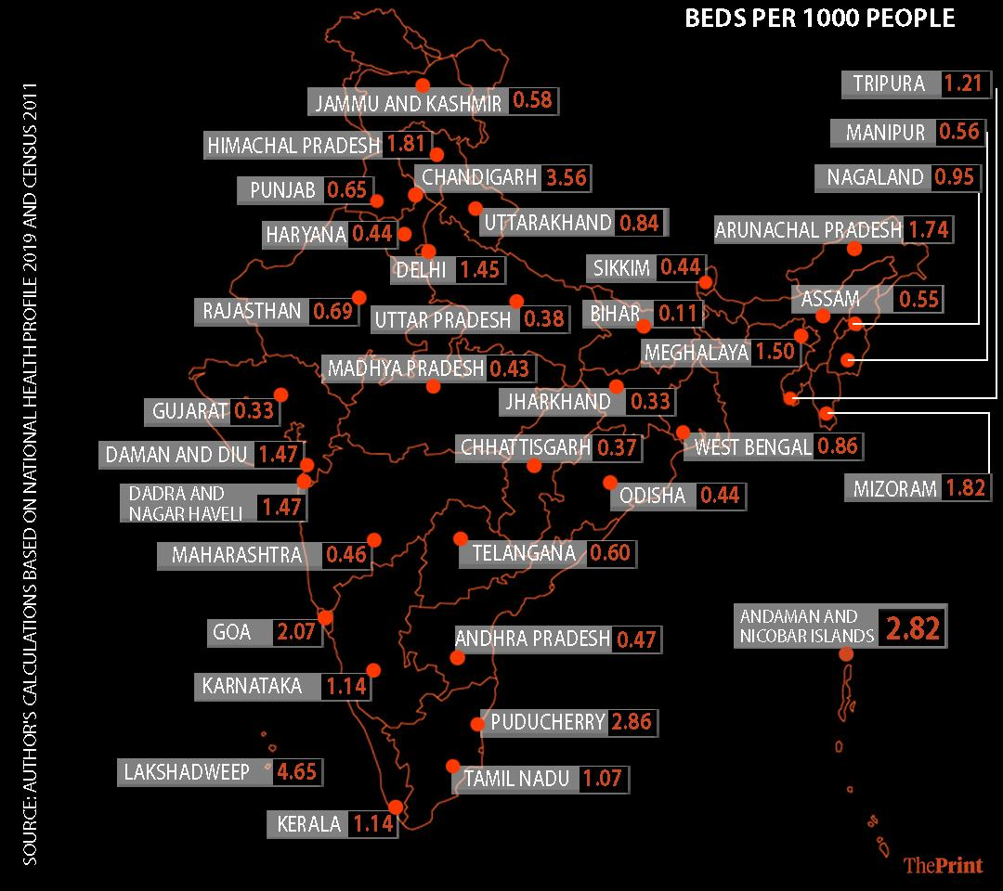

Figure 1 -Beds per 1000 people

Thus far, Karnataka has 12 recorded death, 279 confirmed cases and 80 cured individuals (Ministry of Health and Welfare, GOI, 16/04/2020, 10:30 am). The Karnataka Government exercising its powers under Sections 2,3 and 4 of the Epidemic Diseases Act, 1897 (Central Act 3 1897 & Mysuru Act II of 1897) has framed The Karnataka Epidemic Diseases (Covid - 19) Regulations 2020. Enabling provisions of the Disaster Management Act, 2005 the Government has now imposed territorial restrictions in the revenue districts of – Bangalore Urban including BBMP, Bangalore Rural, Kalaburagi, Chikkaballapur, Mysuru, Madikeri, Dharwad, Mangaluru and Belagavi from 23/03/2020 to 01/04/2020.

The need of the hour in general and in Karnataka is to have in place mobile quarantine units which allow for the transportation of suspected vectors and patients to medical facilities without bringing them into contact with other individuals along the way. This directly impacts the number of cases by controlling the spread in an effective manner. Small efforts to this front have already started with exclusive transport facilities for designated fever clinics in Karnataka. However, the numbers are far from optimum to meet the growing need. Furthermore, regular ambulance services are experiencing unprecedented delays owing to a prioritization of COVID-19 related cases.

PROPOSAL

Aarogya Seva in collaboration with the Government of Karnataka proposes the commissioning of two refurbished, medically equipped, 9 bed quarantine buses and an ambulance with a ventilator system for the sole transportation and in transit SOS treatment of Covid – 19 patients and suspected cases from the source location to a secure medical facility for the city of Bangalore, Karnataka.

Quarantine buses 02

Ambulance with Ventilator 01

The said bus will be equipped with 9 beds, medical equipment to start treatment upon admission, i.e. en route to the designated medical facility. The Ambulance with the Ventilator equipment is intended to support the load of patients taken on by the 2 quarantine buses.

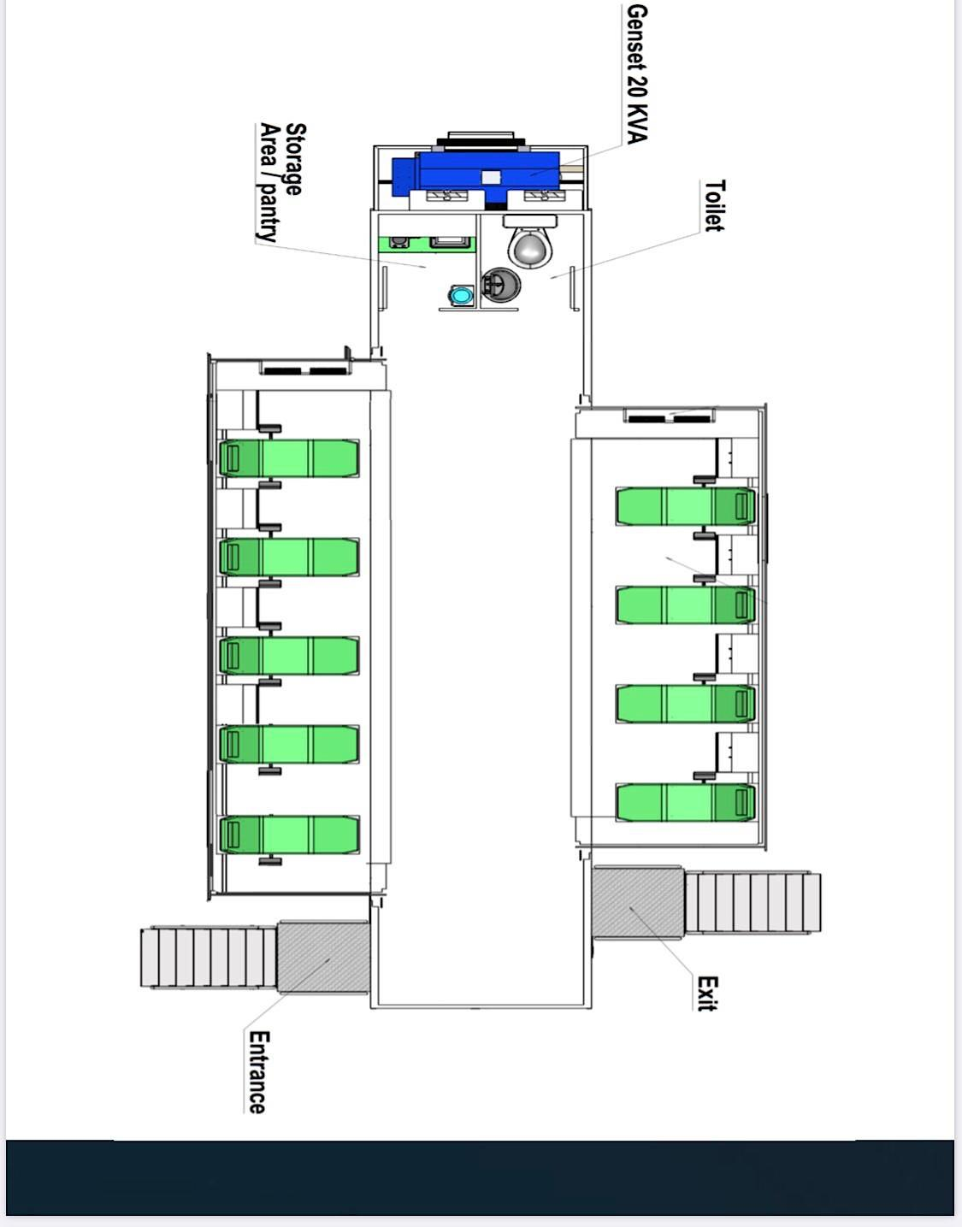
Intended design of the Quarantine bus

Each bus will have 1 general practitioner and 1 nurse aboard it to attend to the quarantined persons. Each Ambulance will have on board one paramedic / group D staff member and 1 ambulance driver.

The sanitation within the mobile quarantine units will be managed through SDS, an advanced state of the art disinfectant solution dispenser (Hospital grade, Eco-friendly, 100% safe and tested) when unoccupied. It guarantees reachability of the disinfectant to all parts of the unit, it is timer controlled and takes 4 minutes to dispense the sanitizing liquid and another 2 minutes for the unit to be aerated, thereby sanitizing the mobile quarantine unit and making it ready for use in a quick 6 minutes.

TOTAL STAFF NUMBER
Doctor 02

Nurse 02

Ambulance

BUDGET

Anticipated costs as listed below –

Considering that the procurement of a new bus is necessary, cost breakdown is as follows:

Item |  | Cost for 1 | Cost for 2
1 fully equipped bus (9 beds) | INR 70 Lakhs |  | INR 1.4 Crores
Equipping 1 Ventilator unit | INR 30 Lakhs
Total |  |  | INR 1.7 Crores

Considering the bus is acquired via the Government, and it is then refurbished, cost breakdown is anticipated as below:

Item |  | Cost for 1 |  | Cost for 2
Refurbishing 1 bus | INR 35 Lakhs |  | INR 70 Lakhs
Equipping 1 Ventilator Unit | INR 30 Lakhs
Total |  |  | INR 1 Crore

https://www.indiatoday.in/india/story/coronavirus-in-india-12-private-labs-authorised-to-conduct-covid-19-tests-have-15-000-collection-centres-1658796-2020-03-23

https://theprint.in/opinion/current-rate-india-30000-covid-19-deaths-may-no-hospital-bed-june-data/385386/

https://karunadu.karnataka.gov.in/hfw/pages/Contact-Us.aspx

https://www.who.int/docs/default-source/coronaviruse/situation-reports/20200322-sitrep-62-covid-19.pdf?sfvrsn=f7764c46_2

