Muwakhat Foundation provide food to needy families in COVID-19 Lockdown

PROGRESS REPORT
Period: Feb 26 – Jun 20, 2020
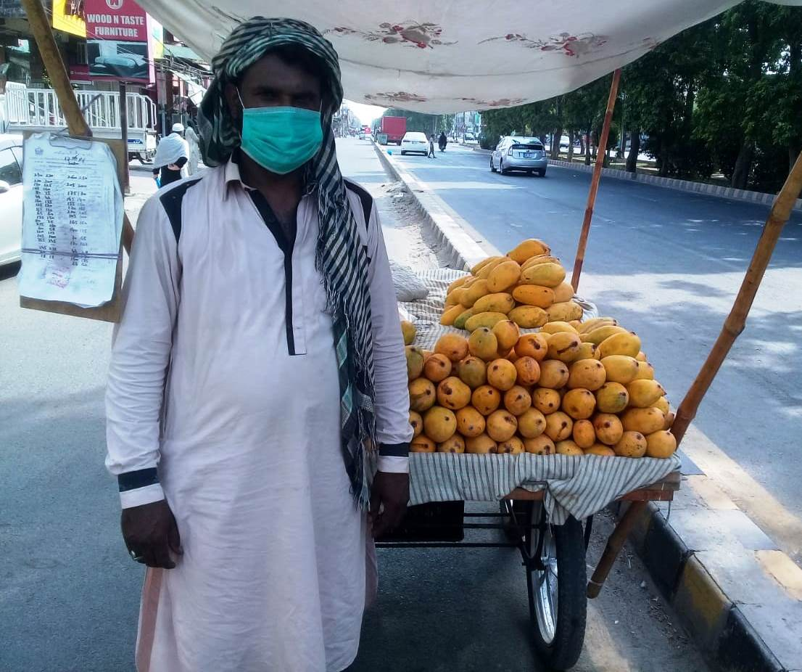

In Coronavirus pandemic, Muwakhat Foundation tirelessly working with poor families who are living hand to mouth. Since March 20, 2020 serving meal, food package, cash and emergency safety kit 1800 affected families through 28 volunteers in Lahore and Kasur districts. This help overcome hunger and survive in Lockdown period.
POOR FAMILIES FORCED TO WORK IN LOCKDOWN PERIODS TO FEED THEIR HOME AND SAVE FROM STARVATION.
Muwakhat Foundation is one of the organizations who come in action within a week of corona virus confirmed in Pakistan.
Following activities did for support of poor families from February 26 till June 20, 2020:
Hand Wash and stay home Campaign

Muwakhat Foundation started awareness campaign of hand wash in communities of Lahore and Kasur District after confirmed first two cases of the corona virus in February 26, 2020.
Our volunteers spread awareness in schools, members’ home and community centers to washing their hands advising to stay home and practice social distancing.
Following activities done from March 03 till June 20, 2020:
- 28 volunteers joined organization for save people in working communities.
- Data collected of daily wagers, factory workers and other affected labours affected from lockdown.
- Result of data collection: total 36,839 daily wagers affected from lockdown.
- Awareness of washing hands, stay home and practice social distancing given to 4800 members of community.
- Distributed 2 soaps and 6 masks to one family and total 1600 families received kits.

Hand Fresh Meal Box distributed to street children, daily wagers and homeless families

Fresh cooked food boxes distribute in streets and traffic signals where daily wagers and street children need immediate help.
Cost of one box per head is 1.25 US Dollar
Total Fresh meal boxes distributed: 4,950
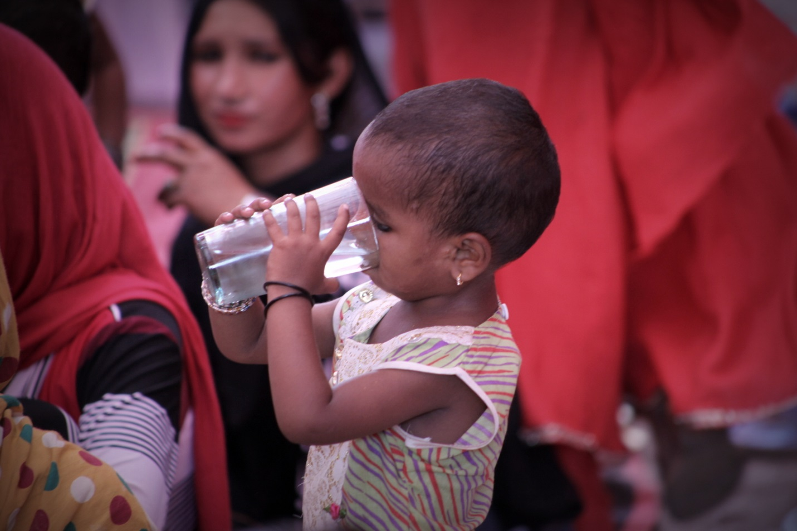

Distributed Food packages and cash to daily wagers’ families affected from lockdown.

Monthly dry food package distribute to families along with cash support.
Food package includes Include wheat, rice, lentils, sugar, tea, surf, soap, and mask and each food package cost US$ 35
Cash amount for help to cover day to day home expenses and distribute US$ 45 to one family
Total monthly support to one family is 80US$
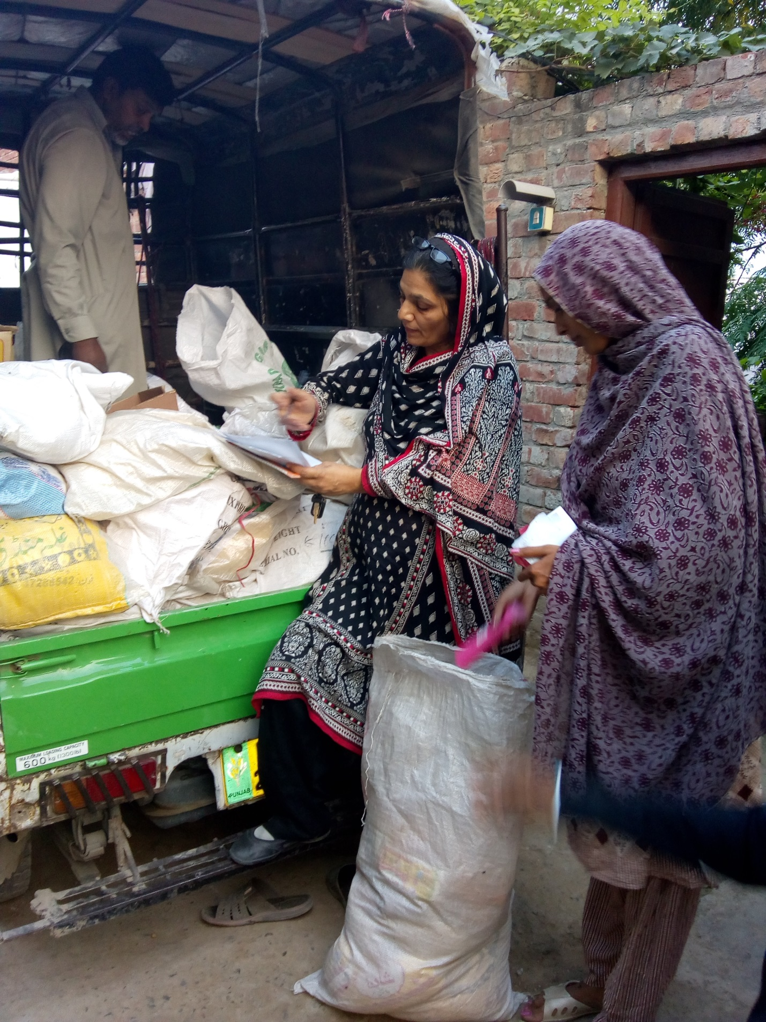

FOOD PACKAGE & CASH DISTRIBUTED TO 376 POOR FAMILIES

# of FOOD PACKAGES 1890 units
# of Cash Packets 1340 Packets

We reached only 1900 families out of 32000 families. Let’s all come together to fight this pandemic and ensure that nobody is hungry during this difficult time.
Let’s all come together to fight this pandemic and ensure that nobody is hungry during this difficult time.
Help us feed them. Join the movement. Donate generously.

