MASAMBA COMMUNITY DEVELOPMENT INITIATIVE REPORT

Masamba Community Development Initiative Committee was formed on 25th April, 2020. It was formed after members from the Zawe family being members of the Chikayela village decided to come together with some community members to spearhead the development of their original village. Though now working from different parts of the country in different capacities, they want to pay back to their community through different developmental programmes. This was after realising that the village had remained behind in terms of development for a long time. The main aim of its establishment is to spearhead developmental activities, to support the elderly, the HIV/AIDS affected, the disabled, manage the environment and sensitizing the community on the importance of education. The committee through its members will work hand in hand with various government agencies and non- governmental organisations.

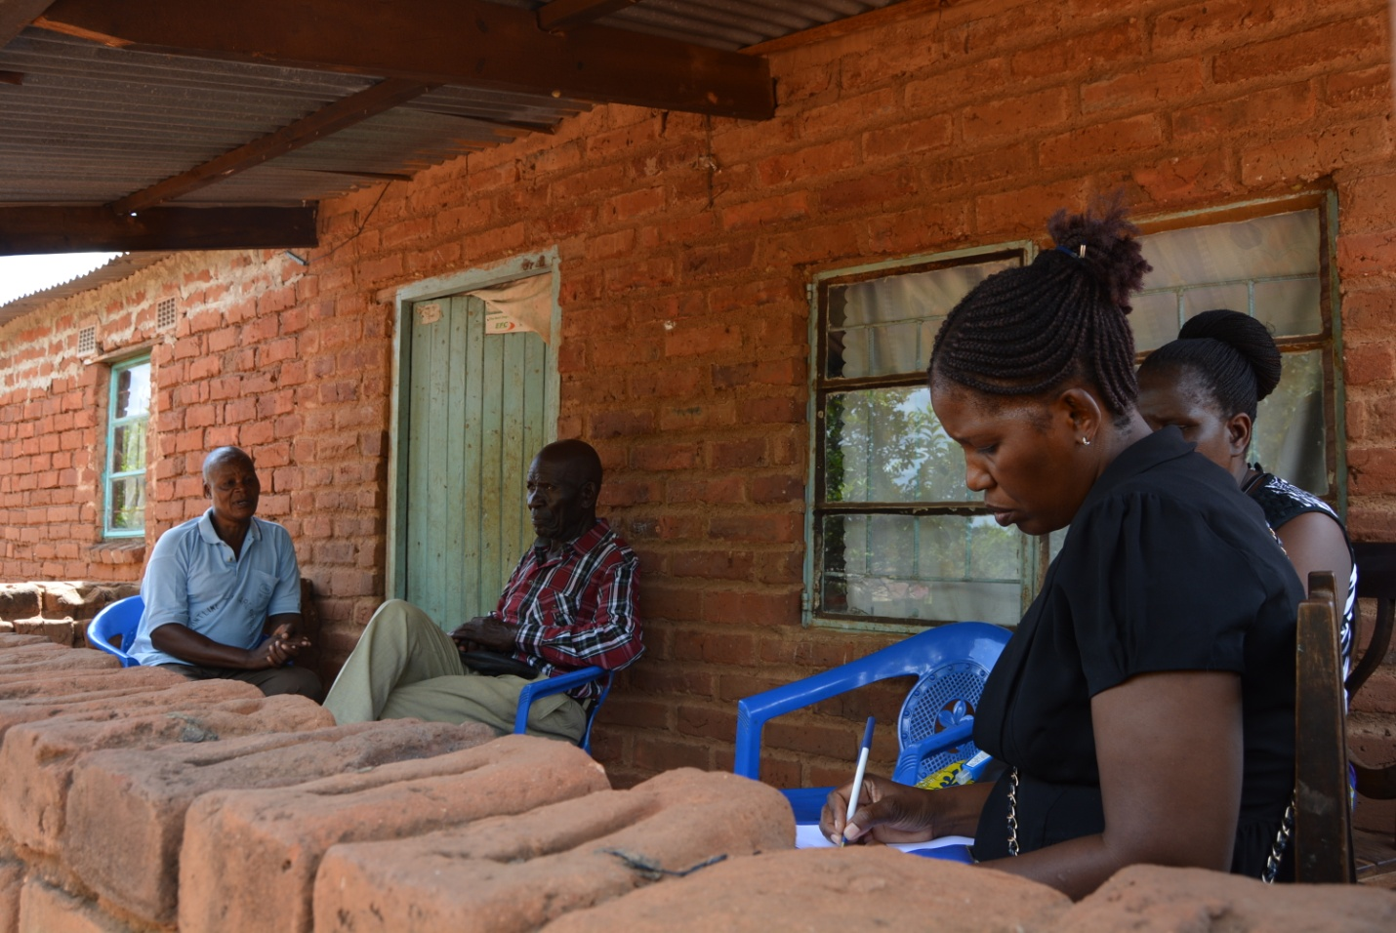
The secretary and some members of the committee talked to the village headman on the challenges faced by the community. The headman informed the members that the challenges are many but the most urgent ones were construction of a 1 by 3 classroom block and a health post. Many children in the community do not go to school because of the poverty levels faced by the parents. The nearest clinic is about 10 km away as a result some pregnant mothers deliver on the way. Lack of clean drinking water was another challenge which the community is facing.
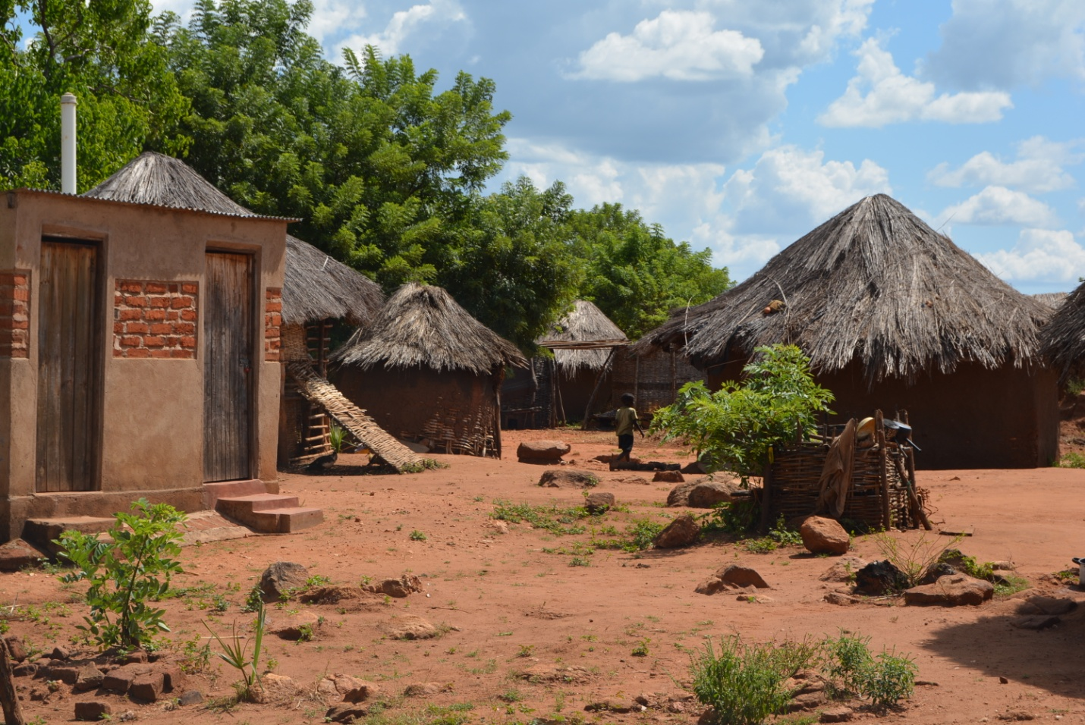
Some of the mud hut where people live in the village. From this picture one can see that this community is far from achieving the first four millennium development goals. High poverty levels can be seen from the entrance of the village.

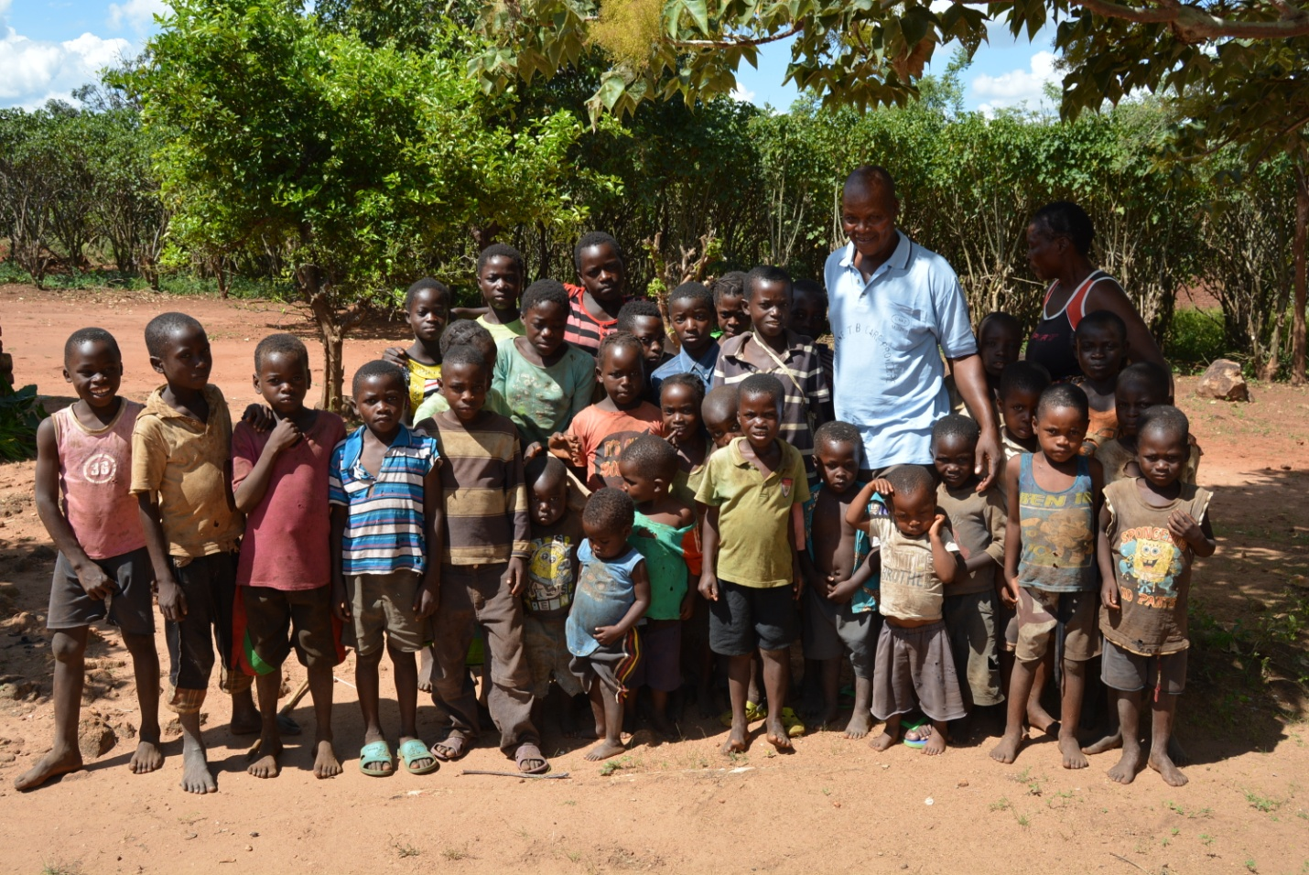
These children do not go to school because the parents cannot afford to buy school uniforms, books and other school requirement. Moreover some parents do not see the need of sending a child to school because very few finish the twelfth grade. For the girls they fall pregnant as soon as they reach puberty.

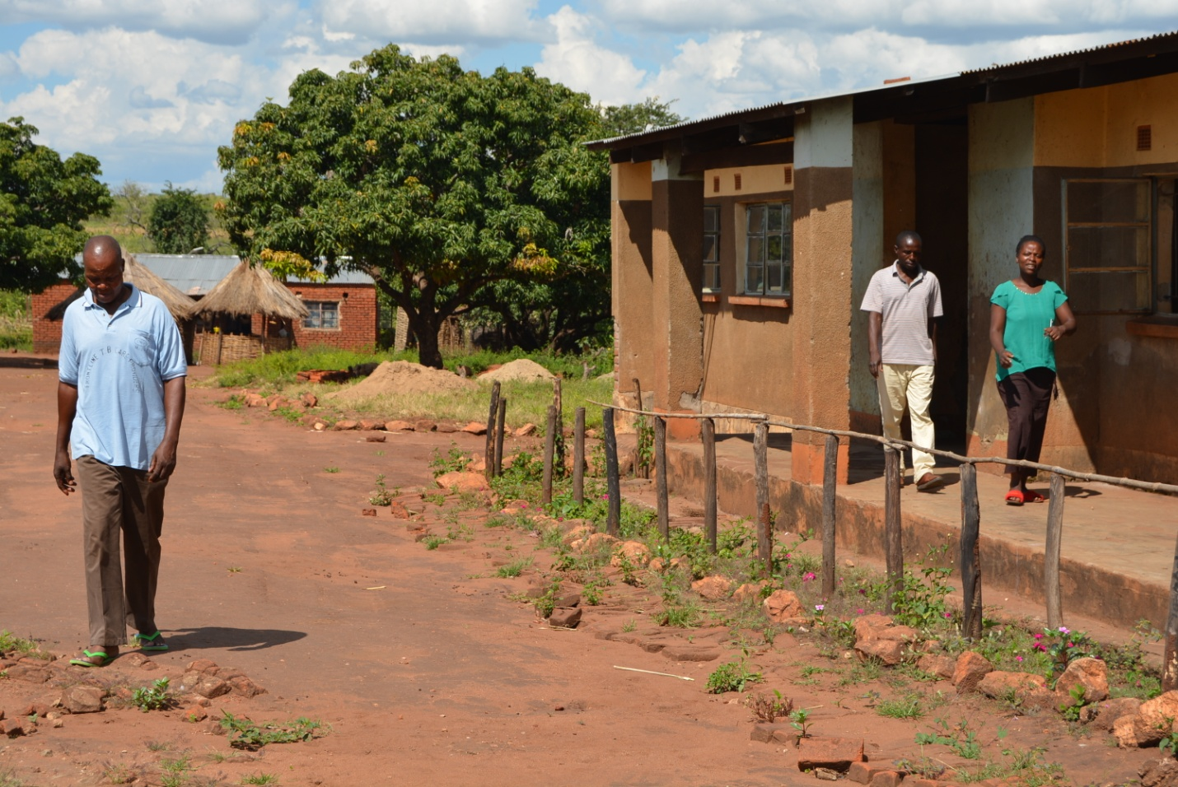
The committee went on to chat with the school senior teacher who gave us a brief history of the school and its challenges. Fifteen years ago, the community came together and established Masamba Community School to promote early childhood and primary education among children. The School has since graduated into a primary school after the construction of the only 1 by 3 classroom block with the support of the government and two staff houses by the community. However, due to poverty some students drop out before the seventh grade. As a result of this problem, girl children are forced into early marriages. The only school has also got its own problems. The only 1 by 3 classroom block is not enough to cater for early childhood up to the seventh grade now standing at more than 500 pupils. Four trained teachers plus three volunteers have to deal with the entire pupil population. Books, desks and other educational materials needed for quality teaching and learning are also in short supply. These challenges faced by the school have also contributed to children dropping out of school as some of them are made to learn from ramshackle structures due to shortage of classrooms.

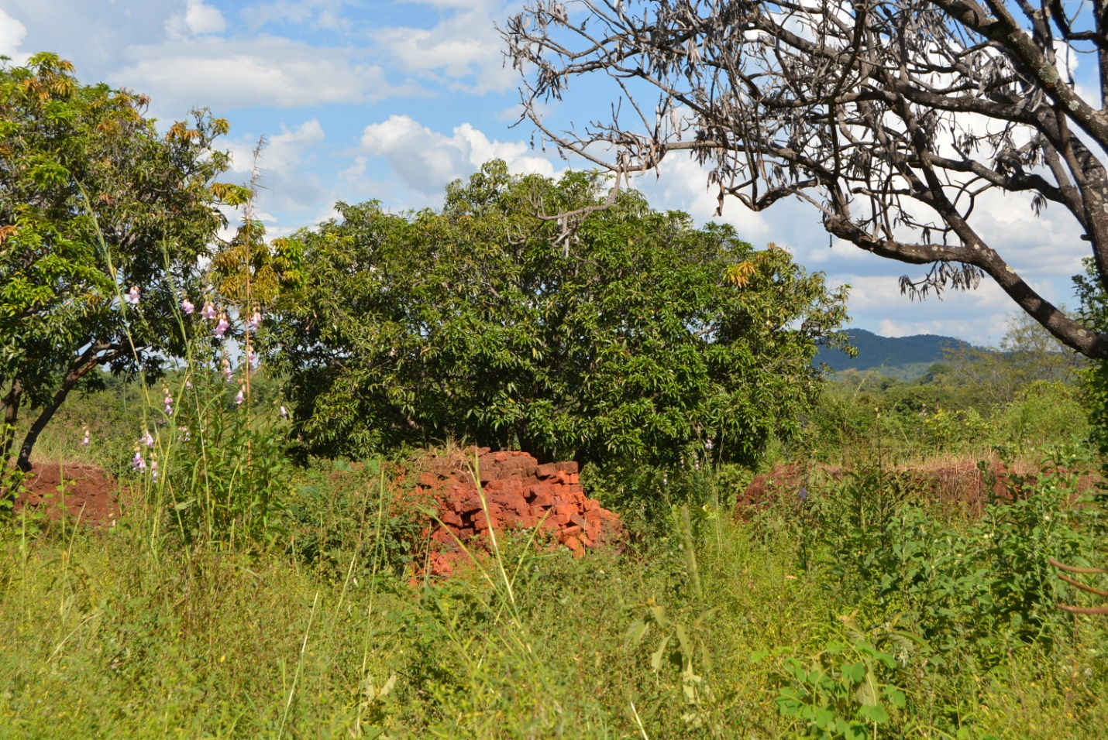
After being sensitized by our organization the community has now seen the need to work together for the betterment of the community. As a result of our sensitization meetings, the enrollment for the first graders has doubled for next year’s enrollment. The community volunteered to mould the burnt brick as seen in the picture. This was part of community contribution towards the construction of a 1 by 3 classroom block. They have now realized that development comes from within them.
Masamba community development Initiative would want to continue to engage and spearhead developmental activities for the betterment of everyone in the community.

