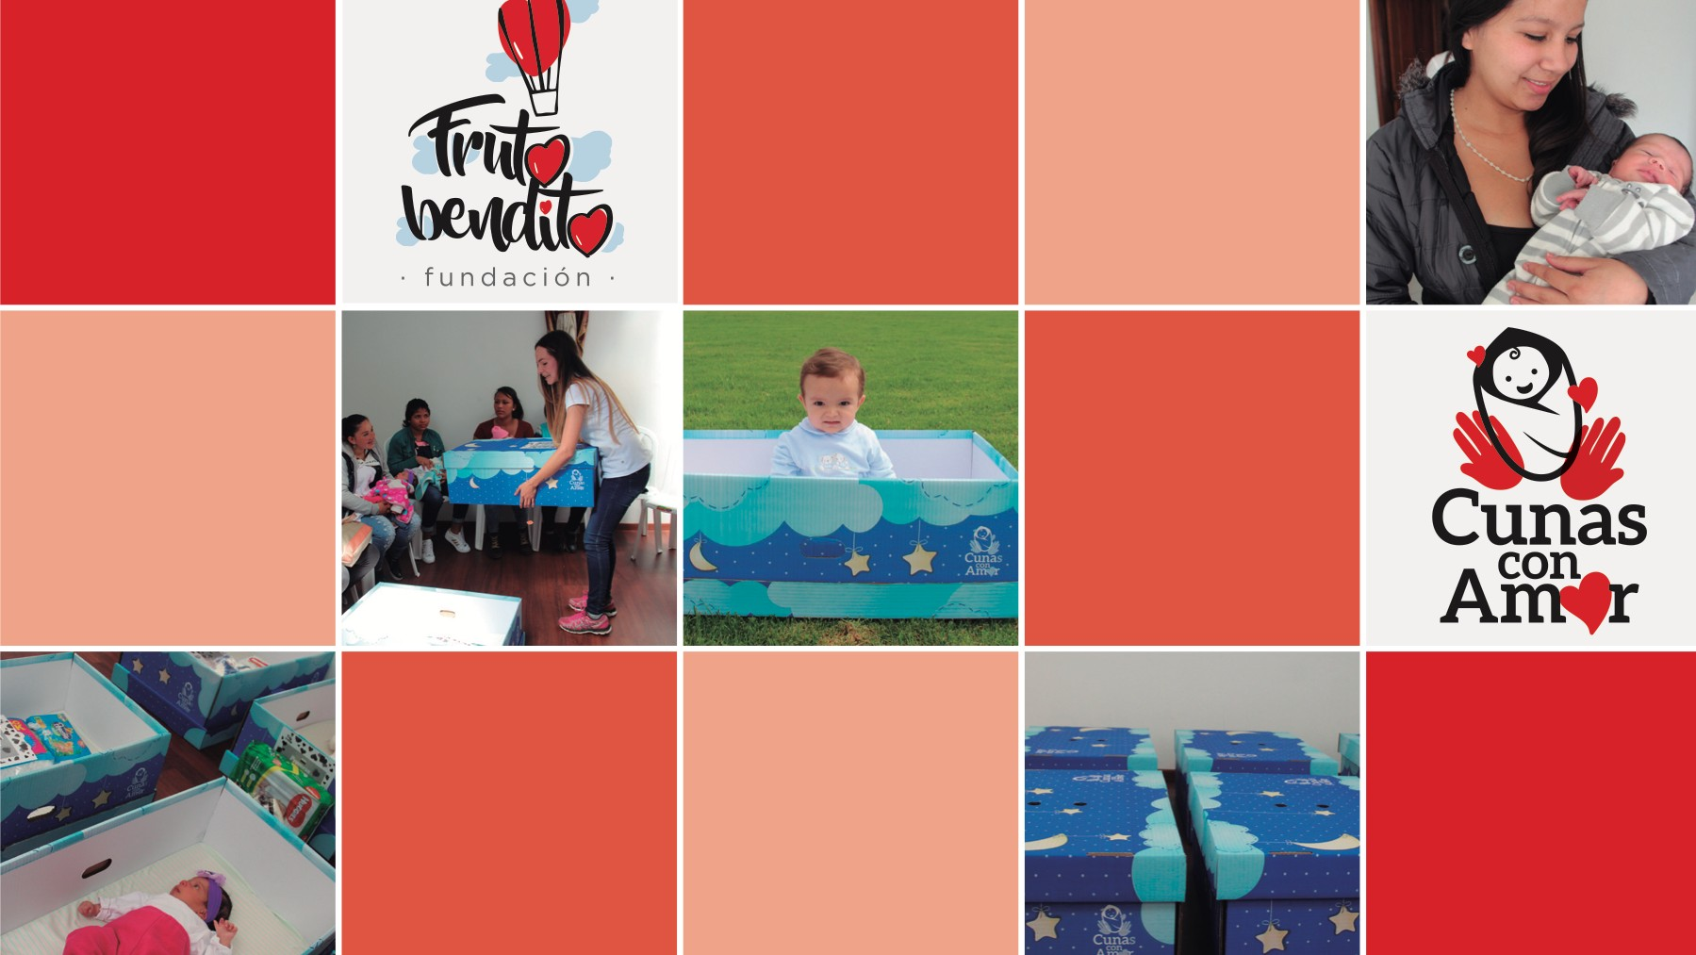

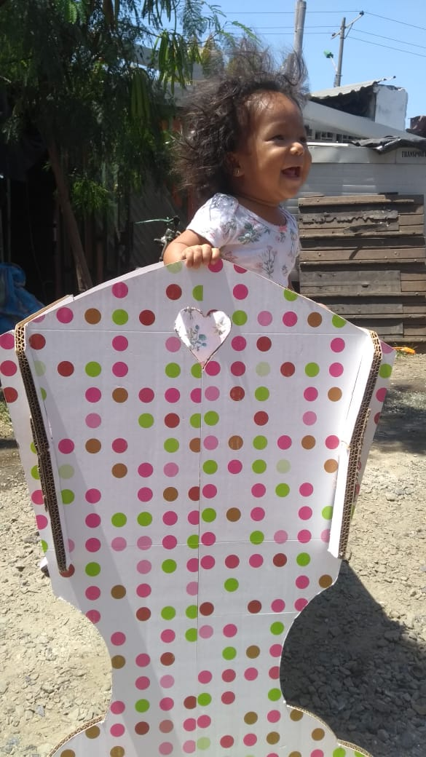
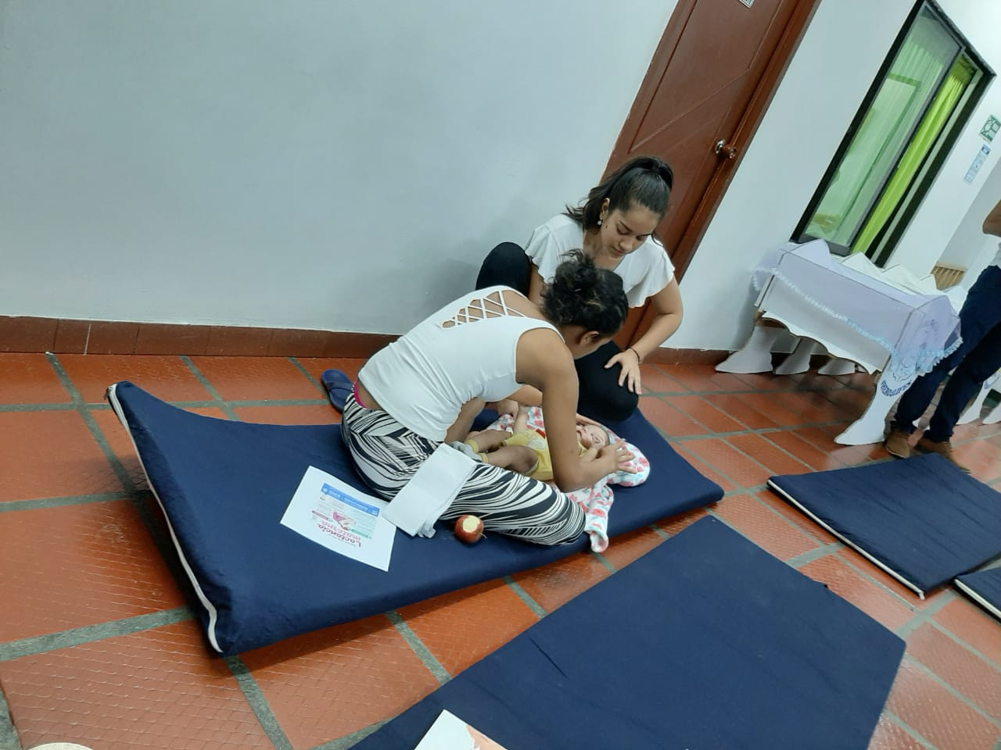

WWW.fundacioncunadevida.org

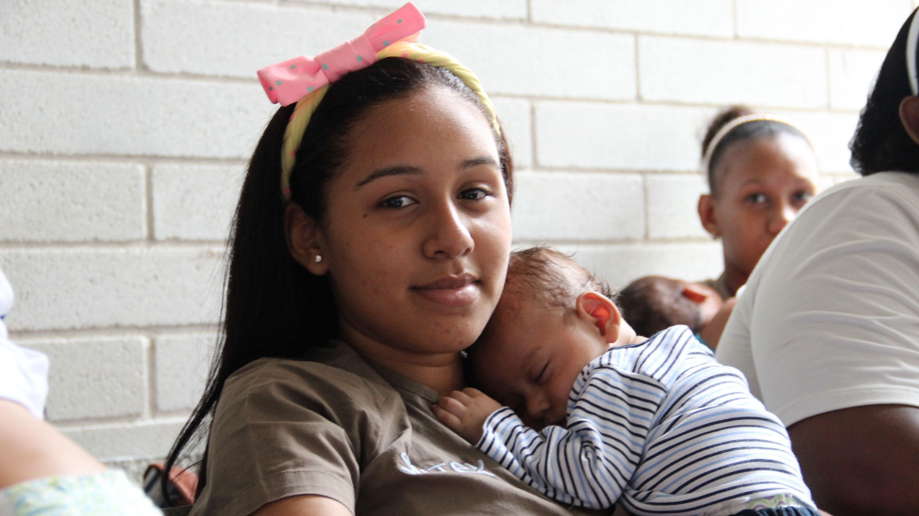
Management report

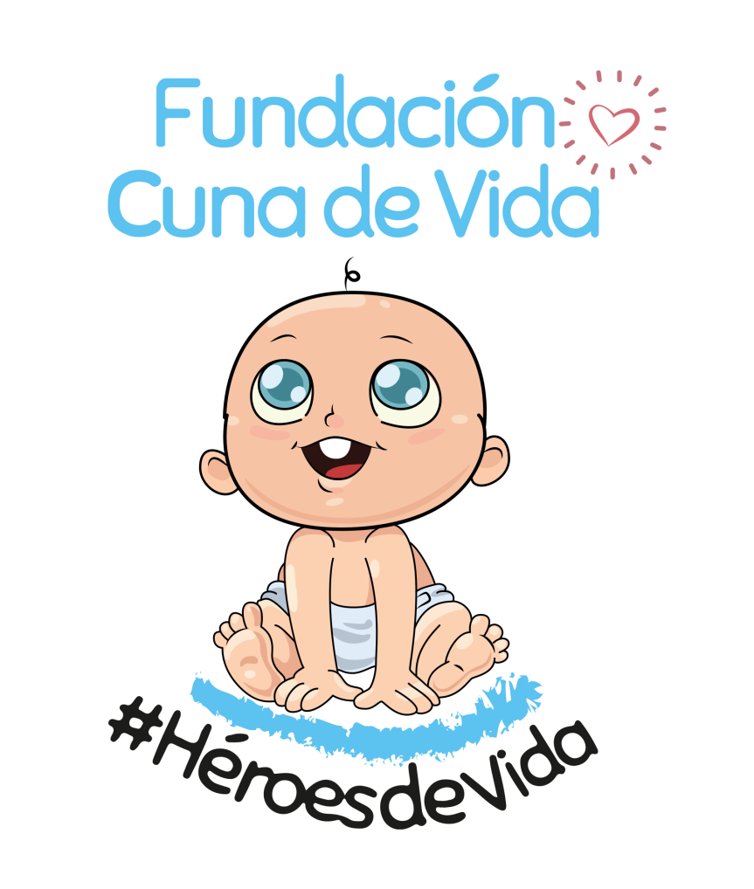

WWW.fundacioncunadevida.org

Index

Índice
3

2
1
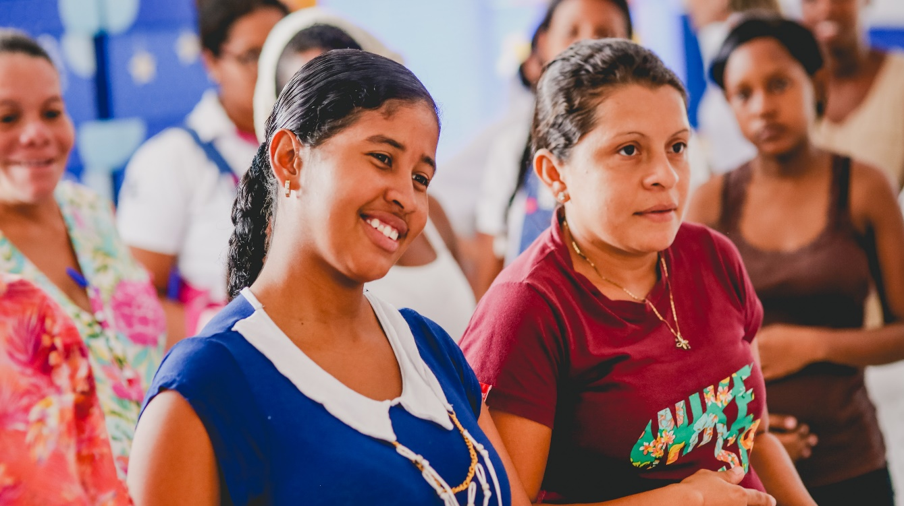

Donations
Legally in order
Our steps

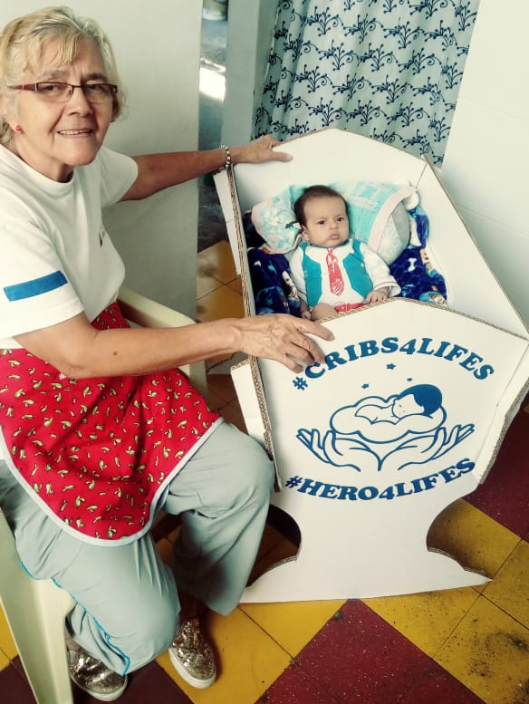
4
Financial aspects
Foreseeable evolution of the company
5
4

The non-profit organization Cuna de Vida Foundation, identified with NIT 901349482-4, was legally constituted on December 18, 2019 before the Chamber of Commerce of Cali. Our foundation was born with the objective of cutting the cycle of poverty in vulnerable families in Colombia, first through the dignification of life and later with education for mothers and their children on health and well-being issues.

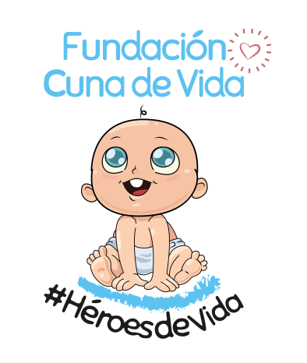
Our first project is called Heroes of Life, where we protect the newborns of Colombia until almost 2 years old and accompany the children almost up to 3 years old. We make cribs in corrugated cardboard and donate them with their mattress, protective blanket and starter kit for the vulnerable population, in strata 1, 2 and 3.

Our Steps
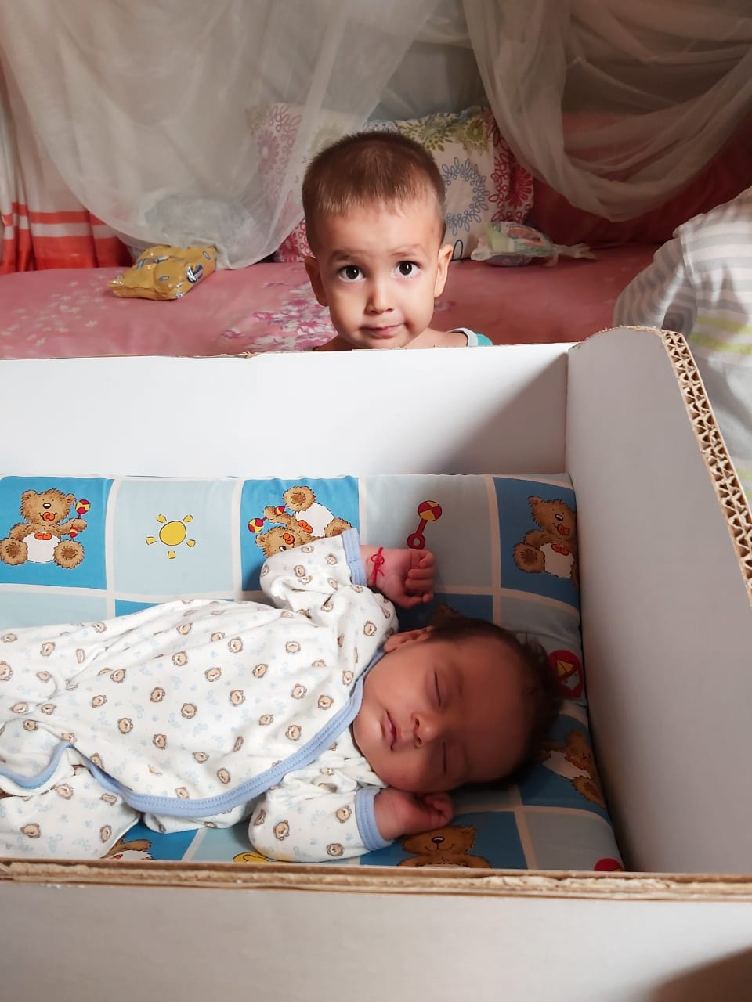

1

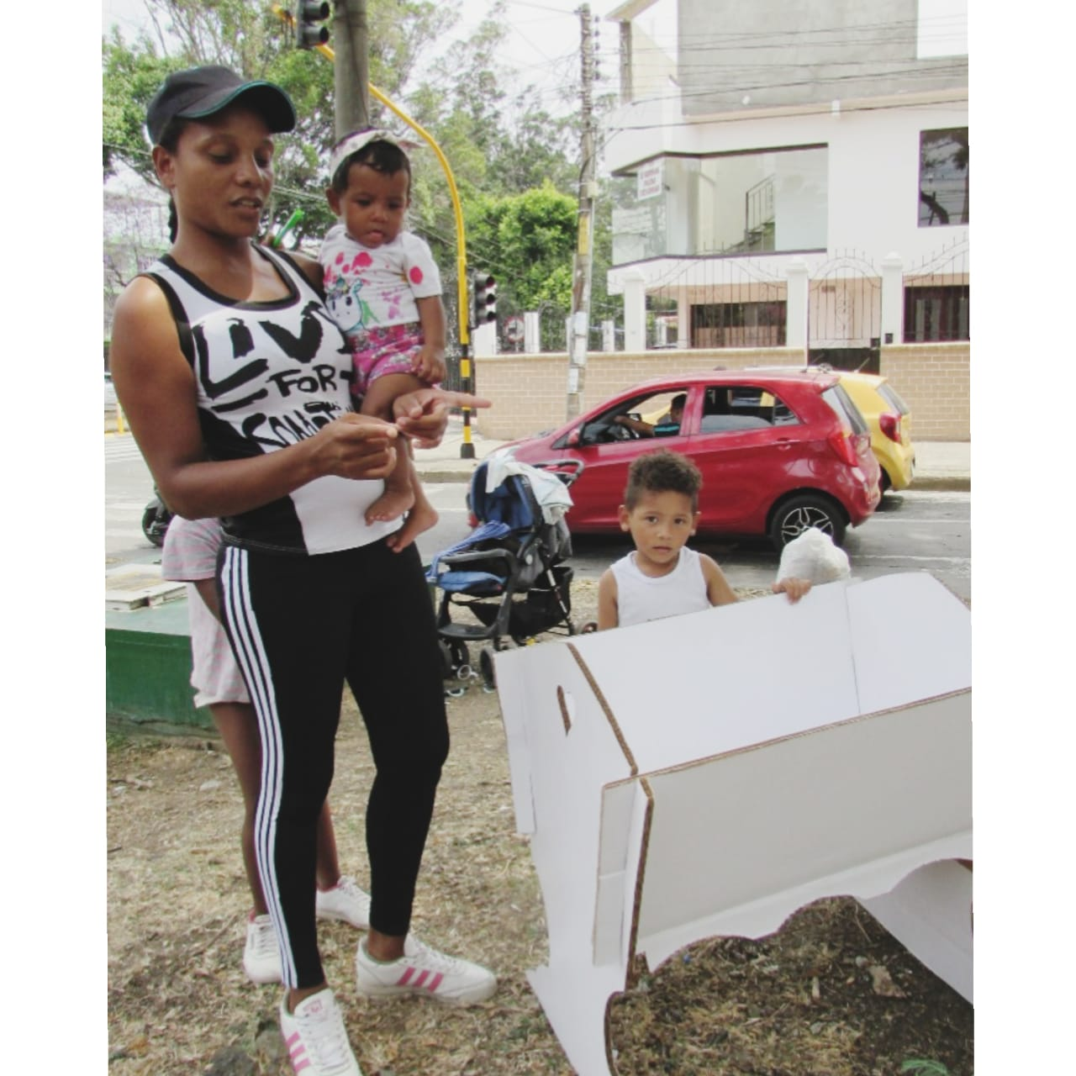

In compliance with the bylaws of the Foundation and in accordance with the legal regulations in force (article 46 and 47 of law 222 of 1995 and law 603 of 2000) we present ourselves before the entities Chamber and Commerce and DIAN, who gave the guarantee for our operation by complying with the provisions of the law.

Soon we will present to the
District Directorate of Inspection and Surveillance, the management report describing the most relevant activities carried out since December 2019.

Legally in order
2
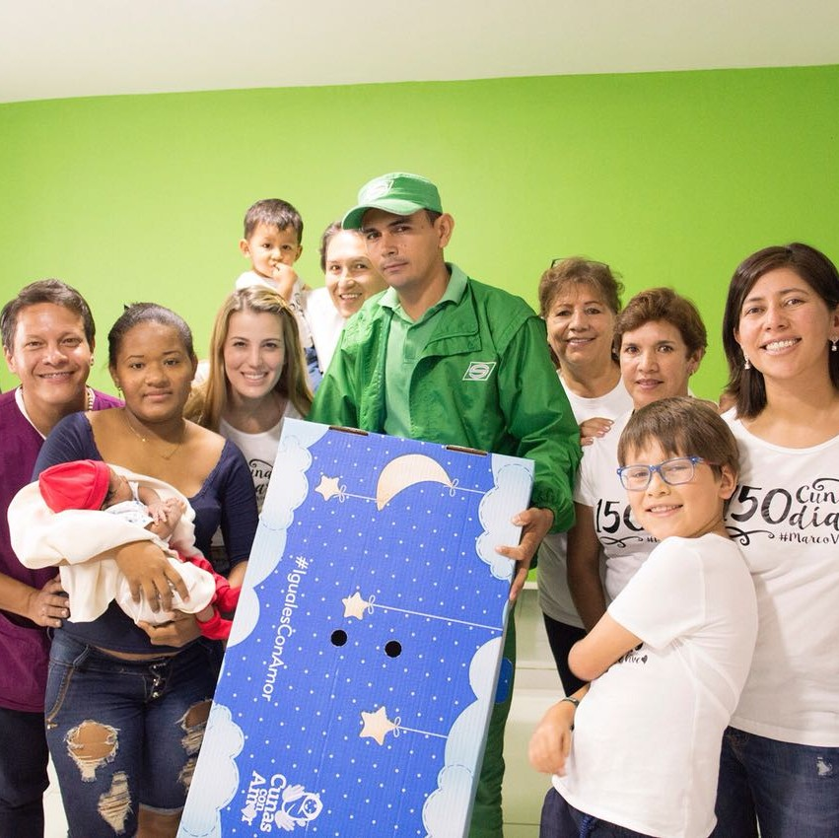
Donations
3
The “Cuna de Vida” project is funded through the sponsorship of a crib that has a value of $ 49,000COP where it is delivered with its mattress, blanket and an initial kit. We offer cribs to organic mothers where they buy two for $ 95,000COP, one for them and the other we donate.

During the time we have been, we have delivered 30 cribs and taught the workshops of our educational program for mothers and their children.

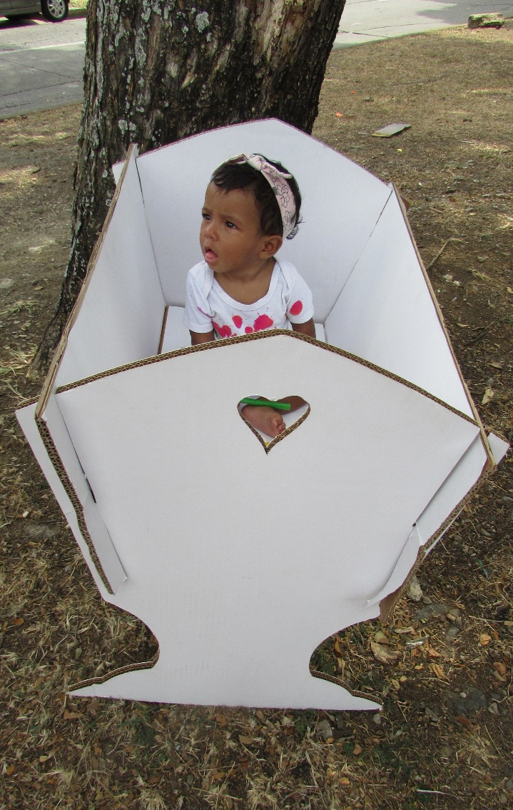
Financial Aspects

The Cuna de Vida Foundation is in the search and implementation of activities aimed at generating income for the fulfillment of its corporate purpose.

We accompany through the Heroes of Life plan, 15 migrant families from Venezuela. The creation and launch of the Godfather Plan is under development and continue to bring education and love to the vulnerable corners of Colombia.

.

4

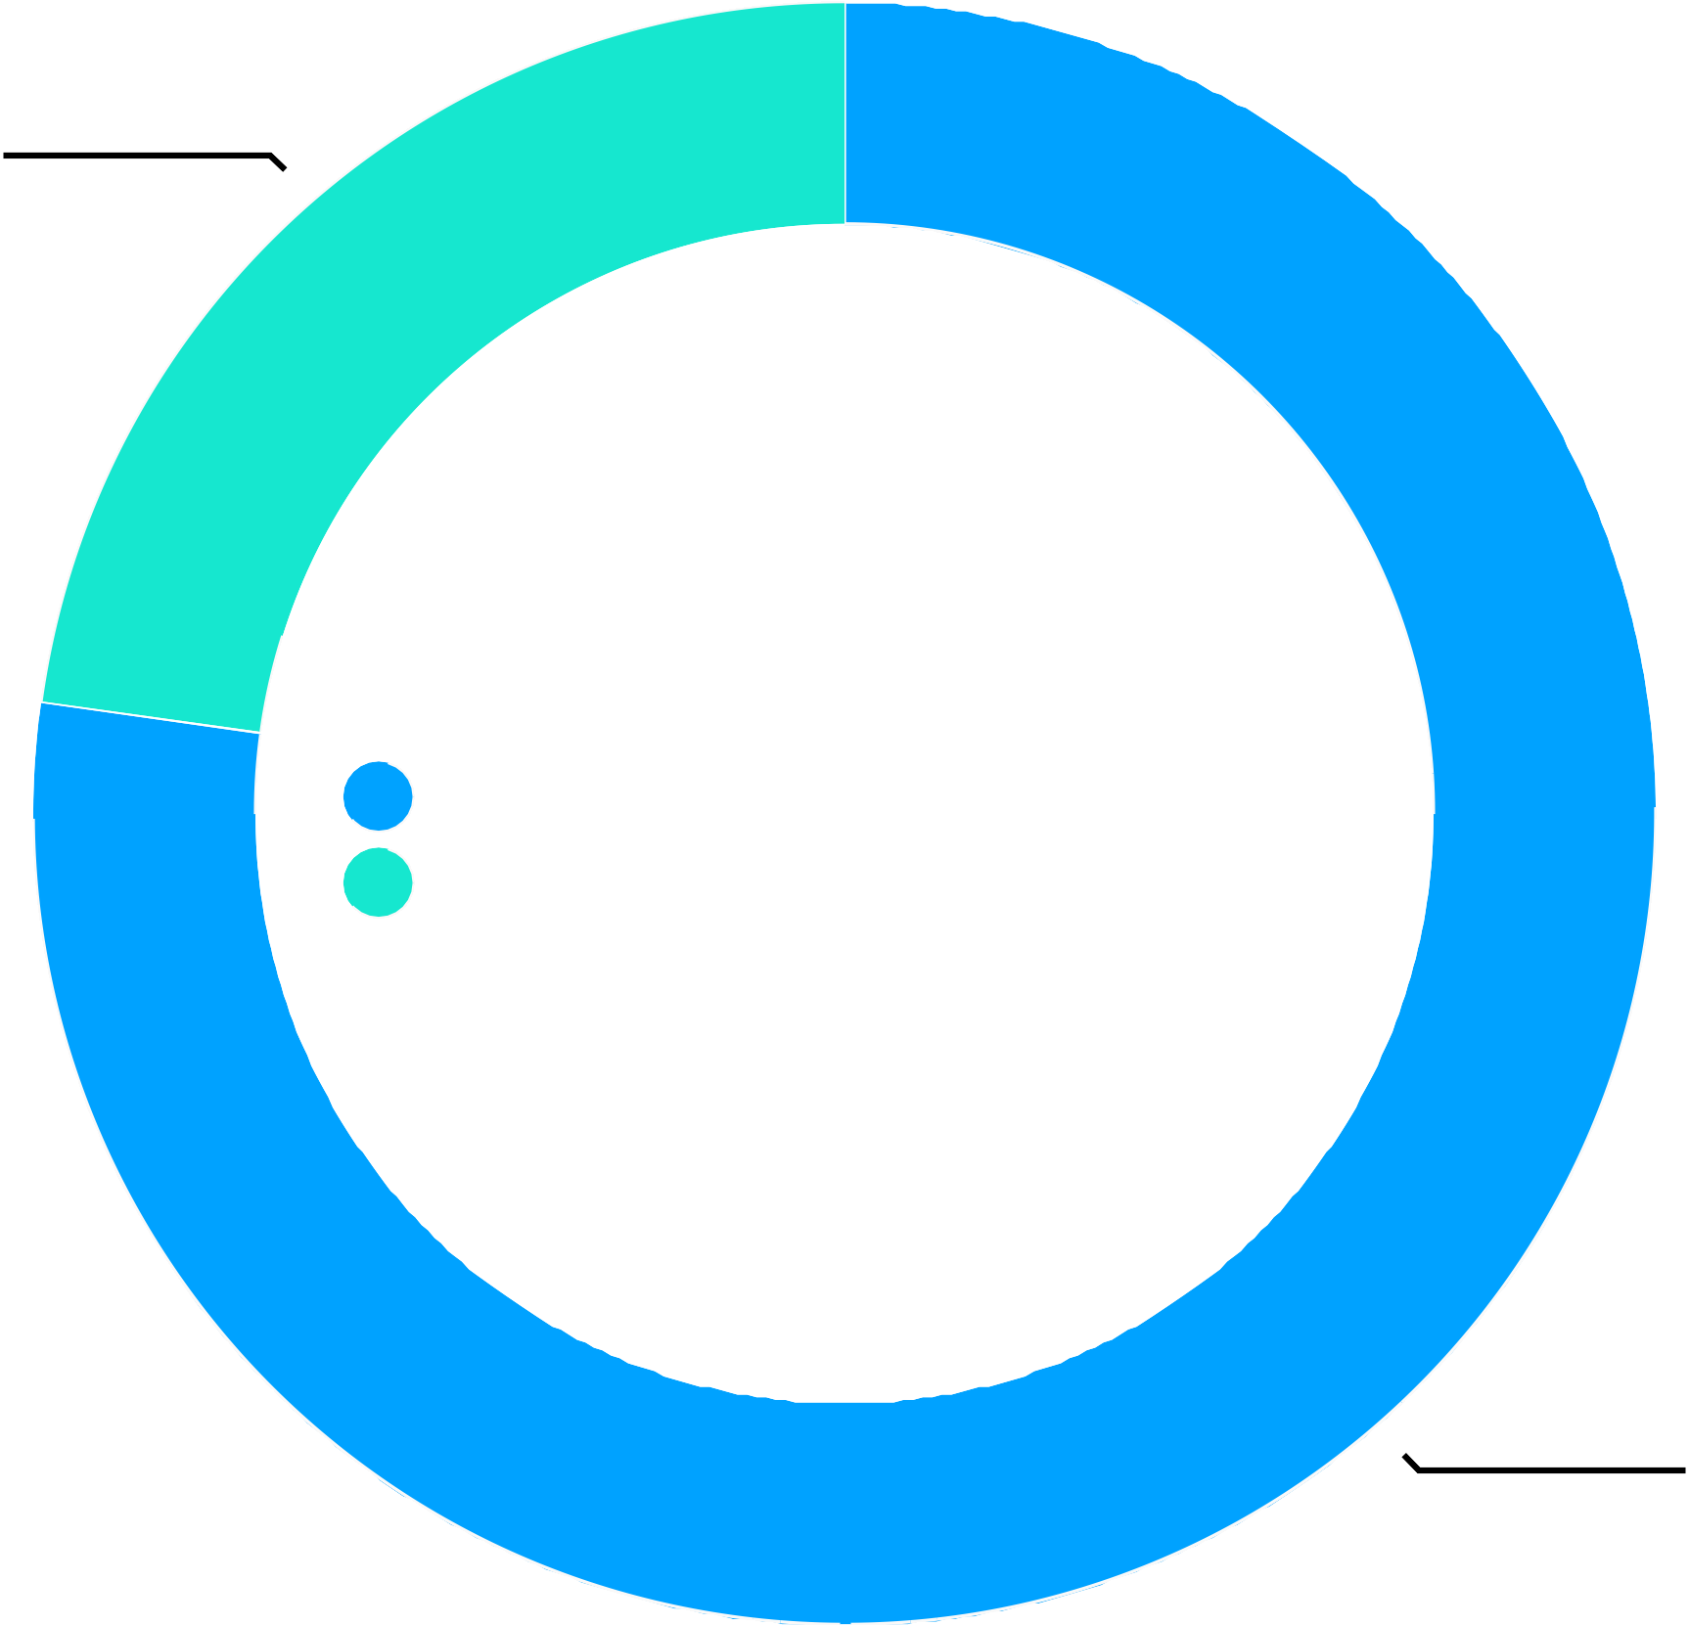
Financial Aspects

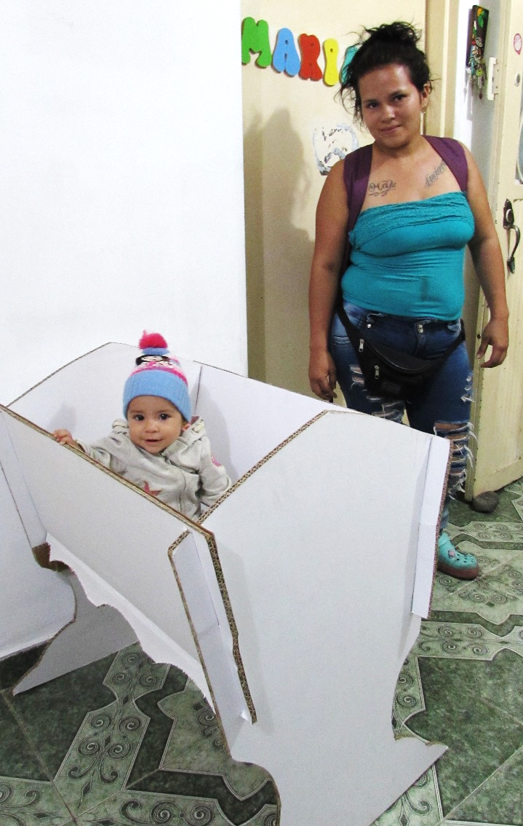

Expenses
administrative
200,000COP

Program Cuna de Vida 1.000.000 COP

Foreseeable evolution of the company

The priority objective of Fundación Cuna de Vida, for the year 2020 is to continue fulfilling our mission as agents of social change, to reach rural areas where the need is even greater, to continue attending the emergency due to migration of Venezuelan families and to build or adapt a space where our moms can be productive while they are with their children.

Provide education so that they are more integral women and therefore can raise their children in a safer and more dignified way.
We want to build functional families in Colombia.

5

IMPORTANT EVENTS HAPPENED AFTER EXERCISE

To date there have been no events that affect the financial and administrative structure of the company.

OPERATIONS CELEBRATED WITH PARTNERS AND ADMINISTRATORS

The entity did not enter into operations with the partners or with the administrators.

STATUS OF COMPLIANCE THE RULES ON INTELLECTUAL PROPERTY AND COPYRIGHT

Law 603 from 2002
The entity is fully complying with Law 603 of the year 2000 and the current legal norms regarding copyright and intellectual property.

Law 1676 from 2013
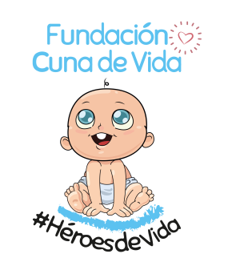
The entity is complying with the provisions of article 87 of law 1676 as long as it did not hinder the free circulation of invoices issued by suppliers

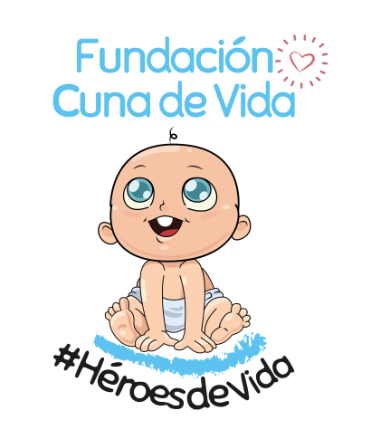
From here
we transform to
COLOMBIA

