Sierra Cares Foundation Vision and Plan
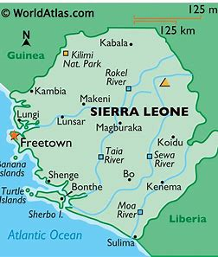
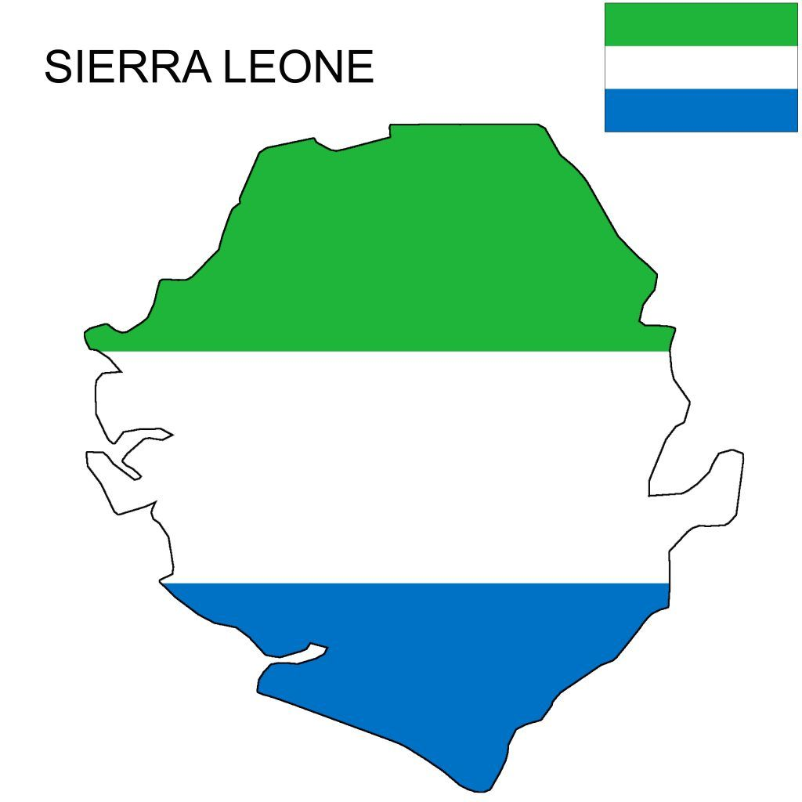

Summary: Sierra Cares Foundation is based in Makeni, Sierra Leone and has been operating for the past 10 years by volunteer, Ibrahim Bangura, to assist women and children who are vulnerable to poverty, human trafficking and lack of food and housing. Sierra Cares Foundation became a registered official US non-profit in September 2020 and will continue to sponsor children for school, orphan children with no other source of support and to aide vulnerable women to gain education and employment to live independently. We believe that prevention, not reaction, is the key to changing communities and supporting them for long term sustainability.
Why Makeni: Makeni is the largest city in the Northern Province of Sierra Leone. The city is the capital of Bombali District, and is the economic center of the Northern Province. Makeni is the fifth largest city in Sierra Leone by population. It is approximately 100 miles east of Sierra Leones Capitol of Freetown. The economic driver in Makeni is agriculture and it is considered a rural community. While it has the largest University in Sierra Leone, the access to education is a barrier to many families which results in creating vulnerabilities for the poor, mainly women and girls. This leads to systemic sexual abuse, child prostitution and families using their girls as dowry or selling them for a price. It is also a hot bed for many Middle Eastern officials to recruit women and children under the guise of working in textile or domestic service situations, with the promise of sending money home to their families. While the promise wounds good, many women and children are forced into labor and sex trafficking situations which end up creating horrific situations for them or even death. The lack of education and understanding of this situation makes many women and girls vulnerable in this region.
Challenge: Working towards sustainable living for women and children who are vulnerable to poverty, disease and lack of education. Many Sierra Leonese woman and children seek jobs in countries such as Kuwait, Saudi Arabia, UAE, etc. with the hopes of finding steady work and funding to send home. Most are tricked and enslaved in horrific working conditions where they are victims of labor and sex trafficking, so do not make it home. When these women do make it home, they are often shunned by their family and members of the community, typically due to the abuse they suffered, facial and bodily deformities and pregnancies. Sierra Cares Foundation aims to provide community education to prevent more women from being sold to Middle Eastern Countries looking to abuse them, and children forced into labor or child bride/marriage and/or prostitution situations.
Solution: Sierra Care foundation serves to provide (1) an emergency safe house for abused women and orphaned children, with no other options, (2) to help educate Children in the Makeni School and (3) to provide education in the form of literacy, basic hygiene, and financial independence to live on their own successfully. Sierra Cares Foundation will also provide an educational job program that is applicable to meet the needs of impoverished women who have been repatriated after being trafficked to other countries.
Sierra Cares Foundation has 3 main components, all set into phases that will create a sustainable, healthy community:
- Education Program: Center for vulnerable populations that includes a facility for education on literacy, wellness, mental health, maternal health and financial literacy. We envision owning land and building a center that can house the education endeavors and serve as a community center. We would like to include a maternal/medical care site for basic needs and resources to support pregnancies, healthy parenting, reproductive needs and sexual abuse care. This community center will also be rounded out with a shelter (see below).
- Safe Shelter Program: A Safe House for repatriated women and children who have been held captive or for child bride situations in Middle Eastern countries and used for State Sanctioned Slavery (in accordance with IOM definitions). This shelter will consist of a 24-bed facility for short- and long-term care, medical needs, psychological and maternal needs of recovered survivors of human trafficking to reintegrate them into their communities. This includes partnering with community resources and educating families about the dangers of sending their women and children to other countries to “work”.
- Orphan Prevention Program: We currently have 68 children who need sponsorship (some are sponsored at $35 a month) to pay for school fees and a partisan nutrition program. We want to continue to support these children with their education and will do so via sponsorship and engagement with their families and/or caregivers during non-school times. Nutrition is essential and we want to build the program to continue to provide food and nourishment for these children as well. In addition to the orphan children, there are several children who need assistance with school fees each year and we would like to provide a scholarship program to assist with these needs to support single parents or poverty-working families, as no child should be without basic education. This will also prevent the children from being forced to work in labor camps or child prostitution, as children who are not enrolled are highly vulnerable to this situation.

Building costs for Wellness center, Clinic and Shelter: $500,000
Immediate need for Land: $3000
Vehicle purchase for transportation: $30,000 and $6,000 a year for upkeep and fuel.
Total: $533,300 to build what we need, this is a 5 year capital plan to raise $133,000 in the first year to meet needs and the remaining $100,000 for 2022-2026.

Funding Needs: Our SCF program is staffed by Ibrahim Bangura and will require two additional staff members at a salary of $350 a month for Ibrahim and $250 a month for each staff member.
Total: $10,200 year for staff.
Monthly costs for sponsorships: 100@$35 a month.
Operating costs:
- Shelter costs: $18,000 for water, sewar, electricity, wifi, food a year.
- Office Space for Ibrahim and team: $3000 year.
- Clinic costs a year: $25,000.
Food for school children $12,000
Emergency child bride recovery funding: $15,000
Repatriation funding to bring women home from Middle East: $10,000
Wellness training program funding: $6,000
Incidentals: $5000

*All costs are anticipated and may change depending on the needs and costs fluctuations.
One-time costs to get Sierra Cares Foundation running as envisioned: $533,000.
Annual Anticipated Operating Costs: $108,200
Currently, SCF with partnership of AAI has 8 women and children sponsored and has incurred expenditures that have not been fundraised for but paid for by members of the AAI/SCF board.

In addition to the program, we would like to schedule 2-3 tris a year for our sponsors to visit Makeni and see their sponsored children and the progress of what we endeavor to do.

Our most pressing need it to purchase land to build Sierra Care Foundation on. This is $3,000.

