WHO WE ARE

ABOUT CAHLIN: Care For Healthy Life Initiative (CAHLIN) was established in 2018 and registered with the Nigerian Corporate Affairs Commission and Anambra State Ministry of Social Welfare, Children and Women Affairs, to promote healthy lifestyle for the people with focus on ending HIV/AIDS, through HIV/AIDS awareness/sensitization, counselling and testing people and referring/linking those that test positive to HIV treatment centers, care and support for people living with HIV/AIDS, prevention of new HIV infections and advocacy to end HIV discrimination/stigmatization.

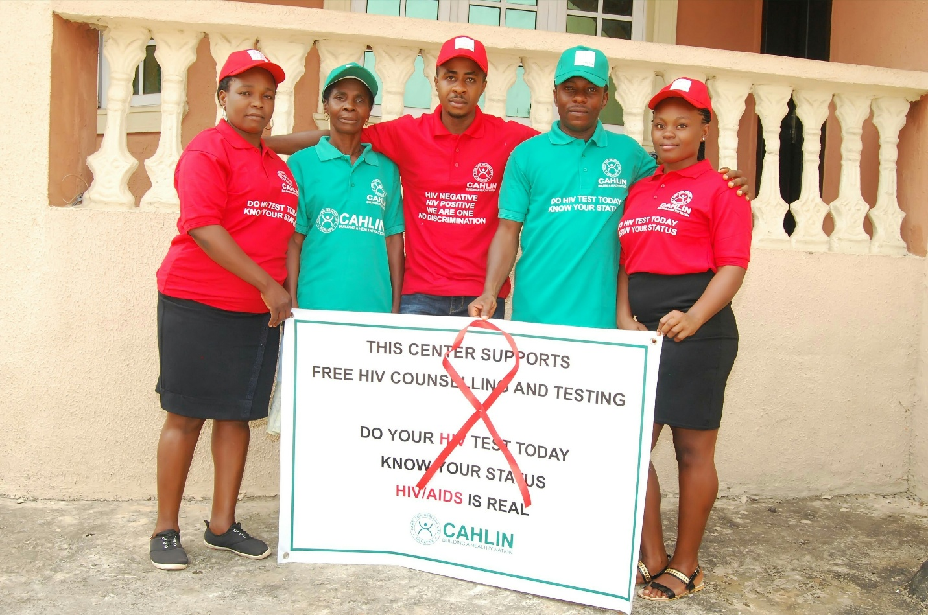

VISION: To have a healthy nation, free of HIV infections, where people living with HIV/AIDS have equal rights with everyone else without any discrimination.

MISSION: To conduct HIV/AIDS awareness/sensitization, counseling and testing people and referring/linking those that test positive to HIV treatment centers, in order to reduce HIV/AIDS prevalence, prevent new HIV infections and also help people to maintain healthy lives.
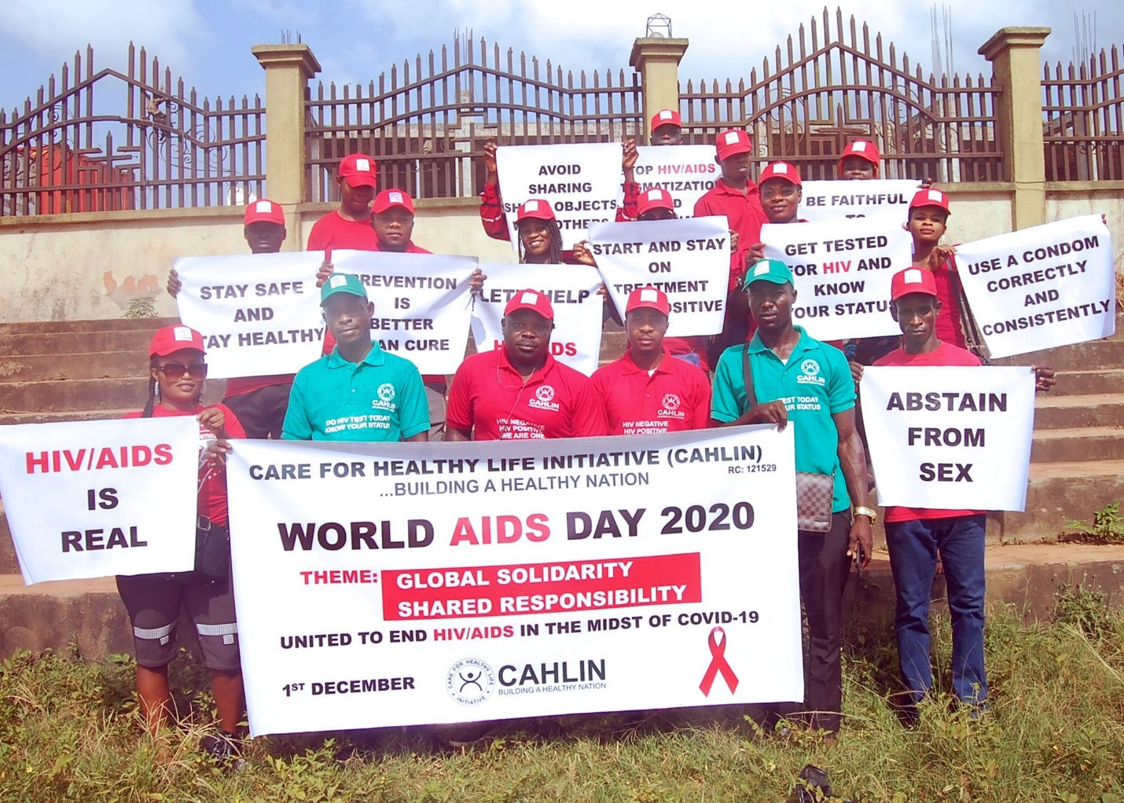
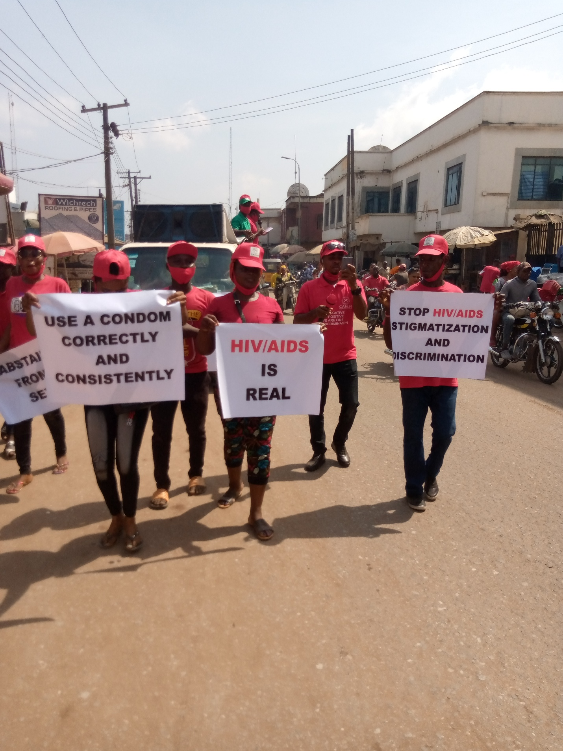
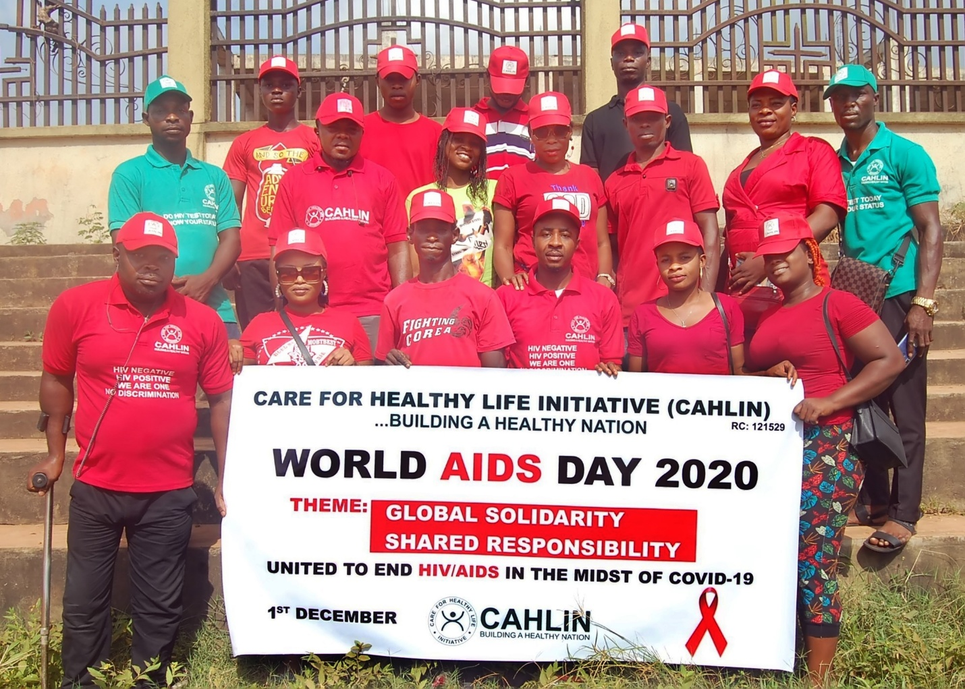

WHAT WE DO

HIV/AIDS SENSITIZATION: We are conducting HIV/AIDS awareness/sensitization in the communities, schools, churches, markets, companies etc, counseling and testing people and referring those that test positive to HIV treatment centers, so they can be enrolled and started on Antiretroviral Therapy (ART). Our positive patients are also linked to HIV support groups. We're working with the United Nations target of 90-90-90 to end HIV/AIDS epidemic.








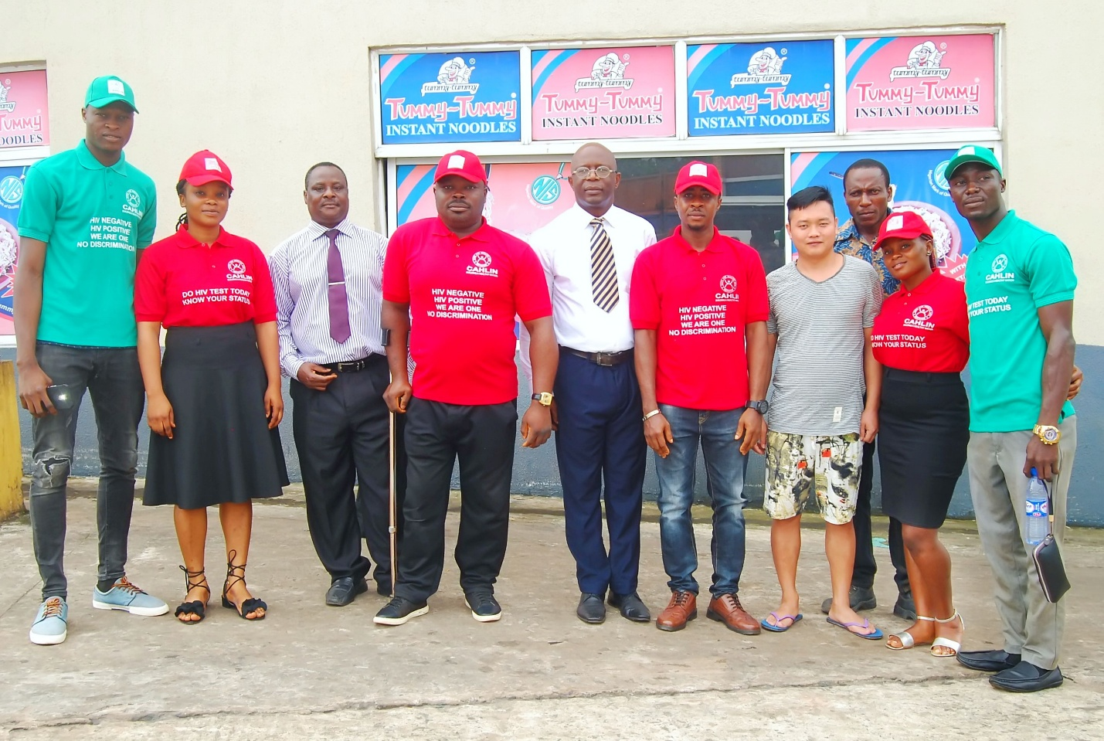
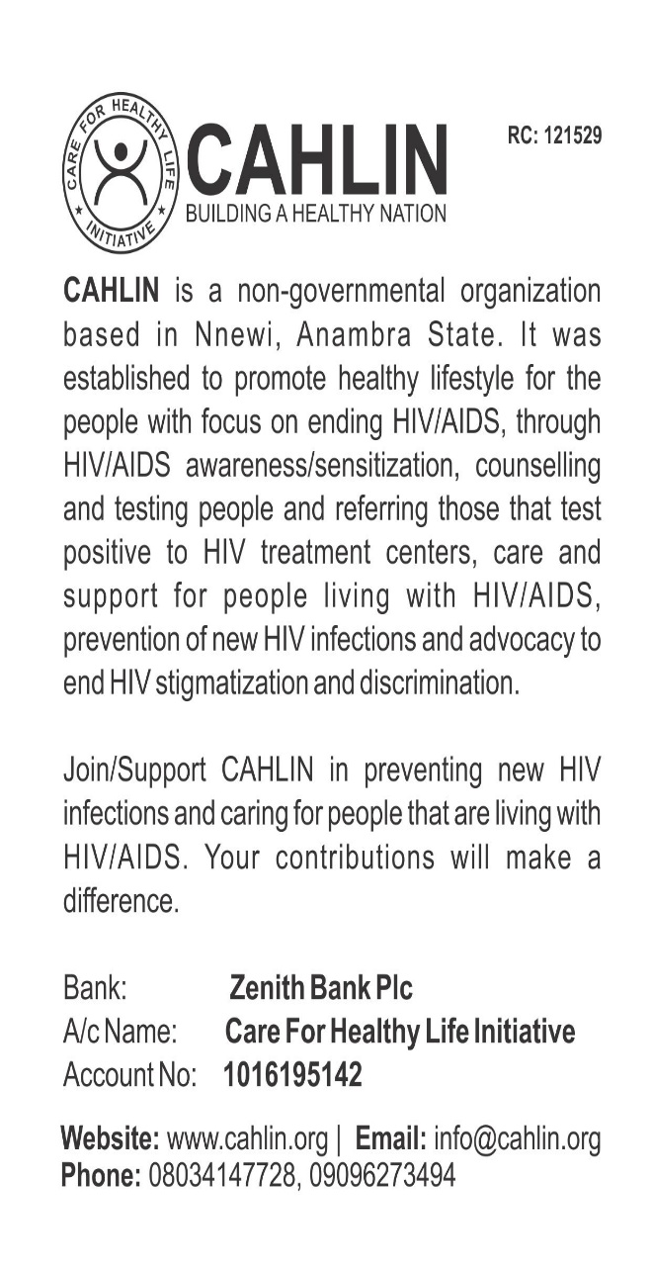
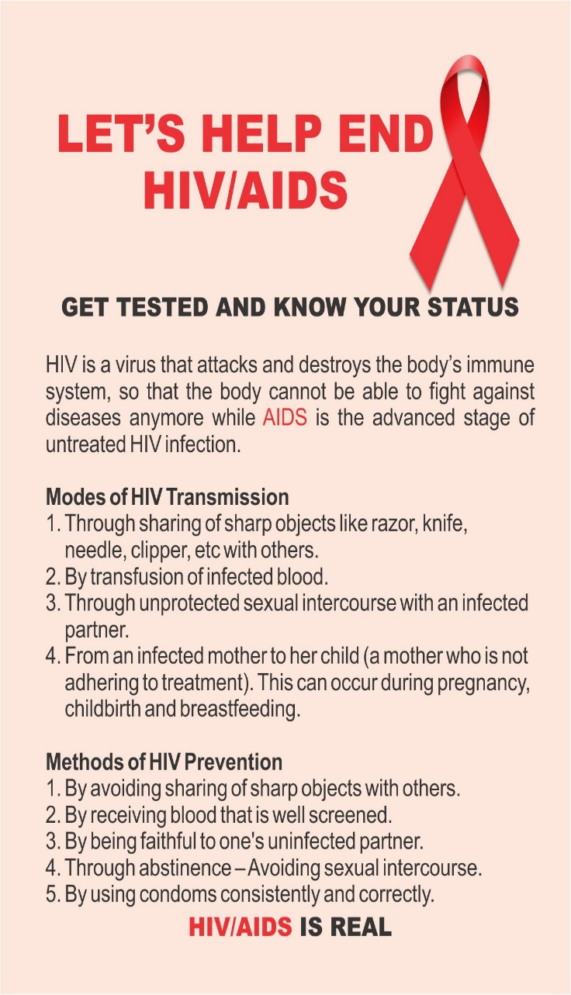

CASE MANAGEMENT: Our patients who are on antiretroviral treatment, are being managed to make sure they're adhering to treatment and receiving all the services they need in order to help them achieve and maintain a suppressed/undetectable viral load, so that they won't be able to transmit the virus sexually to others. We offer Partner Notification Services (PNS)/Sexual Network Testing (SNT) to our patients, to elicit their sexual partners and get them tested too, while testing their children also.

PMTCT: Pregnant women are being educated by CAHLIN on the need to get tested for HIV during Antenatal Care (ANC), from the inception of pregnancy till delivery, so they can access the necessary services of Prevention of Mother-to-Child Transmission (PMTCT) of HIV, if they're found to be HIV positive, hence avoid infecting their children with the virus.

HEALTH FACILITY SUPPORT: We're supporting some primary health centers in the rural communities, by providing them with HIV testing kits in order to make HIV testing services accessible to the people in those communities.
