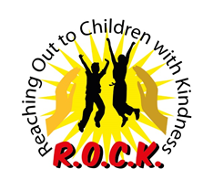
Opening Doors to Education

Learning Dynamics Club Project
helping to increase reading and English-speaking

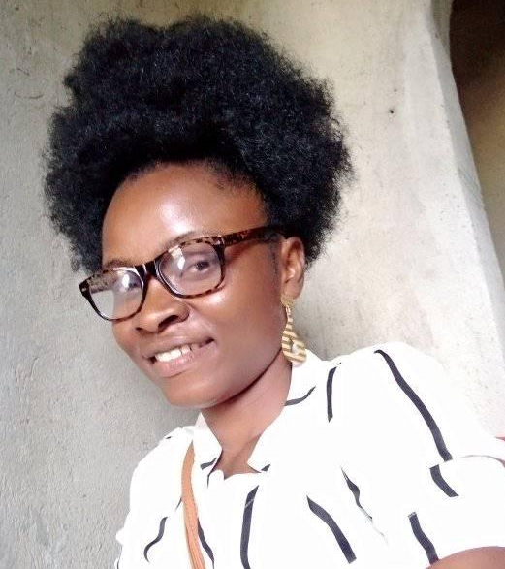
Abigail Gornen
R.O.C.K. Liberia Correspondent & Project Coordinator

WHAT IS THE PROBLEM?
Children in Teahplay lack reading and English-skills and vocational training. This project increases reading and English-speaking skills and provide vocational training, books, and critical support services for 250 underserved and at-risk children and teenage girls in Teahplay, Liberia, who are affected by poverty and Liberia's civil wars. Strategies include reading and writing circles, vocabulary building, discussion groups to learn how to apply language skills, public speaking skills and vocational training.

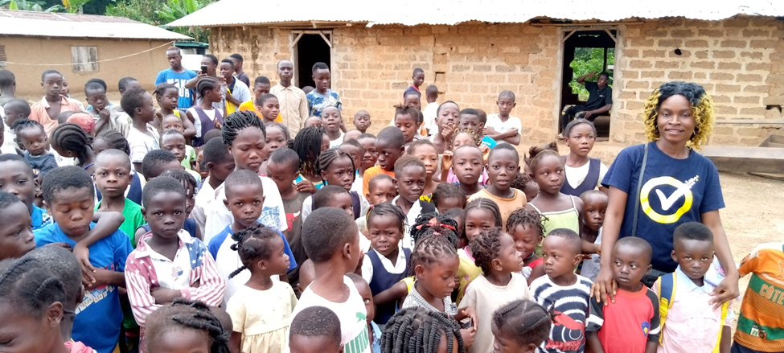
Children from Teahplay School
WHY EDUCATE CHILDREN?
Above are some of the children from Teahplay school, in Teahplay, Nimba County, Liberia who R.O.C.K. has been giving a hand up through the work of our Learning Dynamics Club. These children are among the millions of children around the world who either struggle to get an education or who are not in school. There is extremely poor enrollment of student at Teahplay Elementary School. Up to the date of visit (January 8, 2021), the school has the total enrollment of two hundred and twenty-five (225) students. Of this total, 132 are boys and 93 are girls. With the population of school age children, this number is far lower than expected.
They face many difficult challenges. Some of the challenges they face are cultural attitudes and behaviors that minimize the value of girls’ lives; lack of finances to pay school fees, lack of support they need to get an education, little or no support from the national government, extremely poor infrastructure of the current school building in Teahplay, lack of books and a reading room, and a lack of qualified teachers.
Figures from UNESCO Institute of Statistics confirms that “across sub-Saharan Africa one in every three children, adolescents and youth are out of school - with girls more likely to be excluded than boys. For every 100 boys of primary age out of school, there are 123 girls denied the right to education.”
Childhood education is especially important. This is so because children develop critical, emotional, social, and cognitive skills during the first years of their lives. Without an education, these children would be left behind, their future blighted and their potentials stifled. When children learn to read and write, when they are educated, they become more confident and can escape the cycle and trap of poverty. This empowerment has a ripple effect on their lives, their family, their community, and the world.

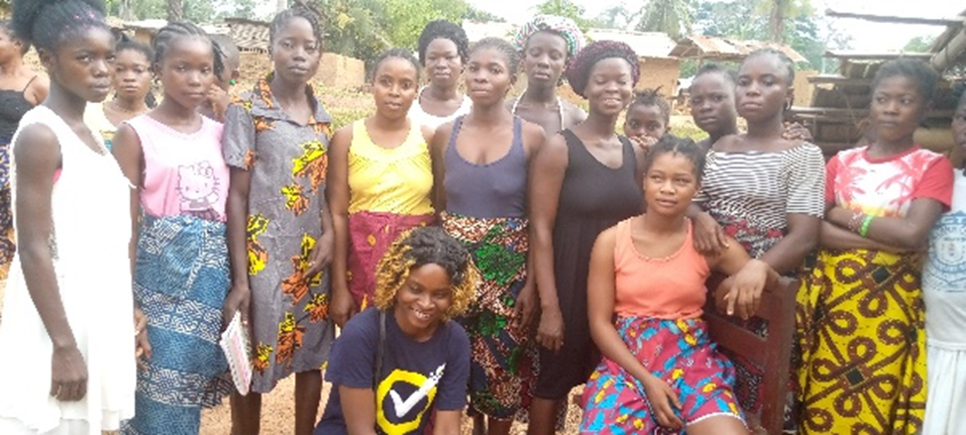
Girls in Teahplay
WHY EDUCATE GIRLS?
Above are some of the girls from Teahplay, Liberia who R.O.C.K. has been giving a hand up through the work of our Learning Dynamics Club. These girls are among the millions of girls around the world who either struggle to get an education or who are not in school.
These girls face many difficult challenges. The journey to get an education is intimidating. Some of the challenges they face are cultural attitudes and behaviors that minimize the value of girls’ lives; lack of finances to pay school fees, risking long and dangerous walks to attend school in other villages, teenage pregnancies or being forced to marry, lack of support they need to get an education, little or no support from the national government, very poor infrastructure of the current school building in Teahplay, lack of books and a reading room, and a lack of qualified teachers.
Education is one of the most critical ways to empower girls and young women. When girls are educated, they are more respected, they are healthier, they are more productive, and they have choices. Also, they are more confident and can escape the cycle and trap of poverty. This empowerment has a ripple effect on their lives, their family, their community, and the world.

HOW WILL THIS PROJECT SOLVE THE PROBLEM?

Malcolm X said, “Education is the passport to the future, for tomorrow belongs to those who prepare for it today.”

The Learning Dynamics Club seeks to empower children and adolescent/youths girls in Teahplay through education, allowing them to achieve their full potential and to transform their families, communities, country, and the world.

Program Focus

The Learning Dynamics Club provides training in the following areas. R.O.C.K.’s Liberia Correspondent has been collaborating and working with the principal, vice principal and teaching staff and twenty girls on Mondays, Tuesdays and Wednesdays to provide additional training support in the following areas:

- Reading
- Writing
- Vocabulary building
- Discussion to learn how to apply language skills
- Public speaking skills

Methods

- Reading Circles
- Discussion Groups
- Public Speaking
- Debate Competitions
- Book Clubs

R.O.C.K.'s Learning Dynamics Club provides textbooks, teaching, training, and educational support. I work with the principal, vice principal and teaching staff and twenty girls on Mondays, Tuesdays, and Wednesdays to provide additional training support in the following areas: reading, writing, vocabulary building, discussion to learn how to apply language skills, and public speaking skills.

POTENTIAL LONG-TERM IMPACT

This Learning Dynamics Club project will increase reading and English-speaking skills for 250 children and teenage girls allowing them to become more confident and to escape the cycle and trap of poverty. This empowerment will have a positive ripple effect on their lives, families, community, and the world. Teenage girls will learn to read for the first time. They will be able to speak English confidently (the national language of Liberia) and increase connections and opportunities in Liberia and the world.

CURRENT NEEDS
The community members of Teahplay needs positive changes. Some of the positive changes needed are:
- Updated reading materials – books and curriculum
- Trained teachers/volunteers (currently two volunteers who are high school graduates need financial assistance to start teacher’s college)
- Library and computer lab
- A generator
- Staff room for teachers
- Additional funds to continue to pay Liberia Correspondents and volunteer teachers.

HOW CAN YOU HELP?
Support R.O.C.K.’s Learning Dynamics Club in any of the following ways:
- Host an Email and Social Media Campaign on behalf of Learning Dynamics Club. Even if you do not have time to put together an event, you can support us through your own email and social media campaign—anything to raise awareness and funds to support girls’ education!
- Help to research funding sources and write grants
- Support R.O.C.K.’s GoFundMe campaign at
https://www.gofundme.com/f/opening-doors-to-education
- Contribute via R.O.C.K.’s website www.rockreachesout.org
- Donate through Global Giving https://www.globalgiving.org/
- Any other way you can think of

