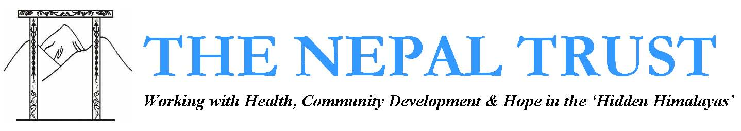

Humla School Repair Project 2021-2023
Humla district, Nepal

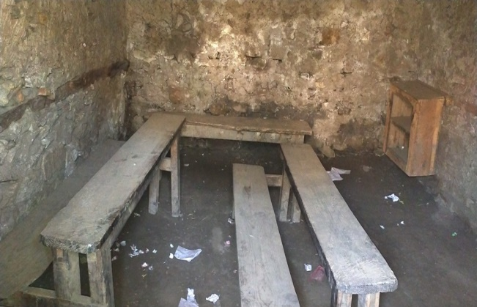
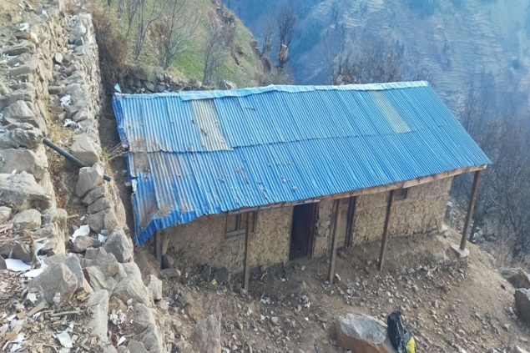

Shree Anshubarma klaslokaal in poor condition Shree Surya Tara school inside
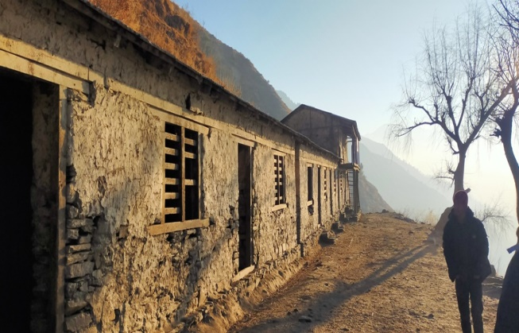
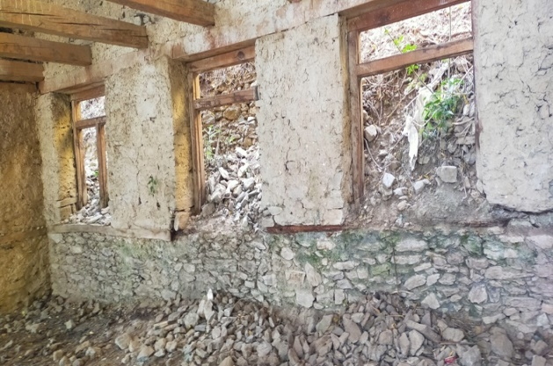

Shree Kot school in poor condition Shree Shoyambu school in poor condition

Concept Note by: Jeroen van den Bergh - The Nepal Trust
September 2021
Concept Note

- Program background
The overall pattern of poor education standards in both urban and rural Nepal is dominated by severe lack of education infrastructure, skilled and motivated teachers and education materials and equipment.

The level of education in Humla district, Nepal Trust’s main project area, is poor and ranks among the lowest in Nepal, with many people, particularly women, being illiterate. Education development indicators of Humla indicate that the total literacy rate of people (6+ years) is 22.62% (female 8.87%, male 36.5%) and approx. 60% of children never go to school, due to poverty (Source: District Development Plan 2008, District Information and Documentation Centre, District Development Committee, Humla).
Child illiteracy rate (10-14 years) is 45.3% and only 2.6% of children pass the SLC, equivalent to the Irish Junior Certificate or British GCSEs, whereas in 66% of the district, there is no secondary school (Source: District Profile and Analysis, District Development Committee 2007) and enrolment of children in primary education (up to Class 5) is only 26.8% (Source: Population of Nepal, National Planning Commission, Government of Nepal, 2006).

- Problem
Many schools lack basic infrastructure such as sufficient class rooms in proper condition to accommodate students and teachers, sanitation measures and basic furniture, such as cabinets, desks and chairs. Only a few economically well-off families are able to send their children to private schools in cities outside, but for the majority of people there is no other alternative than to accept the current conditions within their villages. It is paramount therefore in any education approach to consider the problems faced within the communities and link any proposed education intervention to this analysis. Such an approach allows for a better use of resources - in Humla, the population groups which exhibit the highest levels of illiteracy, social skills and malnutrition in Nepal are women and young children.

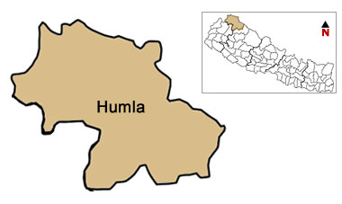
The government has built schools in many of the villages in Humla district with the plan to ensure education for all Humli children. The schools are staffed and managed by the District Education Office (DEO) in coordination with the local school management committees.

The Nepal Trust has been working in Humla for nearly 30 years implementing education, sport and literacy programs, school and library construction projects, hostel establishment projects, child health education programs (Little doctors) and education volunteer placement programs.

- Objectives and project beneficiaries

The objective of the project is to repair various government schools in Humla that are in a poor condition and in a dilapidated state and to provide them with basic furniture which will allow the schools the opportunity to provide classes on a regular basis in a safe environment.

For this project 16 government schools have been identified that are in urgent need of repair. These schools have 2,613 students in total (1,216 girls and 1,397 boys) and 112 teachers that will benefit directly from the project.

An overview of these schools and their location can be found below;

S.N. | School Name | Girls | Boys | Total students | Teachers | Lokatie
1 | Shree Budha Lower Secondary School | 56 | 107 | 163 | 8 | Namkha Municipality -1 Hapka Humla
2 | Shree Anshubarma Lower Secondary school | 56 | 107 | 163 | 8 | Sarkghad Municipality -8 Radev Humla
3 | Shree Suryatara Primary School | 95 | 106 | 201 | 5 | Sarkeghad Municipality -7 Rodikot Humla
4 | Shree Kot Secondary School | 229 | 221 | 450 | 11 | Sarkeghad Municipality, Rodikot Humla
5 | Shree Sarkideb Primary School | 54 | 52 | 106 | 6 | Adhanchuli Municipality -6 Lamahi
6 | Shree Ramdep Lower Secondary School | 89 | 98 | 187 | 8 | Tajakot Municipality -3 Ramagau
7 | Shree Manakamana Primary School | 25 | 28 | 53 | 5 | Chankhali Municipality, Humla
8 | Shree Panchamukhi Primary School | 85 | 83 | 168 | 4 | Simikot Municipality -1 Thehe
9 | Shree Debkota Lower Secondary School | 136 | 125 | 261 | 8 | Sarkeghad Municipality, Unapani
10 | Shree Shoyambu Lower Secondary School | 25 | 36 | 61 | 3 | Sarkeghad Municipality -6 Barai Humla
11 | Shree Saipal Himal Secondary School | 119 | 127 | 246 | 12 | Simikot Municipality -8 Sayada
12 | Shree Mahendra Primary School | 56 | 87 | 143 | 6 | Changkheli Municipality -3 Mimi
13 | Shree Dhafe Lower Secondary School | 75 | 86 | 161 | 9 | Changkheli Municipality -3 Napka
14 | Shree Hilsa Naudhara Secondary School | 55 | 65 | 120 | 9 | Kharpunath Municipality, Durpa Humla
15 | Mahadev Primary School | 33 | 37 | 70 | 7 | Sarkeghad Municipality, Mundi Humla
16 | Shree Prem Balbikas Kendra Secondary School | 28 | 32 | 60 | 3 | Simikot Municipality -7 Pangalathung
 | Total | 1,216 | 1,397 | 2,613 | 112
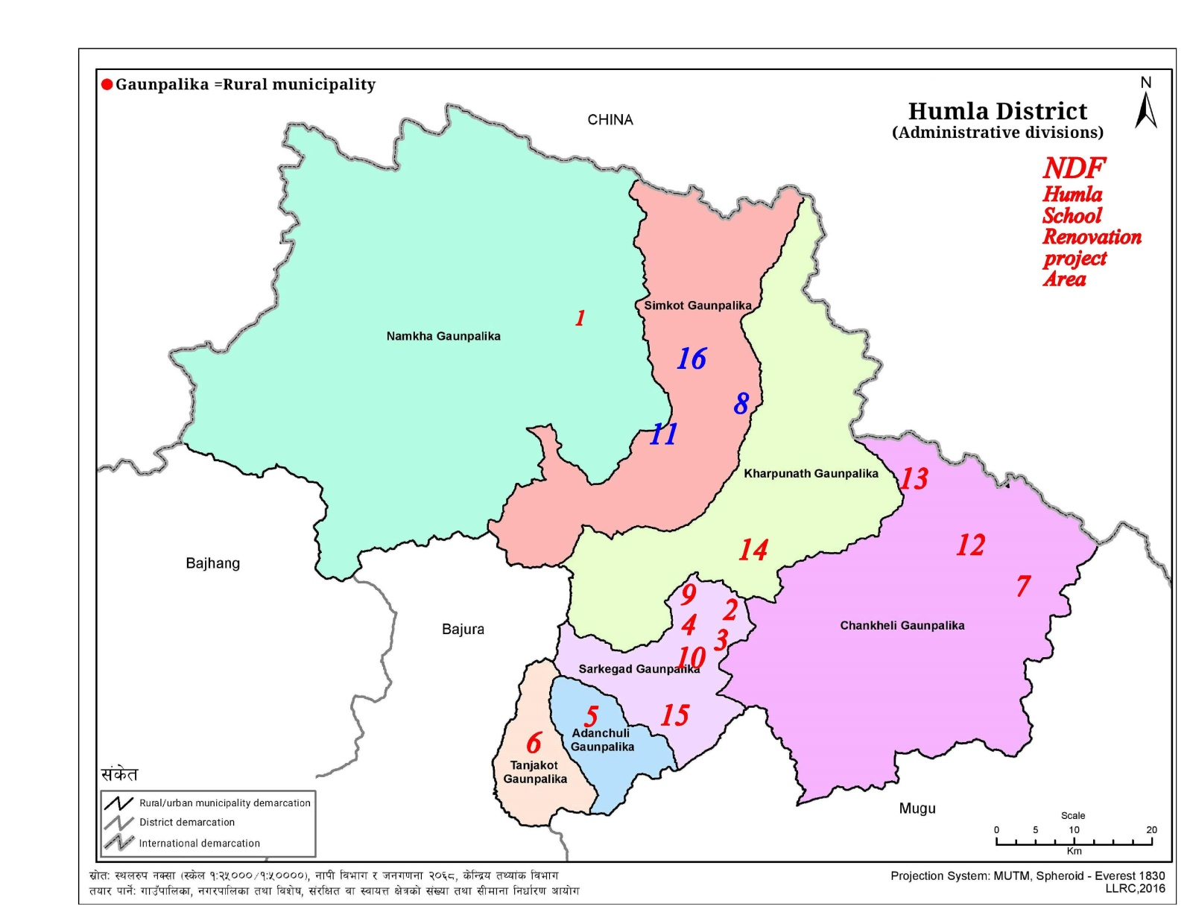

- Project duration

The whole project will take 2 years to complete, whereby the aim is to repair 8 schools per year. The project will be implemented by The Nepal Trust in partnership with its local partner organization Nepal Development Foundation.

- Budget

For an overview of the cost per school and the cost per year (year 1 + 2) see below.

S. N. | School | Local Management (A) NPR. | Renovation (B) NPR. | Furniture (C) NPR. | Total NPR. | Total GBP (£) | Year 1 (2021/22) | Year 1 (2021/22) GBP (£) | Year 2 (2022/23) | Year 2 (2022/23) GBP (£)
 |  |  |  |  |  |  | NPR. |  | NPR.
1 | Shree Budha Lower Secondary School |  | 1,315,750.00 | 419,832.00 | 1,735,582.00 | 10,847 |  |  | 1,735,582.00 | 10,847
2 | Shree Anshubarma Lower Secondary School |  | 994,015 | 382,375 | 1,376,390 | 8,602 | 1,376,390 | 8,602
3 | Shree Suryatara Primary School |  | 1,056,510 | 382,375 | 1,438,885 | 8,993 | 1,438,885 | 8,993
4 | Shree Kot Secondary School |  | 838,802 | 382,375 | 1,221,177 | 7,632 | 1,221,177 | 7,632
5 | Shree Sarkideb Primary School |  | 1,503,117 | 309,311 | 1,812,428 | 11,328 | 1,812,428 | 11,328
6 | Shree Ramdep Lower Secondary School |  | 1,481,630 | 364,378 | 1,846,008 | 11,538 | 1,846,008 | 11,538
7 | Shree Manakamana Primary School |  | 1,202,570 | 300,411 | 1,502,981 | 9,394 |  |  | 1,502,981 | 9,394
8 | Shree Panchamukhi Primary School |  | 379,590 | 368,632 | 748,222 | 4,676 |  |  | 748,222 | 4,676
9 | Shree Debkota Lower Secondary School |  | 1,770,460 | 435,265 | 2,205,725 | 13,786 | 2,205,725 | 13,786
10 | Shree Shoyambu Lower Secondary School |  | 667,100 | 382,375 | 1,049,475 | 6,559 | 1,049,475 | 6,559
11 | Shree Saipal Himal Secondary School |  | 1,343,913 | 420,730 | 1,764,643 | 11,029 |  |  | 1,764,643 | 11,029
12 | Shree Mahendra Primary School |  | 1,021,960 | 293,370 | 1,315,330 | 8,221 |  |  | 1,315,330 | 8,221
13 | Shree Dhafe Lower Secondary School |  | 1,766,585 | 371,809 | 2,138,394 | 13,365 |  |  | 2,138,394 | 13,365
14 | Shree Hilsa Naudhara Secondary School |  | 713,166 | 382,375 | 1,095,541 | 6,847 |  |  | 1,095,541 | 6,847
15 | Shree Mahadev Primary School |  | 686,132 | 382,375 | 1,068,507 | 6,678 | 1,068,507 | 6,678
16 | Shree Prem Balbikas Kendra |  | 804,848 | 173,385 | 978,233 | 6,114 |  |  | 978,233 | 6,114
 | Total Cost B+C |  | 17,546,148 | 5,751,373 | 23,297,521 | 145,610 | 12,018,595 | 75,116 | 11,278,926 | 70,493
17 | Local Field staff/ Management (2 Years) | 1,040,000.00 |  |  | 1,040,000 | 6,500 | 520,000 | 3,250 | 520,000 | 3,250
 | Total Cost A+B+C |  |  |  | 24,337,521 | 152,110 | 12,538,595 | 78,366 | 11,798,926 | 73,743
18 | 10% Overhead |  |  |  | 2,433,752 | 15,211 | 1,253,860 | 7,837 | 1,179,893 | 7,374
 | Total Cost |  |  |  | 26,771,273 | 167,320 | 13,792,455 | 86,203 | 12,978,819 | 81,118
 |  |  |  |  |  |  | Year 1 |  | Year 2
 |  |  |  |  |  |  | (2021/22) |  | (2022/23)
 | Total Cost per Year in NPR. |  |  | Total | 26,771,273 |  | 13,792,455 |  | 12,978,819
 | Total Cost per Year in GBP (£) |  |  | Total | 167,320 |  | 86,203 |  | 81,118

Note 1: 1 GBP (£) = NPR. 160 (September 2021) Note 2: GBP (£) amounts are indicated in red and yellow

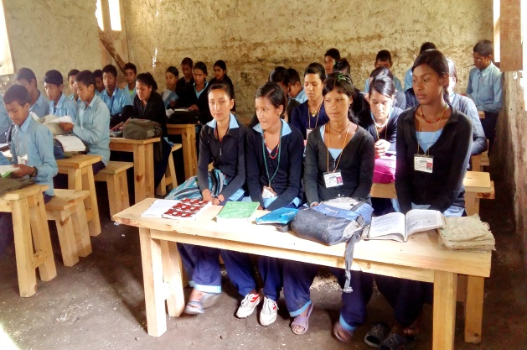
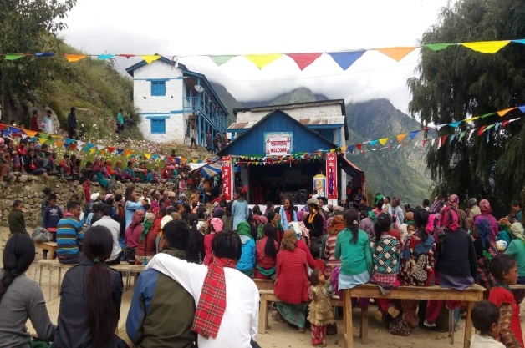
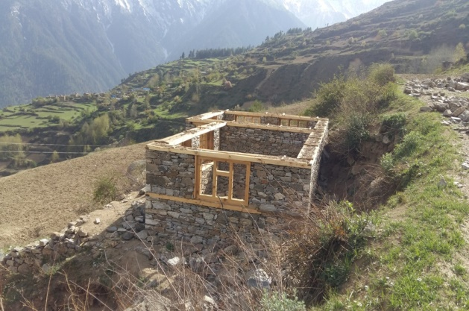
Humla school kids with new furniture School class in repair Celebration opening new school building

