San Juan Bautista Children's Dining Room, Group 13 - Lomas de Amauta, Ate
As part of the projects that Malteser Peru implements in the country, under the financing of Malteser International America, the San Juan Bautista Children's Dining Room was implemented in 2007. From its operation until 2019, the dining room was installed inside the El Salvador Parish in the Asentamiento Humano Amauta 1, located in the district of Ate, province of Lima.
After the change of parish priest, the site was requested for other parish activities, so it was necessary to look for another place where we could continue developing the project. Thus, we arrived at Group 13, in the human settlement Lomas de Amauta, which is located in an area of extreme poverty.
After discussions, the dining room was moved to a place rented by the community, but shortly after it was installed and the projects were about to begin in 2020, the Covid-19 pandemic spread throughout the country. Due to the social distancing measures, the project started to be executed through the delivery of food baskets to low-income families, reaching a total of 75 households, which received a monthly delivery of basic food.
After two years of pandemic and following the commitment of the Community Brigades formed in the human settlement in question, it was possible to build a communal building, in which, after lifting the restrictions imposed by Covid-19, it began to operate as the new San Juan Bautista Children's Dining Room.
This project, which has 89 school-age children, has been operating with worn-out utensils due to the passage of time and disuse during the two years of the pandemic. It also doesn’t count with adequate furniture because the number of beneficiaries has increased, many children are using improvised tables and chairs.
It should be noted that, in this same space, which is shown in the attached photos, the beneficiaries will receive their educational reinforcement classes, which to date have not started because we are searching for donations so that the premises can be adapted and provide the necessary facilities for the children to adequately receive their food, as well as the educational reinforcement classes as indicated in the projects.
Equipment necessary for the operation of the Dining Room
Roof covering, with calamine structure, quantity: 8 pcs.

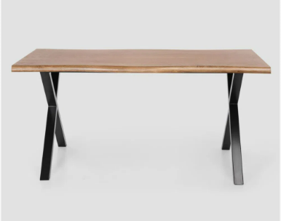
Dining tables, quantity: 4 units

Dining chairs: 30 units
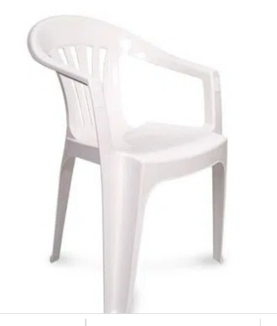

Large pots for dining room: 2 units
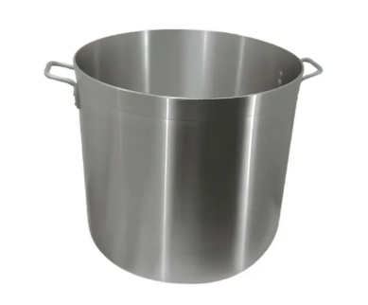

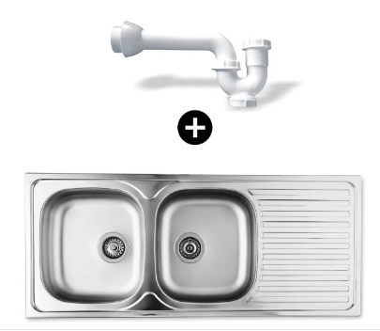
Lavatory: 1 unit

Soup plates: 100 units
Dishes for second course: 100 units
Cups: 100 pcs.
Cutlery: 100 sets of cutleries
Kitchen utensils: 2 large sets

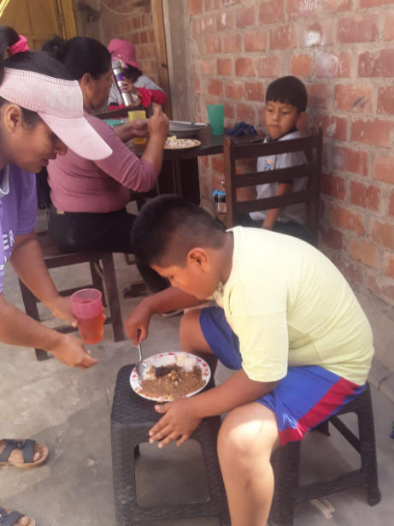
Photo Annex
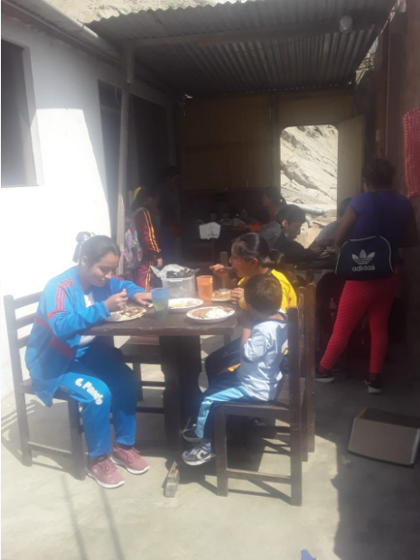
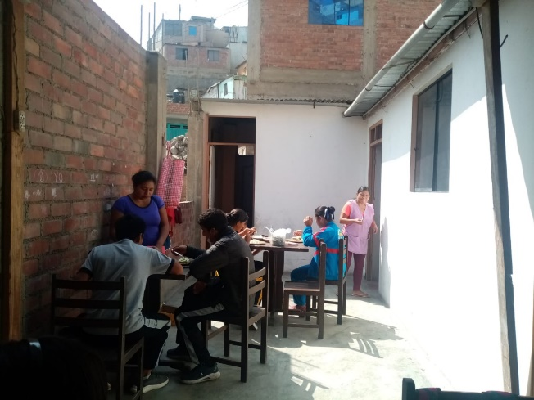
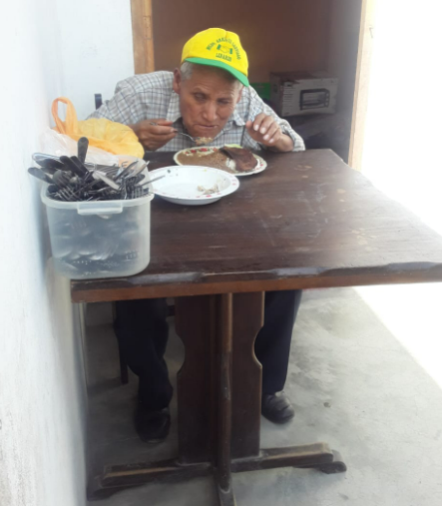
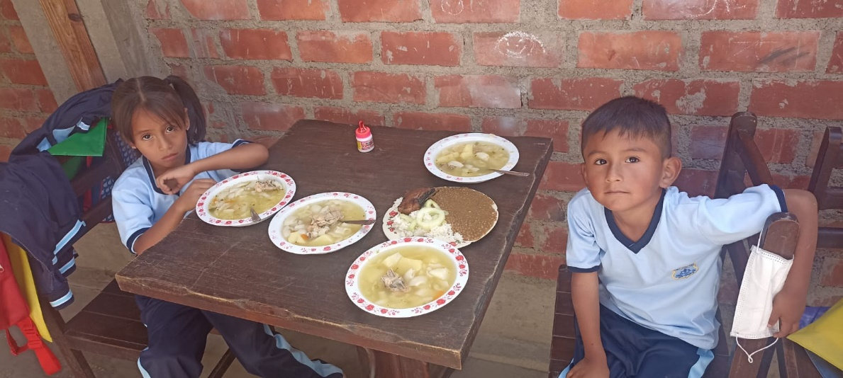

Budget
Description | Price Unit | Total Price | Total Price USD
Roof covering (8 U.) | S/36.90 | S/295.20 | $ 75,26
Dining table (4 U.) | S/290.00 | S/1160.00 | $ 295,73
Dining chair (30 U.) | S/35.00 | S/1050.00 | $ 267,68
Large pots (2 U.) | S/323.00 | S/646.00 | $ 164,69
Lavatory (1 U.) | S/385.00 | S/385.00 | $ 98,15
Soup plates: 100 units | S/3.90 | S/390.00 | $ 99,43
Dishes for seconds: 100 units | S/3.50 | S/350.00 | $ 89,23
Cups: 100 pcs. | S/1.50 | S/150.00 | $ 38,24
Cutlery: 100 sets of cutlery | S/3.00 | S/300.00 | $ 76,48
Kitchen utensils: 2 large sets | S/80.00 | S/160.00 | $ 40,79
Total |  | S/4886.20 | USD 1.245,68

