Globalgiving Campaign
for flood victims
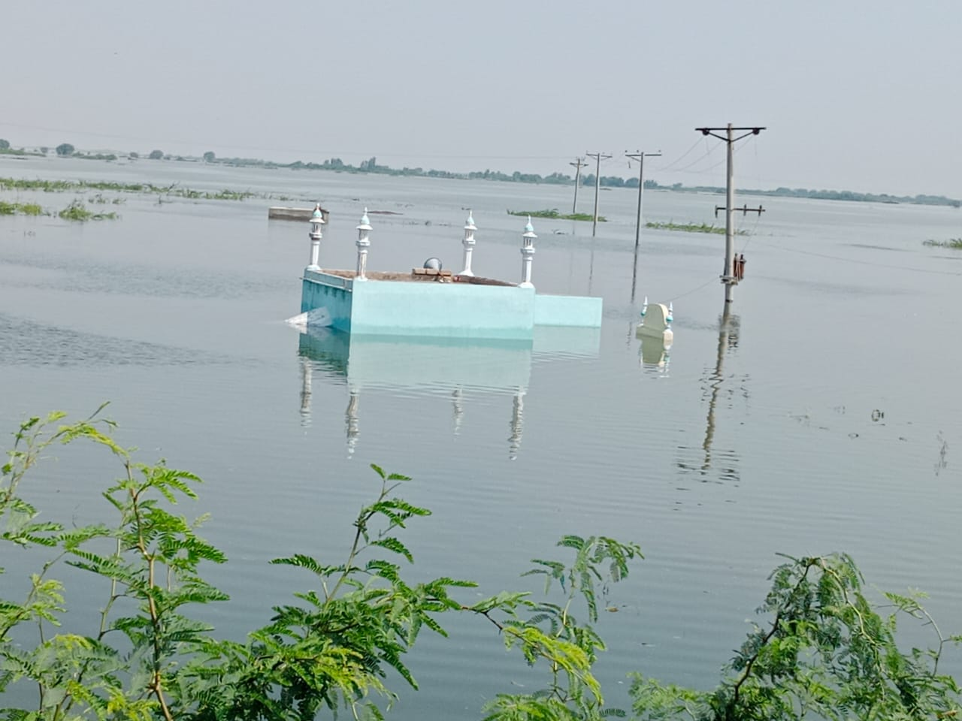

Project Title: Relief Funds for Flood Victims in Pakistan
Project Summary:
Floods in Pakistan have affected numerous communities, most flood victims have no choice but to drink contaminated water which will affect their health and they'll suffer different diseases like malaria due to the abundance of mosquitoes, gastro and diarrheal infections due to drinking unhygienic/contaminated water. AHD will provide immediate help to people with mosquito nets, rations and will meet their emergency needs, such as the provision of food, safe drinking water, and shelter/tents.
Theme: Disaster Response
Funding amount: ___________________
The Problem:
Floods in Pakistan have affected numerous communities; most flood victims have no choice but to come on to the roads and live in tents or under open skies as their homes are destroyed. People are drinking contaminated water which will affect their health and can cause infections like gastro and diarrheal. They are suffering different diseases like malaria due to the abundance of mosquitoes. AHD will provide immediate help to people with rations, mosquito nets and will meet their emergency needs, such as the provision of food, safe drinking water, and shelter/tents.
How the project will solve the problem:
The donations to this campaign will help in procurement and distribution of food rations, mosquito nets, shelter/tents, health kits and to raise awareness regarding water-borne diseases. Due to the heavy flooding affected areas have lack of drinkable water and people are forced to consume contaminated water. The funds will support recovery and relief efforts for people impacted by flooding across Pakistan.
Long-term impact:
These deadly floods have economically destroyed the affected populations due to which most of them can’t fulfill their daily needs, we will provide each family with enough food rations and shelter to last for months. We will provide mosquito nets so they can sleep safe at nights and prevent mosquito bites which can lead to hazardous diseases, these precautions will be able to minimize loss of lives and improve the health and hygiene among the victims, along with these victims will also be able to go back to their businesses and work.

