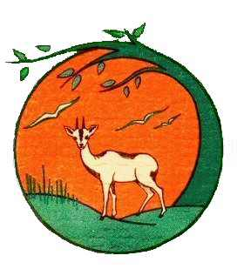
Striped love Stories
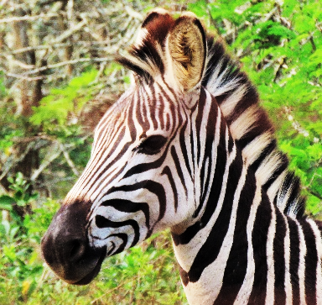
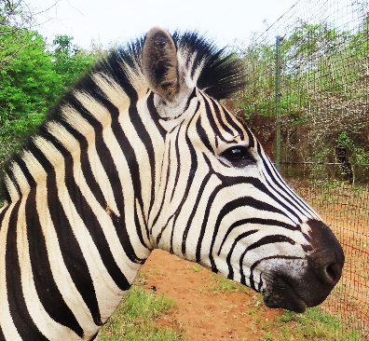

Milky Way
Pretty Girl
MilkyWay our rescued zebra stallion, recently lost his much-loved female zebra Tammy, who had been with us for over 15 years. She had been injured and after our Vet tried to help her, I spent two weeks tracking her in the bush, taking her supplement feeds and water and treating her wound.
The last morning, I lifted her head and she ate an apple but put her head down while eating! She was so weak. The end was inevitable. She was shivering and it was raining. I covered her with blankets to keep her warm and placed a cover in the tree above her to keep her dry and placed hay under her head. MilkyWay stayed with her but the end was inevitable and sadly, she did not recover. We buried her under the tree. MilkyWay would not leave the site of her grave, calling her incessantly, for two weeks.
But there is some happy news: MilkyWay has found a new friend. Although she is on a neighbouring property and they are separated by the boundary fence, he has remained near to her at the fence line, for many weeks. She is a beautiful, dainty young, female zebra of about 2 years of age, that has apparently been excluded from her herd. We have named her “Pretty Girl” She has been offered for sale and we would love to help bring her to join MilkyWay and Stripy our other female Zebra.
Her price is 500 USD. We would love to adopt her and we would greatly appreciate any support that may help to sponsor us to buy her and bring her to join MilkyWay.
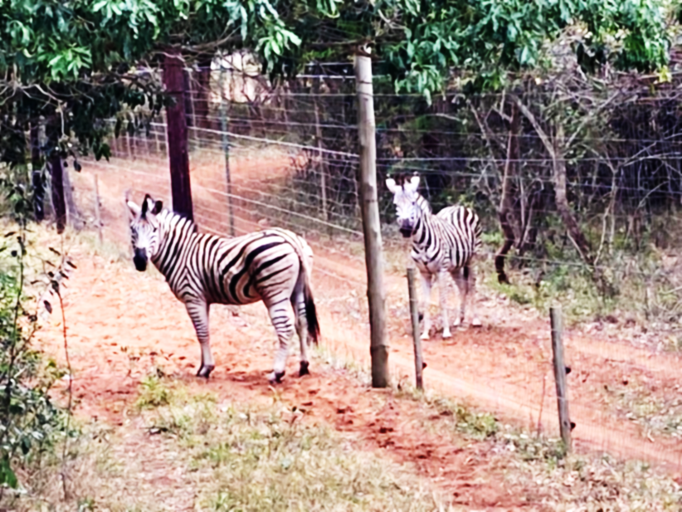

Tammy with MilkyWay at her side before she died.
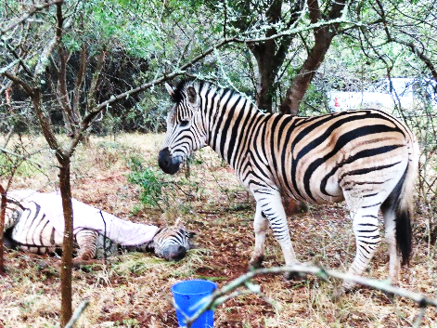
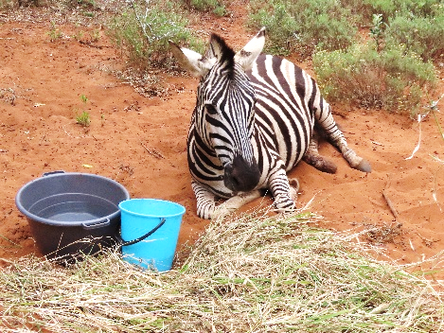

The bigger picture
In the Serengeti Plains thousands of zebras migrate in huge herds of adjoined family groups. Here they are only understood and seen as a wild species of Africa.
But those who have been fortunate to be in close contact with zebra, know that they are really striped horses, each with unique stripes and his or her very own personality.
Zebra males will run behind the females to protect them as kicking with their hind legs is their first line of defence. However, should the threat become very serious he will move to the front and lead his herd as best as possible, away from the danger of an attack.
MilkyWay’s personality is particularly gentle and kindly. He has proved to be exceptionally caring – having stayed with Tammy for all the time she battled with her injury and mourning her for such a long time after she died.
It is well recorded that elephant and many other species mourn when a baby, a mate or even a friend, is lost. We have seen first-hand how a zebra mourns! They also have other personalized traits such as courage and preferences in socializing.
We hope our story about MilkyWay and his new found love, will have a happy ending and that we will be able to find support to help us buy the beautiful young female zebra to be his forever friend.
Thanking you

www.suni-ridge.org.za
www.leopardwalklodge.co.za

