OFFLINE COMPUTER LAB FOR SIX REMOTE COMMUNITY SCHOOLS CHILDREN
Sierra Leone Children are facing limited access to offline computer learning which they are encountering several challenges including lack of computer and internet access, many of these children in many of this remote communities’ schools are blind to these opportunities especially those from disadvantaged background or rural areas, communities, are not having access to computers, devices or the internet at schools and home. This limits their ability to engage in computer based learning activities and limited to educational resources Offline computer learning often requires access to specific software, application, or educational material. If children do not have access to theseresources, they may miss out on valuable learning opportunities and inadequate technology infrastructure. The technological infrastructure is not sufficient to support offline computer learning and limited to electricity supply, outdated hardware, and inadequate maintenance can hinder children s access to computer based on education. Digital literacy and technical skills children who lack exposure to computer and digital devices are struggle with basic digital literacy skills. They are facing difficulties navigating operating systems, using software application, or troubleshooting technical issues, making it challenging to engage in offline computer learning often independently limited guidance and support. Offline computer learning often require guidance and support from teachers, parents, or mentors without adequate support for the children that are going through challenges in understanding the complex concept, troubleshooting technical issues. Lack of interactivity and collaboration and not accessing Offline computer learning may lack the interactive and collaborative element that online learning platform provide.Limited opportunities for real-time interaction, peercollaboration, and feedback can hinder children s engagement and motivation limited exposure to online resources and advancement, Offline computer learning can restrict children s access to the vast array of online educational resources, interactiveplatforms, and innovative tools. They may miss out on opportunities to explore new concept engage in online communities, or stay update withthe latestadvancement. Addressing these challenges requires concerted efforts from policymakers, educational institutions, and communities to bridge the digital divide, provide equitable access to technology, enhance digital literacy and ensure the availability of quality offline learning resources.

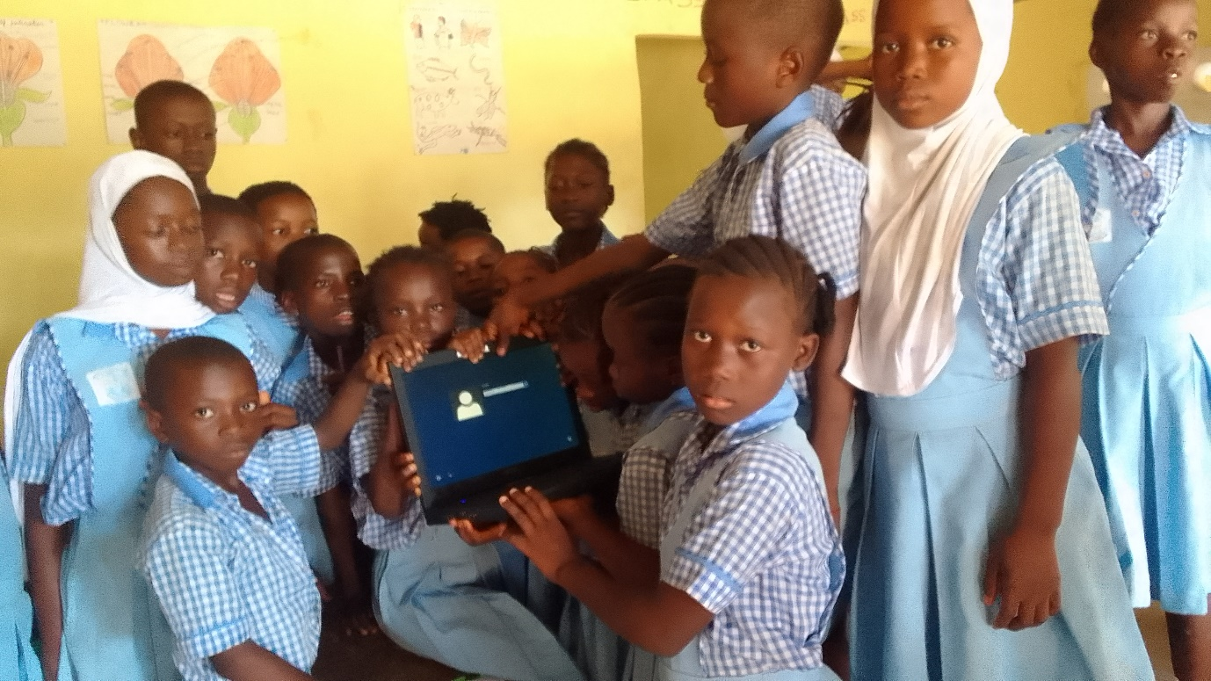
Our object goals is to provide the provision of offline learning resources and these project can develop or curate high – quality educational content ,software application ,and interactive materials specifically designed for offline use and these resources should cover a wide range of subject and be tailored to different age groups and learning levels and distribution of technology and infrastructure , and the project can provide access to computer desktops or tablets in schools, community centres, libraries, ensuring that children have the necessary hardware to engage in offline computer learning and efforts can be made to improve the technology infrastructure in areas lacking reliable electricity or internet connectivity. The offline computer lab empowerment for the remote children will uniquely encourage the children to take the ownership of their learning process and become self-directed learner and able to explore educational content at their own pace which also can make change of the mind to engaged independently in problem solving and develop a critical experience for the children.

BUDGET
Organization Name: Discourage Youths from Poverty - Sierra Leone
BUDGET FOR OFFLINE COMPUTER LAB FOR REMOTE CHILDREN FOR SIX (6) COMMUNITY SCHOOLS
BUDGET FOR 2023 - 2024
No. | Category | Description | Qty. | Unit | Unit Cost (Nle) | Total (Nle)
1 | Computer i5 | Purchase of Desktop Computers | 15 | Pcs | 12,000.00 | 180,000.00
2 | Software | Operating System and Programs | 15 | Pcs | 200.00 | 3,000.00
3 | Computer Lab Space | Setting of Lab Space | - | - | - | 6,000.00
4 | Furniture | Desks, Chairs and Storages | 15 | Set | 1,650.00 | 24,750.00
5 | Networking | Rachel Servers, Cables and Switches | 10 | Set | 1,500.00 | 15,000.00
6 | Power Backup | Uninterruptible Power Supply (UPS) | 15 | Pcs | 1,000.00 | 15,000.00
7 | Maintenance | Repairs & Servicing | - | - | - | 1,000.00
8 | Training & Support | Workshops & Technical Supports | - | - | - | 3,000.00
9 | Training | Instructor Or IT Support Staff | - | - | - | 2,500.00
10 | Printers | HP LaserJet MFP M476 (All-In-One) Color | 1 | Pc | 11,000.00 | 11,000.00
11 | Electrical Setup | Wiring, Power Backup etc | - | - | - | 3,000.00
12 | Generator | 6.5KVA KIPO | 1 | Pc | 24,000.00 | 24,000.00
13 | Stationary | Assorted | - | - | - | 5,000.00
 | Miscellaneous | Expenses | - | - | - | 1,500.00
Total Le |  |  |  |  |  | 294,750.00
Total in Dollars $ |  |  |  |  |  | 18,421.88
Note: Exchange Rate 1$ = Nle 16.00

