Why Georgia needs a National Trust
Preserve built heritage and historic landscapes in Georgia before they disappear

Challenge  What is the problem we are trying to help solve?  Georgia possesses a large number of historic sites worthy of saving and promoting, It has a highly distinctive culture and depends financially on its tourism.  Yet it currently lacks expertise & collective will/resources to preserve its own heritage. Too many buildings are knocked down by their owners or local government because they are not valued.  The NTG meets the need for a pro-active, well-resourced, internationally connected organisation to promote, educate, and physically assist Georgia’s citizens to preserve their national cultural identity. | Solution  What are we doing to solve it?  The National Trust of Georgia (NTG) provides practical support and sustainable methods of preserving Georgia’s historic built environment and landscape. We support major restoration projects, provide workshops, consultation and advice to private owners, local neighborhoods, developers, and other organisations.  Our resource center is staffed by volunteers at our restored historic building in old Tbilisi. We draw upon our extensive network of donors and experts as well as grassroots membership to raise awareness and educate owners and builders in cost-effective conservation techniques | Long-Term Impact  How will this make a lasting impact on our community?  The long-term impact of preserving historic buildings, houses, and landscape is a priceless and unrecoverable resource for any nation. The NTG is one of Georgia’s few local organisations concerned with stopping the destruction of this precious history.  Through INTO we are affiliated with UK National Trust, the world leader caring for places of historic intertest and natural beauty. We actively apply their advice and leverage an international network of professional resources to transfer knowledge to Georgians to enable them to save these assets which in turn support sustainable heritage and tourism sector.

http://www.nationaltrustofgeorgia.org.ge follow us: საქართველოს ეროვნული ფონდი / The National Trust of Georgia

Sample NTG projects

Rehabilitating Communities with Eco-Towerism

The National Trust of Georgia is partnering with the International National Trusts Organisation (INTO) and Rempart in France for a two-year project to restore the Tsiskarauli Tower up in the Assa Valley, and help develop local historic tourism. Generous support from the ALIPH Foundation will allow rehabilitation of this site, damaged by a missile in the 2001 Chechen War. Working with an international group of volunteers we have started to stabilise and restore the structure, as part of a working holidays programme. Contact us to contribute funding or to join a working holiday in summer of 2023.

Preserving Historic Landscapes

The National Trust is as concerned with landscape as with architecture – seeing them both walking hand in hand. In the UK, many priceless pieces of countryside and coast have been saved for posterity by generous donations because National Trust land is protected by law. It tends to remain protected because it is always open to the public. We need funding to engage the public and mount a legal challenge to Stop the Khada Valley Road, Build the Better Alternative.

Encouraging Conservation- Heritage Competition
In 2019 we initiated a new competition to encourage local Georgian people to preserve their own heritage homes, or historical details in their homes. We hope this will lead to a new and growing trend toward awareness of cultural heritage values, not only physical but also monetary (original features are increasingly rare and therefor valuable). Funding this program will provide ongoing sustainable support and recognition to property owners to invest in Georgia’s remarkable architectural heritage.

Developing & Engaging Historic Communities
In October 2017 the Trust took over a unique, unusually unmolested 18th -19th century property in the Metekhi cliffs area of the city, adjoining Avlabari. The property is large enough to act as the Trust’s headquarters on a permanent basis, as well as contain space for exhibitions, events and offices. Like so many properties in Georgia this three story building was in a poor stage of repair, but it has now been beautifully restored and is being used as an example for locals as to how building repair can be done cheaply, effectively and with historic sensitivity, on their own homes.

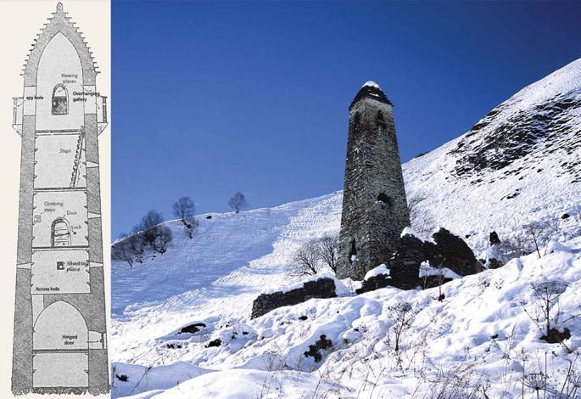 | 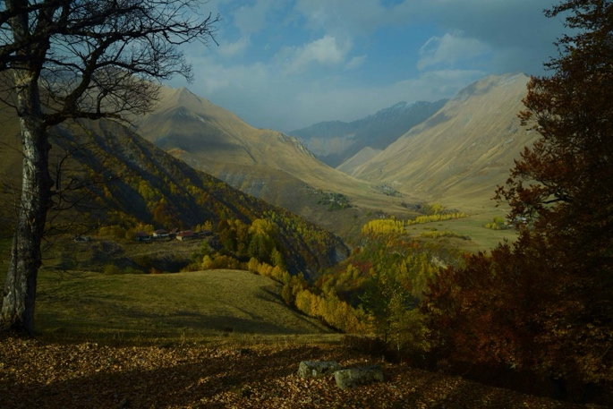
Support us by  helping rebuild this tower | Stop the Khada Valley Road,  Build the Better Alternative
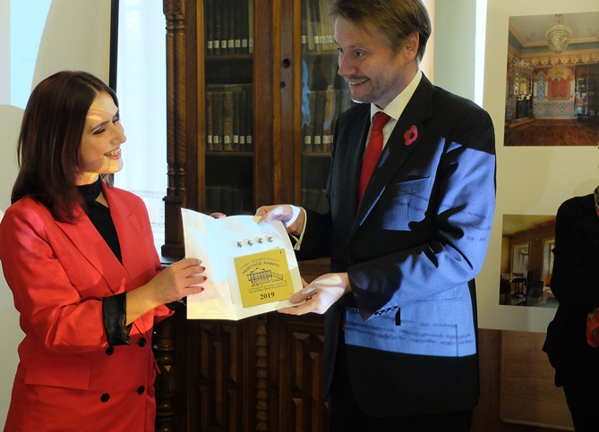  Heritage Award presentation  by UK ambassador to Georgia | 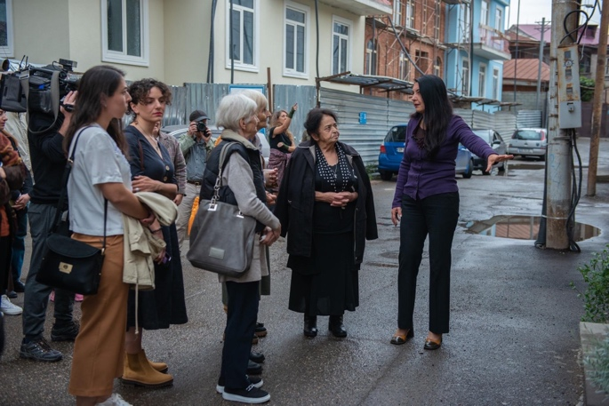 - „თუშეთი - ჩემი მემკვიდრეობა“ - საქართველოს ეროვნული ფონდის ინიციატივას წარმოადგენს, რომელიც მსოფლიო მემკვიდრეობის ფონდის მხარდაჭერით განხორციელდა.
Encourage conservation effort  & award excellence | Build community awareness  and provide expert advice  to home owners

