Our Team

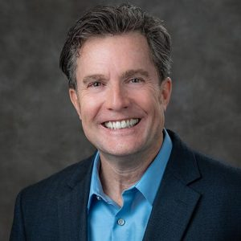  Jim Alvey (VP)  Inkind Donations, Funding and Strategy  Damian Morales (Director)  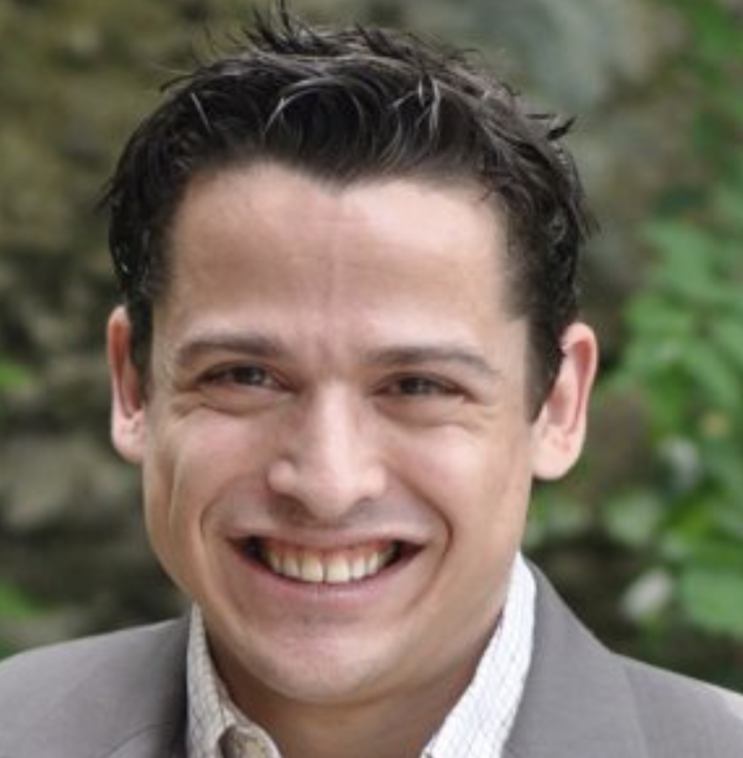  Nonprofit/Government Relations | 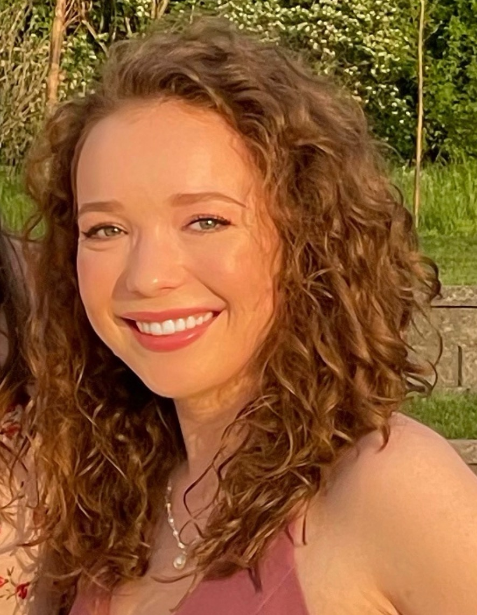  Peyton Kliewer (Specialist)  Logistics/Internal Operations  Maddie Pennie (Specialist)  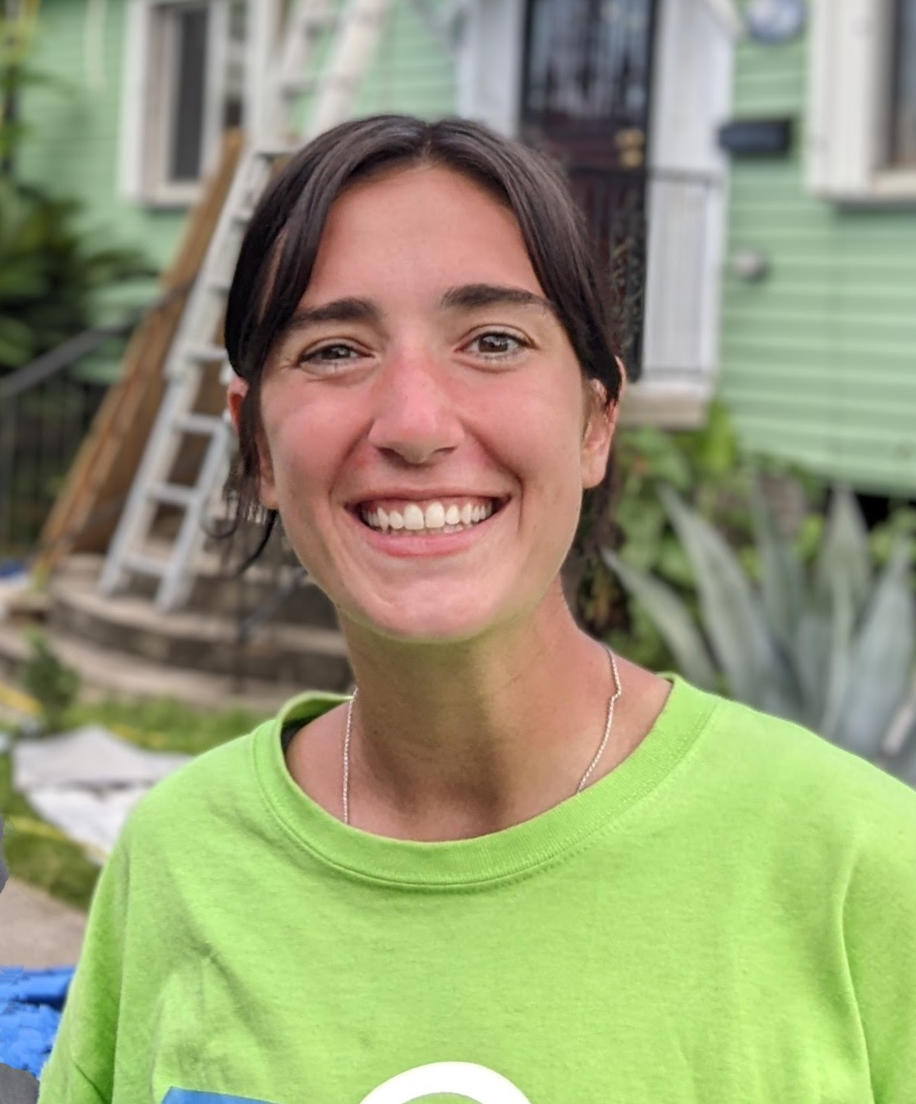  Nonprofit Support/Internal Operations

Committed to ensuring the right goods are delivered to the right people at the right time, through prepositioning and dedication to long-term recovery. We prepare and provide support for natural disasters and humanitarian crises that overwhelm regional capacity.

How We Operate

Activation Determination: Good360 uses an internal decision matrix that considers our internal resources, community impact, donor engagement, and nonprofit needs.
Disaster Needs Assessment: Once active, the DR team sends out a needs survey to network members within the impacted region to understand current and forecasted product gaps.
Donation Fulfillment: Good360’s work in disaster is grant funded, enabling us to leverage our resources to closes gaps without fees, while still ensuring we honor donor intent.
Collaboration: We work in partnership with government and disaster networks to ground truth the most critical product need gaps and contribute to a holistic recovery effort.

Disaster Warehouse Pre-Staging and Capacity Expansion:

The Disaster Recovery team is expanding our capacity to pre-stage donated products with nonprofit partners that have warehouse capacity in disaster-prone regions.
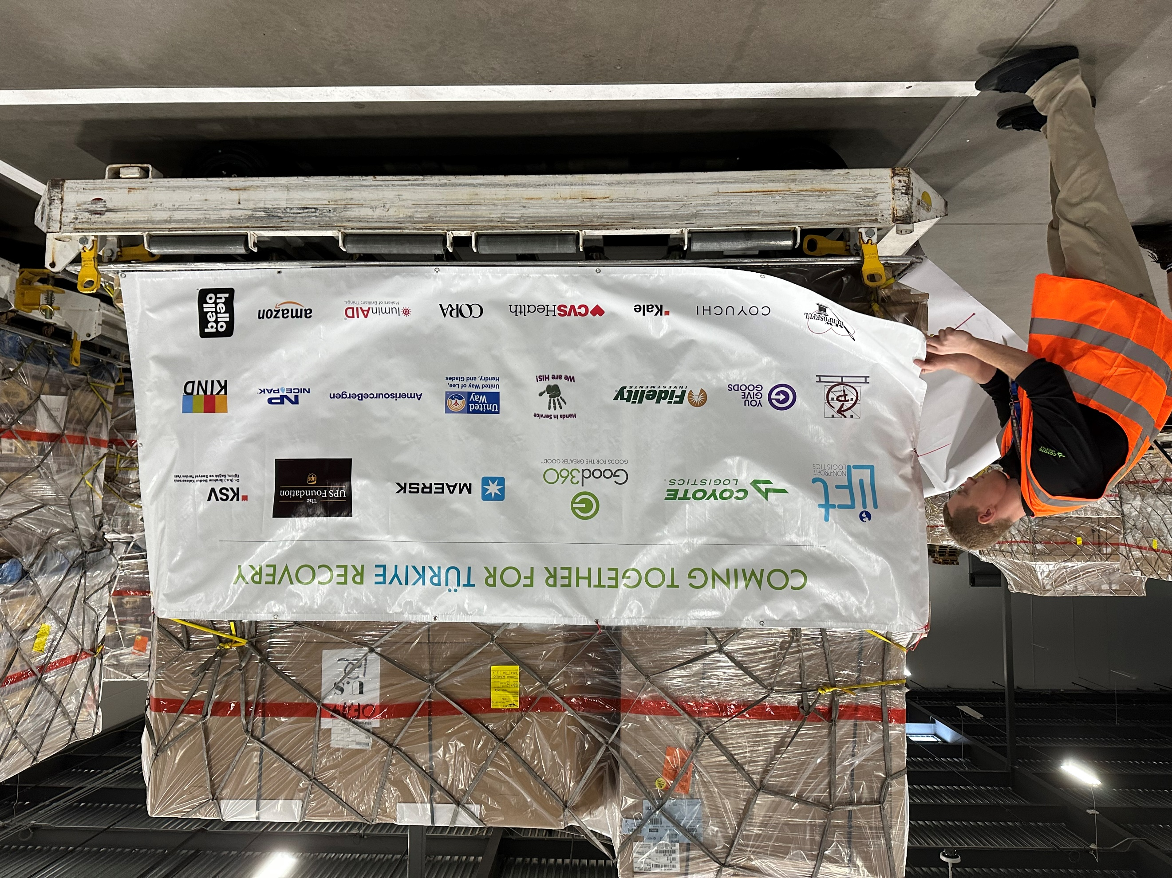

Contact
Damian Morales (damian@good360.org)
Maddie Pennie (maddie@good360.org)
Peyton Kliewer (peyton@good360.org)
Jim Alvey (jalvey@good360.org)

