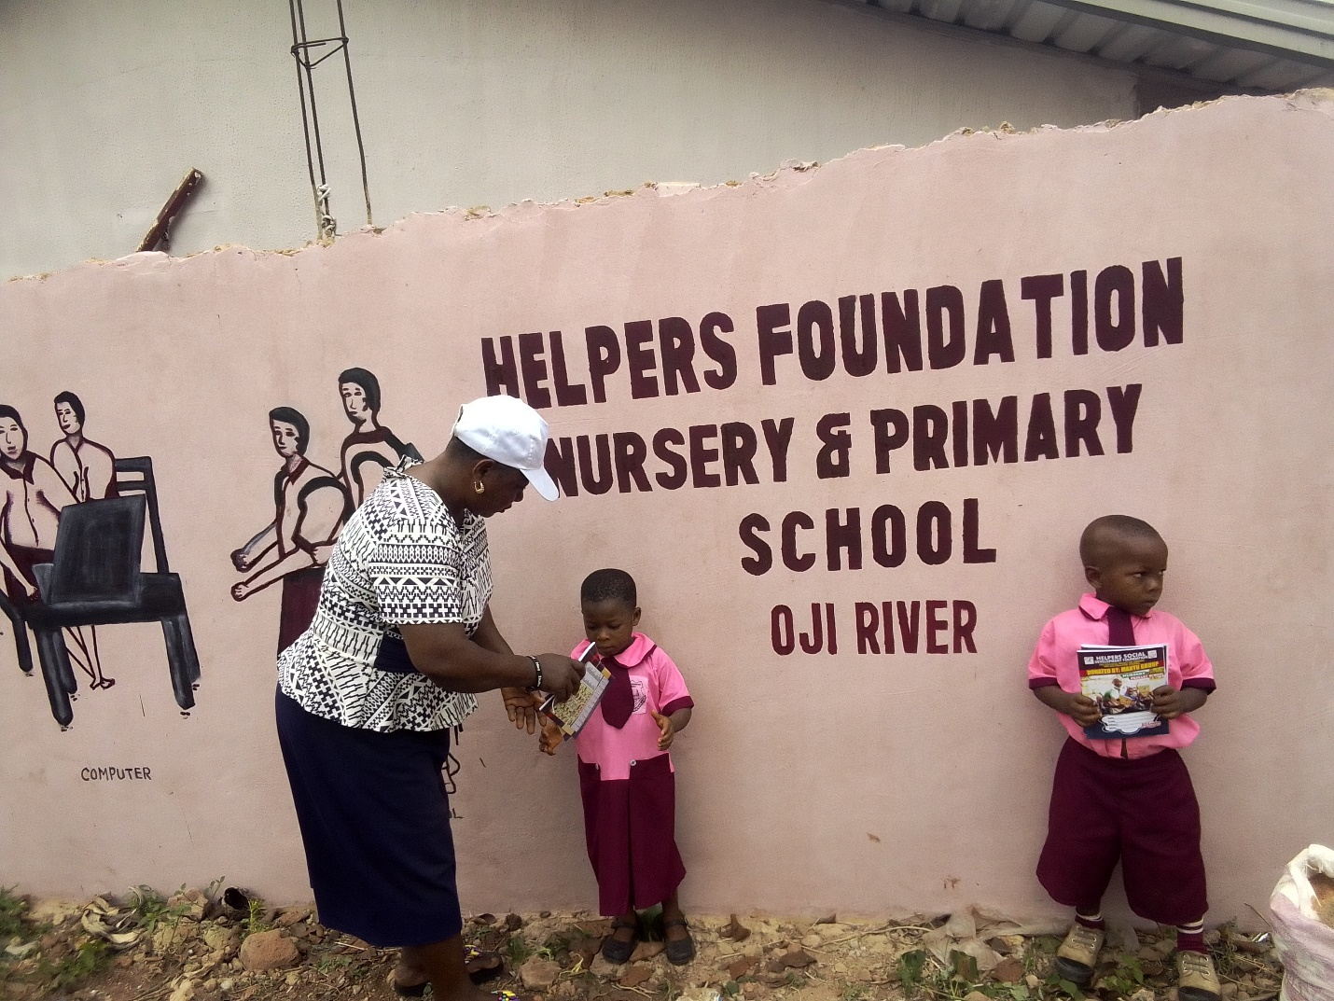
HELPERS SOCIAL DEVELOPMENT FOUNDATION.
(A NONPROFIT ORGANIZATION)
Who we are?
- Registered in 27th June 2019
- Headquartered in Enugu State, south eastern Nigeria
- Focus area – Nigeria
- Core emphasis on Education, Healthcare and Economic Empowerment
We strive to achieve SDGs 4, 5.1,2,6 and 10 2030

Primary focus area:
- Advancing Helpers Foundation free school vision and classroom building project.
- School supplies for underprivileged children
- Sanitation and Hygiene project in public primary schools.

Nigeria Project: Helpers Foundation Schools
Nigeria is among the top five nations in the world for out-of-school children of primary school age. Due to a lack of access, affordability, and awareness, children in rural areas are unable to receive the education to escape poverty. Unfortunately, this has a disproportionate impact on women and girls. More than 50 percent of girls fail to enroll in school, and those that do are likely to drop out by the age of 12. As a result, these children lack the skills to break the cycle of poverty.
In the communities that Helpers Foundation works, we have observed poor school infrastructure, lack of teacher’s commitment in public schools, incongruence between curriculum and felt realities of the students, lack of vocational training and low social standing of women. These are common obstacles to realizing the full potential that education can provide. With you help, Helpers Foundation school will be established in more rural communities in need of education so that more girls will have access to education.
Helpers Social Development Foundation believes so much that education is the key to human liberation and development. As such, we have been empowering underprivileged children by providing their basic school supplies like school uniforms, books, mentoring programs, building toilet facilities in public schools using open defecation with aim to end the practice. In 2021, we established Helpers Foundation nursery and primary school in Oji-River due to the growing rate of out of school children and children marriage.

Why classroom building initiative for our ongoing program:
In 2021, we established Helpers Foundation nursery and primary school in Oji-River due to the growing rate of out of school children and children marriage in Oji-River. We want you to contribute to ensure our school Helpers Foundation nursery and primary continued to offer free education by building classroom blocks to have access to education. Supporting this initiative will help close the gap by helping more than 100 underprivileged children to have access to education annually to break a circle of poverty. There will be relief on the burden of parents, who are unemployed to provide these basic essentials for underprivileged children. Our experienced in Oji-River where our school is located have shown that parents and their children actual wants to go to school but hunger are preventing them. Despite making education free, 25% of our pupils miss school because of hunger. Together, let us help poor children annually get back their happy lives by helping them access quality education as well as reduce child marriage, sexual exploitation.

Our School’s mission
“To create world-changers through the power of high-quality free education, love in action, and humble service.”
We focus on nursery and primary school pupils to impact these children through early intervention education

The problem Nigeria children faced
Nigeria is among the top five nations in the world for out-of-school children. 20 million children in Nigeria are out of school. Due to a lack of access, affordability, and awareness, children in rural areas are unable to receive the education to escape poverty.

How donations from GlobalGiving community will help us to alleviate some of these challenges.
Your donation will benefit various underserved communities in need of help to have access to free education. Donation funds to us will help us to build classroom blocks for more underprivileged children to have access to education to break a circle of poverty. Together, let us help at least children annually get back their happy lives by helping them access education as well as reduce child abuse. Your donations aim to build confidence and enable underprivileged children to achieve their dreams and feel protected.
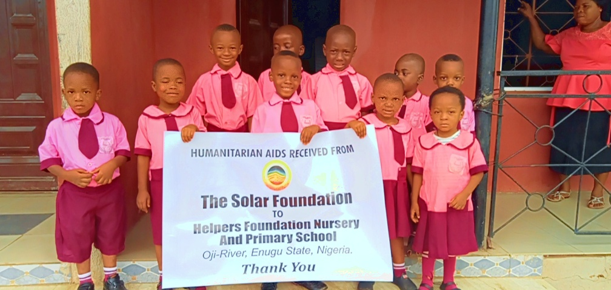
Helpers Foundation School’s Principles and Community Center Programs
The primary school will provide an excellent education to all students, regardless of their gender or demographics, so that they can become skilled and active future change agents in their communities. Teachers and parents will work together to ensure that students at the primary school develop rigorous critical thinking skills, core values, and acquire enduring understandings on how to exercise appropriately.
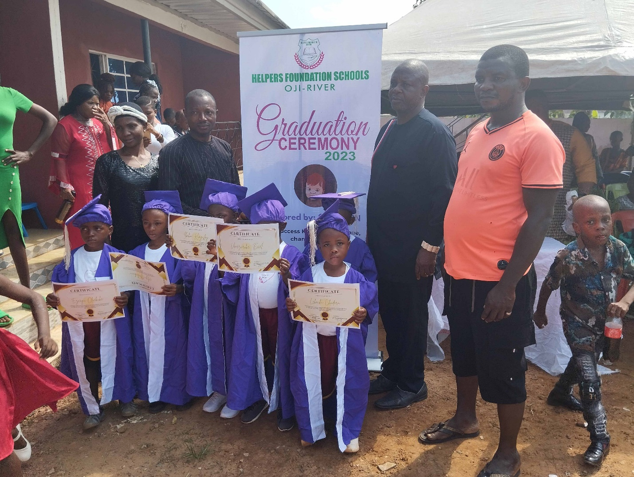
Pillars of Success.
The cultural pillars for the success of our primary school are five-fold:
1. Student Culture – Helpers Social Development Foundation is developing a school curriculum where students are taught enduring values and are building a bank of socio-emotional strategies. Our six habits and mindsets of student culture are urgency, preparedness, wonder, initiative, persistence, and empathy
2. Student Instruction - Helpers Foundation school will maintain high expectations to develop students into proficient readers, writers, and mathematicians; ensuring that all students have opportunities to approach their problems creatively and engage in critical thinking.
3. Staff Development - Helpers Foundation school will provide structures for teachers and school leaders to deepen their craft by protected time set aside for professional development, regular observation and feedback, and one-on-one meetings with their direct manager. Staff will reflect on and be evaluated by their competencies across eight major areas of responsibility including professionalism, classroom management, race and equity, vision and goal setting, instructional delivery, building student relationships and assessment design.
4. Staff Culture – Helpers Foundation school will ensure that staff members feel highly valued, excited about the mission and direction of the school, and feel like they see a pathway for professional development in their work. Classroom systems will reflect the habits and mindsets of student culture. Teachers interactively model each system with students, focusing on what each habit and mindset looks like and sounds like.
5. Family and Community Engagement - School teachers and administrators will partner with families in order to best support our students at school and also at home. This includes, but is not limited to, having multiple touch points with family members during the year, such as community meetings, parent teacher meeting.
Members of the community will be represented on the board of governors for the school. In addition, the school will emphasize the involvement of mothers in school matters, such as parent teacher meetings, exposure to management concepts for ‘cottage’ businesses, and conducting of sanitation and hygiene focused initiatives for mothers and children. The empowerment of women through these initiatives will have a significant impact on the health and economic prosperity of the larger community.
The school will also provide several noteworthy features to enhance the educational experience of children and the community at large. These include free tuition to promote equitable educational opportunities.

Take Action Today
To help enroll more orphans, widows and widowers’ children back to school.
HSDF has been supporting less privileged children since 2016 through supplying school supplies, scholarships, school toilet construction, child marriage prevention education. Your support for this cause will help us to achieve our goals towards children's well-being. Monthly donations will help us to implement regular programs to impact lives.

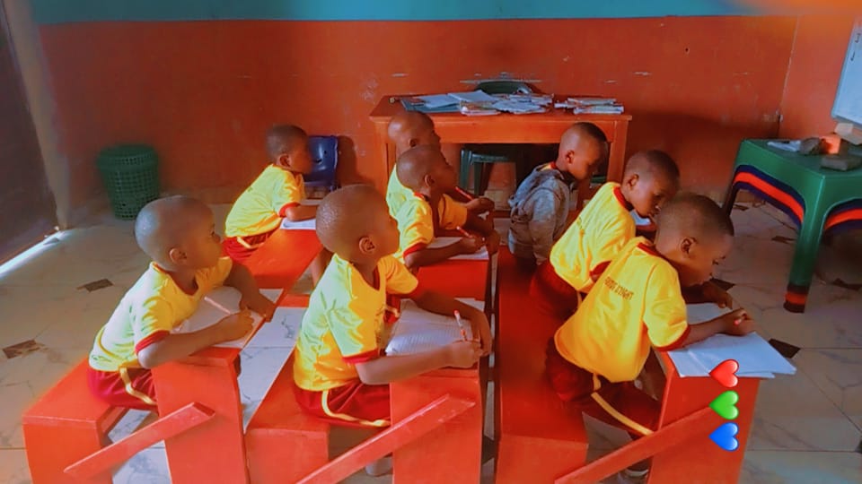
Our Financial Needs - Year 1 Budget
S/no | Description | total $112,245
Curriculum development
1. | Teaching Aid | $1550
2. | Teacher office supplies (basic) | $700.00
3. | Library books and stationaries | $830
4. | Office desk & chairs | $1030
8 | Total staff supplies and curriculum | $4,110
Classroom Furniture, school feeding and Writing Board
1 | Classroom Furniture 150 pieces @$30 each | $4500
2 | Writing Board 10 pieces @ $25 | $250
3 | 10 ceiling Fans | 150
4 | 5 laptops computers | $750
4 | School feeding program for 100 kid’s annually | 15,000
Total Classroom Furniture, school feeding and Writing Board |  | $19,900
Technology
Salary for one year
1 | Seven teachers (basic)@ $1500 each yearly | $10,500
Total Salary for one year |  | $10,500
Electricity & bills
1 | Annual Electricity and utility bills | $535
 | Total for Electricity and utility bills | $535
Purchase of land drilling of bore hole
1 | Two (2) plots of land | $25,200
2 | Construction of 5 blocks of classroom | $35,500
3 | Fencing of our school premises | $5000
4 | Staff & Student Toilets | $7000
 | Drilling of Borehole (water) and overhead tank | $4,500
Total for construction of classrooms and drilling of borehole (water) |  | $77,200

Education is not filling of a pail but the lighting of a fire -William Butler
Donate generously to this noble cause today. Thank you!
