Report of Ahimsa’s work for
the people with disability(PWD)

Ahimsa Philanthropy Service Center is a support, hub and platform-type of NGO in Jiangxi. One of our main focal group is the people with disability(PWD).Since 2016, we have carried out various work and services that support Jiangxi disabled groups and organizations, and actively participated in the work that supports disabled groups and disabled organizations. In addition to traditional assistance，we pay special attention to disseminate Convention of the Rights of Persons with Disabilities, which is signed by Chinese government. Disable and gender, disabled person's self -reliance life, and other issues. We will hold training and workshop for them. After training, we will provide small funding support them organize activities for PWD, such as traveling, visiting museum, etc.

Providing Alms for the poor PWD
Most of the PWD are unemployed and poor due to physical, psychical and social barriers. We had provided them with alms for their family and their children.

Warming kit for the children of PWD family
No. | Organization | number | Value(RMB)
1 | Guangfeng Disable Aid Service Centre | 25 | 9125
2 | Fuzhou Disable Aid Service Centre | 120 | 43800
3 | Nanchang Haemophilia Philanthropy Association | 31 | 11315
4 | Middle Way Family of Leqiu | 1 | 365
5 | Shangrao Disable Aid Service Centre | 25 | 9125
6 | Xinyu Qiaojiang PWD Association | 20 | 7000
TOTAL |  | 222 | 80730

Training for the PWD
In order to empower the PWD and raise the awareness, we had hold training about CRPD, self-identification and social integration since 2016. The content of the training is mainly to re -understand and discover the difficulties of disability, disability and equality, the status quo of disabled people and the difficulties faced by the disabled, the introduction of policies and regulations related to the disabled, social integration, disability and gender, how to communicate with the government, etc. The trainees not only learned the policies, policy of disability, and three models of disability, but also had a contact with new concepts such as social integration and self -reliance life, which boom the trainees’ self-confidence and optimistic attitude.

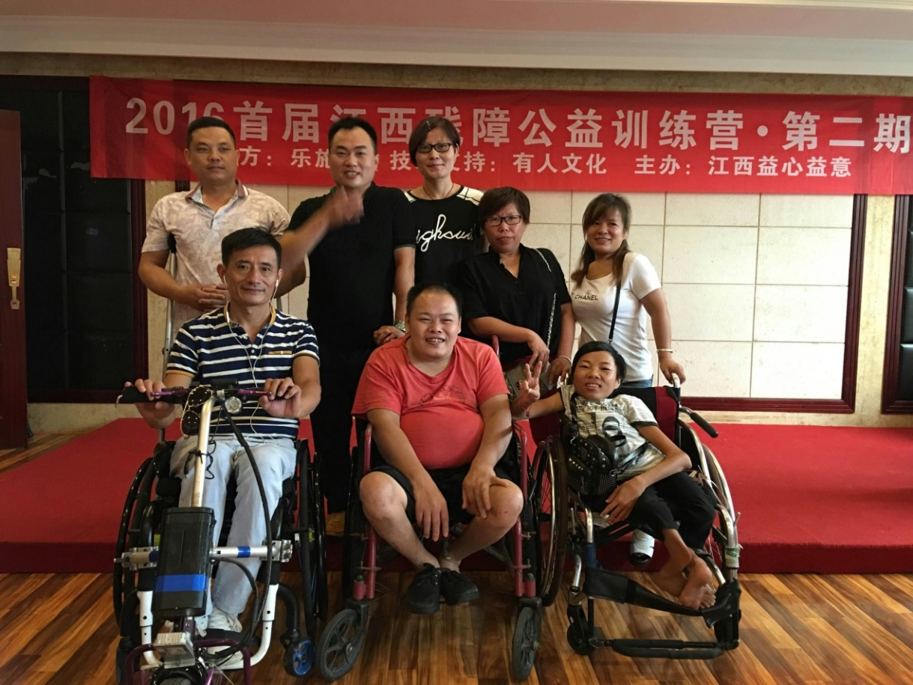

Financing the disable activities

Since 2017, we have provided funds for disabled organizations in Jiangxi to carry out disabled activities, including disabled travel and employment training for disabled people. Such activies have changed the stereotype of the society that the PWD is passively accepting help and assistance. While achieving the social value of the disabled and establishing self -confidence, it also makes the society to treat PWD with a more positive attitude, thus reduce the prejudice against them .

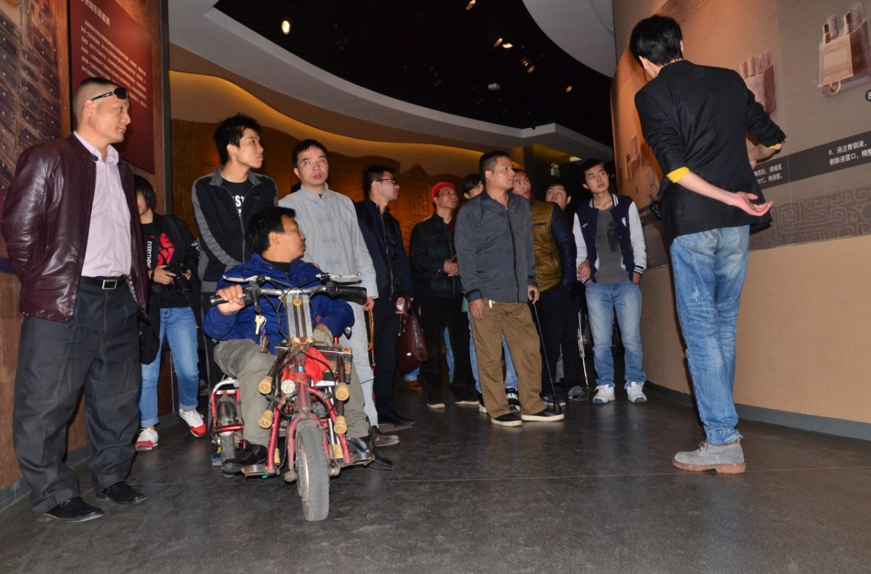
Visiting Museum

To Make a Barrier-Free World

In order to improve the life of PWD, we enthused in encouraging the PWD to travel around in groups. While traveling, we suggested them to provide feedback about the accessible facilities to the public department. We believe that when the "disability is visible", then can we realize the social integration of the PWD
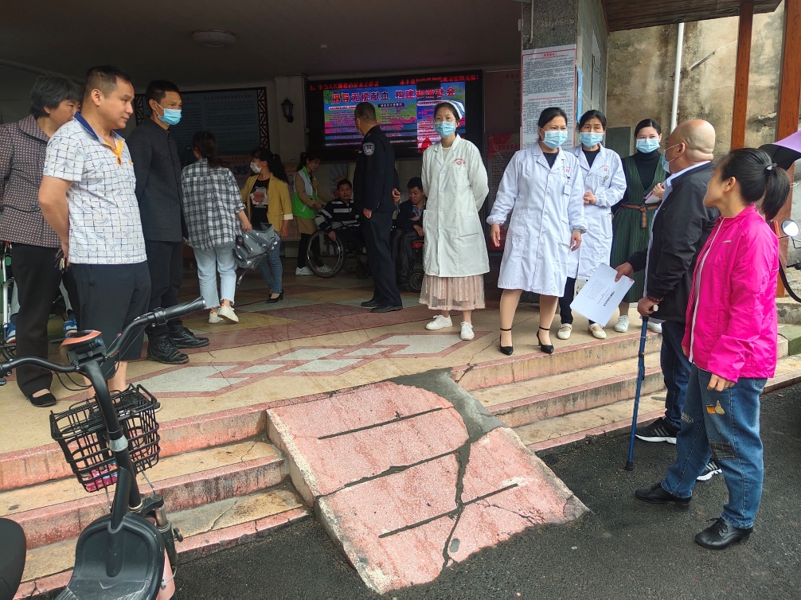
Discuss with the hospital about their accessible facilities.
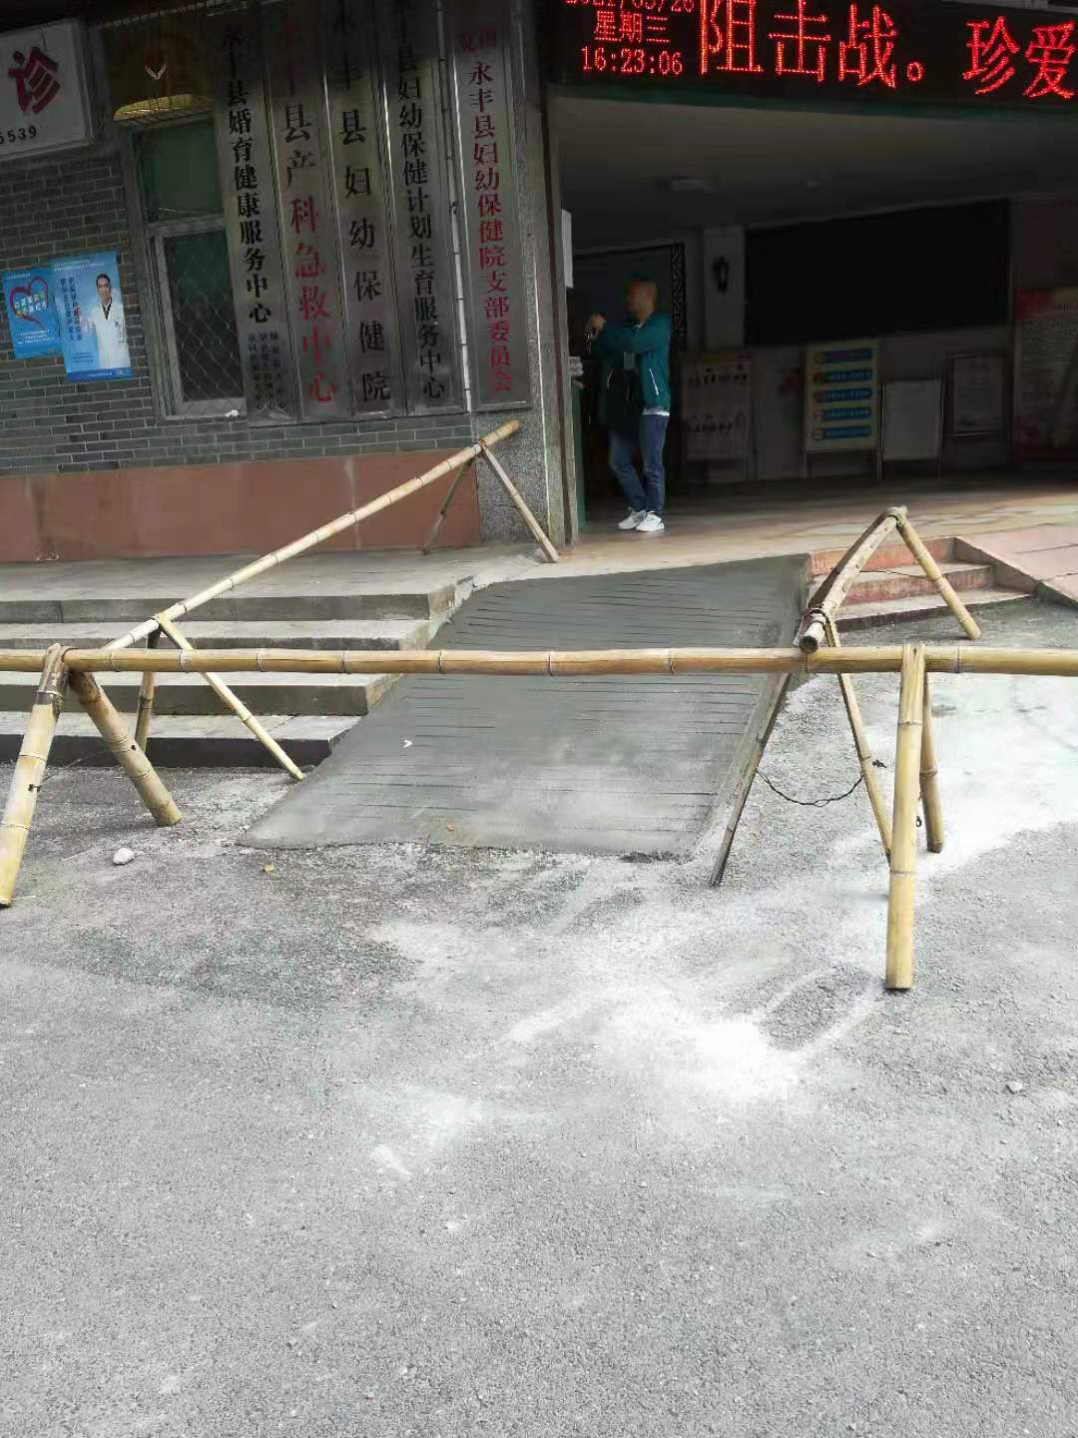
Improved by the hospital after receiving the feedback from the PWD
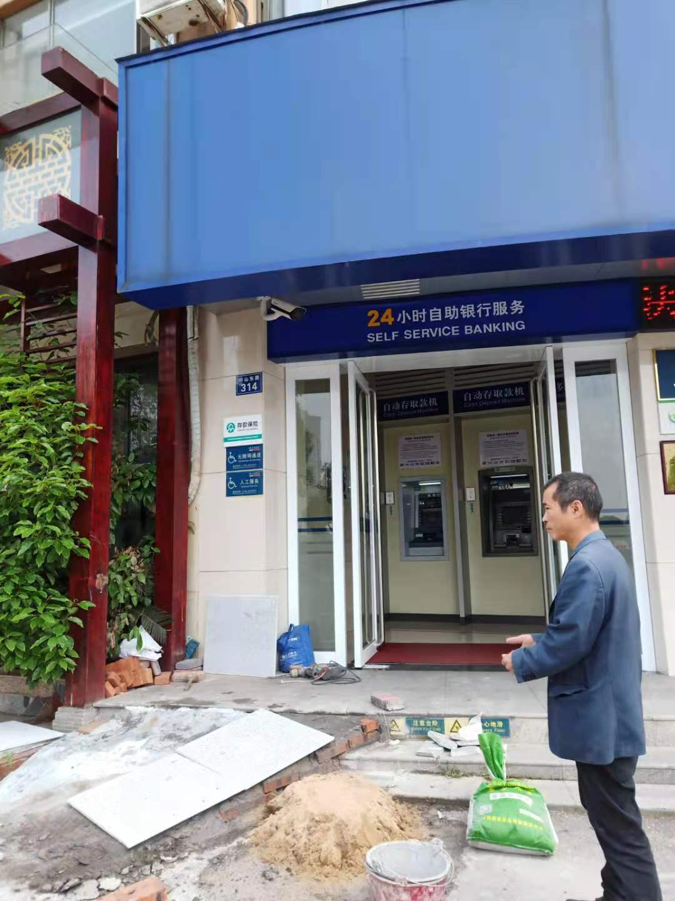
分宜银行进行无障碍设施整改
通过在永丰、分宜、南昌、九江、新余、兴国、抚州等地的无障碍出行的实践，我们支持残障组织积累了丰富的无障碍出行经验，找摸索出了一条推广无障碍出行的有效方法。未来我们会继续和各地的残障组织一起，分享江西残障无障碍出行的成果与经验，让更多残障组织加入进来，造福社会。

