Our achievements from February to October 2023

Children Project

- Full sponsorship for the child
To this time we fully sponsor three children: Javira, Gilashia and Stuart by financing their meals, offering them education. The children live in new home – an orphanage in Entebbe , attend to the privet school

Below you can see what changes have occurred in the children since they were taken into care:

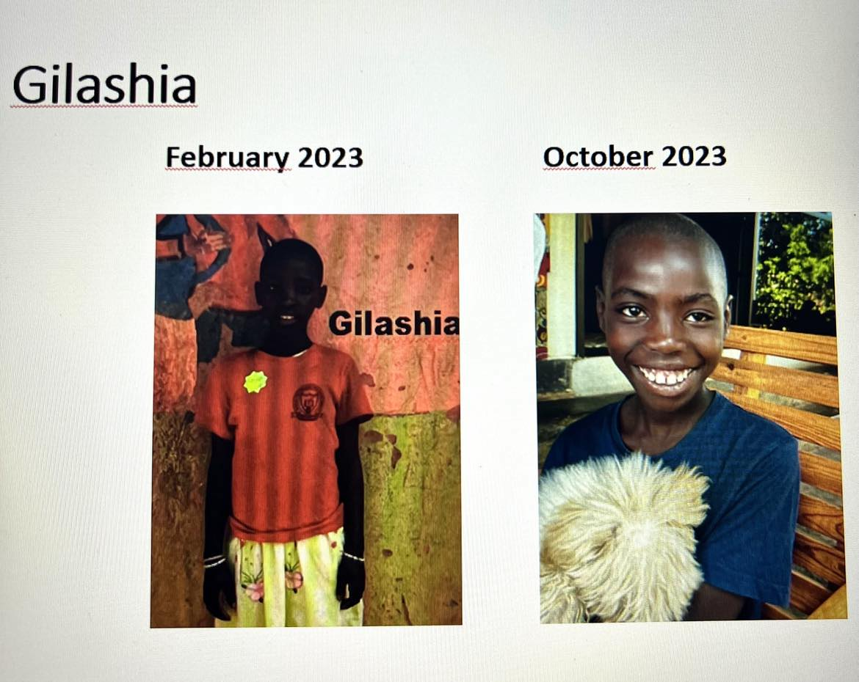

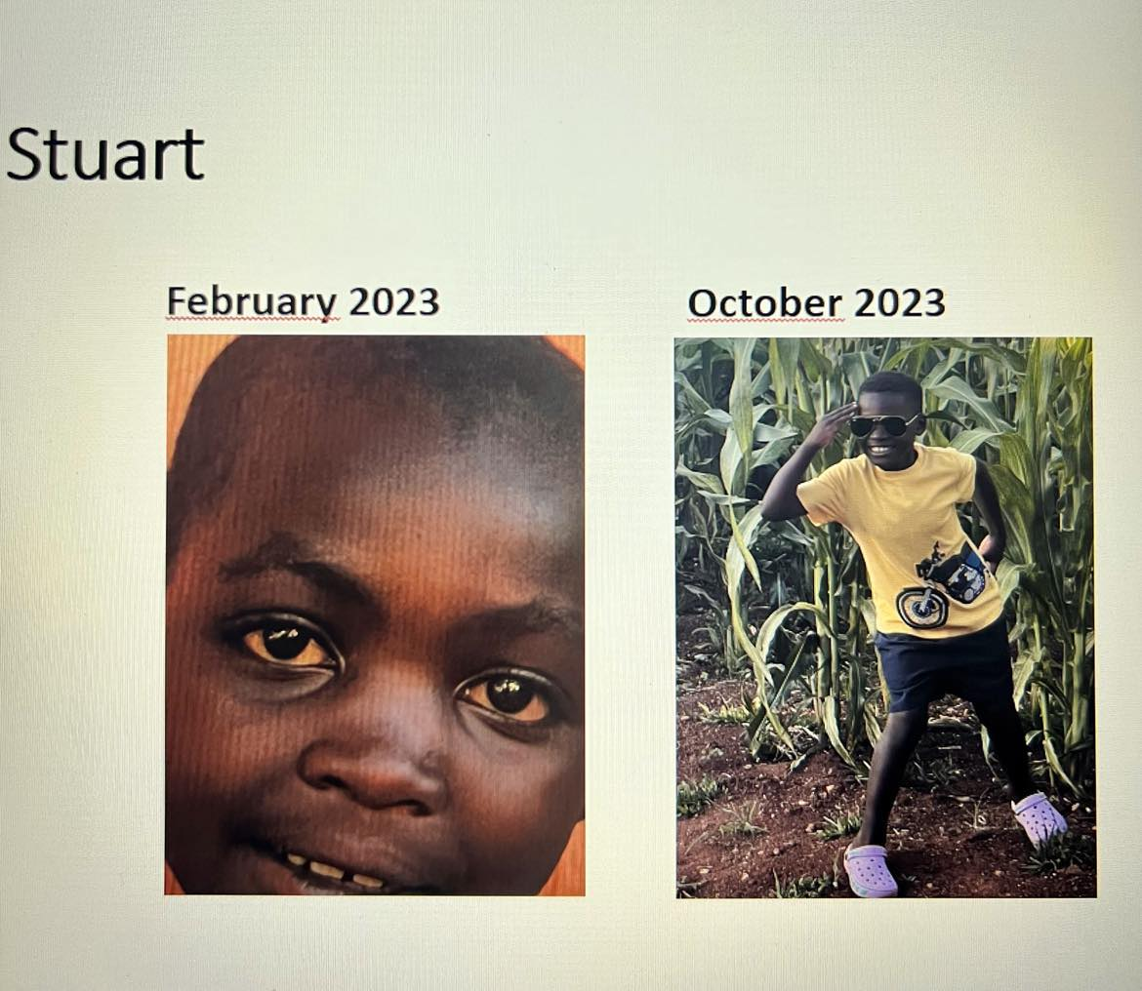

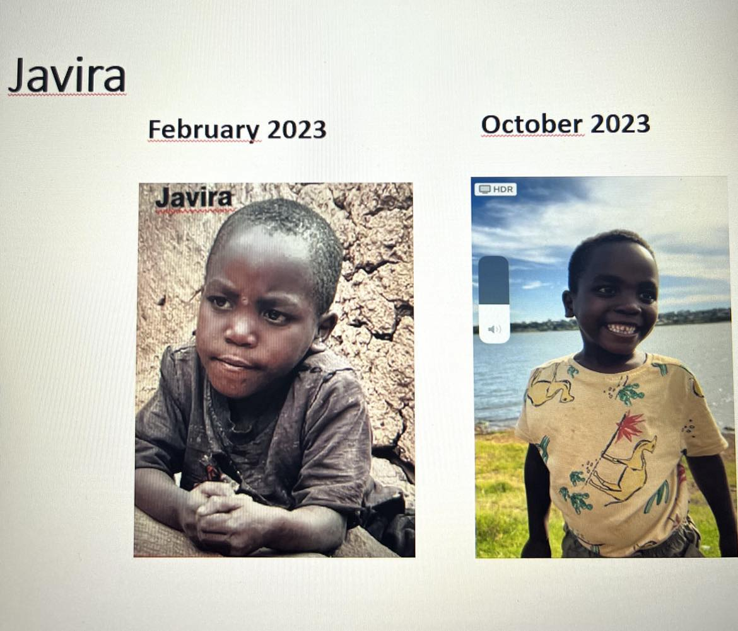

- Feeding support for 120 children from Ruhija

We regularly deliver food to villages for orphans and families in need. Every three months we go to Ruhija and organize special meals with meat, vegetables and lots of vitamins. Children can also taste popcorn, cookies and sweets – to show them a bit of a normal childhood.

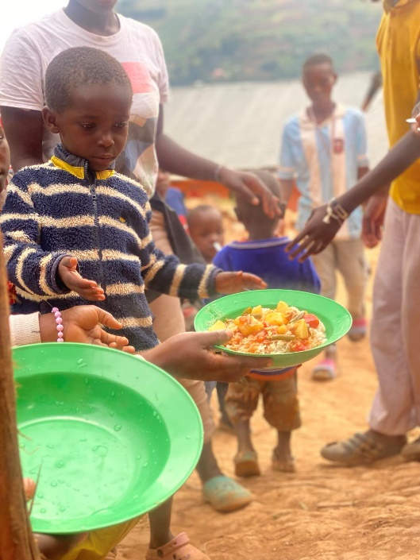
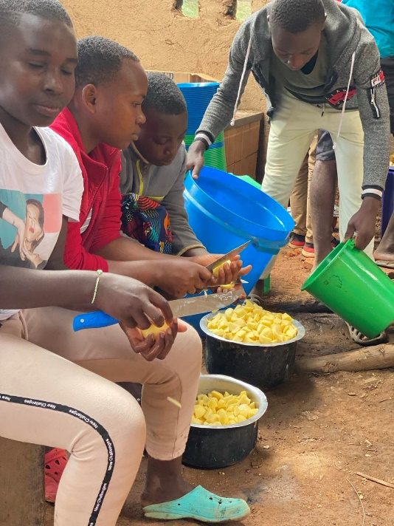

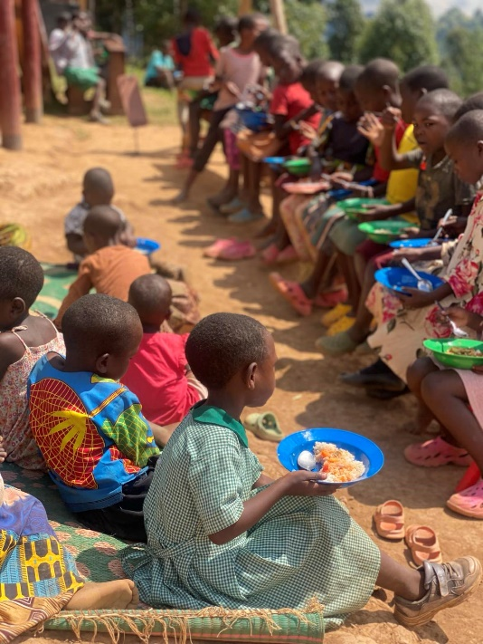
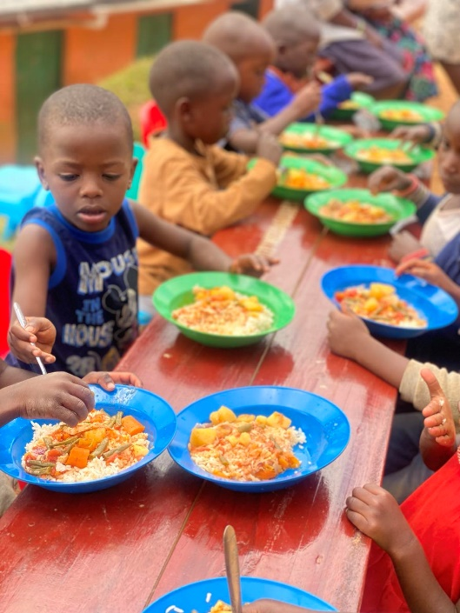

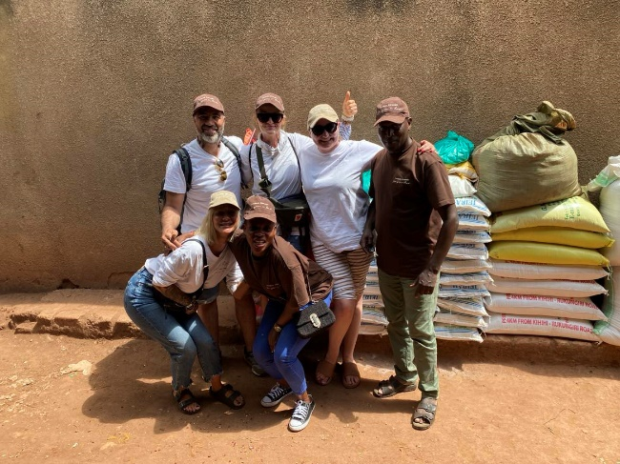

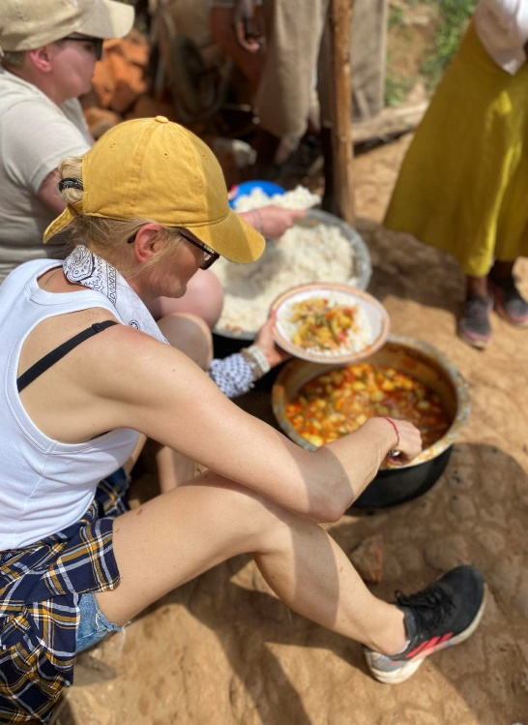
Kitchen Project

a/ Previously at least two children used to eat from one and the same plate. We purchased 120 mugs, plates and spoons. Now each child has its own dining set

b/ The roof of the kitchen was leaking and there was no oven. On rainy days, there was no possibility to prepare a meal. We bought materials for renovating the roof modernizing the kitchen and constructing the oven. Now the roof is finish and the oven can be use.

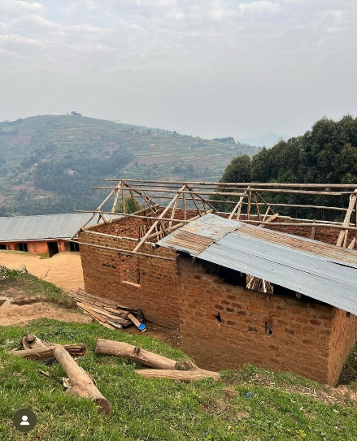
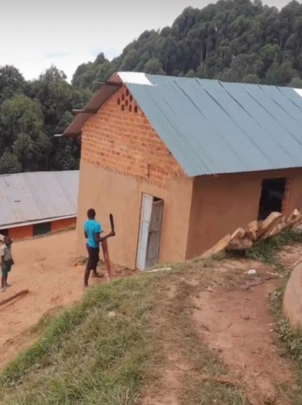
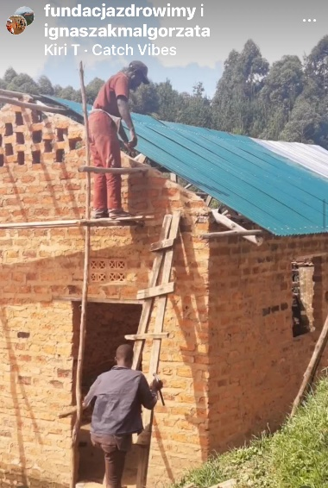

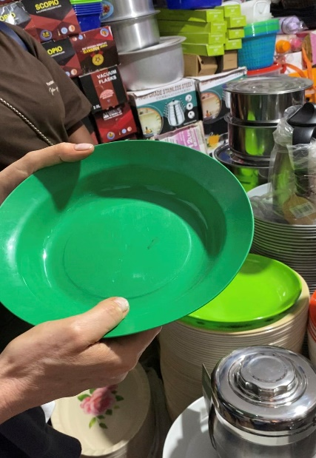
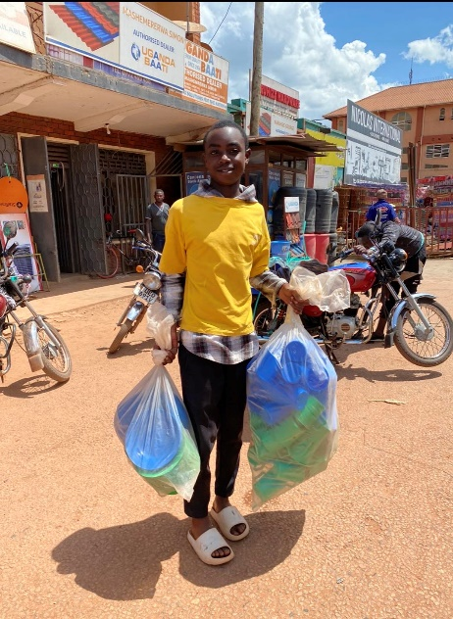

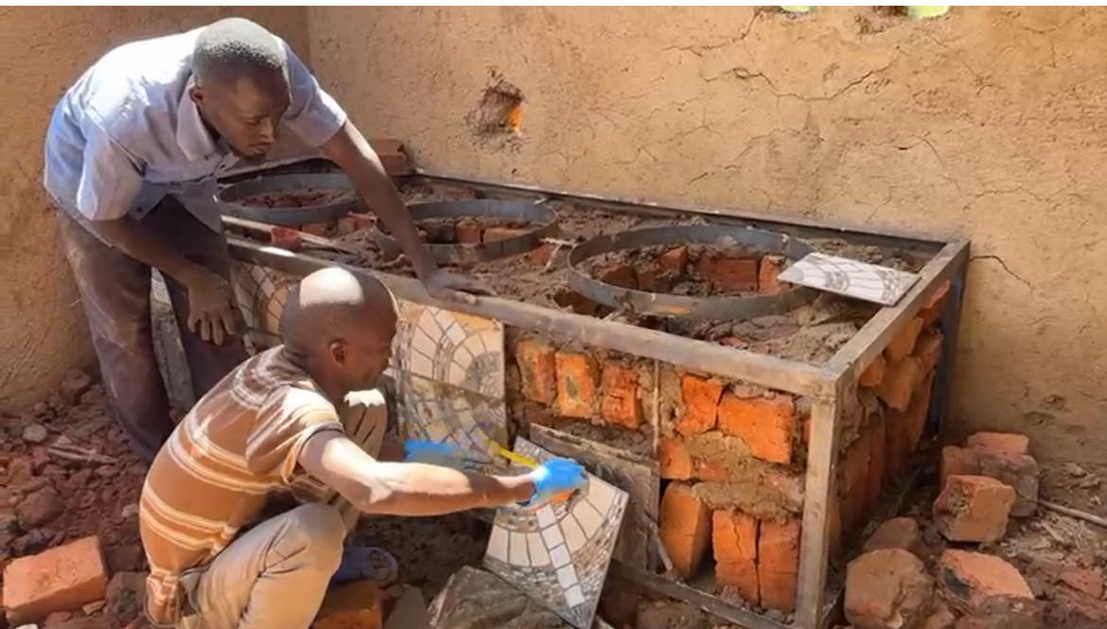

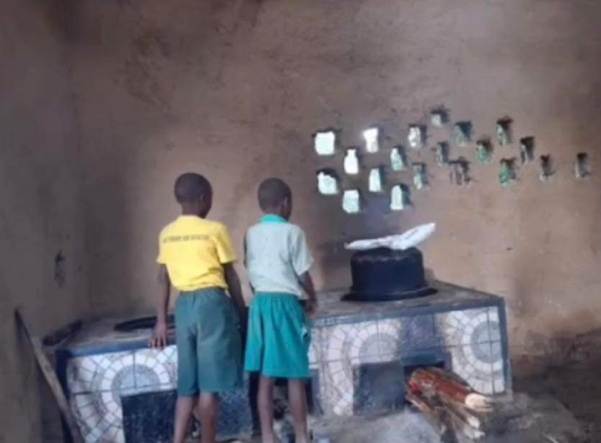

--------------------------------------------------------------------------------------------

Sleeping place Project

In the orphanage, children slept in conditions devoid of human dignity. Six, seven children used to sleep on the same mattress. We took decision that we acquired 20 brend-new mattresses of a higher quality so that they could serve longer.
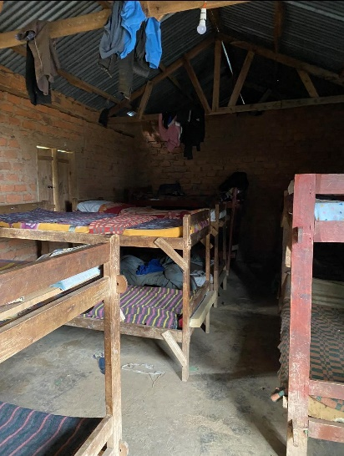
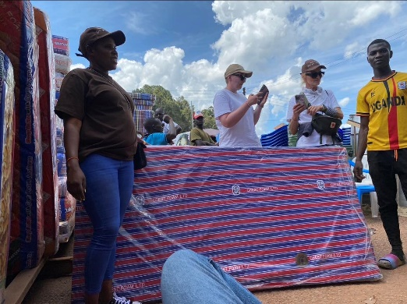
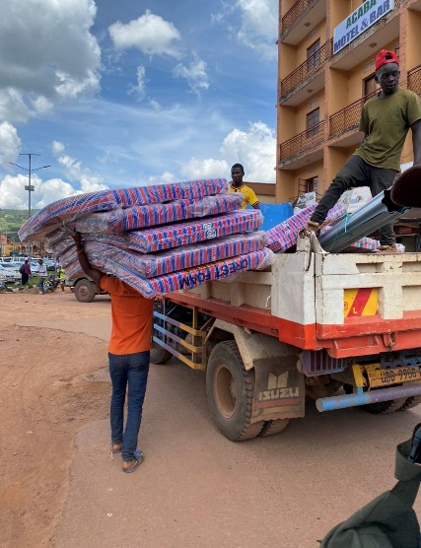

--------------------------------------------------------------------------------------------

Medical dressings and school supplies Project

Children were granted crayons, pens, pencils, drawing paper, adhesive bandages, flue medicine, dressings, vitamins.

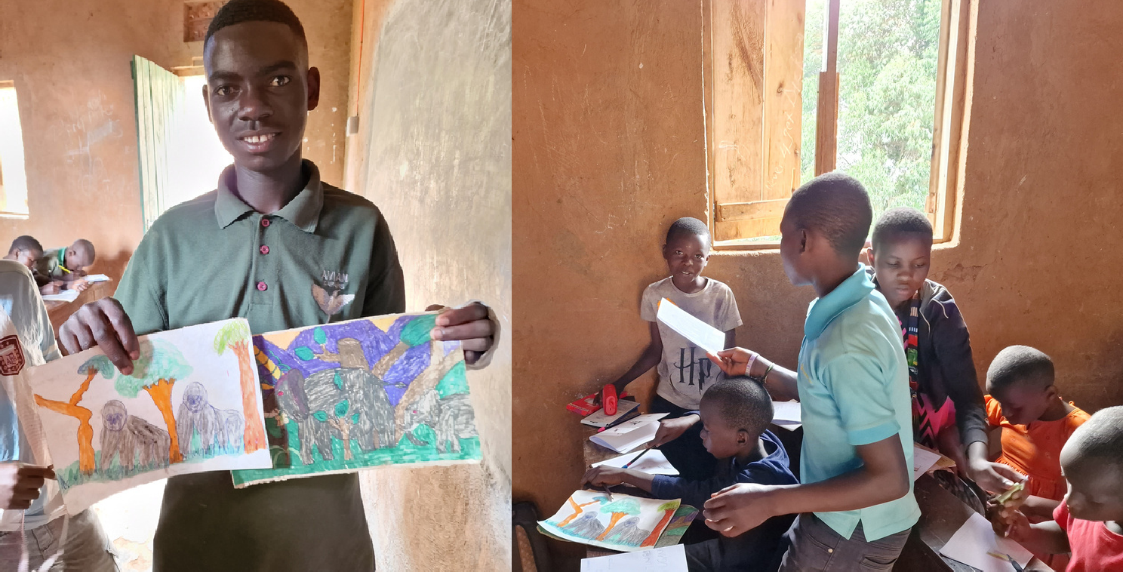
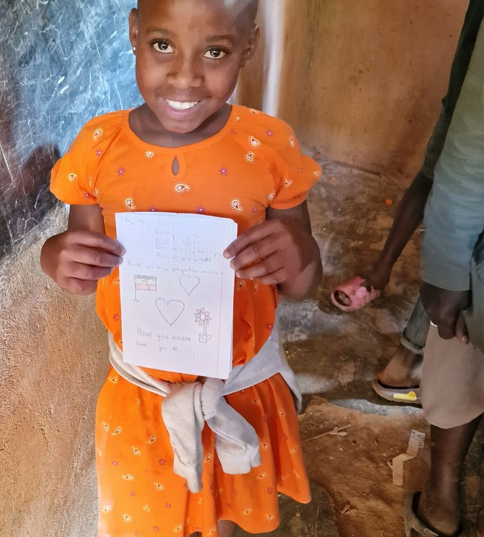
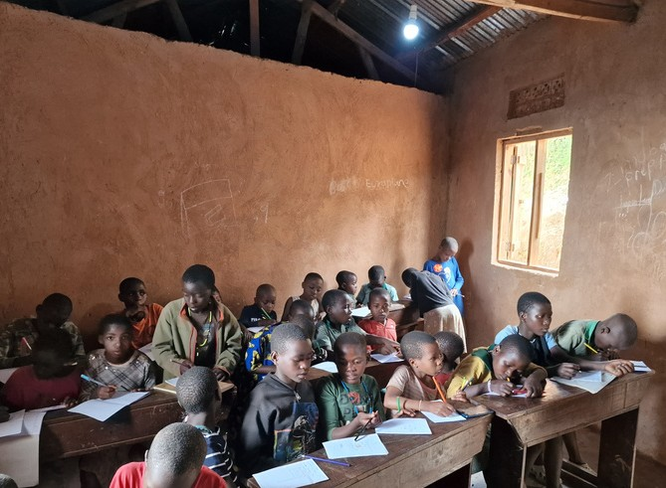
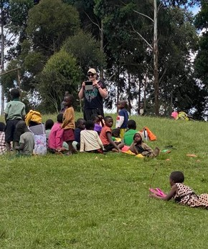

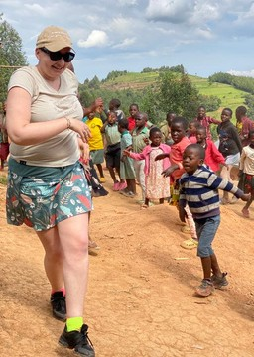

Clothing and footwear Project

We organized a collection of clothing items in schools and at different workplaces. We managed to gather the volume of 2 suitcases to equip each child with new outfits and shoes.
Children participated in a set of session with a psychologist and teachers. They did some drawings, wrote letters in English, danced, watch English cartoons and dialogued

