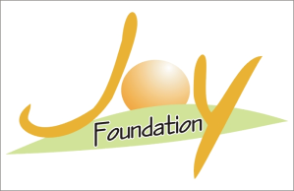
A PROPOSAL
Presented to

TO FUND

Basic Primary Education Program for the Brick kiln Worker’s Children in District Toba Tek Singh, Pakistan.

Submitted:- 2023

By

Mr. Yaqoob Sadiq
Joy Foundation
Madina Colony St # - 2 Shorkot Road,
Toba Tek Singh, Pakistan
Phone: - +92-46-2517752 +92 3462575075
Email: - shaziayaqoobpak@gmail.com

Contact Details

Joy Foundation  Shazia Yaqoob  Madina Colony St # - 2,  Shorkot Road  Toba Tek Singh  Pakistan  Tel: +92-46-2517752+92 3462575075  Email:- joyfoundationpak@gmail.com | BANK DETAILS  Account Title: - Joy Foundation  IBAN Number: - PK98KIP020420041424001  Plot No, XFCG+7X9, 260 Allama Iqbal Rd  Toba Tek Singh  Punjab, Pakistan  Swift Code:U N I L P K K A

Project Information
Title: Basic Primary Education Program for the Brick Kiln
Worker’s Children in District Toba Tek Singh, Pakistan.
Location: Toba Tek Singh, Pakistan
Project Duration: 12 months
Total Project Budget in Pakistani Rupees:
Total Funds Requested from Donor in Pakistani Rupees:
Total funds requested from donor in US dollars:

Background of the project:
Many children are forced to work under very harsh conditions in Pakistan to help support their families. The heads of household are paid according to the number of bricks produced. Hence, the children are being forced to work to maximize profit. These children do not want to work at the kilns, but feel like they must sacrifice for their families. In Pakistan 60% of brick kiln laborers are children. There are 11,000 brick kilns in Pakistan, 90% of them in rural areas. Two thirds of child laborers in Pakistan work in brick kilns. The children and their families are often held against their wills by the kiln owners. Often time’s children fell ill while working at the kiln due to unclean working environments and living conditions. In order to have education, health, contributing members to the world’s economy later, it is necessary to eliminate child labor now, before the economic effects start to show up.
In conclusion, these children sacrifice a lot to work in the brick kilns. They do not receive proper education; they are subjected to unhealthy working conditions, and are exposed to abuse and lack of care by the owners. The children have to live in small brick shacks with their entire family and work at the kilns for years at a time for low wages. It’s time to make a difference and try to get these children educated and out of one of the many types of forced child labor: Brick kiln
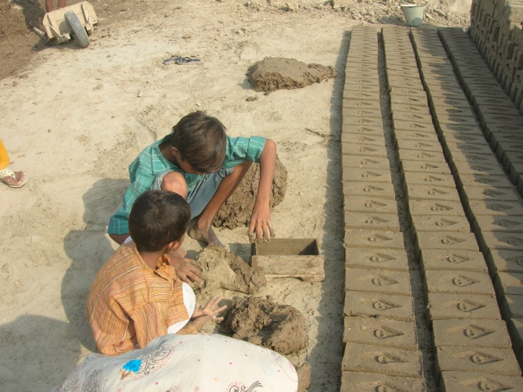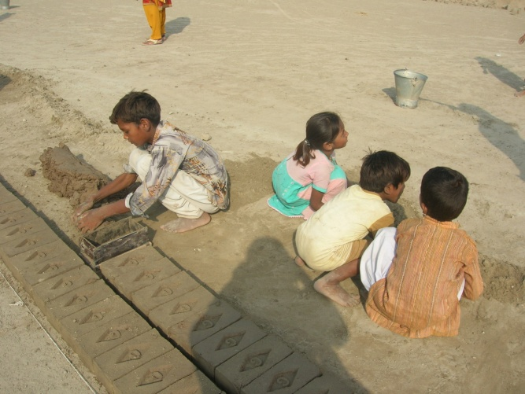
Rational of the project:
Joy Foundation has remained involved in the development of marginalized and down trodden communities of Pakistan for the last 10 years. It has special focus on the development of the marginalized children and disables children and oppressed center for the providing skill training to unskilled disable children. It has also established one primary school for street and brick kiln workers children.
This project has emerged during a base line survey with the brick maker’s children of ten areas of district Toba Tek Singh due to the following reasons.
- Majority of the small children aged 7 to 12 go along with their parents on brick makers work on the brick kiln and make mud for making bricks. The whole family makes bricks and making one thousand bricks the family is given Rs.90 (which is less than one euro) and in order to make one thousand bricks the brick makers have to involve their small children.
- The average family size of the brick makers is 6 to 7 family members. These brick makers do not use any family planning methods. Therefore, they have increased numbers of children further more they believe the more children, more income.
- The small brick makers children have to sit for long hours in order to make bricks as a result they get joint pain and due to work in dust they become victim of various skin and lung diseases. The owner of brick kiln do not provide them any medical leave or medical facility or give very cheap local made medicines in order to get well, furthermore the brick makers live in the narrow mud built houses where there is no proper ventilation or sanitary system which effects specially the small children. The patients of Tuberculosis (T.B) which has a treatment for long duration which these poor brick makers cannot afford.
- These brick makers’ children have never attended any school since there are no any schools nearby. There are some schools which are private and these poor brick makers cannot afford to send these children to school. During the base line survey and several meetings with the parents of these children the parents have strong by demand to provide education to their children in order to get out of the external slavery. Therefore, Joy Foundation has planned to provide basic primary education to 250 brick makers’ children within the period of one year by opening up five small schools in five target areas of the district Toba Tek Singh.
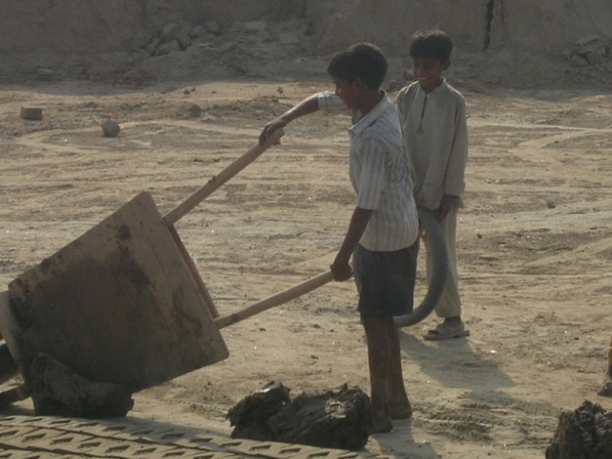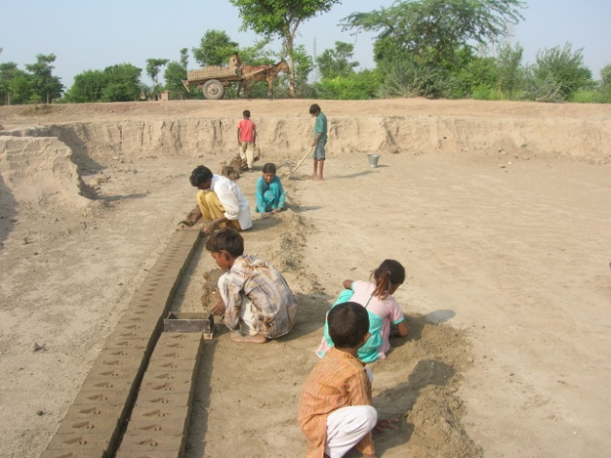

Target Areas:-
1:- Chak No 331 G.B Toba Tek Singh
2:- Chak No 295 G.B Toba Tek Singh
3:- Chak No 199 G.B Toba Tek Singh
4:- Chak No 323 J. B Kiampur Toba Tek Singh
5:- Chak No 327 G.B Toba Tek Singh

Project Goal and Objectives
Objectives:
- To establish 5 schools for providing basic education to 250 small brick makers children.
- Hiring 5 teachers and 5 helpers for imparting basic education to 250 small brick makers’ children.
- Provision of books, uniforms and furniture to 250 brick makers’ children for studies.
- Medical treatment will give to the children to save them from different diseases
- Hygiene education programs with children and their mother
Methodology

Objective no.1
Establish 5 schools for providing basic education to 250 small brick makers’ children.

Methodology:
5 schools in the 5 target areas of district Toba Tek Singh will be established.
The place for conducting classes for children would be provided by Joy Foundation. In each school there would be 50 children which means in 5 schools there would by 250 children.
Purchase of material for schools.
The following material will be purchased for establishing schools.
- 5 tables for teachers
- 10 arm chairs
- 10 mats for children to sit
- 5 black boards
- 500 packets of chalks
- Stationery for teachers

Objective No. 2
Hiring 10 teachers for imparting basic education to 250 small brick maker children
Methodology:
An interview panel will be formed which will interview the teachers for selection no. TA. DA will be granted to the teacher coming for interviews. The following criteria will be used to select the teachers.
- Be the resident of the target area.
- Aged 25-45
- Must be graduate
- Have experience of 3 to 4 years
- Agreed to sign the contract
These teachers will provide basic education to brick makers’ children. Each teacher will be responsible for 50 children. These teachers will be paid salaries for their services.
Objectives No. 3
Advocacy campaign with parents, owners of Brick kiln and Local Government
Methodology:
Advocacy campaign will be start with the other stakeholders to make our program strong and more benefited for the children. For this purpose Joy Foundation will organize meeting with parents to motivate them to send their children for the school. Joy Foundation will also organize meetings with owners Brick kiln to motivate them to stop the child labor and give chance to children to get education for their better future. For this Joy Foundation will organize meetings and seminars with them time to time. Same will be done with Local Government to motivate them to stop the child labor and give them chance to the children to get education. For this, meetings and seminars will be organized with local government. International Labor Day, Children and education will be celebrated with all five schools.
Objective no. 4
Provision of books and uniforms to 250 brick makers children for studies
Methodology:
250 small children will be provided uniforms and books for studies. The books and uniforms will have the logo of Joy Foundation. These uniforms and books would be provided free of cost.
Objective no. 5
Medical treatment will give to the children to save them from different diseases
Methodology:
An M.B.B.S Doctor will be hired for the prevention and the treatment of these small brick makers’ children he would be paid monthly salary.
Objective no. 6
Hygiene education programs with children and their mothers
Methodology:
Seminars will be organized with the mothers and children on cleanliness and hygiene. Mothers are involved because at homes mothers are responsible for the cleanliness of the children.

Logical Frame work

 | Intervention logic overall broader objective to which the action will contribute | Objectively verifiable indicators of achievement what are the key indicators related to overall objective. | Source and means of verification the source of information for this indicators | Assumption
Specific Objective No.1 | To establish 5 schools for providing basic education to 250 brick makers children | The 5 school have been established for the provision of educating to 250 brick makers children | Photos  Video  Reports
Specific Objective No.2 | Hiring 5 teachers and 5 helpers for imparting basic education to 250 small brick makers children | 5 teachers and 5 helpers have been selected for imparting education to 250 small brick makers children | Photos  Video  Interviews
Specific Objective No.3. | Meetings with Parents, Owners of Brick kiln and local Government will be organized and International Day will be celebrated with the children | After the meetings and seminars parents and owners of Brick kiln and local Government will cooperate with Joy Foundation | Photos  Video  Interviews
Specific Objective No.4 | Provision of books and uniforms to 250 brick makers children for study | The books and uniforms have been provided to 250 children for studies | Books  Video  Photos  Reports  Case studies
Specific Objective No. 5 | Medical treatment will given to the children to save them from different diseases | Medical treatment provided to the children by a Doctor for prevention from diseases | Photos  Videos  Interveiws
Specific Objective No. 6 | Hygiene education programs with children and their mothers | Seminars are conducted with children and mothers | Photos  Videos  Interviews
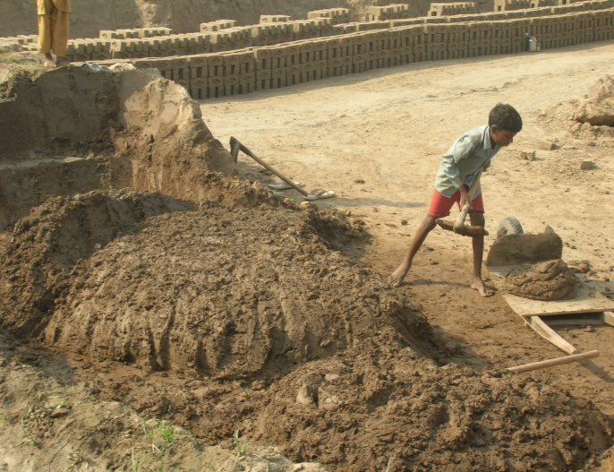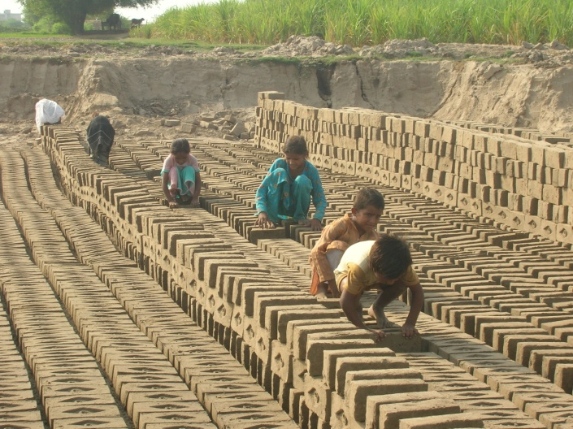
Financial Plan
Total Project Budget in Pakistani Rupees:
Total Funds Requested from Donor in Pakistani Rupees:
Total funds requested from donor in US dollars:-
Monitoring & Performance Measurement
- Monitoring and Evaluation:
Joy Foundation fully believes that continuous monitoring is the only key to a successful project. Through monitoring, we can ensure effective and efficient results. Also, we will be in a better position to adjust or revise our work-plans accordingly in order to do away with the possible shortcomings, well in time. The respective officials of Joy Foundation would conduct monitoring visits quarterly of the target communities and the findings would be recorded and needful would be done in this regard.
The evaluation enables to review the Program using records and information gathered during monitoring and to make an analogy between the original goals and objectives of the program. The observations made by the evaluators provide the means to improve, make changes or modifications in the best interest of the poor communities. The evaluation of the program activities would be conducted on six monthly bases by external and internal evaluation.

- Reporting and Financial Audit
Detailed Narrative and financial report would be conducted on quarterly basis. Annual audit of the program would be conducted and the report would be shared with the donor partner.

