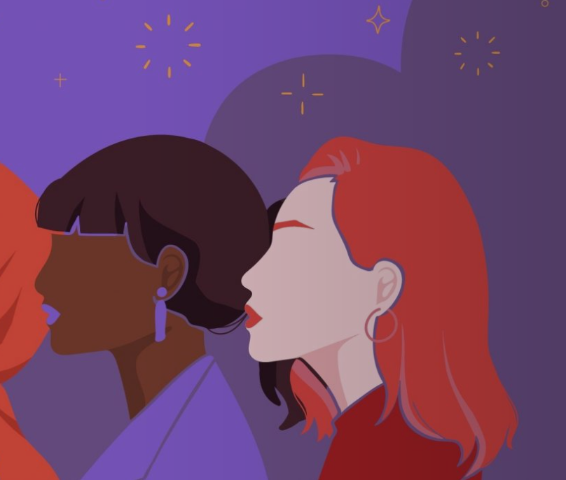**technique**

**WHAT IS FEMALE GENITAL MUTILATION/CUTTING (FGM/C)?**

FGM/C is the removal or injury to a girls’ external genitals, usually practiced before a girl turns five, more commonly in Africa and Asia. It is a violation of human rights and a form of gender-based violence that can bring severe and life-long physical and mental health impacts, including: chronic infections, bleeding, urination problems, trauma, difficulty with sexual intercourse and severe complications during pregnancy and childbirth. A recent study by the University of Birmingham estimates that FGM/C is responsible for more deaths of girls in Africa than HIV/AIDS, measles, or starvation, making it as an urgent social and medical issue alongside a human rights violation. Every year, 4.3 million girls are cut, but due to population growth, more girls are being cut today than ever before.

|  |
| --- |
| **In Africa, a girl dies every 12 minutes as a direct result of FGM/C** |

The driving force behind FGM/C is gender inequality, held in place by harmful gender norms on proper sexual behaviour for women. It continues because of the expectation placed by the community, with families fearing that their daughter will be stigmatised or remain unmarried unless she is cut.

# WHAT DOES ORCHID PROJECT DO?

Orchid Project was founded in 2011 with the sole aim of ending female genital cutting, one of the very few organisations around the world. We work to achieve our **vision** of a world free of FGM/C through:

**1. RESEARCH:** We generate research and evidence of what works to end FGM/C to better-equip those working to end it. **Our research data is seen as a point of reference by global players in the sector, such as the UN, governments, and the media, who direct their stakeholders to our content and cite our work.**

**2. CAPACITY STRENGTHENING:** We partner with grassroot organisations and local activists to build their knowledge and capacity to improve programme designs and impacts to end FGM/C in their communities. We know that only local community members can instigate change. **Since 2011, we have convened more than 200 individuals, from over 90 organisations across Africa; 94% of participants made changes to their programming and 87% saw positive changes in outcomes as a result.**

**3. ADVOCACY:** Weraise the voices of women and girls to influence global and regional policies, actions and funding towards ending FGM/C. We seek to influence, change policy and challenge the systems and structures locally, regionally and globally that allow FGM/C to continue. **Our advocacy work has contributed to the first UK government commitment to end FGM/C and the inclusion of a target in the SDGs to eliminate FGM/C by 2030. We also helped to set up and advise two regional networks to end FGM/C in Asia and Africa, bringing together the efforts of hundreds of grassroots organisations.**

**IMPACT:** Our work has contributed to 9,500 communities abandoning FGM/C in West Africa, the decrease of FGM/C rates in Kenyan communities by 27%, and educating 35,000 people in East Africa on FGM/C and human rights.

# HOW CAN YOU HELP?

Communities want to stop FGM/C, but they need support. The ‘End FGM/C’ movement is severely underfunded, and although ending it targeted for elimination by 2030 by the SDGs, annual population growth means progress needs to be increased 10-fold. For more information please get in touch with Fiona[@orchidproject.org](mailto:fiona@orchidproject.org)

|  |
| --- |
| **Join the movement to end FGM/C!** |