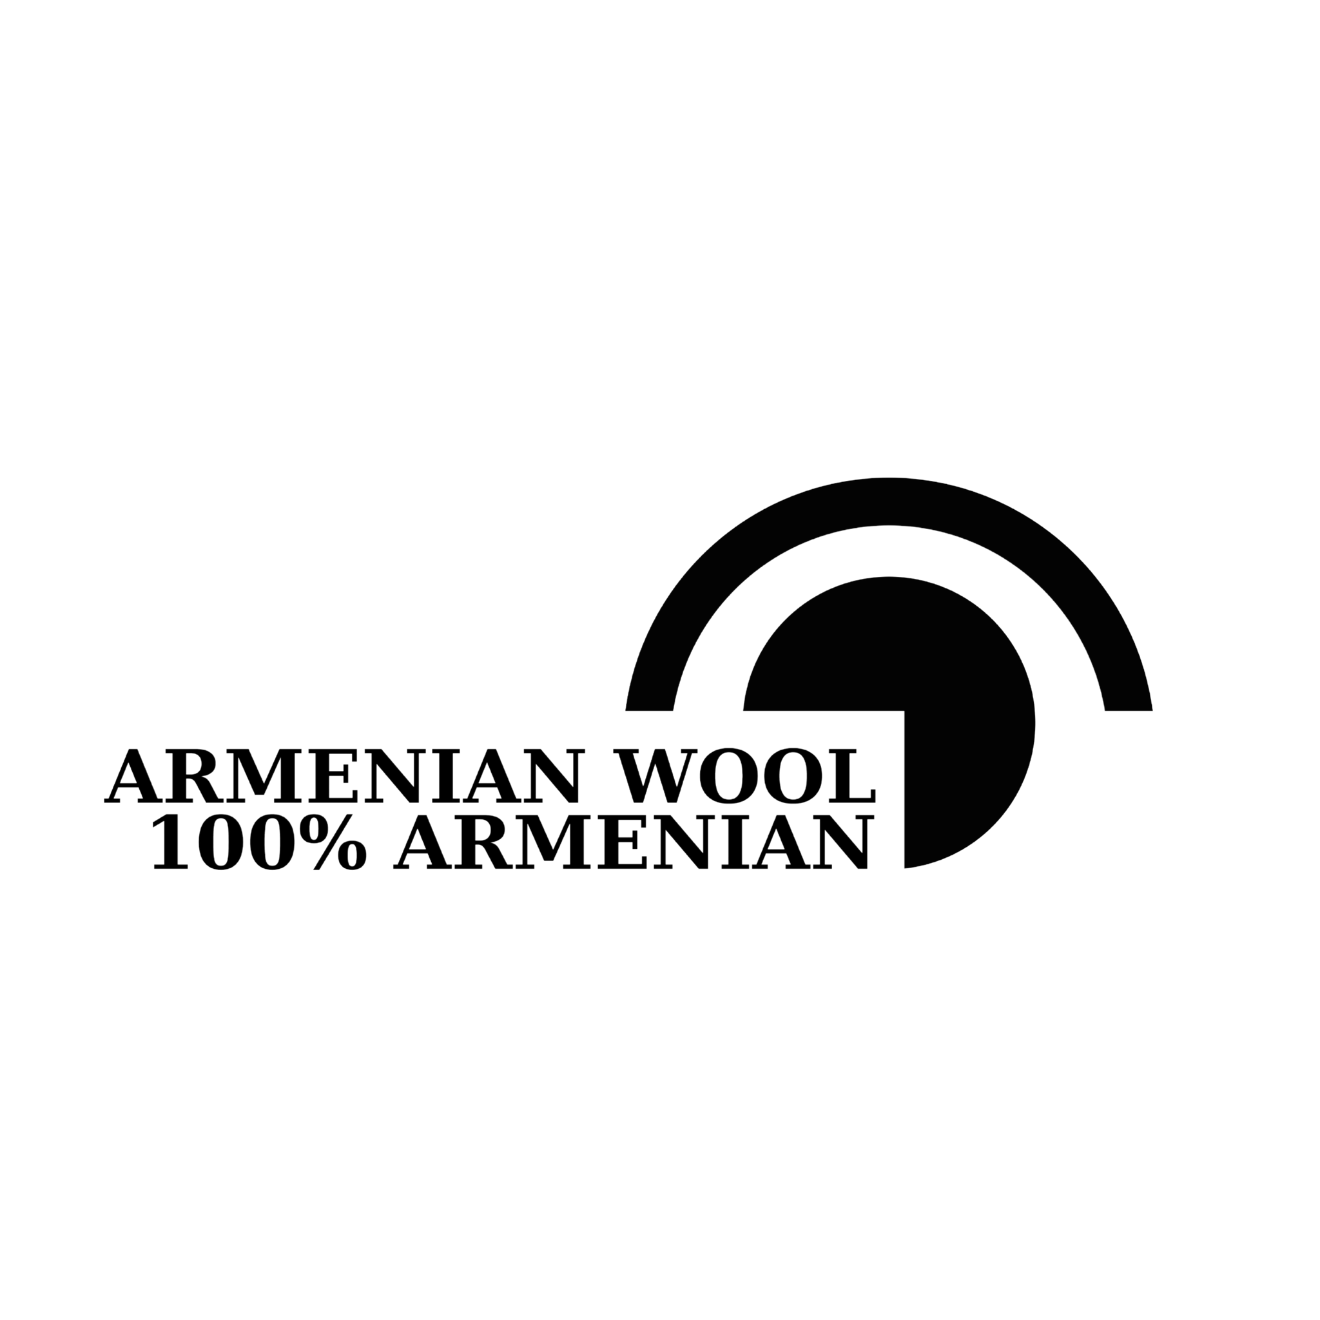
Concept Paper: Creation of a Spinning and Rug making Center for the Armenian Wool Value Chain Enhancement Project
Project Title: Creation of a Spinning Center for the Armenian Wool Value Chain Enhancement Project
1. Background
Armenia has a rich tradition of wool production, but the industry faces challenges such as outdated processing techniques and limited market access. The creation of a spinning center is a strategic intervention aimed at enhancing the Wool Value Chain by improving the quality and efficiency of wool processing, thereby increasing the competitiveness of Armenian wool in both domestic and international markets. The Spinning and Rug making center is a part of the Armenian Wool Value Chain Enhancement Project initiated by HDIF dedicated to elevating the entire wool value chain—from shepherding to the consumer—by instilling superior quality standards, ensuring traceability, and amplifying the value for all stakeholders involved.
2. Project Objective
The primary objective of this project is to establish a state-of-the-art spinning center in Amasia that will serve as a hub for processing raw wool into high-quality yarn. This social enterprise will not only improve the quality of the final product but also provide training and employment opportunities for the local community.
3. Project Components
- Infrastructure Development:
  - Construction or renovation of a facility to house the spinning center.
  - Procurement and installation of modern spinning machinery and equipment.
- Capacity Building:
  - Training programs for local workers on the operation and maintenance of spinning machinery.
  - Workshops on best practices in wool processing and quality control.
- Market Linkages:
  - Establishing partnerships with local and international buyers.
  - Developing a brand for the high-quality yarn produced at the center.
- Sustainability Measures:
  - Implementing eco-friendly practices in the spinning process.
  - Ensuring the long-term financial sustainability of the center through diversified revenue streams.
4. Expected Outcomes
- Enhanced Wool Quality: Improved quality of processed wool, meeting international standards.
- Increased Employment: Creation of jobs for the local community, particularly for women from NKR and marginalized groups.
- Economic Growth: Increased income for wool producers and processors due to higher quality and better market access.
- Knowledge Transfer: Improved skills and knowledge in modern wool processing techniques among local workers.
5. Implementation Plan
- Project Preparation (Months 1-2):
  - Conduct a feasibility study and site selection.
  - Secure necessary permits and approvals.
- Construction and Setup (Months 2-3):
  - Construct or renovate the facility.
  - Procure and install machinery.
- Capacity Building (Months 4-10):
  - Develop and deliver training programs for workers.
- Operationalization (Months 6-12):
  - Start full-scale operations.
  - Establish market linkages and branding initiatives.
6. Monitoring and Evaluation
- Regular progress reports and performance reviews.
- Stakeholder feedback sessions to ensure continuous improvement.
- Impact assessments to measure the economic and social benefits of the spinning center.
Conclusion
The creation of a spinning center is a vital step towards revitalizing the 100% Armenian Wool Trademark and wool industry in Armenia. By enhancing wool processing capabilities, this project will contribute to economic development, job creation, and sustainable growth in the region.
We seek your support to make this vision a reality.

