The Wish appeal, July 2025
Materials for activities:
- Light tables (or "lighted sand boards" or "light tables") are a combination of sensory play and visual stimulation. They use fluorescent sand (which glows under UV or LED light) placed on a lighted surface, usually a table or board illuminated from within.

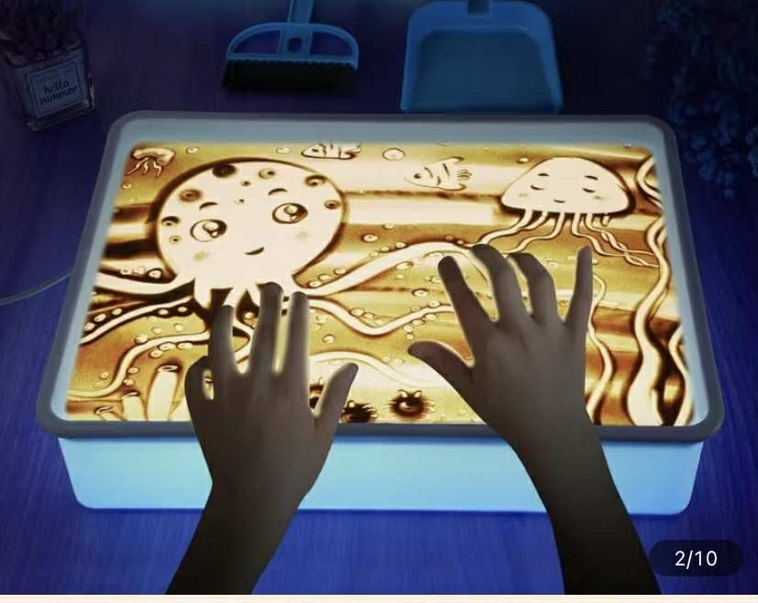
- Sensory panels (or "interactive sensory panels") are used to stimulate the senses and develop cognitive, motor and sensory skills, especially in children or people with special needs.-
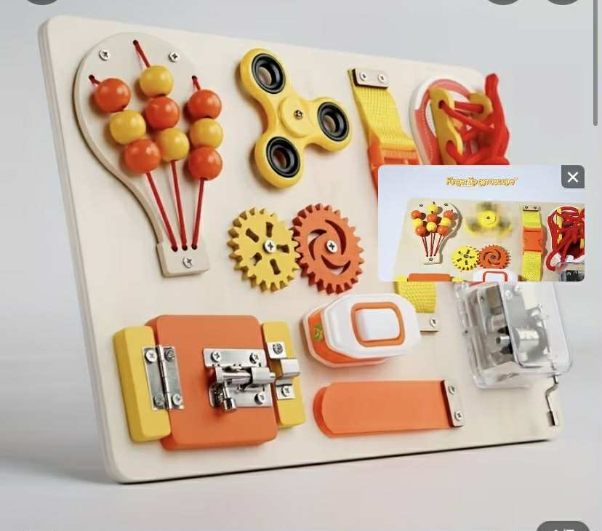

- Set of educational toys for sorting, motor skills, attention, coordination, etc.Set de jucării . 6 different sets -1550 lei

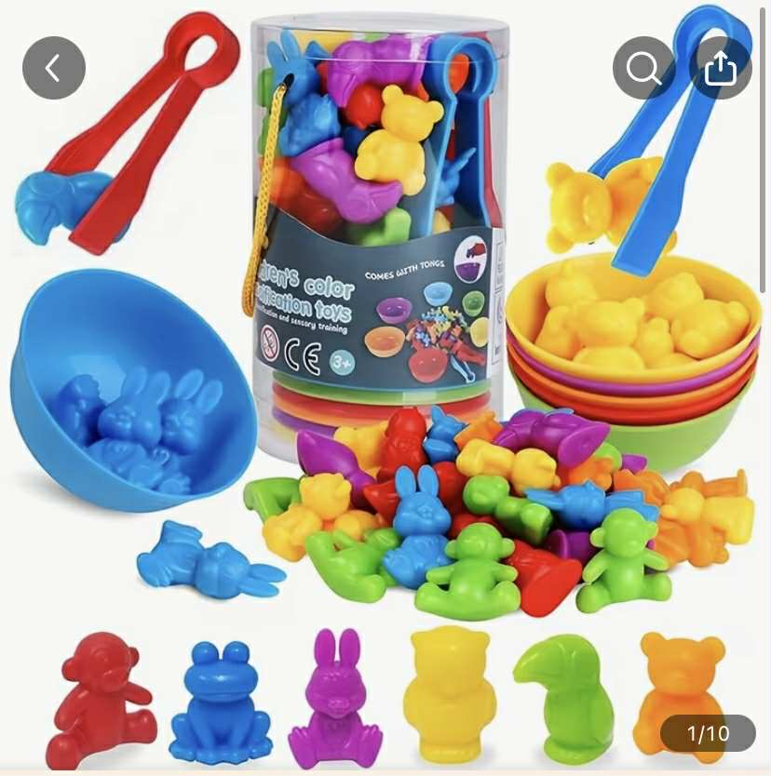
- Educational and creative books: 4 different sets -840 lei
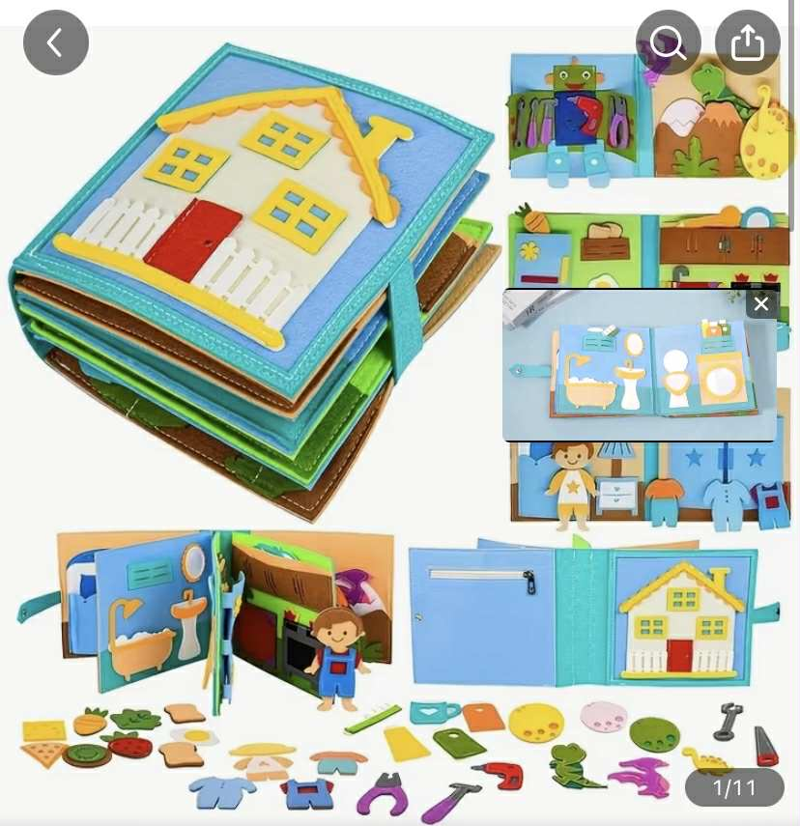
- Reusable notebooks are an excellent tool for preparing the hand and fingers for writing, developing thinking and memory. – 2 bucăți - 630 lei
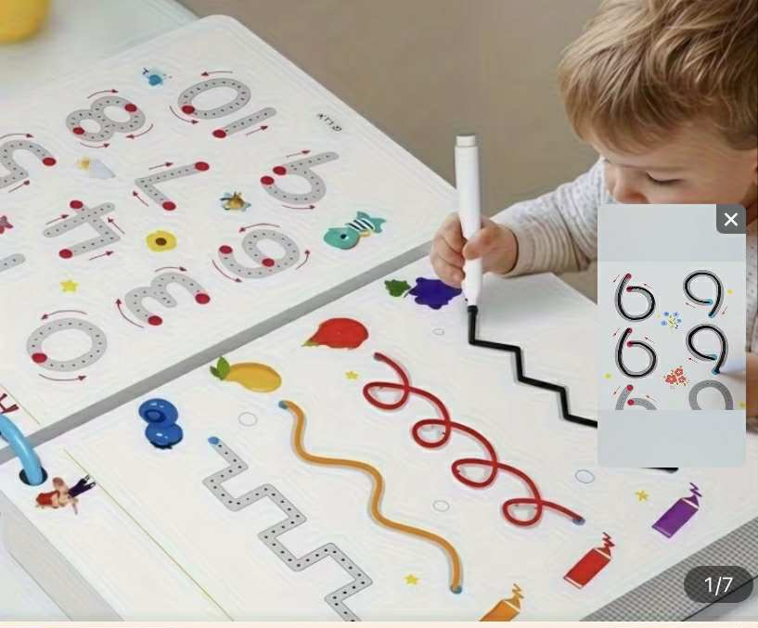
- A balance board is a tool used to develop: body balance, motor coordination, muscle strength (especially of the trunk and legs, awareness of body position (proprioception).Placă de echilibru” sau „balance board”) este un instrument folosit pentru a dezvolta: echilibrul corporal, coordonarea motorie, forța musculaturii (în special a trunchiului și picioarelor, conștientizarea poziției corpului (propriocepția).
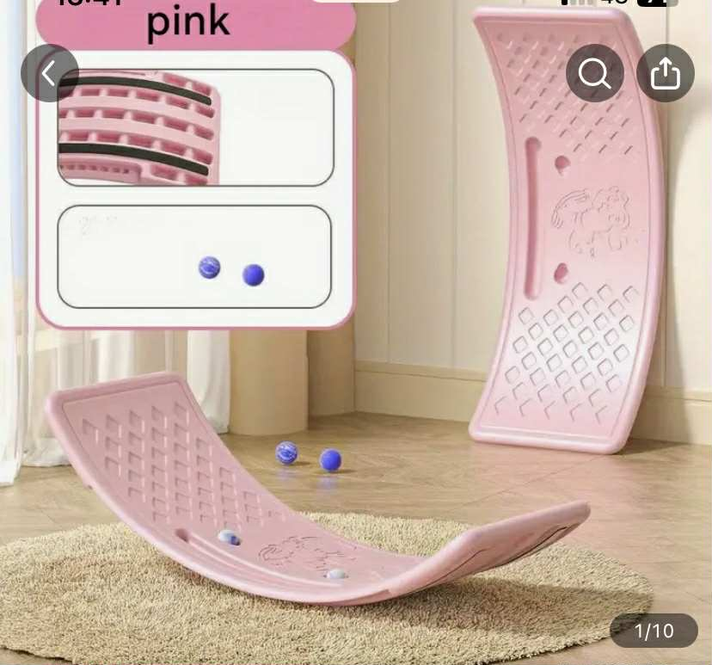
- Sensory mats are educational and therapeutic materials that stimulate the senses (especially tactile, proprioceptive and vestibular) by walking on or touching surfaces with different textures and shapes. They are extremely useful in the motor and sensory development of children, but also in recovery or therapy for people with special needs.
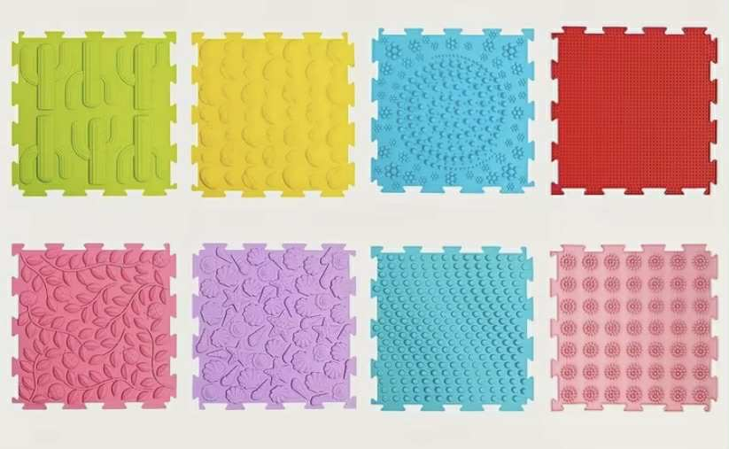
- Balance discs (also known as balance discs, cushions or proprioceptive discs) are round, partially inflated cushions used to stimulate balance, posture and stability. They are excellent for children, adults, athletes, but also in therapy and rehabilitation. 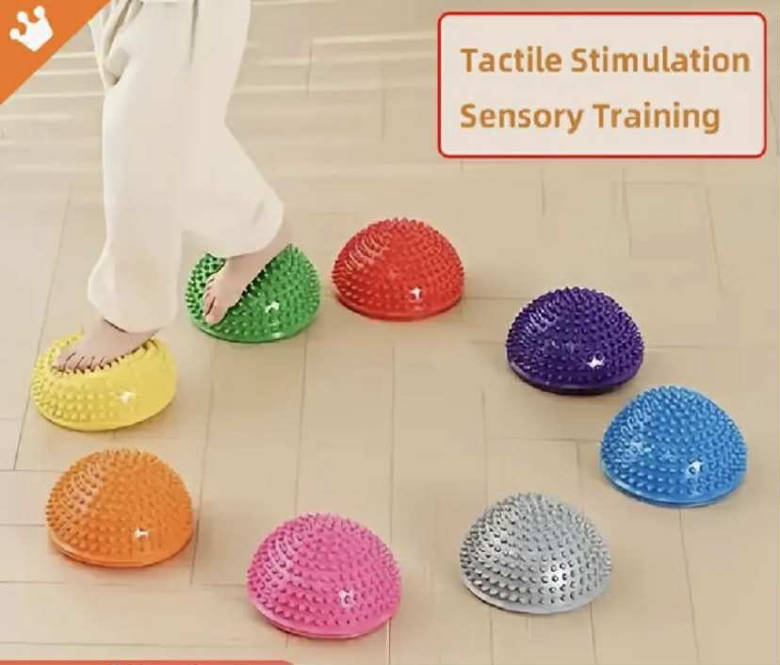
- Kinesiastic sand (or kinetic sand) is a soft, moldable, and tactile play material that combines the properties of dry sand with those of play dough. It is often used for creative play, sensory therapy, and fine motor development in children. – 2 seturi -480 lei

- Bubble tubes and LED light – attract attention and relax – 4 bucăți
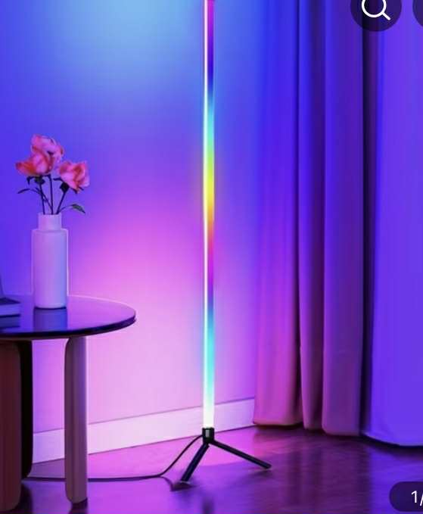

- Board game "My Body" is educational and simple for preschoolers, in which they learn about the human body. During the game, they will learn the names of individual body parts, internal organs, bones and muscles. The knowledge that children acquire during the game is ideally adapted to their age. – 240 lei

.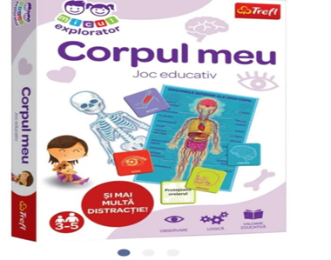
- Classic educational puzzle - ideal for children aged 3 and up. With 15 figured pieces made of thick and durable cardboard, this geometric shape-themed puzzle helps little ones develop logical thinking, hand-eye coordination and basic shape recognition in a fun and interactive way. 6 bucăți -1350 lei

- Worksheets - children with ASD- 5 bucăți – 2000 lei

