New Ambulance Proposal

Kisiizi Hospital, Uganda

1. Overview
Kisiizi Hospital, located in rural Western Uganda, is a 285-bed hospital serving a large and dispersed population with limited access to emergency medical services. Roads are very poor and often turn to mud in the rain. The nearest tarmac road is about an hour away.
The hospital currently relies on an old 4x4 ambulance equipped only with a stretcher and oxygen, which is used primarily for patient transport—not emergency care. Due to long travel times, the current ambulance is able to make approximately 200 trips/ year, which is often a lot less than the demand for services.
Transportation needs include from patients who call asking for assistance, mothers having their babies, referrals from rural health clinics, and some acute patients who need to travel to Mbarara or Kabale for CT scans or advanced care (e.g. cancer treatment, trauma injuries, or neurological care).
This proposal seeks support to procure a fully equipped ambulance that can provide life-saving care during transport, improve referral outcomes, and improve capacity to serve the community.

2. The Problem
- lack of life saving equipment in the current ambulance
- patients transported with limited monitoring, resuscitation or stabilization equipment (the accompanying staff usually carry an emergency kit)
- delays to people needing emergency medical assistance
- no backup ambulance at all when repairs needed
- current ambulance is old with over 216.000kms (135,000 miles)
Without life sustaining ambulance support, patients often deteriorate during transit, leading to preventable deaths.
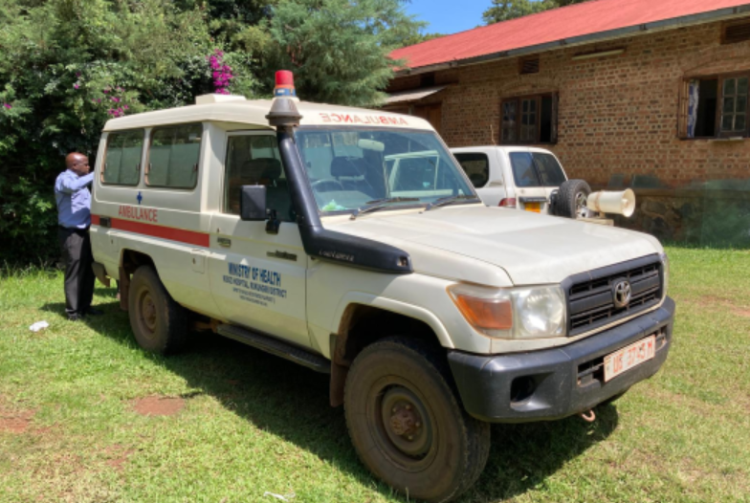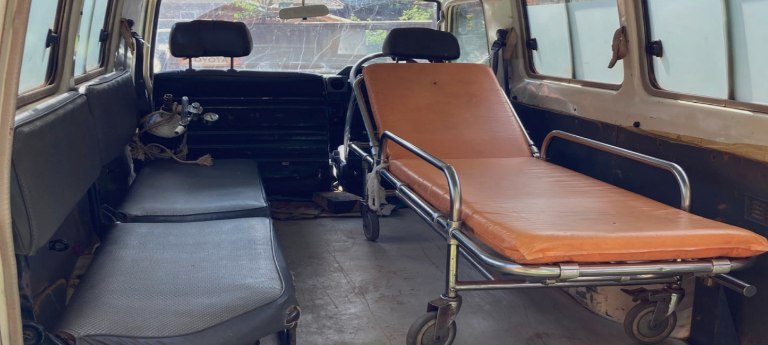
Our current ambulance

3. The Solution
Given the dangerous and slippery roads, we propose to acquire a medically equipped Basic Life Support (Class B) 4x4 ambulance capable of stabilizing patients before and during transport.
Key Features:
- Robust 4x4 to handle rural terrain safely
- Oxygen supply and breathing support
- Patient monitoring (heart rate, blood pressure)
- Stretcher with restraints
- Emergency equipment: defibrillator, suction machine, medication box
Vehicle Requirements:
  - 4x4 capability for rural terrain
  - Reliable and durable platform (e.g., Toyota)
  - Space for paramedic care during transport
  - meets Basic Life Support (Class B) for ambulances in Uganda
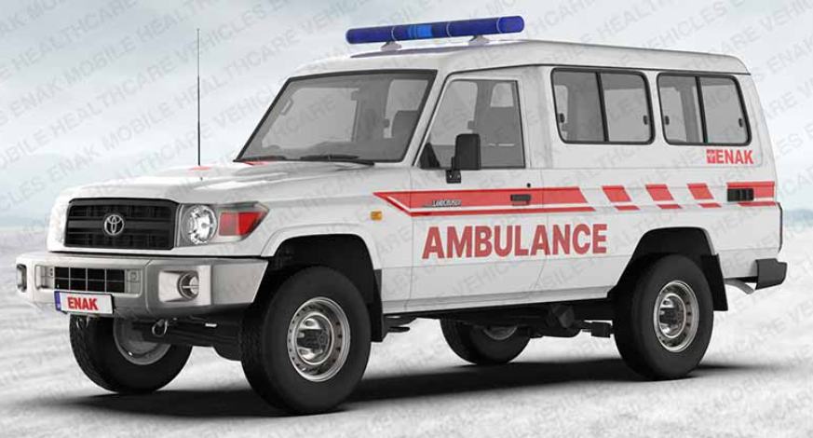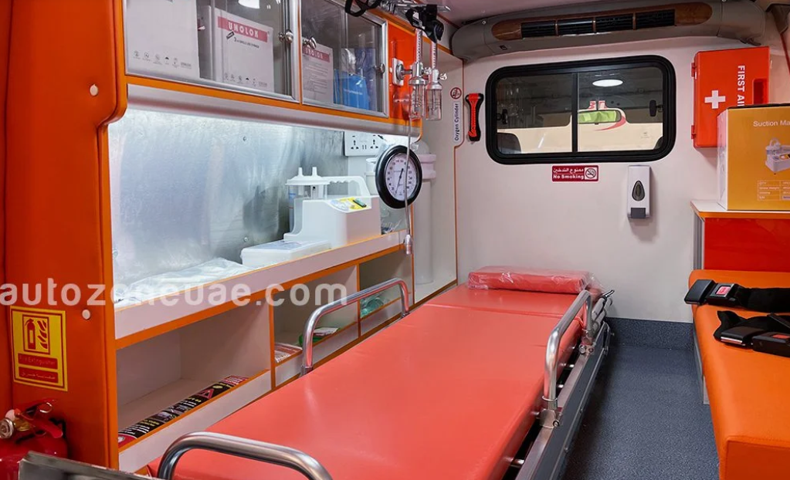
A Class B Toyota 4x4 Ambulance

4. Expected Impact
Our current ambulance makes approximately 200 trips/ year. The additional ambulance will double our capacity to transport patients and save the lives of hundreds of patients annually. The medical capabilities will also mean:
- Improved survival for trauma and critical patients
- Faster emergency response times
- Expanded access to emergency care for remote communities
- Continued ambulance service when one of the ambulances needs maintenance or repair

5. Budget Estimate
The budget reflects the purchase of an almost new ambulance (preferred for reliability) and based on a quote from a Kampala dealer. This cost could be $10-20,000 lower for a nearly new already converted ambulance, or significantly higher for a brand-new vehicle with higher end equipment.
Budget summary: (euros)
- Core 4x4 vehicle $48,000
- Conversion $10,000
- Medical equipment: $12,000
Total Estimated Budget: $70,000
Main conversion breakdown estimates (Class B):
- Interior medical cabin 3,000
- Electrical system (dual battery, inverter) 3,000
- Lighting (LED emergency lights, siren) 500
- Oxygen piping system 2,000
- Mounting rails for stretcher 500
- Infection-control surfaces 1,000
Conversion Total $10,000
Main equipment breakdown estimates (Class B):
- Stretcher system 1,800
- Oxygen cylinders + regulators 1,200
- Suction machine 500
- Defibrillator 2,500
- Patient monitor 3,500
- First aid kits, splints, IV setup 2,500
Equipment Total $12,000

6. Call to Action
We need your financial support to make this meet this critical need. Both Kisiizi Partners and Friends of Kisiizi in the UK and CHEEERS in Ireland have committed to help raise the funds for the new ambulance. Will you join them?
Your support will directly save lives by ensuring patients receive care when it matters most—on the way to hospital.

