School Feeding Program
Zoe Robinson Academy · Congo Town, Monrovia, Liberia
GlobalGiving project: Feed 157 Children at Zoe Robinson Academy, Liberia
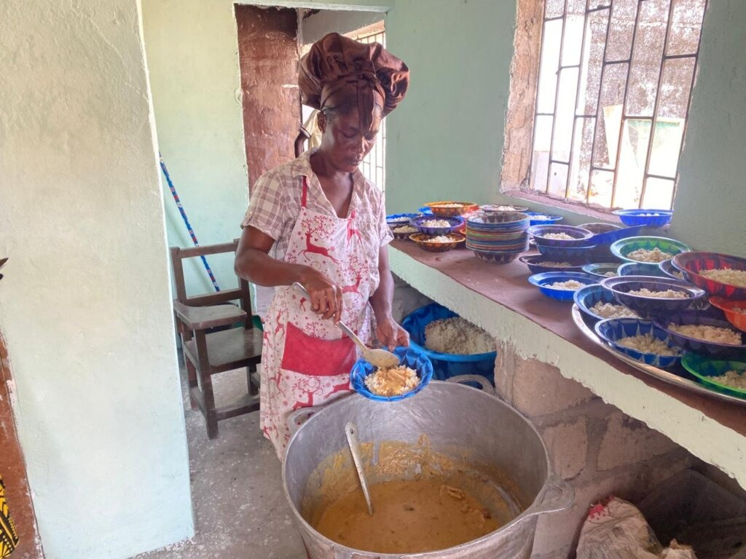  Lunch is served in the school kitchen. | 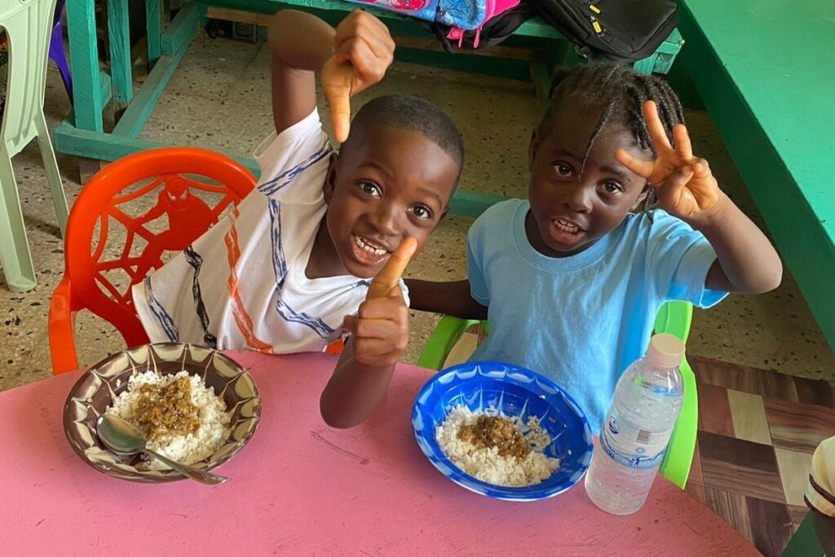  Two thumbs up for lunch.
The program
Every school day, the kitchen at Zoe Robinson Academy cooks two meals for each of its 157 children. Meals continue through summer school, so the children eat all year long. The school serves early childhood through Grade 8, and 32 of its children were referred through Liberia’s national Street Child Project. The school holds a Candid Platinum Transparency Seal, a Rotary International Mark of Excellence, and an operating permit from Liberia’s Ministry of Education.
How it works
- Each month, food money reaches Hilltop Schools in Liberia. Rosaline, head of finance, passes it to Cynthia.
- Cynthia shops at a local open market for rice, fish, chicken, vegetables, drinking water, and charcoal.
- The kitchen staff prepare everything by hand and cook over charcoal fires, right at the school.
- Twice a day, every child is served.
A typical month’s costs
Category | What it buys | Monthly | Annual
Milk and breakfast drinks | Powdered and condensed milk, cocoa, tea, juice | $345 | $4,140
Grains and staples | Rice, flour, corn meal, Cream of Wheat, sugar | $325 | $3,900
Vegetables and soup | Fresh vegetables, soup greens, onions | $190 | $2,280
Protein | Chicken and fish | $175 | $2,100
Drinking water | Clean water for every child | $160 | $1,920
Cooking oils and spreads | Vegetable oil, palm oil, butter, mayonnaise | $115 | $1,380
Charcoal for cooking | Fuel for the cooking fires | $20 | $240
Total | About $8.47 per child per month | $1,330 | $15,960
Figures are estimates for a typical month. Food prices in Liberia change from month to month. Labor is not included.
How it is funded
The Liberian School for Needy Children (LSFNC), a volunteer-run U.S. charity that partners with Hilltop Schools, has paid for every meal so far and will pay half going forward, so it can begin saving to open a high school at the Academy. Right now, the children have nowhere to continue after Grade 8. We are asking GlobalGiving donors to cover the other half of the food cost for the next 12 months. The project goal of $8,700 covers about half of a year’s food and fuel after GlobalGiving’s fees.
Who is involved
- Hilltop Schools manages Zoe Robinson Academy and runs the feeding program in Monrovia.
- Liberian School for Needy Children, based in Rhode Island, USA, is the school’s U.S. partner.
- Project Leader: Paul Sardelli, Impact Officer, Hilltop Schools (paul@hilltopschools.org).

